Submission to the 29th SIOE
Estimating the Educational Impact of Prohibition Laws: A Natural Experiment in India
Shreyas Ramkumar & Kriti Bhargava
FLAME University, India

Abstract
This study examines the unintended educational consequences of alcohol prohibition in Bihar, India, focusing on its impact on student dropout rates. While alcohol prohibition policies are implemented to address public health and social concerns, their effects on educational outcomes remain understudied, particularly in developing nations. We use the alcohol prohibition law promulgated in 2016 in a large Indian state (Bihar, population: 130mn), as a natural experiment to estimate this effect. We conduct a difference-in-difference technique to show that the prohibition significantly increased dropout rates in school-going students, with males experiencing higher increases than females. The increase in dropout rates due to prohibition is because students often get employed for bootlegging activities in the regions of the ban. Even though this effect disappears after a few years, the cost imposed on depriving children from school is high. These results therefore suggest that while prohibition may aim to improve social welfare, it can have unexpected negative consequences on educational outcomes. This study contributes to the growing literature on prohibition policies by establishing a novel connection between alcohol bans and educational disruption, highlighting the need for comprehensive policy approaches that consider potential unintended effects on vulnerable populations.
- Introduction
Alcohol consumption imposes substantial costs on society, including increased mortality, crime, and risky health behaviors (Carpenter and Dobkin 2009, Waddell 2012, Carpenter and Dobkin 2015 in Chaudhari et al., 2024). To mitigate these adverse effects, the prohibition of alcohol has been widely adopted as a policy tool across various regions worldwide (Rorabaugh 2020, Moore & Gerstein 1981, Blocker 2006). This approach is often pursued not only to address public health concerns but also to uphold social order and moral considerations. These issues are particularly pressing in low-income countries, where the burden of alcohol-attributable diseases is significantly higher, and comprehensive national alcohol policies are scarce (WHO 2018 in Chaudhari et al. 2024). Additionally, weak institutional frameworks and inadequate law enforcement exacerbate the consequences of alcohol consumption (Grittner et al. 2012 in Chaudhari et al. 2024).
However, the implementation of alcohol prohibition has led to both intended outcomes, such as reduced alcohol-related harm, and unintended consequences, including economic disruptions and the emergence of illicit markets (Blocker 2006, Thornton 1991, Collins et al. 1997, Livingston 2011). Economists have been particularly interested in studying the multifaceted impacts of such policies, given their profound implications on household dynamics, societal well-being, and public health systems (Miron 1998, Dar & Sahay 2015, Law & Marks 2020, Bao Giang et al. 2013). As a significant policy intervention, understanding the full breadth of its effects remains crucial for informed decision-making and policy formulation (Moore & Gerstein 1981).
Different governmental systems, whether at the central or provincial level, have approached the idea of alcohol prohibition in varied ways, reflecting diverse regulatory stances and cultural contexts (Stockwell et al. 2021, Jha 2022, Jha 2023). Alcohol prohibitions have been prominent globally, implemented for various reasons such as social reform, economic productivity, and religious adherence. In the United States, the Prohibition Era (1920–1933) sought to reduce crime and improve public morality but led to unintended consequences like organized crime, ultimately ending with its repeal. Similarly, countries like Saudi Arabia, Iran, and Afghanistan enforce strict prohibitions rooted in Islamic law to maintain religious and social order. Other nations, including Bangladesh and Malaysia, adopt a dual approach, prohibiting alcohol for Muslims while allowing consumption for non-Muslim communities. Examples include South Africa and Panama's COVID-19 prohibitions to reduce strain on healthcare systems and violence, and historical prohibitions in Finland, Iceland, and Lithuania aimed at addressing social and health issues (Ansari 2016, Blocker 2015). This variation has led to a complex and often contentious relationship with alcohol regulation, making it a significant area of academic inquiry. Over time, the tension surrounding prohibition policies has deepened, as governments balance public health objectives with economic and social considerations. The impact of alcohol consumption extends beyond health, influencing educational outcomes and societal dynamics.
Children, as a particularly vulnerable group, experience the effects of prohibition policies through various channels. These impacts can be categorized into three main areas: children who directly consume alcohol, those living in households where alcohol use is prevalent, and those involved in illicit activities such as bootlegging. The exploitation of minors in illegal alcohol trade not only exposes them to criminal activities but also disrupts their education and adversely affects their overall life outcomes. Research shows it impairs cognitive functioning, reduces academic performance, and decreases educational attainment (Panes et al., 2023; Chabu et al. 2021, Hjarnaa et al. 2020). Studies also link increased drinking with lower high school graduation rates and long-term negative economic outcomes (Yamada et al. 1996, El Ansari et al. 2013, Balsa et al. 2011). Prohibition policies have demonstrated positive effects, with increased disposable household income and investments in children’s education, significantly improving welfare for women and children (Samanta & Narayan 2017, Rumi, 2017). As such, the evolving body of literature on alcohol prohibition presents mixed responses, highlighting both the potential benefits and the unintended consequences of these policies, thereby underscoring the need for continued research in this field.
Alcohol ban can have unintended negative consequences and in this study what we are particularly interested in is the proliferation of illicit alcohol and bootlegging. One notable and concerning consequence of this ban is the exploitation of minors, who are often lured into bootlegging operations due to their perceived "immunity" under the legal framework. Anecdotal evidence and police reports reveal that children are being increasingly exploited for smuggling alcohol using innovative tactics, such as school bottles and tires, which jeopardizes their education and future prospects (Chauhan 2013, Kalra 2015). Adult offenders, facing severe penalties such as life imprisonment or hefty fines for employing minors, have strategically shifted the risk to children. When minors are apprehended, they are tried under juvenile justice laws, which often result in lighter sentences or shorter rehabilitation periods. This shift has significantly impacted the educational outcomes of these children, as many are drawn away from school to participate in these illicit activities.
Our study identifies a distinctive relationship between the prohibition and fluctuations in dropout rates in the state of Bihar, India, both before and after the implementation of the alcohol ban. The Government of Bihar implemented Bihar Prohibition and Excise Act, 2016 aimed at reducing domestic violence and curbing the misuse of earnings by men on alcohol which was believed to impoverish households and affect women’s wellbeing (Bharati & Reddy, n.d.). Using a difference-in-differences (DiD) methodology, we analyze data from various surveys, including the National Family Health Survey (NFHS) Round 4 in 2015-16 and Round 5 in 2019-20, along with UDISE+ data. We examine the changes in educational outcomes through dropout rates associated with the alcohol prohibition. We further conduct a district-level comparison between Bihar and its bordering districts in Jharkhand, Uttar Pradesh, and West Bengal, leveraging this natural experiment to account for the multifaceted factors influencing dropout rates. Our findings reveal that the prohibition significantly increased dropout rates, but this effect disappears after a certain period, suggesting a short-term impact. This study breaks new ground by linking dropout rates to the alcohol prohibition, contributing to the growing body of prohibition research, and, to our knowledge, is the first to establish this connection.
The rest of the paper is divided as follows. Part 2 discusses the literature extensively and identifies the gap we are trying to fill. In Part 3, we explain the background context, the prohibition law in a large Indian state, and the data along with methodology. Part 4 exhibits the result. We discuss our findings in Part 5 and conclude in 6.
- Literature Review
Alcohol consumption and prohibition have been extensively studied in literature, with a significant body of work highlighting their multifaceted impacts on health, society, and policy across diverse socioeconomic and demographic settings. Scholars from various disciplines, including law, sociology, economics, and public policy, have contributed to understanding these complex dynamics.
Thomas Cargiulo (2007) highlights alcohol dependence as a major public health concern, linking it to psychiatric disorders, neurologic impairments, cardiovascular issues, liver diseases, and cancers, with heavy drinking exacerbating mortality risks and impairing cognitive and motor functions. Schmidt and Popham (1975) similarly associate chronic heavy alcohol use with elevated mortality, citing direct physiological effects like cirrhosis and specific cancers, while noting that even moderate consumption poses risks, particularly to liver and cardiovascular health. Adrian and Barry (2004) emphasize alcohol's role in excess morbidity across mental health disorders, infectious diseases, and injuries, underscoring its systemic impact. For adolescents, Clark et al. (2001) report correlations between alcohol use disorders and elevated self-reported health problems, liver enzyme abnormalities, and physical health concerns. On a global scale, Braz (2004) and the WHO report quantify alcohol's burden through disability-adjusted life years (DALYs), attributing 4% of global mortality in 2000 to alcohol consumption.
Alcohol consumption has also been studied for its implications on household dynamics, with a significant body of literature underscoring its multifaceted impact on family stability, economic well-being, and intergenerational outcomes. Research highlights that alcohol abuse within households often leads to increased incidences of domestic violence and familial discord. For instance, studies have shown that alcohol consumption is strongly correlated with the perpetration of intimate partner violence, where abusive behavior is frequently exacerbated by excessive alcohol intake (WHO, 2018). This pattern is further corroborated by insights from Nayak et al. (2017) who argue that alcohol-induced aggression disrupts emotional stability within families, fostering environments of fear and mistrust.
On the economic front, alcohol consumption within households has been linked to significant financial strain, further perpetuating cycles of poverty and deprivation. Banerjee et al. (2019) highlight that a considerable proportion of household income in low-income families is diverted toward alcohol purchases, often at the expense of essential needs such as food, education, and healthcare. This aligns with findings by Jha et al. (2021) note that alcohol-related expenditure disproportionately burdens women and children in vulnerable households, leading to nutritional deficiencies and compromised educational opportunities. Also, de Goeij et al. (2015) explore how economic crises influence alcohol-related health outcomes, identifying mechanisms like psychological distress and tighter budget constraints. They observe a gendered pattern, with harmful drinking behaviors increasing primarily among men during economic downturns.
Alcohol consumption is strongly associated with crime, particularly violent offenses, due to its ability to lower self-control and heighten aggression. Murdoch and Ross (2009) emphasize that alcohol is disproportionately linked to violent crimes, with heavy drinking often preceding conflicts, especially when the instigator is intoxicated. Deehan (2004) explores how situational factors and personal expectations amplify alcohol-related aggression, predominantly among young males. Martin (2001) further reveals that alcohol plays a role in nearly half of all homicides and assaults. While direct causality remains challenging to prove, these findings underscore alcohol's profound influence on violent criminal behavior.
Prohibition laws have been extensively studied in developed nations. In contrast, research on prohibition in developing nations remains less comprehensive and underexplored. Studies from developing countries, such as Ramanan and Singh's (2014) analysis of rural India, reveal how alcohol use contributes to chronic health issues like hypertension and diabetes, alongside strained familial and social relations. Cross-comparative analyses of rural and urban households in the Indian context reveal that alcohol consumption exacerbates gender-based financial inequities, as male members often prioritize alcohol expenditure over shared household responsibilities (De and Saha, 2024). Collectively, these studies affirm that alcohol’s impacts are pervasive and multifaceted, warranting continued attention in both developed and developing nations.
The vulnerability of children to the impacts of alcohol is also documented with respect to the child’s consumption of alcohol and alcohol abuse in the household thus exploring its direct and indirect consequences on health, cognitive, and academic development. Research highlights that alcohol consumption by children adversely affects memory, concentration, and motor skills, leading to diminished cognitive abilities crucial for academic success. Panes et al. (2023) emphasize that binge drinking among youth impairs brain regions responsible for memory and decision-making, resulting in long-term educational setbacks, such as higher dropout rates and expulsions. Similarly, Chabu et al. (2021) identify that alcohol-induced structural changes in the brain exacerbate deficits in impulse control and focus, further impairing academic performance.
Household alcohol consumption significantly disrupts the educational trajectories of children by altering family dynamics and inducing chronic stress. Parental alcohol misuse has been linked to neglect and poor monitoring, as Windle’s work illustrates, leading to adverse behaviors and compromised academic outcomes among adolescents (n.d.). A systematic review by Huq et al. connects these disruptions to long-term neurodevelopmental challenges, negatively affecting children’s behavior and ability to succeed academically (2021). Ha et al. (2024), using data from Vietnam, further demonstrate that household alcohol consumption reduces children’s schooling years and delays their educational attainment, with more pronounced effects in rural areas and on female students. These findings reveal that children are disproportionately vulnerable to the socio-environmental impacts of alcohol, which impede their cognitive, behavioral, and academic growth. While most studies investigate direct alcohol use by students or alcohol abuse by the household members, the broader impact of children being used as a means to get alcohol on children’s education remains underexplored. Together, the above-mentioned studies paint a nuanced picture of how alcohol consumption permeates household dynamics and public health outcomes, manifesting in both immediate disruptions and long-term socio-economic consequences.
Scholars have also focused on prohibition’s unintended consequences in terms of health, domestic violence and crime. Chakrabarti et al. (2024) found that the alcohol ban in India led to reduced frequent alcohol consumption, lower rates of overweight/obesity among men, and decreased emotional and sexual violence against women, emphasizing the positive health and safety outcomes associated with alcohol regulation. Similarly, Blocker (2006) examined the U.S. Prohibition era, revealing a steep decline in death rates from cirrhosis, alcoholic psychosis hospital admissions, and drunkenness arrests during the 1910s and early years of National Prohibition, although these rates rose again afterward. Additionally, the study by Luca et al. (2019) on alcohol regulation in India suggests that stricter alcohol regulation is negatively associated with lower mortality from road accidents, though the estimates did not reach statistical significance. These studies collectively suggest that alcohol prohibition can yield substantial public health benefits, particularly in reducing alcohol-related health issues
There are some notable studies focusing on links between crime and alcohol. Barron et al. (2024) documents a significant reduction in injury-induced mortality and violent crime, particularly homicides, assaults, and rapes, following an alcohol ban in South Africa. The other significant area within the existing literature is the relationship between alcohol regulation and domestic violence, particularly concerning women and children. Studies by Markowitz & Grossman (2024) indicate that increasing beer taxes and implementing alcohol restrictions can effectively reduce violence. Research by Luca et al. (2015) supports this, showing a strong correlation between reduced alcohol consumption and improved marital relations, along with fewer domestic disputes. However, the outcomes of such prohibitions are not uniformly positive. Iyengar (2009) warns that strict enforcement of alcohol bans may inadvertently provoke frustration among alcohol-dependent individuals, potentially escalating retaliatory violence against their partners. Additionally, Kearns et al. (2015) emphasize the role of alcohol outlet density, noting that higher densities are consistently associated with elevated rates of intimate partner violence. They suggest that while reducing alcohol availability is crucial, the implementation of such measures must consider potential unintended consequences. Similarly, research by Luca et al. (2019) demonstrates a causal link between alcohol consumption and domestic violence, suggesting that stricter alcohol regulations could mitigate violent behaviors, particularly partner violence.
A notable gap in the scholarly accounts of alcohol’s influence in household dynamics is that on children’s education. There is little work that systematically explores how an alcohol ban may impact children's schooling, either by affecting their school attendance, performance, or dropout rates. A study by Mishra (2023) is a useful exception, in which the author focused on Bihar, India, and found that the implementation of the alcohol prohibition law resulted in increased school enrollment and improved learning abilities (we build on this study further). However, such studies are rare, and there is little existing research that comprehensively addresses the direct link between alcohol bans and educational outcomes like dropout rates in developing nations. Studies in India for instance, are also thin (but see, Jha 2023, Schess 2023). Some which exists, indicate that women prioritize human development when controlling household income (Rumi 2023, Von Braun 1988, Ranis et al. 2000). There are some newspaper reports that highlight that the prohibition led to a notable shift in household expenditure towards healthier goods, reflected in increased sales of milk, honey, and cheese. These findings suggest a positive reallocation of resources towards health and education, reinforcing the economic benefits outlined in Bihar's economic survey.
Bihar’s prohibition, which is the subject of our study as well, has been explored by scholars to some extent. Studies show a reduction in alcohol-induced health issues and violent crimes, with significant decreases in intimate partner violence and overall violent crime rates (Chakrabarti et al. 2024, Chaudhuri et al. 2024). Evidence from Dar and Sahay (2018) however suggests that the prohibition may have inadvertently increased property crimes due to diverted law enforcement resources and rising black-market activities. While the ban in Bihar has yielded positive social outcomes the judicial system's burden highlights the challenges of implementing such widespread reforms (Mishra, 2024). A worrying part about the ban is the growing involvement of women and children in the illicit alcohol trade (Jha, 2022).
We examine and add to this literature, but linking with prohibition, an otherwise unobserved, but hugely important social variable, namely dropout rates in Bihar. There is limited evidence on the impact of alcohol prohibition on educational outcomes in developing nations. Our study aims to address this gap and advance a new dimension in the study of prohibition.

Background and Methodology

Bihar’s Prohibition of 2016
Bihar is the third most populous state in India. As per UNICEF, home to 47 million children—comprising nearly half (46 percent) of its 104 million residents—Bihar has the highest proportion of children among Indian states, with its children making up 11% of the nation's total population. In response to the challenges faced with respect to domestic violence, deteriorating health outcomes, the Bihar government implemented a state-wide alcohol prohibition policy. It aims to curb alcohol-related issues and protect its vulnerable populations, especially children.
Bihar's alcohol policy has undergone dramatic shifts, shaped by economic challenges and social pressures. Following the bifurcation of Bihar and Jharkhand in 2000, which left Bihar devoid of its mineral wealth, the government introduced the New Excise Policy in 2007 to generate revenue. This strategy expanded alcohol sales, raising revenues from ₹87.18 crore in 2005-06 to ₹1,777 crore in 2014-15—a staggering 1,938% increase (Ahmed 2022, MN, 2020). However, the rapid proliferation of alcohol led to societal issues, particularly in rural areas, including domestic violence and crimes against women. By 2015, women-led self-help groups protested the adverse effects of alcohol, prompting Kumar to promise prohibition as an electoral commitment (Jha 2022). This led to the enactment of the Bihar Prohibition and Excise Act, 2016, enforcing a phased prohibition on alcohol starting from April 2016. The policy sought to mitigate alcoholism's social and economic toll, including domestic violence and misuse of household income, while fostering shifts in household dynamics, rising women's autonomy, and reducing intimate partner violence (Bharati & Reddy, n.d., Dar & Sahay 2018, Chaudhari 2024, Chakrabarti et al. 2024). The ban has its unintended consequences but the literature stays silent with respect to impact on educational outcomes.

Data and Methodology

Our primary outcome variable, dropout rates, is sourced from the Unified District Information System for Education Plus (UDISE+), an extensive information system established by the Ministry of Education. Since its inception, UDISE+ has served as a comprehensive repository of educational data, encompassing information from over 1.5 million schools, 10 million teachers, and 250 million students across India. This dataset spans 11 distinct sections and provides district-level dropout data, disaggregated by gender, social class, and student class. For the purposes of this analysis, we construct a panel dataset at the district level, covering the academic years from 2012–13 to 2021–22.

Given the panel nature of our data, where multiple observations are recorded over time, we incorporate additional variables to control for fixed effects and contextual differences across districts. One such variable is the number of schools per district, also derived from UDISE+. This variable serves as a fixed-effect control, as the percentage change in the number of schools over time is minimal and unlikely to significantly influence dropout trends within the study period.

To account for the context of alcohol consumption, we include data on mean alcohol consumption levels for all relevant districts, sourced from the National Family Health Survey (NFHS) 2019–20 (Men’s Recode). This variable captures representative consumption levels across districts, reflecting that male alcohol consumption is significantly higher than that of females, whose consumption levels are negligible in the dataset.

Additionally, to capture district-invariant time-specific effects, we utilize Gross State Domestic Product (GSDP) data from the Economic and Political Weekly Research Foundation (EPWRF) dataset. This data is adjusted for population (per capita) and is provided as a yearly panel dataset at the district level.

The dropout data is disaggregated by sex, social class, and student age group. The social class categories include General, Scheduled Castes, Scheduled Tribes, and Other Backward Castes. Student age groups are categorized as primary students (Class 1 to 5), upper primary students (Class 6 to 8), and secondary students (Class 9 and 10). This dataset yields a pooled set of 13,771 observations, including aggregated ‘overall’ categories for social class and gender, providing a robust basis for our analysis.

The prohibition of alcohol in Bihar serves as a natural experiment, utilizing geographic boundaries to compare treated and untreated districts. This approach leverages adjacent districts, separated solely by state boundaries, to conduct a comparative analysis between districts in Bihar (treated with the ban) and neighboring districts in Uttar Pradesh, Jharkhand, and West Bengal (not treated). The dataset comprises 14 districts from Bihar and 20 districts from neighboring states, with an equal number of observations per district, as data is consistently collected at the district level (see Figure 1).
<Insert Fig 1 here>

The Difference-in-Differences (DiD) methodology is employed to estimate the impact of the prohibition. A key assumption of the DiD approach is that the outcome variable must exhibit parallel trends prior to the treatment. Figure 2 confirms this assumption, showing that dropout rates in both Bihar and non-Bihar districts followed similar trends for three years before the implementation of the ban, fluctuating in parallel. After the ban, a divergence in trends is observed, indicating potential policy effects. Although these visual differences may appear subtle, the regression analysis confirms that they are statistically significant.
<Insert Fig 2 here>

The regression equation used to estimate the impact of the policy is specified as follows:
Ydt = ⍺ + ꞵ1Post_2016t + ꞵ2Treatd + ꞵ3Post_2016t*Treatd + γdt + + ƞt + edt

In this equation, Ydt represents the main outcome variable—dropout rates. Post_2016t is a binary variable indicating the post-2016 treatment period, and TPost_2016t*Treatd is a binary variable for the treatment group (districts in Bihar). γdt accounts for district-specific time trends, ƞt​ captures time trend-based effects, and edt​ represents the error term. The coefficient ꞵ3 is the difference-in-difference estimate, which measures the effect of the prohibition policy on dropout rates.

This analysis is further disaggregated across social class, gender, and student age groups to provide a comprehensive understanding of the policy's impact across different demographic segments.

Results
In analyzing dropout rates across gender and social class, Uttar Pradesh exhibits the lowest dropout rate at 10%, followed by Bihar at 11.5%, and West Bengal at 13.25%. A closer examination of the distribution in terms of gender reveals that, on average, male dropout rates are higher than those of females (refer to Table 2). The disparity in dropout rates between genders is smallest in the secondary student age group and largest in the upper primary age group. The dataset used is a balanced panel, ensuring equal data representation across all 34 constituencies in terms of time period, gender, social class, and student age group.
<Insert Table 2 here>
The first layer of analysis considers the overall data on gender and social class. Regression results indicate that prohibition has a significant effect on dropout rates (see Table 3). For primary school students (classes 1-5), dropout rates increased by approximately 4 percentage points post-prohibition (p<0.01). For upper primary students (classes 6-8), the increase was 5.5 percentage points (p<0.01). In contrast, the increase in dropout rates for secondary students (classes 9-12) was only 1.5 percentage points, and this result was not statistically significant. It is noteworthy that the R-squared value across these regressions is around 0.1, indicating modest explanatory power.
<Insert Table 3 here>
In the second layer of analysis, social class data is kept in the overall category, while gender is compared across male and female categories (see Tables 4 and 5). Among primary students, males exhibit a 0.5 percentage point higher dropout rate than females across the four states. Difference-in-Differences (DiD) estimates further validate this, showing a male dropout increase of 4.45 percentage points compared to 3.26 percentage points for females, both significant at the 1% level. At the secondary level, the difference in dropout rates between males and females due to prohibition is marginal, with males experiencing a 5.99 percentage point increase and females a 5.01 percentage point increase (both p<0.01). However, similar to the overall analysis, the increase in dropout rates at the secondary level for both males and females is statistically insignificant (p>0.1).
<Insert Table 4 and 5 here>
The third layer of analysis examines the impact of social class on dropout rates. Using data from UDISE+, which categorizes students into General, Scheduled Caste, Scheduled Tribe, and Other Backward Castes (OBC), we pooled data for Scheduled Caste, Tribe, and OBC categories and compared it against the General category. The results indicate that the increase in dropout rates is statistically insignificant across all three student categories—primary, upper primary, and secondary (see Tables 6 and 7).
<Insert Table 6 and 7 here>
- Discussion

We hypothesized that dropout rates in Bihar would increase post-prohibition compared to other states, driven by three primary factors. The first is the possibility that children themselves consume alcohol. However, this is less likely in Bihar, as the data indicates that the highest increase in dropouts occurred among primary and upper primary school children, who are too young to consume alcohol at levels that would directly affect their school attendance. Thus, this factor does not provide a strong explanation for the observed trends.
The second factor pertains to alcohol consumption within households. In abusive households where alcohol consumption is prevalent, children might feel unsafe and seek refuge outside, potentially leading to lower dropout rates. With the prohibition, alcohol availability in such households is theoretically reduced, potentially making children feel safer. However, another possibility arises: if illicit alcohol is being purchased post-prohibition, household resources might still be diverted away from essential needs such as education and nutrition, potentially leading to higher dropout rates. This creates a complex scenario where the intended economic and social benefits of prohibition might not fully materialize in certain households.
The third factor considers the involvement of children in alcohol distribution or bootlegging. It is plausible that primary and upper primary school children are being used for such activities, which could contribute to higher dropout rates in these groups. However, if this were the case, we would expect to see similarly high dropout rates among secondary school students, which our data does not show. This discrepancy calls for a deeper investigation into the roles and activities of children across different age groups in the context of prohibition. Literature and on field investigation on whether secondary school children are involved in bootlegging activities could provide clarity. If secondary students are indeed not involved, this could support our findings. Alternatively, if literature suggests they are typically involved, our results may challenge this assumption and highlight a need for further research.
Our data also revealed that male students experienced higher dropout rates than females. This trend may be explained by gender norms in rural communities, where males are more likely to venture out and have greater freedom, which might expose them to higher risks of school discontinuation. Further literature review could strengthen this argument.
Interestingly, the data did not show significant differences in dropout rates among different social classes, such as SC, ST, OBC, and general categories. It was hypothesized that marginalized communities, given their history of discrimination and deprivation, might be more vulnerable to education disruptions and possibly more likely to be involved in bootlegging activities. However, our findings suggest otherwise. This could indicate that while historical marginalization and economic struggles persist, they may not directly translate into significant differences in dropout rates under the specific conditions of alcohol prohibition. Literature exploring the intersection of alcohol-related activities and educational outcomes in marginalized communities would be valuable to contextualize these results.
In conclusion, our findings challenge several common assumptions and underscore the need for nuanced research into the complex socio-economic dynamics of alcohol prohibition and its impact on education. Further exploration of these factors, supported by robust literature, can provide deeper insights into the unintended consequences of policy interventions like prohibition.
<more to be added>
Conclusion
A key limitation of this study is the relatively small sample size, which may affect the generalizability of our findings. The sample size for all regressions is fixed at 306 observations, as this analysis is based on perfectly balanced panel data. This limitation arises from the structure of the data, which is aggregated at the district and year level, covering 34 states over nine time periods. While this ensures consistency across regressions, as each regression focuses on specific categories within social class, gender, or student age groups, the limited number of observations may constrain the ability to generalize the effects of alcohol prohibition on dropout rates to other contexts. Future research with larger and more granular datasets could provide more robust insights and enhance the applicability of these findings.
<more to be added>
Acknowledgement
Authors would like to thank Yugank Goyal under whose guidance this study was done. They would also like to thank Abhay Bang, Aman Mittal, Anwesha Basu, and Reshmi Sengupta for their help in constructing the argument better. All errors and omissions remain authors’ alone.
References
- Adrian, M., & Barry, S. J. (2003). Physical and mental health problems associated with the use of alcohol and drugs. Substance Use & Misuse, 38(11–13), 1575–1614. https://doi.org/10.1081/JA-120024230
- Ahmed, S. (2022, April 3). What is the Problem with Bihar’s Alcohol Ban. News Click.
- Al-Ansari, B., Thow, A.-M., Day, C. A., & Conigrave, K. M. (2016). Extent of alcohol prohibition in civil policy in Muslim majority countries: The impact of globalization. Addiction (Abingdon, England), 111(10), 1703–1713. https://doi.org/10.1111/add.13159
- Alcohol ban making Bihar land of milk & honey: State study. (2018, June 15). The Times of India. https://timesofindia.indiatimes.com/india/prohibition-making-bihar-land-of-milk-honey-state-study/articleshow_new/64594160.cms
- Balhara, Y., & Kalra, S. (2017). The alcohol and tobacco burden of India. Journal of Social Health and Diabetes, 05(02), 061–062. https://doi.org/10.1055/s-0038-1676240
- Balsa, A. I., Giuliano, L. M., & French, M. T. (2011). The effects of alcohol use on academic achievement in high school. Economics of Education Review, 30(1), 1–15.
- Banerjee, A., Duflo, E., Keniston, D., & Singh, N. (2019). The efficient deployment of police resources: Theory and new evidence from a randomized drunk driving crackdown in india (Working Paper No. 26224). National Bureau of Economic Research. https://doi.org/10.3386/w26224
- Bao Giang, K., Van Minh, H., & Allebeck, P. (2013). Alcohol consumption and household expenditure on alcohol in a rural district in Vietnam. Global Health Action, 6(1), 18937. https://doi.org/10.3402/gha.v6i0.18937
- Blocker, J. S. (2006). Did prohibition really work? Alcohol prohibition as a public health innovation. American Journal of Public Health, 96(2), 233–243. https://doi.org/10.2105/AJPH.2005.065409
- Cargiulo, T. (2007). Understanding the health impact of alcohol dependence. American Journal of Health-System Pharmacy: AJHP: Official Journal of the American Society of Health-System Pharmacists, 64(5 Suppl 3), S5-11. https://doi.org/10.2146/ajhp060647
- Carpenter, C. S., C. Dobkin, and C. Warman. 2016. “The Mechanisms of Alcohol Control.” Journal of Human Resources 51 (2): 328–56.
- Carpenter, C., & Dobkin, C. (2009). The effect of alcohol consumption on mortality: Regression discontinuity evidence from the minimum drinking age. American Economic Journal: Applied Economics, 1(1), 164–182. https://doi.org/10.1257/app.1.1.164
- Carpenter, C., and C. Dobkin. 2015. “The Minimum Legal Drinking Age and Crime.” Review of Economics and Statistics 97 (2): 521–24.
- Chabu, M. (2021). Impact of Alcohol Consumption on Cognitive and Academic Performance of Students at David Livingstone College of Education. International Journal of Research and Innovation in Social Science, 5(7), 280–286. https://ideas.repec.org/a/bcp/journl/v5y2021i7p280-286.html
- Chakrabarti, S., Christopher, A., Scott, S., Kishore, A., & Nguyen, P. H. (2024). Effects of a large-scale alcohol ban on population-level alcohol intake, weight, blood pressure, blood glucose, and domestic violence in India: A quasi-experimental population-based study. The Lancet Regional Health. Southeast Asia, 26, 100427. https://doi.org/10.1016/j.lansea.2024.100427
- Chaudhuri, K., Jha, N., Nilayamgode, M., & Suryanarayana, R. (2024). Alcohol ban and crime: The ABCs of the Bihar prohibition. Economic Development and Cultural Change, 72(4), 1795–1827.
- Chauhan, A. (2023, April 13). Minor orphans used as drug couriers in Ahmedabad: Cops. The Times of India.
- Children in Bihar: The challenge. (n.d.). UNICEF. https://www.unicef.org/india/children-bihar
- Collins, J. J., Kroutil, L. A., Roland, E. J., & Moore-Gurrera, M. (1997). Issues in the linkage of alcohol and domestic violence services. In M. Galanter, H. Begleiter, R. Deitrich, R. Fuller, D. Gallant, D. Goodwin, E. Gottheil, A. Paredes, M. Rothschild, D. Van Thiel, & D. Winczewski (Eds.), Recent Developments in Alcoholism: Volume 13: Alcohol and Violence—Epidemiology Neurobiology Psychology Family Issues (pp. 387–405). Springer US. https://doi.org/10.1007/0-306-47141-8_20
- Dane, A., Panes, D., Ablian, J., Anthony, M., & Gantang, R. (2023). The Effects of Alcohol Consumption on Academic Performance: A Literature Review. https://www.ajmrd.com/wp-content/uploads/2023/02/I527784.pdf
- Dar, A. H., Deeksha, Thakur, S., & Saha, S. (2024). Alcohol prohibition, home environment and learning: Evidence from India (SSRN Scholarly Paper 4958902).
- Dar, A., & Sahay, A. (2018). Designing Policy in Weak States: Unintended Consequences of Alcohol Prohibition in Bihar. Paper Draft.
- de Goeij, M. C. M., Suhrcke, M., Toffolutti, V., van de Mheen, D., Schoenmakers, T. M., & Kunst, A. E. (2015). How economic crises affect alcohol consumption and alcohol-related health problems: A realist systematic review. Social Science & Medicine, 131, 131–146. https://doi.org/10.1016/j.socscimed.2015.02.025
- Debnath, S. (2015). The impact of household structure on female autonomy in developing countries. The Journal of Development Studies, 51(5), 485–502.
- Debnath, S., Paul, S., & Sareen, K. (2023, July 27). Impact of Bihar’s alcohol ban on intimate partner violence. Ideas For India. http://www.ideasforindia.in/topics/governance/impact-of-bihar-s-alcohol-ban-on-intimate-partner-violence.html
- Deehan, A. (n.d.). Alcohol and Crime: Taking stock. http://webdoc.sub.gwdg.de/ebook/serien/n/CRRS/3-fr.pdf
- El Ansari, W., Stock, C., & Mills, C. (2013). Is alcohol consumption associated with poor academic achievement in university students? International Journal of Preventive Medicine, 4(10), 1175–1188.
- Grittner, U., S. Kuntsche, K. Graham, and K. Bloomfield. 2012. “Social Inequalities and Gender Differences in the Experience of Alcohol-related Problems.” Alcohol and Alcoholism 47(5): 597–605.
- Ha, V. T. C., Tran, T. Q., Pham, T. T. T., & Doan, T. T. (2024). Does Household Alcohol Consumption Affect Children’s Education? Evidence from a Lower Middle-Income Country. Child & Youth Services, 1–32. https://doi.org/10.1080/0145935x.2024.2389088
- Hansen, B., and G. R. Waddell. 2018. “Legal Access to Alcohol and Criminality.” Journal of Health Economics 57: 277–89.
- Health Problems in Adolescents with Alcohol Use Disorders: Self-Report, Liver Injury, and Physical Examination Findings and Correlates BY Duncan B. Clark, Kevin G. Lynch, John E. Donovan, Geoffrey D. Block
- Huq, T., Alexander, E. C., Manikam, L., Jokinen, T., Patil, P., Benjumea, D., Das, I., & Davidson, L. L. (2021). A systematic review of household and family alcohol use and childhood neurodevelopmental outcomes in low- and middle-income countries. Child Psychiatry and Human Development, 52(6), 1194–1217. https://doi.org/10.1007/s10578-020-01112-3
- Iyengar, R. (2009). Does the certainty of arrest reduce domestic violence? Evidence from mandatory and recommended arrest laws. Journal of Public Economics, 93(1–2), 85–98. https://doi.org/10.1016/j.jpubeco.2008.09.006
- Jha, R. (2022). Bihar prohibition: An unmitigated disaster. https://www.orfonline.org/expert-speak/bihar-prohibition-an-unmitigated-disaster
- Jha, R. (2023). Experiments in Alcohol Prohibition: A Review of Maharashtra’s Chandrapur Experience. ORF. https://www.orfonline.org/research/experiments-in-alcohol-prohibition-a-review-of-maharashtra-s-chandrapur-experience
- Kalra, R. (2015, November 28). Prohibition in Bihar: Good or bad? [Times of India]. Random Access, India.
- Kearns, M. C., Reidy, D. E., & Valle, L. A. (2015). The role of alcohol policies in preventing intimate partner violence: A review of the literature. Journal of Studies on Alcohol and Drugs, 76(1), 21–30. https://doi.org/10.15288/jsad.2015.76.21
- Law, M. T., & Marks, M. S. (2020). Did early twentieth‐century alcohol prohibition affect mortality? Economic Inquiry, 58(2), 680–697. https://doi.org/10.1111/ecin.12868
- Lino, M. (1993). [Review of Review of the economics of prohibition, by M. Thornton]. The Journal of Consumer Affairs, 27(2), 433–436. https://www.jstor.org/stable/23859628
- Livingston, J. D., Milne, T., Fang, M. L., & Amari, E. (2012). The effectiveness of interventions for reducing stigma related to substance use disorders: A systematic review. Addiction (Abingdon, England), 107(1), 39–50. https://doi.org/10.1111/j.1360-0443.2011.03601.x
- Livingston, M. (2011). A longitudinal analysis of alcohol outlet density and domestic violence. Addiction, 106(5), 919–925. https://doi.org/10.1111/j.1360-0443.2010.03333.x
- Luca, D. L., E. Owens, and G. Sharma. 2015. “Can Alcohol Prohibition Reduce Violence against Women?” American Economic Review 105 (5): 625–29.
- Luca, D. L., E. Owens, and G. Sharma. 2019. “The Effectiveness and Effects of Alcohol Regulation: Evidence from India.” IZA Journal of Development and Migration 9(1): Article 4.
- Markowitz, S., Kaestner, R., & Grossman, M. (2005). An investigation of the effects of alcohol consumption and alcohol policies on youth risky sexual behaviors. American Economic Review, 95(2), 263–266. https://doi.org/10.1257/000282805774669899
- Martin, S. E. (2001). The links between alcohol, crime and the criminal justice system: Explanations, evidence and interventions. The American Journal on Addictions, 10(2), 136–158. https://doi.org/10.1080/105504901750227796
- Meloni, J. N., & Laranjeira, R. (2004). Custo social e de saúde do consumo do álcool. Revista Brasileira de Psiquiatria, 26(suppl 1), 7–10. https://doi.org/10.1590/S1516-44462004000500003
- Miron, J. A. (n.d.). THE EFFECT OF ALCOHOL PROHIBITION ON ALCOHOL CONSUMPTION. https://www.nber.org/system/files/working_papers/w7130/w7130.pdf
- Mishra, N. (2023). Alcohol Ban: Good or Bad? [Working Paper]. https://krea.edu.in/ifmrgsb/wp-content/uploads/2023/06/WP23-002_ResearchPaper_EA_Narbadeshwar.pdf
- MN, P. (2020, October 28). Prohibition in Bihar has pushed its poor towards cheap drugs and hooch. Scroll.In. https://scroll.in/article/976919/prohibition-in-bihar-has-pushed-its-poor-towards-cheap-drugs-and-hooch
- Moore, M. H., & Gerstein, D. R. (1981b). Temperance and prohibition in america: A historical overview. In Alcohol and Public Policy: Beyond the Shadow of Prohibition. National Academies Press (US). https://www.ncbi.nlm.nih.gov/books/NBK216414/
- Moore, M. H., & Gerstein, D. R. (Eds.). (1981a). Alcohol and public policy: Beyond the shadow of prohibition. National Research Council (US) Panel on Alternative Policies Affecting the Prevention of Alcohol Abuse and Alcoholism. http://www.ncbi.nlm.nih.gov/books/NBK216421/
- Murdoch, D., Pihl, R. O., & Ross, D. (1990). Alcohol and crimes of violence: Present issues. The International Journal of the Addictions, 25(9), 1065–1081. https://doi.org/10.3109/10826089009058873
- National Research Council (US) Panel on Alternative Policies Affecting the Prevention of Alcohol Abuse and Alcoholism. (1981). Alcohol and public policy: Beyond the shadow of prohibition (M. H. Moore & D. R. Gerstein, Eds.). National Academies Press (US). http://www.ncbi.nlm.nih.gov/books/NBK216421/
- Prohibition: A very short introduction (very short intr…. (n.d.). Goodreads. Retrieved January 15, 2025, from https://www.goodreads.com/book/show/44403243-prohibition
- Ranis, G., Stewart, F., & Ramirez, A. (2000). Economic growth and human development. World Development, 28(2), 197–219. https://doi.org/10.1016/S0305-750X(99)00131-X
- Reddy, B., & Bharati, K. (2020, December 8). Has the alcohol prohibition in Bihar, India resulted in less violence against women? SVRI.
- Rorabaugh, W. J. (2020). Prohibition: A very short introduction. Oxford University Press.
- Rumi, F. (2023, February 22). 7 years of prohibition: 95% men in Bihar stopped consuming alcohol after ban, says report. The Times of India.
- Samanta, D., & Narayan, S. (2017). 27 Human development in Bihar and impact of alcohol Prohibition Policy: An analysis. Journal of Governance & Public Policy, 7(2), 27–38.
- Schess, J., Bennett-Li, L., Velleman, R., Bhatia, U., Catalano, A., Jambhale, A., & Nadkarni, A. (2023). Alcohol policies in India: A scoping review. PLOS ONE, 18(11), e0294392. https://doi.org/10.1371/journal.pone.0294392
- Schmidt, W., & Popham, R. E. (1975). Heavy alcohol consumption and physical health problems: A review of the epidemiological evidence. Drug and Alcohol Dependence, 1(1), 27–50. https://doi.org/10.1016/0376-8716(75)90005-8
- Singh, S., & Ramanan, Vv. (2016). A study on alcohol use and its related health and social problems in rural Puducherry, India. Journal of Family Medicine and Primary Care, 5(4), 804. https://doi.org/10.4103/2249-4863.201175
- Stockwell, T., Giesbrecht, N., Vallance, K., & Wettlaufer, A. (2021). Government options to reduce the impact of alcohol on human health: Obstacles to effective policy implementation. Nutrients, 13(8), 2846. https://doi.org/10.3390/nu13082846
- Suryanarayana, R., Chaudhuri, K., Nilayamgode, M., & Jha, N. (2023). Alcohol Ban and Crime: The ABC’s of the Bihar Prohibition. Economic Development and Cultural Change. https://doi.org/10.1086/725452
- Thornton, M. (1991, July). Alcohol Prohibition Was a Failure. https://www.cato.org/policy-analysis/alcohol-prohibition-was-failure
- Unintended consequences. (n.d.). Prohibition | Ken Burns | PBS. Retrieved January 15, 2025, from
- Von Braun, J. (1988). Effects of technological change in agriculture on food consumption and nutrition: Rice in a West African setting. World Development, 16(9), 1083–1098.
- WHO (World Health Organization). 2018. “Global Status Report on Alcohol And Health, 2018.” WHO, Geneva
- Yamada, T., Kendix, M., & Yamada, T. (1996). The impact of alcohol consumption and marijuana use on high school graduation. Health Economics, 5(1), 77–92.

Appendix

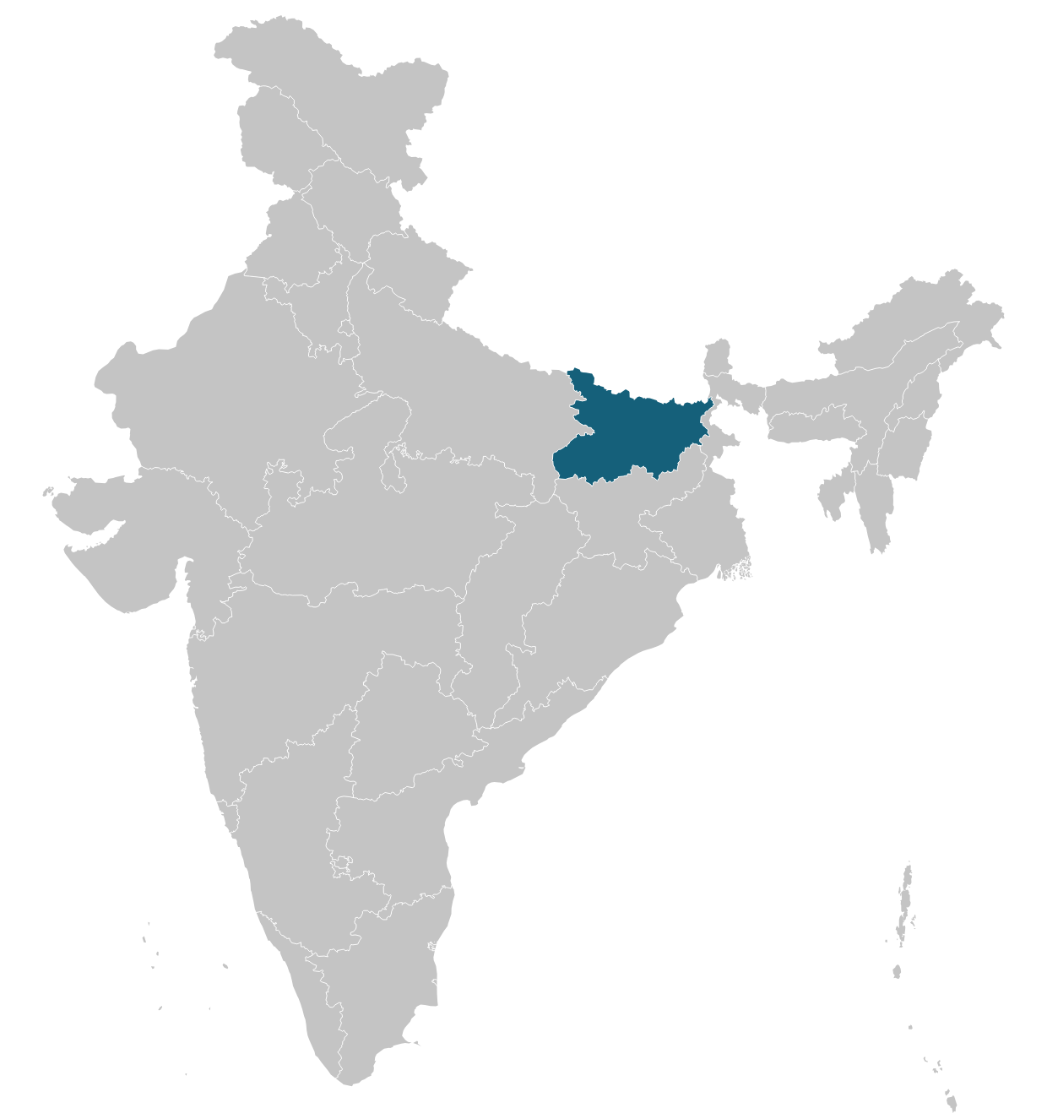
Figure 1a: Districts of Bihar highlighted in the map of India

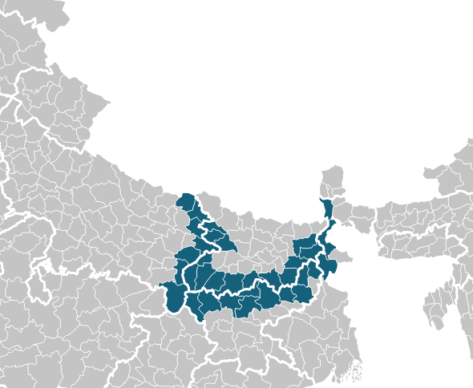
Figure 1b: Districts used for this study, border districts of Bihar, Jharkhand, Uttar Pradesh and West Bengal

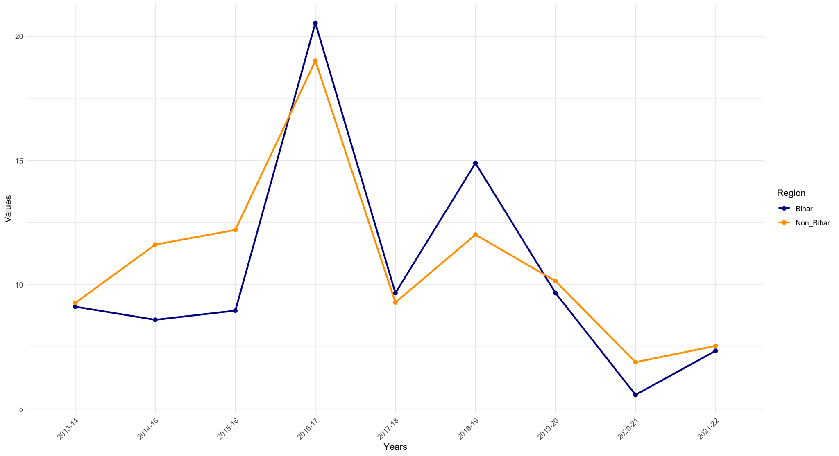

Figure 2: Dropout Rate trends in Bihar and other states across time

Sr. No | State Name | District | Mean | Std Dev
1 | Bihar | Aurangabad (Bihar) | 8.84 | 12.65
2 | Bihar | Banka | 10.91 | 9.98
3 | Bihar | Bhagalpur | 12.53 | 12.98
4 | Bihar | Buxar | 13.88 | 15.7
5 | Bihar | Gaya | 12.17 | 15.52
6 | Bihar | Gopalganj | 9.11 | 11.1
7 | Bihar | Jamui | 9.74 | 9.08
8 | Bihar | Kaimur (Bhabua) | 9.3 | 10.85
9 | Bihar | Katihar | 15.98 | 12.79
10 | Bihar | Nawada | 10.25 | 16.44
11 | Bihar | Purnia | 11.15 | 9.4
12 | Bihar | Rohtas | 12.56 | 14.69
13 | Bihar | Saran | 12.7 | 14.67
14 | Bihar | Siwan | 11.52 | 13.74
15 | Jharkhand | Chatra | 15.12 | 13.95
16 | Jharkhand | Deoghar | 12.9 | 11.73
17 | Jharkhand | Dumka | 13.01 | 11.29
18 | Jharkhand | Garhwa | 16.26 | 15.33
19 | Jharkhand | Giridih | 13.13 | 11.07
20 | Jharkhand | Godda | 13.39 | 13.66
21 | Jharkhand | Hazaribag | 9.26 | 9.6
22 | Jharkhand | Kodarma | 12.61 | 14.22
23 | Jharkhand | Palamu | 11.19 | 13.71
24 | Jharkhand | Sahibganj | 17.84 | 13.9
25 | Uttar Pradesh | Ballia | 9.43 | 12.47
26 | Uttar Pradesh | Chandauli | 8.61 | 15.34
27 | Uttar Pradesh | Deoria | 7.68 | 9.48
28 | Uttar Pradesh | Ghazipur | 9.77 | 12.68
29 | Uttar Pradesh | Kushinagar | 11.96 | 20.2
30 | Uttar Pradesh | Maharajganj | 13.06 | 17.89
31 | Uttar Pradesh | Sonbhadra | 9.55 | 7.76
32 | West Bengal | Darjeeling | 18.02 | 17.43
33 | West Bengal | Maldah | 10.34 | 9.69
34 | West Bengal | Uttar Dinajpur | 11.41 | 10.86

Table 1: District Wise mean and standard deviation of dropout rates

 |  | Primary | Upper Primary | Secondary
Bihar | Female | 4.09 | 7.47 | 23.60
 | Male | 4.82 | 7.41 | 21.16
Jharkhand | Female | 7.33 | 11.04 | 21.30
 | Male | 8.24 | 10.82 | 21.20
Uttar Pradesh | Female | 7.42 | 5.38 | 16.52
 | Male | 7.61 | 4.18 | 16.47
West bengal | Female | 10.51 | 7.03 | 21.59
 | Male | 11.08 | 8.93 | 18.60
Table 2: State Wise mean dropout rates for Primary, Upper Primary, and Secondary student groups, grouped by gender

 | Primary | Upper Primary | Secondary
Treat | -5.94*** | -3.69** | -0.29
 | (3.57) | (1.95) | (3.57)
Post | -0.3 | 0.41 | -0.45
 | (2.08) | (1.14) | (2.08)
Treat x Post | 3.87*** | 5.53*** | 1.54
 | (2.85) | (1.55) | (2.84)
Sample | 306 | 306 | 306
R squared | (0.12) | (0.17) | (0.07)

Table 3: Effect of Prohibition on dropout rates, disaggregated by student age groups, in ‘overall’ categories of gender and social class. Covariates used: Number of schools, if mean alcohol consumption in district was higher than mean of distribution and Gross State Domestic Product. ***, **, * indicate significance at 1, 5 and 10 percent levels, respectively.

 | Primary | Upper Primary | Secondary
Treat | -5.82*** | -2.38 | -0.83
 | (1.76) | (2.04) | (3.7)
Post | -0.65 | -0.2 | -0.1
 | (1.03) | (1.19) | (2.16)
Treat x Post | 4.45*** | 5.99*** | 0.18
 | (1.4) | (1.62) | (2.95)
Sample | 306 | 306 | 306
R squared | (0.12) | (0.17) | (0.05)

Table 4: Effect of Prohibition on dropout rates, disaggregated by student age groups, in male category of gender and ‘overall’ category of social class. Covariates used: Number of schools, if mean alcohol consumption in district was higher than mean of distribution and Gross State Domestic Product. ***, **, * indicate significance at 1, 5 and 10 percent levels, respectively.

 | Primary | Upper Primary | Secondary
Treat | -6.06*** | -4.74** | 0.97
 | (1.68) | (1.91) | (3.55)
Post | 0.06 | 1.06 | -0.59
 | (0.98) | (1.11) | (2.07)
Treat x Post | 3.26** | 5.01*** | 2.56
 | (1.34) | (1.51) | (2.82)
Sample | 306 | 306 | 306
R squared | (0.12) | (0.18) | (0.09)

Table 5: Effect of Prohibition on dropout rates, disaggregated by student age groups, in female category of gender and ‘overall’ category of social class. Covariates used: Number of schools, if mean alcohol consumption in district was higher than mean of distribution and Gross State Domestic Product. ***, **, * indicate significance at 1, 5 and 10 percent levels, respectively.

 | Primary | Upper Primary | Secondary
Treat | -3.6 | -5.45 | -2.02
 | (4.33) | (2.83) | (4.33)
Post | -0.83 | -1.18 | 3.98
 | (2.53) | (1.65) | (2.53)
Treat x Post | 1.35 | 4.14* | -5.74*
 | (3.46) | (2.25) | (3.46)
Sample | 306 | 306 | 306
R squared | (0.09) | (0.09) | (0.13)

Table 6: Effect of Prohibition on dropout rates, disaggregated by student age groups, in overall category of gender and general category of social class. Covariates used: Number of schools, if mean alcohol consumption in district was higher than mean of distribution and Gross State Domestic Product. ***, **, * indicate significance at 1, 5 and 10 percent levels, respectively.

 | Primary | Upper Primary | Secondary
Treat | -5.58*** | -2.67 | 3.06
 | (1.69) | (-1.76) | (-2.69)
Post | -0.24 | 1.67 | 1.43
 | (0.99) | (1.03) | (-1.57)
Treat x Post | 2.38* | 1.95 | -3.8*
 | (1.35) | (1.4) | (-2.14)
Sample | 918 | 918 | 918
R squared | (0.05) | (0.06) | (0.02)

Table 7: Effect of Prohibition on dropout rates, disaggregated by student age groups, in overall category of gender and SC, ST and OBC categories of social class. Covariates used: Number of schools, if mean alcohol consumption in district was higher than mean of distribution and Gross State Domestic Product. ***, **, * indicate significance at 1, 5 and 10 percent levels, respectively.

