Network Neighborhoods:
From Handshakes to Formal Collaboration among US Fire Departments *

Jay R Horwitz
Rotman School, University of Toronto
jhorwitz@rotman.utoronto.ca

Bill McEvily
Rotman School, University of Toronto
bmcevily@rotman.utoronto.ca

Anita M McGahan
Rotman and Munk Schools, University of Toronto
amcgahan@rotman.utoronto.ca

August 10, 2021

Abstract (194 words)

This paper extends and develops the concept of the “network neighborhood,” which we define uniquely for pairs of collaborating organizations. The analysis examines how the network neighborhood influences a collaborating pair within the neighborhood. Specifically, we study how collaborating U.S. Fire Departments assess a possible switch from established informal agreements to formal contracts after an exogenous shock advances into the population the option of switching to a formal contract. In this context, the pair seeks to avoid making the switch because of the loss of flexibility that comes with formality. We find that, all else equal, collaborators successfully resist formality when (a) the network neighborhood includes significant numbers of mutual ties and (b) the network neighborhood includes significant numbers of informal agreements. However, formal contracts tend to be adopted when one or both members of the collaborating pair have exclusive formal ties in the network neighborhood. We interpret these results as an indication that both the structure and the level of formality of the network neighborhood significantly influence the way that collaborators work together. We conclude by arguing that the governance choices of collaborating pairs cannot be understood fully without considering the network neighborhood.

* Thanks to the editor and referees as well as Juan Alcacer, Sarah Kaplan, Will Mitchell, Jackson Nickerson, Joanne Oxley, Oliver Schilke, Brian Silverman, Olav Sorenson, Anne ter Wal, Dan Trefler, Libby Weber, Aks Zaheer, and seminar participants at Bocconi University, Imperial College London, the University of Illinois, the University of Minnesota, the University of North Carolina at Chapel Hill, and the University of Toronto for discussions, comments, and suggestions. We are grateful to Andy Back and Leandro Pongeluppe for outstanding research assistance.

Copyright © 2014, 2020, 2021 Jay R Horwitz, Bill McEvily, and Anita M. McGahan. All rights reserved.

Introduction

In this paper, we examine how the network neighborhood surrounding a pair of organizations that informally collaborate influences whether the pair switches from an informal agreement to a formal contract. Researchers contributing to the literature on social networks have established that networks influence the propensity of a collaborating pair to form a tie through both local structural embeddedness surrounding the pair and global positional embeddedness of the pair within the population of collaborators (Gulati, 1995; Gulati & Gargiulo, 1999; Robinson & Stuart, 2007). Relatively less attention, however, has been devoted in the network literature to the question of how networks influence whether a pair of organizations makes a transition from an informal agreement to a formal contractual tie (McEvily, Soda & Tortoriello, 2014). Separately, prior studies on contracts, property rights, transaction costs, and informality vs. formality have considered the social precedents and consequences that may influence a pair of collaborators in adopting a formal contract (Bernheim, 2014, 2015; Bernheim & Parisi, 2014; Coase, 1992; Dorobantu & Odziemkowska, 2017, 2020; Macneil, 1974, 1978; Mayer & Argyres, 2004; North, 1991; and many others).
The primary purpose of this paper is to extend and develop – both theoretically and empirically – the concept of the network neighborhood (Burt, 2010) so as to advance understanding of how networks influence the switch from an informal agreement to a formal contract between a focal pair of collaborators. Network neighborhoods constitute an intermediate level between local structural embeddedness and global positional embeddedness. Previous research has conceptualized network neighborhoods as dense, non-overlapping community structures whose member organizations are connected more to each other than to organizations outside the community (Knoke, 2009). The concept of network neighborhoods builds on the notion of communities as interactional fields that are defined by members’ interactions and their resulting proximity in social and/or geographic space (Kaufman, 1959; Upham, Rosenkopf & Ungar, 2010). Through such concentrated interactions, network neighborhoods have ‘homogenizing’ effects on its members who come to resemble each other in terms of stocks of knowledge (Sytch & Tatarynowicz, 2014; Clement, Shipilov & Galunic, 2018) and imitate each other in adopting innovation (Greve, 2009). Building on this line of research, we argue that, through concentrated interaction, members of network neighborhoods also evolve shared understandings about the significance of their joint activities and common expectations about how to govern their interactions in order to sustain the network neighborhood.
We believe this research makes three contributions toward understanding the influence of the network neighborhood on collaborating pairs. First, we extend and develop the concept of the network neighborhood as a unique feature of each collaborating pair, rather than a shared feature of a community that influences all members equally. Doing so affords us the opportunity to consider variation across pairs of collaborators that are relatively proximate. We argue that such variation is relevant to explaining partner-level dynamics, such as the transition to a formal contract, but has yet to be systematically examined. Second, we examine the influence of both the structure and level of formality of the network neighborhood surrounding a collaborating pair on the decision to switch to a formal contract. Whereas prior research has conceptualized and examined network effects primarily in terms of the structure of ties (Robinson & Stuart, 2007), we extend this line of research by also incorporating level of tie formality. By linking the network neighborhood to tie governance as an outcome, we respond to the call in Sytch & Tatarynowicz (2014) for research on how network communities drive action. Third, we show that both the structure and level of formality of the network neighborhood influence the ability of the collaborating pair to resist formality and thereby preserve the flexibility of informality in their own collaboration. Finally, we observe that the network neighborhood may serve as a substitute for formal contracting by enabling informality.
This final contribution is relevant for several streams of literature. For scholars investigating whether formal contracts and relational governance function as substitutes or complements (e.g., Cao & Lumineau, 2015; Gulati & Nickerson, 2008; Malhotra & Murnigham, 2002; Poppo & Zenger, 2002), we show that the structure and level of formality of the network neighborhood create relevant contingencies. When relational governance is represented in the network neighborhood through both mutual ties and extensive informality, then the network neighborhood may serve as a substitute to formal contracts. However, when formal contracts are prevalent among exclusively tied network neighbors, then the network neighborhood complements the incentive for the collaborators to switch to a formal contract. For researchers examining how the design of contracts influences contract evolution and collaboration outcomes (e.g., Argyres, Bercovitz & Mayer, 2007; Argyres & Mayer, 2007; Mayer & Argyres, 2004; Reuer & Arino, 2007; Ryall & Sampson, 2009), we show that even standard contracts evolve based on the structure and level of formality of the ties of the collaborators to network neighbors.

Theory Foundations: Essential features of the research setting

Prior to motivating the hypotheses, we describe in this section several essential elements of the research setting. Each of these elements is integral to the context through which the network neighborhood influences the collaborating pair in the decision to switch from an informal agreement to a formal contract. The subsequent theory section builds on these essential elements to describe how the network neighborhood influences the collaborating pair.
The collaboration imperative
The fixed jurisdictional borders between municipalities do not define the location, kind, or seriousness of incidents, nor are they drawn to reflect the logistical concerns of fire departments. Because demand for fire services is lumpy and because these services cannot be stored, fire departments often cooperate by working across boundaries informally in a practice known as mutual aid (Barr & Eversole, 2006). Historically, during our period of analysis, and largely today mutual aid operates under norms of reciprocity (Gouldner, 1960; Greif, 1993). No money is exchanged. Mutual aid is often organized under a formal contract in a practice known as automatic aid that is supported by various technical and legal arrangements that we explain below. In this paper, we refer to mutual aid organized informally as an “informal agreement,” and automatic aid as a “formal contract.” We detail the population level changes that led fire departments to reconsider the form of their aid arrangements with other departments.
The transition from an informal agreement to a formal contract
We study the adoption of formal contracts by pairs of U.S. fire departments that have a shared history of an informal agreement to provide “mutual aid” to one another. The chiefs of the two collaborating departments are authoritative decision-makers under national guidelines on whether to make the switch (Barr & Eversole, 2006). In this empirical setting, social context is salient. No payments or financial transactions occur under either informal agreements or formal contracts. The exchange between collaborators is entirely of technical assistance during incidents. Among fire departments, both informal agreements and formal contracts are standardized to reflect the guidelines of the National Fire Prevention Association (NFPA). Fire departments follow these guidelines closely because doing so limits liability and supports the insurability of departmental activity. The NFPA allows a department to engage in as many informal agreements and to write as many formal contracts with partners as the chief finds optimal. We have no evidence of negotiation over contract terms. At the beginning of our study period, the option of a formal contract was advanced through the population of collaborators by an exogenous shock. Prior to this shock, formal contracts were rare.
The substantive decision that the pair makes is whether to switch from the standard informal agreement to the standard formal one. Because all of the formal contracts between pairs of departments are basically the same, and similarly because all of the informal agreements are basically the same, the primary implication of the switch is a change in the level of the commitment of the two departments in the pair to prioritize interaction with each other relative to other departments in the network neighborhood.
Several features of the setting make it an opportune context for the study of network neighborhoods. One is that informal collaboration is reported in national databases. Another is that the population is extremely stable since there is virtually no exit, entry, change in boundaries, or combination of organizations in the setting. As a result, there is no confounding of changes in organizational boundaries, the number of network nodes, or the location of network nodes on the influence of the neighborhood on collaborators.
Incompleteness of both informal agreements and formal contracts
A broad range of collaborative behavior arises under both informal agreements and formal contracts, which are each incomplete in their specifications for how the relationship between collaborators will unfold (Baker, Gibbons & Murphy, 2002; Klein 1996, 2000). The dimensions of these differences may involve planning (Macneil 1974, 1978; Mayer & Argyres, 2004), cultivation of mutual understanding (Bernstein, 2014, 2015; Bernstein & Parisi, 2014), trust-building (Lumineau, 2017; Mahoney, Huff & Huff, 1994), coordination (Puranam, Singh & Zollo, 2006; Srikanth & Puranam, 2011), resource deployment (Castaner & Oliveira, 2020; Dyer & Singh, 1998), learning (Argyres & Mayer, 2007; Mayer & Argyres, 2004), and enforcement (Lumineau, Wang & Schilke, 2020; Ryall & Sampson, 2009).
The collaborative behavior that occurs under both informal agreements and formal contracts reflects several facets of NFPA guidelines. Formal contracts contain provisions that relieve a department from responsibility to respond when all resources are already committed to incidents. Thus, there is no binding limit on the number of transitions from informal to formal arrangements that can occur within a neighborhood. The remedies that the collaborating partners may employ for enforcement include appeals to the NFPA for review and the pursuit of legal remedies. National authorities may intervene in communities to recommend significant changes in firefighting operations, such as would occur if a chief were replaced or a department re-trained or restructured (Barr & Eversole, 2006). Research on formal contracts has explained that, even when not fully enforceable, the deliberations that occur over their adoption, maintenance, relevance, and enforcement can advance mutual objectives regarding coordinated behavior (Bernstein & Parisi, 2014).
Challenges of collaboration under informal agreements
Informal agreements rely on diffuse communications supported by professional norms and a history of direct interactions (Barr & Eversole, 2006). Through informal agreements, the chiefs of each department in the collaborating pair come to an understanding of when and how the departments will work together (Grant, 2008; O’Neill & Rothbard, 2017). Despite the cooperative norms among firefighters and the limited benefits of behaving opportunistically (Grant, 2008), effective collaboration under informal agreements may be hampered by several challenges. First, when companies from two different fire departments are at the same incident, it is often unclear who has command authority (Horwitz & McGahan, 2019). Should control accrue to the first department on scene, the home department, or the department with highest-ranking members? There are no specified answers to these questions under the standard informal agreement regarding the allocation of decision rights to resolve this question. Second, critical communication is often hindered by confusion arising from variation in department-specific terminology and incompatible radio systems (Barr & Eversole, 2006; Horwitz & McGahan, 2019). Third, it can be difficult to coordinate activities because departments modify standard routines and operating procedures based on idiosyncratic local experiences (Barr & Eversole, 2006). Standard routines and procedures also sometimes fail because even detailed best-practice guidelines cannot fully anticipate every contingency (Horwitz & McGahan, 2019). Fourth, the incentive to collaborate may be blunted in the field when members of departments giving aid are asked to put their lives at risk for the preservation of property outside their immediate community (Grant, Parker & Collins, 2009; Horwitz & McGahan, 2019). Fifth, due to differences in jurisdictional size, budgets, urbanity, and other factors, collaboration may be difficult when the provision of help between partners is asymmetric in the sense that one partner provides more help than the other over time (Grief, 1993, Gulati, 1995b). This may occur, for example, when an urban department calls on the departments of neighboring rural communities more extensively than vice-versa. Finally, the balance of the common goals of preventing casualties, preserving property, and pursuing operational efficiencies may shift, such as when a department is pressed by local leaders to allocate greater resources toward the preservation of property while the other prioritizes preventing casualties (Horwitz & McGahan, 2019).
Strain that is unrelated to the network neighborhood
Partners collaborating under an informal agreement may be challenged by strains to the arrangement that originate between the partners and that are unrelated to the network neighborhood (Barr & Eversole, 2006; Grant, 2008; Horwitz & McGahan, 2019). Consider, for example, the problem of lopsidedness, which arises when partners do not support each other alternately in a round robin of consummated exchange over time. In the absence of a formal contract, reciprocity with lopsidedness can sometimes be achieved through a variety of informal means, such as intensive incident-specific aid, an extended history of favor exchange, and trust (Gouldner, 1960; Zaheer, McEvily & Perrone, 1998). Yet even though norms for resolving internal strain may exist (O’Neill & Rothbard, 2017), they may be, in some instances, insufficient (Leana & Pil, 2006).
As a consequence, some collaborating pairs may seek to switch to a formal contract to resolve internal strain (Arino & Reuer, 2004; Reuer & Arino 2002; Tadelis 2002). Variation across collaborating pairs in susceptibility to the switch reflects the partners’ expectations of resolution through either the deliberations or through the formal contract itself. The deliberations may establish a common understanding of reciprocity that is achieved through the contemplation of change, which may be difficult and costly (Paxton & Moody, 2003). Furthermore, the detailed process required to address reciprocity under formal contracts may test the limits of the partners’ willingness for collaboration, and thus create additional stresses in the relationship that constitute costs that at least partly offset the benefits of the switch. When a formal contract is adopted, the resulting specification of expectations of reciprocity may either reinforce or make obsolete prior informal agreements.
Exogenous shock
Historically, formal contracts were rare. In 1999, less than one percent of U.S. fire departments had even a single formal contract in place. However, over the period under study, departments began entering into formal contractual relations, as described in the Fire Chief’s Handbook (Barr & Eversole, 2006, Ch. 4, p. 175):
The practice of fire departments helping one another is nothing new. However, often such arrangements are informal in nature, and not infrequently are even unwritten contracts... A written contract forces the parties to consider what their expectations are of the other party, and memorializes those expectations for the benefit of those who may not have been around when the original agreement was made. A mutual aid contract is a contract like any other. It sets out certain rights and obligations of the parties and liability can flow from failure to abide its terms.
By 2010, 35 percent of collaborating pairs employed a formal contract rather than an informal agreement (see Table 1). Under a formal contract, two fire departments agree to integrate systems so that fire-fighting personnel and equipment are dispatched automatically across jurisdictional boundaries. The terms are legally binding and describe the positioning and commitment of resources, and the consequences of imbalance in the provision of help across jurisdictional lines. These agreements typically assign liability to each party when fighting fires outside their home jurisdiction that is equivalent to the liability assumed at home. The standard formal contract also stipulates rules for assigning authority at the incident, mutual consultation on equipment purchasing, and schedules of joint training exercises. In addition to coordinating activities, these contracts create expectations of partner behavior and so act as both a device for appealing to the legal system to resolve and avoid disputes as well as a repository of common understanding.
Prior to the period we study, an exogenous shock elevated the advantages of formal contracts and thus advanced their adoption in the population. Three changes gave rise to this shock. First was the adoption by the NFPA and Occupational Safety and Health Administration (OSHA) of the “two-in, two-out” rule for fighting structural fires. The rule stipulates that for every pair of firefighters deployed inside a structure, there must be a team of two additional firefighters positioned and ready outside the structure. The NFPA 1500 standard first proposed this measure in 1987 while the OSHA Respiratory Protection Standard was issued in 1998. “Two-in, two-out” effectively raised the number of firefighters needed at any incident to comply, thereby placing a higher standard of personnel required than was commonly practiced particularly for property fires.
The second major change was the emergence in the 1990s of the technological capabilities to consolidate emergency 9-1-1 call centers to higher levels of political and geographic aggregation such as the county. With centralized call-taking and dispatch centers, it was possible to implement rules stipulated in formal contracts directly. This consolidation effectively lowered the cost of coordinating response plans.
The third major change was recognition in the late 1990s by the Insurance Service Office (ISO) of both informal agreements and formal contracts in their fire ratings schedule. The ISO is an organization that assesses departments across the U.S. for insurance purposes through their Public Protection Classification (PPC) system. On the basis of points assigned through application of the Fire Suppression Rating Schedule (FSRS), communities are assigned a PPC code ranging from 1 to 10. Insurers rely on ISO assessments to establish the rates charged to municipalities to cover the liabilities of fire departments and to private property owners. By crediting departments with formal contracts with a higher rating than received by those with informal agreement, the ISO encouraged adoption through lower insurance rates.
These three changes, all of which occurred immediately prior to the period of study in this paper, raised the benefits of formal contracts. Nonetheless, formal contracts were not universally adopted because of their disadvantages relative to informal agreements.
Challenges of collaboration under a formal contract
The first relative disadvantage of a formal contract as compared to an informal agreement arises from the priority attached to the provision of service to a formal partner and the elevated threat of legal action if something goes wrong. This threat challenges the core values and ideals of camaraderie and mutual commitment among firefighters to preserve life and prevent casualties. The historically strong norms of solidarity among firefighters are also challenged by the priority that a department must put on responding to formally tied partner over those that are tied through informal agreements.
Partners lose flexibility under formal contracts in other ways as well. A formal contract imposes on the partners the requirement to appear at fires where they might not be needed. Importantly, a department with available resources is required to respond under a formal contract to a call from a partner even if only property is at risk in the partner’s jurisdiction (Horwitz & McGahan, 2019). By contrast, under an informal agreement, a partner is not compelled legally to respond to property fires. Because fire chiefs are intrinsically motivated to avoid firefighter casualties, the option not to respond may be attractive to mitigate the risk of firefighter injury or death (Horwitz & McGahan, 2019).
Formal contracts also increase the risk of contention, which occurs when multiple departments are dispatched to an incident. The algorithms implemented under integrated 9-1-1 systems for the allocation of collaborator resources across incidents are programmatic and do not reflect subtleties of judgment that fire chiefs would otherwise exercise. These subtleties could include, for example, awareness of the specific skills of available personnel; knowledge of firefighter limitations such as fatigue; understanding of team dynamics; etc. Formal contracts as well as informal agreements are incomplete largely because many fire incidents are inherently unpredictable and even unprecedented in their demands on collaborators. However, the risk of contention is greater under formal contracting than under an informal agreement because the dispatching of firefighting services is programmatic under a formal contract (Barr & Eversole, 2006).
In the decision to make the transition from informal to formal arrangements, it is the loss of flexibility that matters most to fire chiefs when a formal contract is adopted (Barr & Eversole, 2006). This is because of the requirement for the dispatch of personnel to save property in neighboring jurisdictions. Loss of property is much more common than casualties. Thus, on the margin, fire chiefs generally prefer informality because the social costs of formal arrangements are often outweighed by the social benefits of informal ones. In other words, a social benefit of informality is the flexibility not to send firefighters into neighboring jurisdictions to save property when no civilian lives are at risk at the incident. In contrast, town administrators tend to favor formal contracts to save property and accomplish efficiencies (see Bryson, 1996).
Research Question
We define the network neighborhood surrounding a collaborating pair as both (a) the set of organizations that have a history of working together informally or formally with either or both members of the pair, and (b) the set of organizations that are proximate to the pair even if they have not worked with either member in the past. A conceptual representation of a network neighborhood appears in Figure 1, panel (a).
Our conceptualization emphasizes that both the structure of ties and the level of formality of those ties are integral elements of the neighborhood. The structure of ties in the neighborhood reflects the existence of working relationships that either or both members of the collaborating pair have with neighbors. When only one member of the collaborating pair has a relationship with a neighbor, we call the tie exclusive. When both members of the collaborating pair have a relationship with a neighbor, we call the tie mutual. The level of formality of each tie in the neighborhood is either informal or formal based on whether the neighbor has an informal agreement or a formal contract with one or both members of the focal collaborating pair. Because a network neighborhood is defined for each pair of collaborating organizations, it may differ even across proximate pairs. Our conceptualization of network neighborhoods in this way supports analysis of governance choice at the level of the collaborating pair, which is central to the purpose of this paper. In particular, we address the following question. Under what conditions does the network neighborhood surrounding two organizations with a history of informal collaboration influence the pair to make the switch to a formal contract?
In the development of the theory that guides our analysis, we consider systematically three major types of collaboration issues that arise from the network neighborhood as collaborators consider the switch: access, contention, and flexibility. In particular, the theory explains how the network neighborhood surrounding collaborators influences these collaboration criteria and informs their decision to make the transition from an informal agreement to a formal tie.

Theoretical Constructs, Relationships, and Hypotheses

The theory deals with the specific implications of the network neighborhood surrounding a collaborating pair as the two members of the pair consider whether to switch from an informal arrangement to a formal contract.
Collaboration criteria and considerations in the decision to switch
First, we turn to collaboration criteria and considerations that influence the decision to switch. Our specific aim is to focus on factors that chiefs consider in assessing the influences from and consequences for the network neighborhood. However, these influences are not the only factors that fire chiefs consider. As noted in the prior section, the chiefs also consider factors that are internal to the collaborating pair under the established informal agreement. Some collaborating pairs are more susceptible than others to make the switch to a formal contract because of strain arising within the partnership under the established informal agreement. In our analysis, the susceptibility of a collaborating pair to make the switch to a formal contract is a contextual condition for which we control by measuring lopsidedness in the provision of aid between the members of the collaborating pair in prior and contemporaneous periods. The specific measure of lopsidedness is explained in the subsequent subsection on measures.
Against this backdrop of susceptibility based on internal strain, the two fire chiefs in the collaborating pair consider the influence of and consequences for the network neighborhood of the switch to a formal contract. The three social values and considerations of fire chiefs related to the network neighborhood are (i) enhancing access to neighbors, (ii) preventing contention in the neighborhood, and (iii) retaining flexibility in working with neighbors. These factors are empirically salient as described in the prior section. They also are theoretically prominent in network theory. The importance of access to a network for the performance of embedded organizations has been a central insight of network theory (e.g., Burt, 1992; Granovetter, 1985; Gulati, Nohria & Zaheer, 2000; Pfeffer & Salancik, 1978; Reagans & McEvily, 2003; Uzzi, 1996). Contention may arise especially when formal contracts are incomplete and an informal alternative is available, as among fire departments (Baker, Gibbons & Murphy, 2008; Brass, Galaskiewicz, Greve & Tsai, 2017; Burns & Wholey, 1993; Burt, 1992, 2001, 2010; Cao & Lumineau, 2015; Casciaro & Piskorski, 2005; Gargiulo & Benassi, 2000; Gulati, 1995b; Fernandez & Gould, 1994; Kossinets & Watts, 2009; Krackhardt, 1999; Uzzi, 1997). Conflict as a form of contention may evoke moderating influences from network neighbors (Operti, Lampronti & Sgourev, 2000). Flexibility within a network reflects the retention of structural autonomy and the ability of embedded organizations to rely on social relationships to retain agency even within relationships (Burt, 1980, 1992; Pfeffer & Salancik, 1978). We suggest that, in a network neighborhood, the issues of access, contention, and flexibility emanate from the structure and level of formality of collaborations among members.
Influence through the structure and form of the network neighborhood
Recall that the structure of the network neighborhood reflects the presence of other departments that may have either exclusive or mutual ties with the collaborating pair. The level of formality in the network neighborhood reflects whether these ties are informal or formal. Figure 1 illustrates four situations that can arise. M1, M3, and M4 represent network neighbors with exclusive, informal ties to the collaborating pair, P1 and P2. M2 represents a network neighbor with mutual, informal ties to the collaborating pair. M6 represents a network neighbor with mutual, formal ties to the collaborating pair. Finally, M7 represents a network neighbor with an exclusive, formal tie to the collaborating pair.
Network theory suggests variation across these types of ties in the influence of the network neighborhood on the collaborating pair due to the three collaboration criteria and trade-offs that fire chiefs consider in their deliberations over making the switch to a formal contract.
Exclusive, formal ties. Access to the network is threatened for one member of a collaborating pair when the other member has an exclusive, formal tie. In Figure 1, for example, P2 is threatened by P1’s formal tie to M7. This is because, under the formal tie, P1’s obligations to M7 are greater than its obligations to P2. P2 is faced with the prospect of being locked out of collaboration with P1 (Gulati, Nohria & Zaheer, 2000). All else equal, P2 would be compelled to seek to equalize P1’s obligations by pursuing the switch to a formal contract with P1. The pressure to switch to a formal contract is to assure that P2 has access to P1 and, through the network, to M7. In this way, P2 is able to balance what is otherwise an inherently unstable and imbalanced dependence relationship (Casciaro and Piskorski 2005; Emerson 1962; Pfeffer and Salancik 1978). The value that P2’s fire chief attaches to access creates the pressure to switch.
The principal drawback of the switch to a formal contract for P1 and P2 is a loss of flexibility in balancing the goals of preventing casualties and saving property. This is because P1 and P2 would be obliged to position equipment and personnel at specified locations and respond with priority to each other’s requests. Nevertheless, the balancing of P1’s two contracts has the effect of restoring some flexibility and discretion to P1 in terms of how to fulfill its legal obligations to both M7 and P2. Since legal contracts are designed with the presence of other contracts in mind, they contain clauses that relieve a party from obligations under certain conditions, such as when that party seeks to redeploy resources and personnel engaged elsewhere given emergent priorities. Importantly, since such clauses cannot fully anticipate all circumstances, they are necessarily incomplete and describe general conditions, leaving some latitude to the parties involved to assess normatively their obligations to each other. For instance, when P1 is at less than full capacity and called upon simultaneously by M7 or P2 (or both), we suggest that P1 would favor the partner with whom it has a stronger history of social exchange and reciprocity (Gouldner, 1960). That is, in the presence of competing legal obligations, collaborating partners rely on relational mechanisms to supplement formal contracts (Gibbons & Henderson, 2012). To the extent that parties such as P2 anticipate the potential for such competing formal demands, balancing a partner’s exclusive formal tie with a legal contract in the focal relationship while continuing to build the social relationship appears to be more beneficial than relying solely on an informal agreement in the focal partnership. Thus, exclusive formal ties in the neighborhood are associated with making the switch, all else equal. This leads to our first prediction:
Hypothesis 1: The greater the number of exclusive formal ties in the network neighborhood, the greater the probability of a switch by a collaborating pair from an informal agreement to a formal contract.

Mutual ties. Drawing on network theory, we propose that mutual ties that are either informal or formal influence collaborating partners in deliberations over whether to switch from an informal agreement to a formal contract (Quintane & Carnabuci, 2016). In Figure 1, both M2 and M6 have mutual ties to the collaborating pair, P1 and P2.
Neither P1 nor P2 is threatened with loss of access to the network by the other’s tie to M2 and M6 because the network closure arising from the informal agreement between P1 and P2 assures that the four fire departments are deeply embedded in social exchange. Mutual third parties facilitate collaboration in two ways (Uzzi, 1997; Uzzi & Spiro, 2005). First, the mutual third party may ‘roll over’ expectations of behavior from its experience with each prospective partner. Second, mutual third parties may ‘call on’ the reciprocity outstanding with one partner and transfer it to the other. In this way, the mutual third party creates a basis for trust and commitments to be established and developed (Burt & Knez, 1995; Gulati, 1995b). Once established, collaborations connected through mutual third parties are more stable than those lacking such third-party ties (Krackhardt, 1999; Zollo, Reuer & Singh, 2002). Mutual third-party ties create normative pressures to sustain the collaboration on a continuing basis (Heider, 1958; Kossinets & Watts, 2009) and enable members to coordinate in the sanctioning of deviant behavior (Coleman, 1988; Gargiulo and Benassi, 1999).
Mutual ties allow the partners to manage contention, another concern of fire chiefs in a collaborating pair as they consider the switch to a formal contract. When collaborating partners are connected to mutual third parties it is easier for them to share private information (Operti & Carnabucci, 2014), including gossip in the form of personal accounts (Burt 2001), about their partner’s behavior and the extent to which it corresponds with their expectations for equity and is consistent with the institutionalized values and ideals in the community. Given this, partners connected to mutual third parties are more likely to cooperate because they recognize that, if they do not, news of contentious behavior will not only spread through the network quickly, but also limit their potential to collaborate with other members of the network in the future (Reagans and McEvily, 2003). In this way, mutual third-party ties constitute network closure for the collaborating pair, which reduces contention.
These functions of mutual ties allow the collaborating pair to privilege the goal of maintaining flexibility through maintenance of the informal agreement. Thus, mutual ties in the neighborhood are associated with not making the switch to a formal contract, all else equal. Accordingly, we predict:
Hypothesis 2: The greater the number of mutual ties in the network neighborhood, the lower the probability of a switch by a collaborating pair from an informal agreement to a formal contract.

Informal ties. Access, reduced contention, and flexibility are all enhanced by the presence of informal ties in the network neighborhood. These ties may be either exclusive or mutual. For example, in Figure 1, the ties of the collaborating pair, P1 and P2, are informal to M1, M2, M3, and M4.
When a party has informal agreements in the neighborhood, and when social norms and understandings arise under those agreements, then the parties develop cohesion simultaneously with retaining autonomy (Burt, 1992; Sorenson & Waguespack, 2006). These conditions may deepen social ties in the neighborhood (Hirschman, 1970). That is, should one party to a focal partnership governed under an informal agreement determine that its needs are not being fulfilled by the counterpart, and that party has exclusive ties to other members that are likewise tied under informal agreements, then that party is free to collaborate with those other members in place of the focal partner. As a result, the importance of the focal exchange relationship is reduced. The flexibility in the neighborhood reduces contention while enhancing and deepening social exchange.
These functions of informal ties support access, reduced contention, and flexibility simultaneously. Thus, informal ties in the neighborhood are associated with not making the switch to a formal contract, all else equal. These arguments are summarized in our final prediction:
Hypothesis 3: The greater the number of informal ties in the network neighborhood, the lower the probability of a switch by a collaborating pair from an informal agreement to a formal contract.

Representation of relationships for modeling. Four categories of ties may arise for each collaborating pair in the network neighborhood: (i) exclusive formal ties, (ii) mutual formal ties, (iii) exclusive informal ties and (iv) and mutual informal ties. Ties in each category may arise simultaneously for each collaborating pair. However, the theory suggests that the network neighborhood influences the collaborating pair through three mechanisms: (i) exclusive formal ties, (ii) mutual ties (both formal and informal) and (iii) informal ties (both exclusive and mutual). Thus, mutual informal ties are reflected in the theory twice.
In our analytical models, we assess the influence of the network neighborhood on the collaborating pair’s decision to switch from an informal agreement to a formal contract by assessing all four categories of ties that arise. These assessments are then interpreted in light of the theory, which considers three major mechanisms linking the categories to the outcome of decisions by the collaborating pair to switch. The relationships between the categories of ties and the theoretical mechanisms are represented in Figure 1, panel (b), for convenience.
Together, hypotheses 2 and 3 provide support for the conjecture that relationships in the network neighborhood may substitute for formal contracts (Corts & Singh, 2004; Gulati & Nickerson, 2008; Malhotra & Murnighan, 2002; Poppo & Zenger, 2002). When resistance supported by mutual ties (hypothesis 2) and informal ties (hypotheses 3) is great enough to offset the benefits of formal ties (hypothesis 1), then the collaborating pair successfully declines to switch from an informal agreement to a formal contract by relying on relationships in the network. Overall, the hypotheses suggest that it would not be possible to observe or properly theorize about the switch from informal agreements to formal contracts by neglecting the influence of the network neighborhood on the collaborating pair.
Research Methods
Operationalized definition of the network neighborhood
Assessment of the network neighborhood is operationalized uniquely for every collaborating pair in the population of U.S. fire departments with a history of informal agreement at any time over the period that we study, which is 1999-2010, as:
(a) The collection of departments with which either member of the collaborating pair has worked either informally or formally irrespective of geographic distance; and
(b) All departments that are within 25 miles of either member of the collaborating pair even if no prior collaboration occurred.
The 25-mile boundary that appears in part (b) of this definition was selected because, in the U.S., 95% of departments engaging in any form of collaboration over the period of observation were headquartered within 25 miles of each other.
The network neighborhood around each pair is almost always geographically proximate, but our definition allows for the possibility the neighborhood may include a prior collaborator of one or both of the members of the focal collaborating pair that is far afield. It is rare that the neighborhood includes a far-flung neighbor, but this can occur when, for example, a pair of departments in a rural area has a history of receiving aid from the closest large city, which may be more than 25 miles away from the rural collaborators. The structure of the network neighborhood around each pair is identifiable as an initial condition, and it does not change much over the period of the study because changes only arise if one member of the pair takes on a new partner that is more than 25 miles away. This paper does not deal specifically with where the network neighborhood comes from (Ahuja, Soda & Zaheer, 2012; Gulati & Gargiulo, 1999), but rather investigates the consequences of the network neighborhood for the collaborating pair.

Dataset and sample
We draw a sample from a panel of approximately 26,000 US fire departments. The data is collected by the U.S. Fire Administration (USFA) and reflects standardized reporting by individual fire department using the National Fire Incident Reporting System (NFIRS). In raw form, the data contain detailed information about each time a department is called to respond to an incident, which we refer to as a ‘department run.’ Using a matching file provided by the USFA, we identified individual department runs in which partners provided aid under either informal agreements or formal contracts. We then develop a dataset containing information on pairs of collaborating departments that includes information on runs. This dataset includes information on all pairs of departments that worked together at some point between 1999 and 2010. Data were aggregated to represent the characteristics of each collaborating pair by year. The cleaned sample includes 280,338 pair-years spread among 53,814 unique collaborating pairs each with an average of 5.2 years in the sample.
A regression sample was then formed by eliminating observations prior to the first year of informal collaboration for each pair. By screening observations prior to the year of initial collaboration, we condition our analysis to include pairs with a history of working together informally. This construction allows us to assess the likelihood that a collaborating pair makes the transition from an informal agreement to a formal contract depending on the structure and form of the network in which the pair was embedded.
The database was further screened to eliminate pairs in the years subsequent to the achievement of a formal contract. This reduced the sample size to 200,832 observations by pair and year. This elimination is necessary because our analytical approach is akin to a hazard model in which the estimated coefficients represent the effect on the probability of switching to a formal contract conditional on not having done so already.
Figure 2 illustrates three different cases of interest that arise among the dyads in our data. Figure 2(a) illustrates the situation covered in Hypothesis 1. The towns of Arma and Frontenac, Kansas, maintained an informal agreement through 2007. These two towns made the switch to a formal contract in 2009 in line with the prediction of Hypothesis 1, which points to the significance of Arma’s outside exclusive formal ties to two other towns – Girard and Pittsburg – in the network neighborhood. Figure 2(b) illustrates the situation represented in Hypothesis 2 where the presence of a mutual tie arose between the towns of Mohawk and Copper Harbor, Michigan, with a third town called Eagle Harbor. In line with the prediction, these two towns sustained an informal agreement in the presence of the mutual formal tie. Similarly, Mongo and Howe, Indiana, maintained an informal tie over time in the presence of a mutual informal tie to Lagrange. Figure 2(c) provides an example of the mechanism represented by Hypothesis 3 on the influence of informal ties in the network neighborhood. Dyersville and New Vienna, Iowa, maintained an informal agreement reinforced by a proliferation of informal ties in the network neighborhood. Resistance is also evident in the maintenance of the informal agreement between Mongo and Howe in Figure 2(b).

Measures
We measure the switch from an informal agreement to a formal contract with an indicator variable for the first year in which collaboration takes place.
Explanatory variables. For each collaborating pair in each year, we assess the number of ties to network neighbors in each of the four categories represented in Figure 1(b), i.e., exclusive formal, mutual formal, exclusive informal, and mutual informal. On average, each dyad has more informal ties with neighbors than formal ties with neighbors; and more ties that are exclusive than mutual. In an average year, the average collaborating pair has 3.7 exclusive formal ties, 0.7 mutual formal ties, 10.3 exclusive informal ties, and 1.6 mutual informal ties.
Lopsidedness. In our analysis, we rely on a measure of lopsidedness to represent the internal strain between collaborating partners that makes some more susceptible to a switch than others. This susceptibility is a condition for which we control in assessing the influence of the network neighborhood on the collaborating pair that is further explained below in the section on theoretical constructs, relationships, and hypotheses. We represent strain on the relationship with a measure of the extent to which exchange between dyad members is reciprocal or lopsided. Specifically, we construct a measure equal to the cumulative sum of incidences of aid given by one member to the other in the previous four years as a percentage of the total number of aid runs between dyad members in the previous four years. Values close to zero or one suggest lopsided exchange in which one of the partners either never or always gives aid to the other during the four-year window. A value of 0.5 is balanced exchange. We transform this measure to yield a value of lopsidedness from 0.5 to 1 by subtracting from 1 only those values below 0.5. As a result, a value of 0.5 indicates that one member helped the other in half of incidences, while a value of 1 indicates that one member helped the other in every instance of collaboration.
Controls. We include two sets of control variables. The first set we refer to as partnership control variables. These variables address the direct working relationship between the two members of the collaborating pair. The second set we refer to as collective department controls. These variables address the context and conditions of each member of the collaborating pair that may influence the decision on whether to make the switch to a formal contract.
Partner Control Variables. ‘Prior interactions between collaborating partners’ accounts for the experience and embeddedness of the collaborating pair over the history of exchange. Including a control for the history of exchange is central in studies of repeated exchange governance choice and performance (Corts & Singh, 2004; Poppo and Zenger, 2002; Ryall and Sampson, 2009). This control is operationalized as the number of aid runs involving the members of the collaborating pair over the four previous years. We also control for the historical performance of the pair when working together (whether through an informal agreement or a formal contract) over the prior four years. This variable is operationalized as the cumulative dollar value of property damage in the jurisdictions of the pair during mutual aid runs normalized by the total number of casualties for the two departments.
To address potential structural differences across collaborating pairs in conditions inside of the partnership, we included four additional controls: an indicator to represent whether the two members are located in different US states, the size of the network neighborhood around each member of the collaborating pair, the distance between headquarters in miles, and a measure of the intensity of collaboration in terms of concurrent interactions (number of mutual aid runs) between members of the collaborating pair in a given year. The rationale is as follows. First, partners located across state borders face different institutional environments that may influence both their ability to form neighbor ties as well as the cost of contracting. Second, since the number of eligible neighbors may influence the number of ties formed by collaborating partners, we include this variable as a control (i.e., neighbors included in part (b) of the operationalized definition of the network neighborhood). Third, the distance between collaborating partners will influence the configuration of ties to neighbors. That is, departments that are farther apart are more likely to have a higher ratio of exclusive to mutual ties than departments that are located close together. At the same time, distance may affect the costs and benefits of switching to a formal contract. We include a control for the intensity of collaboration because low-frequency collaborators may have systematically different characteristics than high-frequency collaborators.
Collective department control variables. We control for department-level heterogeneity in the following manner. First, we control for concurrent aid runs as well as cumulative prior aid runs with neighbors over the previous four years. This control directly measures the aggregate demand on the collaborating partners. Second, we control for the total load on both members of the collaborating pair measured by the sum of fire and other hazards experienced in a year. Departments with fewer incidents are less likely to require help and thus to form ties. Third, we control for performance as measured by the total property damage in each jurisdiction net of the damage on mutual aid runs between the pair. Fourth, we control for variability of the fire load on the pair by including a variable that represents the rate of arrival of fires over the year measured by the average of the variance of daily personnel runs to incidents for each department. This control variable addresses the ‘lumpiness’ of demands on partners, which in turn is likely to affect the ability to plan in advance. Finally, we include fixed effects for period-specific shocks that affect each pair. Summary statistics and correlation coefficients for all variables are presented in Tables 2 and 3, respectively.
Model
We estimate the probability that department i and informal collaborating partner j make the switch to a formal contract in year t as a function of the hypothesized features of the network neighborhood (i.e., exclusive formal ties, mutual formal ties, exclusive informal ties, and mutual informal ties), controls, and a residual using the following specification:
$\operatorname{Pr}\left(Contract=1|T_{ijt},X_{ijt}\right)=Φ({T^{'}}_{ijt}Θ+{X'}_{ijt}Β)$ (1)
In Equation (1), the probability of the switch to a formal contract for collaborating pair ij in year t is modeled as the function$Φ(.)$ of the vector of explanatory variables (denoted by $T_{ijt}$) and of control variables (denoted by $X_{ijt}$) with parameter vectors $Θ$ and $Β$, respectively. The vector $X_{ijt}$ is comprised of controls for department-level covariates, pair-specific covariates, and covariates for the history of exchange between the collaborating partners.
We model equation (1) using three different functions: first, where $Φ(.)$ is the standard normal cumulative distribution function estimated by a maximum likelihood procedure (Probit); second, for comparison, where $Φ(.)$ is the logistic function also estimated by a maximum likelihood (Logit); and third, where $Φ(.)$ is linear in parameters (LPM) estimated by ordinary least squares. The results are consistent across all three models. The Probit is the preferred specification because it is robust to intertemporal correlation among errors that arises with repeated observations for each dyad over time (Train, 2003). As a result, we present results only from the Probit estimation of (1). The presentation of results also includes a supplementary analysis to verify the robustness of our reliance on the Probit estimation. This appears in Table 7, where we report estimates of the influence of our control structures on the probability of the switch to formal contracts under the Logit, and LPM specifications in comparison with the Probit specification. This analysis includes fixed effects regression to represent collaborating pairs and demonstrates that fixed differences in pairs do not drive the decision to switch. The results in Table 7 further support the presentation of the main results using the Probit model.
In all our specifications, variation in units across repeated observations identifies the effects we study. For example, suppose a pair had two mutual outside ties last year (t=0) and five in the next year (t=1), of which three are additional and two carry over from t=0. The pair formalizes in t=1. The analysis will pick up the change – three additional – and associate it with the transition from the informal agreement to formal contract at t=1. Because we use the increment to identify the effect, we do not de-mean with fixed effects to represent each collaborating pair.

Results
Table 4 reports estimates for Equation (1) including the full set of controls and explanatory variables. The model in column (1) contains the measure of lopsidedness as well as the full controls and serves as a baseline for assessing the representation of the context. The lopsidedness variable reflects the susceptibility of the members of the collaborating pair to make the switch to a formal contract due to challenges internal to their informal collaboration rather than emanating from the network neighborhood. The analysis in column (1) is motivated by the conjecture that, when reciprocity is not self-enforcing over time, members of the collaborating pair will be more likely to turn to formalization to resolve asymmetries in their partnership (Gouldner, 1960). The coefficient on lopsidedness is positive and significant, which supports our claim of variation in the susceptibility of the collaborating pair when the pair experiences internal strain within the partnership due to non-reciprocal provision of aid under the pair’s informal agreement.
The main results are supported by the analysis reported in column (4) of Table 4. The Pseudo R-squared in the full model (column (4)) increases by 10.6 percent over the control model (column (1)). Overall, this suggests that the network neighborhood explains a large fraction of variation across collaborating partners in the propensity to make the transition to a formal contract. To assess our hypotheses, we now turn to the individual coefficient estimates on the variables that represent the structure and form of the network neighborhood surrounding the collaborating pair.
Hypothesis 1 stipulates that exclusive formal ties to network neighbors increases the probability that the collaborating pair will switch from an informal agreement to a formal contract. The estimates reported in columns (3) and (4) of Table 4 support this hypothesis. The effect is large and statistically significant. On average, a collaborating pair has 3.7 of these ties, and the magnitude of the effect is greater than any other type of tie. The size of the coefficient in conjunction with the high salience of exclusive formal contracts to outsiders suggests that formal ties in the network neighborhood are highly influential on the collaborator’s decision.
Hypothesis 2 suggests that the number of mutual ties to network neighbors held by the two members of the collaborating pair – regardless of whether informal or formal – will inoculate the partners from implementing a formal contract. The estimated coefficients in the full model in column (4) reported in Table 4 support this hypothesis. Similarly, the partial models reported in columns (2) and (3) also support the hypothesis. The estimates indicate that an increase in the number of mutual informal ties with network neighbors reduces the probability of switching to formal contract for the collaborating pair. The estimates are significant and meaningful. On average, the pair has 2.3 mutual informal ties. A two standard deviation increase from the mean is equal to an additional four mutual ties. Therefore, an increment of even one mutual informal tie significantly reduces the probability of transitioning to a formal contract.
The result is also obtained when the form of the mutual outside ties is formal. The estimated coefficient on mutual formal ties is statistically and materially significant, although the magnitude of the coefficient is less than half the size of the coefficient on mutual informal ties. This is due in part because mutual formal ties are relatively rare at an average of 0.7 per pair.
Taken together, these results provide compelling and consistent evidence in support of hypothesis 2.
Hypothesis 3 stipulates that informal ties that are exclusive are associated with a lower probability that the collaborating pair makes the switch to a formal contract. This result is robust in column (3) as well as column (4) of Table 4. In the full model, the estimated effect of an increase in the number of exclusive informal ties in the network neighborhood on the probability that the collaborating pair makes the switch is negative and statistically significant. In an average year, a pair has more than 10 informal agreements with outside parties. The magnitude of the estimated coefficient relative to others suggests that these ties are particularly important.
Because we estimate non-linear models using a Probit link function, we present the results graphically in Figures 3 and 4 to facilitate interpretation across the entire support of each explanatory variable (Hoetker, 2007; Zelner, 2009). These elaborate the magnitude, shape, and significance of the results described above using the simulation approach proposed by King, Tomz, and Wittenberg (2000). Figure 3 shows the influence of formal ties in the network neighborhood on the probability that the collaborating pair switches. Figure 4 shows the influence of informal ties. We simulate the effects over the range of data to generate confidence intervals around the non-linear estimates. This allows us to evaluate both the material and statistical significance of the results. To facilitate exposition, the figures include histograms of the independent variables to understand how these results hold across the distribution of each explanatory variable. The figures indicate material, significant, smooth, and well-behaved sets of influences with no saturation for all explanatory variables.
Table 5 provides a supplementary analysis that examines the independent importance of the structure and form of the network neighborhood on the probability that a collaborating pair makes the switch to a formal contract. The results in each model differ from Equation (1) by introducing features of the network neighborhood in the following manner. First, ties are categorized as either informal or formal without distinguishing whether they are mutual or exclusive. Estimates of a model that includes only the form of ties is presented in column (2). The estimated coefficient on informal ties is negative and statistically significant, while the estimated coefficient on formal ties is positive and statistically significant. The magnitude of the effect of informal ties is about a third that of formal ties. Distinguishing between network neighborhood ties according to their form in this manner increases the Pseudo R-squared by an additional 8.5 percent over the control model. The implication is that the form of ties is significant, and that the influence of formal ties in the network neighborhood is greater than the influence of informal ties in the neighborhood by a factor of three. This analysis suggests that informal ties alone are insufficient to resist the switch to formal contracts.
Next, we consider only the structure of ties in the network. For this analysis, ties are categorized as either mutual or exclusive, but they are not distinguished by form. The estimates of this analysis are presented in column (3) of Table 5. The results indicate that exclusive ties have a positive and statistically significant influence on the propensity to transition to a formal contract, but the size of the effect is relatively small compared to mutual ties. In fact, the point estimate is an order of magnitude smaller than all other estimated effects. The estimated coefficient on mutual ties to both partners is negative and statistically significant but small. In the analysis that accounts only for the structure of ties, the Pseudo R-squared increases by just 0.4 percent over the control model. This result suggests that the structure of ties alone is important, but less important than the form. Furthermore, the result also suggests that mutual ties alone are insufficient to resist the switch to formal contracts.
The central finding that arises from the analyses reported in Table 5 is that the main model, reported in Table 4 and which includes variables combining the structure and form of ties in the network neighborhood, has greater explanatory power than the models that account only for structure and form independently. Furthermore, even the combined explanatory power of the independent models in Table 5 is lower than that of the main model. Recall that the Pseudo R-squared of the main specification described in Model (4) of Table 4 in which we analyze all four categories of network neighborhood ties is 2.1 percentage points greater than when we distinguish only among the form of these ties. This implies that the structure and form of the network neighborhood interact in ways that are important and worthy of further research. Network structure and network form together are powerfully intertwined in explaining the propensity of partners to formalize their interaction. While both mutual ties and informal ties are important for resisting the pressure to switch that arises from exclusive formal ties, both together are even more powerful in supporting the collaborating partners in retaining informality.
The analysis in Table 6 provides descriptive evidence regarding how the structure and form of the network neighborhood influences the probability of transition to a formal contract when the dyadic relationship is lopsided and thus susceptible to the switch to a formal contract. We conjecture that the effects of the network neighborhood will diminish when the relationship is not performing well. The results in column (4) of Table 6 provide support for this idea: in the three out of four cases where the coefficients on the interaction terms are statistically significant, they offset the main effects. Clearly much more research is required on the interplay between the network neighborhood and the internal history of a collaborating pair.
We also assessed the extent to which fixed differences in the characteristics of the collaborating pair – not captured by our controls – affect the explanatory power of the model. Table 7 contains the results of this analysis. Probit specifications including our control structures are presented in Models (1) and (2) in which Partnership controls and Collective department controls are introduced in order, respectively. According to McFadden’s Pseudo R-squared, Partnership controls explain 28 percent of the variation in the propensity for transition to a formal contract as shown in column (1) of Table 7. The addition of Collective department controls increases this measure to 29 percent as represented in Model (2). To incorporate fixed effects, we generated estimates using a linear probability specification with results presented in Model (3) without fixed effects and Model (4) with fixed effects for comparison. First, the results for Model (3) are qualitatively similar to the Probit estimates for the comparable specification in Model (2) — albeit with a lower measure for explained variation. Second, fixed effects to capture unchanging differences in collaborating pairs are introduced in Model (4). The inclusion of pair fixed effects actually reduces the amount of variation explained from 17 percent in Model (3) to 15 percent in Model (4). This suggests that unobserved fixed differences in collaborating pairs are not driving the results. This evidence further enhances our confidence in the control structures employed in the Probit specification in Model (3).

We also ran several other sensitivity analyses to assure that our estimates were not biased by saturation of opportunities for transition by collaborating pairs that had histories of conversion of neighbor ties from informal to formal arrangements over the period under study. The details of these analyses are available from the authors. Through a simulation model representing the entire ranges of extant neighborhoods, we verified that the models reached no boundary on the estimated effects.

Discussion and conclusion
In this paper, we consider the influence of the network neighborhood on the decision to make the switch to a formal contract by a pair of collaborating partners with a history of operating under an informal agreement.
The primary findings of the analysis support the hypotheses regarding how the structure and level of formality of the network neighborhood influence whether a collaborating dyad switches from an informal agreement to a formal contract. They also support the hypotheses that collaborating partners can resist making the transition to formality through mutual ties and informal ties in the network neighborhood. Both the structure and level of formality of the network neighborhood together offer more explanatory power than either alone.
The first contribution we make is in developing and operationalizing the construct of the network neighborhood for each collaborating pair that we study. Prior research has primarily focused on antecedent conditions (Baum, Calabrese & Silverman, 2000), evolutionary dynamics (Gulati, Stych & Tatarynowicz, 2012; Soda et al., 2021) and performance outcomes (Clement, Shipilov & Galunic, 2018; Sytch & Tatarynowicz, 2014; Uzzi & Spiro, 2005) of network neighborhoods. We complement these foundational findings with fresh insights about the influence of network neighborhoods on the way that partnering organizations govern their collaborations. In doing so, we suggest that the locus of network neighborhoods is uniquely centered on individual collaborating pairs, consistent with the core idea of network neighborhoods as interactional fields (Kaufman, 1959; Upham, Rosenkopf & Ungar, 2010). We believe that such a recalibration is essential to the realization of a theory of network neighborhoods as robust drivers of action (Sytch & Tartarynowicz, 2010) since it situates members’ agency within the unique set of interactions in which they and their partners are involved. We would further suggest that our approach offers the advantage of honing theoretical attention on mechanisms (e.g., access, contention, and flexibility) that fuse network features (e.g., structure and formality) with consequential organizational outcomes (e.g., governance).
The second contribution is to research on networks and governance (Robinson & Stuart, 2007) by analyzing contemporaneously both the structure of the network and the level of formality of network ties. Our focus on the level of formality of the collaborating partnership as an outcome is similar to the work of Robinson and Stuart (2007) but differs in important respects. Critically, we enrich Robinson and Stuart’s (2007) insights about the influence of network structure on governance by also considering the formality of ties in the local network. By doing so, we identify additional network effects deriving from informal agreements, which are unobserved in Robinson and Stuart (2007). Additionally, we shift the locus of network structural effects from global positional embeddedness, as is the case in Robinson and Stuart (2007), to embeddedness in the network neighborhood. The findings suggest considerable scope for further research on the joint effects of network structure and level of formality, as our empirical findings are strengthened when both structure and formality are considered together. This conceptualization also advances research on the integration of network theory (e.g., Burt, 1992, 2010; Clement, Shipilov & Galunic, 2018; Sytch & Tatarynowicz, 2014) and contract theory (e.g., Coase, 1992; Bernheim & Whinston, 1998; Mayer & Argyres, 2004; Puranam & Vanneste, 2009; Vanneste & Puranam, 2010; Williamson, 1995, 2002; and many others) by facilitating the integration of network constructs into analysis of contracts. Furthermore, we also find evidence of important interrelationships between network structure, level of network formality, and lopsidedness internal to a collaborating pair. Further research on these interrelationships is likely to yield important insights on the mechanisms through which network partners resolve problems of collaboration among embedded partners.
The third contribution is in demonstrating – in support of claims by Cao & Lumineau (2015), Gulati & Nickerson (2008), Malhotra & Murighan (2002), Poppo & Zenger (2002) and others – that effects emanating from network relationships may mitigate pressure on a collaborating pair to make a transition to a formal contract. In this sense, relationships serve as a substitute for formal contracts. However, this effect is contingent as we also find that exclusive formal contracts in the network neighborhood may increase pressure for making the switch. In our data, 35% of the collaborating pairs make the switch to the formal contract whereas 65% do not. This suggests the need for further research to identify the specific ways in which network relationships influence formal contracts. This research could include, for example, examination of how the design of contracts may facilitate constructive interaction between embedded partners and the network neighborhood.
We further contribute to research on networks and governance by considering interplay of network neighborhood and dyadic effects on the decision of the collaborating pair to make the switch after an exogenous shock elevates the benefits of formal contracts. This decision is analyzed in the context of the susceptibility of the pair given factors internal to the dyad such as lopsidedness in the exchange relationship. We find evidence supporting the idea that collaborators with problems of reciprocity are more likely to switch to a formal contract, all else equal, after the exogenous shock promotes the adoption of formal contracts. The results indicate that the influence of the network neighborhood on the decision is reduced when the history of informal interaction between the partners in a dyad is strained by lopsidedness. This is evidence consistent with the idea that the network neighborhood’s capacity to govern contention based on social control may have limits: When a collaborating partnership is strained, then the influence of network neighbors may change to reflect the specific priorities of the strained partners. More research is required to explore the effects of the network neighborhood on the choices and behavior of embedded organizations.
The paper also challenges the conceptualization of social relationships and formal contracting as substitutes vs. complements in an important way. Because our data support a rare focus on the transition from informal agreements to formal contracts in a large-scale population of organizations over an extended period of time, we provide a richer understanding of both relational and contractual mechanisms, as well as the interplay of the two. For instance, we find that the substitutability of informal agreements and formal contracts is conditional on network structure. This insight stands in contrast to prior research that has examined the transition in governance in the context of an isolated dyad rather than a partnership embedded in and influenced by a network neighborhood. Through this study we see that it is the effect of mutual third-party ties, as distinct from the properties of the partners’ dyadic relationship (e.g., history of prior exchange, shadow of the future, etc.), that constitutes the informal social control that substitutes for formal contracts. Additionally, we observe the influence of formal contracts in the network neighborhood, especially those contractual ties to neighbors that are exclusively held by one partner, on the evolution of governance in a focal partnership. Thus, we show that the adoption of formal contracts depends on the structure of the neighborhood. Taken together, the results suggest that the network neighborhood surrounding a focal partnership exerts a powerful influence on the evolution of governance from an informal agreement to a formal contract and that neither relational nor contractual explanations alone are sufficient.
While we believe our study offers important theoretical insights for research on the evolution of relationship governance and network neighborhoods, the unique features of the fire-department research setting that facilitated the identification of network-neighborhood effects may also limit the generality of our claims about the levels of influence of the effects. We cannot generalize from this setting on how important the network neighborhood is to embedded collaborators in other situations. Along similar lines, because the specific characteristics of the fire-department setting are idiosyncratic, we cannot make the claim that the conditions influencing the choices of fire departments are relevant generally. At the same time, the mechanisms themselves may be generally relevant in other settings, and most directly in other non-profit settings. For example, during the COVID-19 pandemic, we see the applicability of our theory for understanding resource-sharing arrangements among neighboring hospitals under peak-load conditions both formally through agreement and spontaneously (or informally) through voluntary healthcare worker labor movements. Our results are similarly informative for understanding the mechanisms that may affect cooperation among first-responder service units (i.e. EMS, Police, and Fire), law enforcement agencies (i.e. local, state, and federal agencies), advocacy organizations during the Black Lives Matter movement, and intelligence agencies regarding the riots at the Capitol on January 6, 2021.
Apart from non-profit settings, it is important to point out that network neighborhood effects have been observed in a variety of for-profit settings including the French TV game show industry (Clement et al., 2018), the global computer industry (Gulati et. al 2012, Sytch & Tatarynowicz, 2014), Canadian investment banking (Baum et. al., 2003), Broadway musicals (Uzzi & Spiro, 2005), and high-technology manufacturing industries (Schilling & Phelps, 2007). We therefore suggest that network neighborhoods are likely to be especially important in situations where social ties enable repeated collaboration between embedded partners, and where such partners act within communities where resource-sharing is valuable.
The robustness analyses presented here suggest that further investigation into the limits of informality is warranted. The main results raise questions for further analysis on how network neighborhoods arise, and whether the characteristics of collaborators are complicit in the form and density of the neighborhood. The results also point to the importance of the dynamic evolution of neighborhoods. Figure 2 suggests only a few of the opportunities for research on network-neighborhood change. For example, the stable relationships depicted in panel (b) of Figure 2 (i.e., on the rural peninsula of the State of Michigan extending into Lake Superior and in rural Iowa) are embedded in network neighborhoods involving symmetric mutual ties. Perhaps the neighborhoods depicted in this panel do not change because the density of ties is relatively low. In panel (c), the network neighborhood surrounding the focal pair of New Vienna and Dyersville proliferates exclusive informal ties over time, which, according to our hypotheses, would fortify resistance to formality. But this example also raises questions about contention among partners for help from Dyersville, which could lead subsequently to lopsidedness and thus a foundation for transitions in the future to formality. Panel (a) represents the transition in the dyad consisting of Arma and Frontenac, Kansas. In the network neighborhood surrounding this dyad, no other transition to formality arises over the period under study except between Arma and Frontenac. Our hypotheses suggest the future evolution of this network could lead to a hub-and-spoke structure with Arma at the hub. Our hypotheses would predict that the two remaining informally tied towns of Mulberry and Fort Scott would each seek formal ties with Arma to assure the provision of resources from Arma given its conflicting obligations. Generally, these results demonstrate that contractual relationships may have important informal antecedents that are both internal to the collaborating partnership and external to it. Formal contracts may arise to address specific problems that cannot be addressed informally. Much more research is required to understand these problems, and how their resolution may become constrained over time within the context of a network neighborhood. Further research on neighborhood archetypes such as hub-and-spoke models would constitute an important advance.
Our analysis also points to the potential for research on how social relationships change as network neighborhoods evolve over time. For example, transitions to formal contracts that occur later in time may be motivated by pursuit of equanimity or legitimacy, or simply to preserve a department’s identity as part of the neighborhood. As Tolbert and Zucker (1983) suggest, in contexts where social relationships are central to performance, institutional norms may have as great an influence on formality as rational calculations about consequences. The analysis presented here demonstrates that understanding formality in the behavior of partners may require examining the network neighborhood surrounding the pair as intensively as the history of the partners’ interactions with each other.
References

Ahuja, G., Soda, G. & Zaheer, A. (2012). “The genesis and dynamics of organizational networks,” Organization Science 23(2): 434-448.
Argyres, N. S., Bercovitz, J., & Mayer, K. J. (2007). “Complementarity and evolution of contractual provisions: An empirical study of IT services contracts,” Organization Science, 18(1), 3-19.
Argyres, N. & Mayer, K. J. (2007): “Contract design as a firm capability: An integration of learning and transaction cost perspectives,” Academy of Management Review 32(4): 1060–1077.
Arino, A. & Reuer, J. (2004). “Designing and renegotiating strategic alliance contracts.” The Academy of Management Executive 18(3): 37-48.
Baker, G., Gibbons, R. & Murphy, K. J. (2002). “Relational contracts and the theory of the firm,” The Quarterly Journal of Economics 117(1): 39-84.
Baker, G., Gibbons, R. & Murphy, K. J. (2008). "Strategic alliances: Bridges between 'Islands of Conscious Power'," Journal of the Japanese and International Economies 22(2): 146–163.

Barr, R. C., & Eversole, J. M. (eds.) (2006). The Fire Chief’s Handbook: Sixth Edition. Tulsa, OK: PennWell Books.
Baum, J. A. C., Calabrese, T. & Silverman, B. S. (2000) "Don't go it alone: Alliance network composition and startups' performance in Canadian biotechnology," Strategic Management Journal 21(3): 267-294.

Baum, J. A., & Oliver, C. (1992). “Institutional embeddedness and the dynamics of organizational populations,” American Sociological Review, 540-559.
Bernheim, B.D. & Whinston, M. D. (1998). “Incomplete contracts and strategic ambiguity,” American Economic Review 88(4): 902-932.
Bernstein, L. (2014) "Copying and context: Tying as a solution to the lack of intellectual property protection of contract terms," Coase-Sandor Institute for Law & Economics Working Paper No. 672 available at http://www.nyulawreview.org/online-features/
Bernstein, L. (2015). “Private ordering, social capital, and network governance in procurement contracts: A preliminary exploration,” https://www.fides.institute/wp-content/uploads/2015/03/afficheConference-Lisa-Bernstein-Beta-CEDCACE-CRDP-FIDES-FIND-Universit%C3%A9-Paris-Ouest-Nanterre-La-D%C3%A9fense.pdf
Bernstein, L. & Parisi, F. (2014). Economics of Customary Law (Edward Elgar).
Brass, D.J., Galaskiewicz, J., Greve, H. R. & and Tsai, W. (2017). “Taking stock of networks and organizations: A multilevel perspective,” Academy of Management Journal 47(6): 795-817.
Bryson, J. M. (1996). Strategic Planning for Public and Nonprofit Organizations. A Guide to Strengthening and Sustaining Organizational Achievement (New York: Wiley & Sons).
Burns, L.R. & Wholey, D.R. (1993). “Adoption and abandonment of matrix management programs: Effects of organizational characteristics and interorganizational networks,” Academy of Management Journal 36(1): 106-138.
Burt, R. S. (1980). “Models of network structure,” Annual Review of Sociology 6(1): 79-141.
Burt, R. S. (1992). Structural Holes: The Social Structure of Competition. Cambridge, MA: Harvard University Press.
Burt, R. S. (2001). “Bandwidth and echo: Trust, information, and gossip in social networks," in Networks and Markets, edited by Alessandra Casella and James E. Rauch. Russell Sage Foundation.
Burt, R. S. (2010). Neighbor Networks: Competitive Advantage Local and Personal. New York, NY: Oxford University Press.

Burt, R. S., Knez, M. (1995). “Kinds of third-party effects on trust,” Rationality and Society 7(3): 255-292.
Cao, Z. & Lumineau, F. (2015). “Revisiting the interplay between contractual and relational governance: A qualitative and meta-analytic investigation,” Journal of Operations Management, 33, 15-42.
Casciaro, T., & Piskorski, M. J. (2005). “Power imbalance, mutual dependence, and constraint absorption: A closer look at resource dependence theory,” Administrative Science Quarterly, 50(2), 167-199.
Castaner, X. & Oliveira, N. (2020). “Collaboration, coordination, and cooperation among organizations: Establishing the distinctive meanings of these terms through a systematic literature review,” Journal of Management 46(6): 965-1001.
Clement, J., Shipilov, A. & Galunic, C. (2018). “Brokerage as a public good: The externalities of network hubs for different formal roles in creative organizations,” Administrative Science Quarterly, 63(2), 251-286.
Coase, R. H. (1992). “The institutional structure of production,” American Economic Review 82(4): 713–719.
Coleman, J. S. (1988). “Social capital in the creation of human capital,” The American Journal of Sociology 94: S95-S120.

Corts, K. S. & Singh, J. (2004). “The effect of repeated interaction on contract choice: Evidence from offshore drilling,” The Journal of Law, Economics, and Organization 20(1): 230–260.
DiMaggio, P. J. & Powell, W. W. (1983). “The iron cage revisited: Institutional isomorphism and collective rationality in organizational fields,” American Sociological Review, 147-160.
Dyer, J. & Singh, H. (1996). “The relational view: Cooperative strategy and sources of interorganizational competitive advantage,” Academy of Management Review 23(4): 660-679.
Dorobantu, S. & Odziemkowska, K. (2017). “Valuing stakeholder governance: Property rights, community mobilization, and firm value,” Strategic Management Journal 38(13): 2682-2703.
Dorobantu, S. & Odziemkowska, K. (2020). “Contracting beyond the market,” Organization Science (forthcoming)
Emerson, R. M. (1962). “Power-dependence relations,” American Sociological Review, 31-41.
Fernandez, R.M. & Gould, R.V. (1994). “A dilemma of state power: Brokerage and influence in the national health policy domain,” American Journal of Sociology 99(6): 1455-1491.
Gargiulo, M. & Benassi, M. (1999). “The dark side of social capital,” Corporate Social Capital and Liability, eds. Leenders R.T.A.J. and S.M. Gabbay (Springer, Boston, MA): 298-322.

Gargiulo, M. & Benassi, M. (2000). “Trapped in your own net? Network cohesion, structural holes, and the adaptation of social capital,” Organization Science, 11(2), 183-196.
Gibbons, R. & Henderson, R. (2012) "Relational contracts and organizational capabilities," Organization Science 23(5): 1350-1364.

Gil, R. (2013). "The interplay of formal and relational contracts: evidence from movies," Journal of Law, Economics, and Organization 29(3): 681-710.

Goldberg, V. P. (1976). “Regulation and administered projects,” Bell Journal of Economics 7(2): 426-448.

Gouldner, A. W. (1960). "The norm of reciprocity: A preliminary statement," American Sociological Review 25(2): 161-178.

Grant, A. M. (2008). “Does intrinsic motivation fuel the prosocial fire? Motivational synergy in predicting persistence, performance, and productivity.” Journal of Applied Psychology, 93(1), 48–58.

Grant, A. M., Parker, S. & Collins, C. (2009). “Getting credit for proactive behavior: Supervisor reactions depend on what you value and how you feel.” Personnel Psychology 62(1): 31-55.

Granovetter, M. (1985). “Economic action and social structure: The problem of embeddedness,” American Journal of Sociology 91(3): 481-510.

Granovetter, M. (1992). “Economic institutions as social constructions: a framework for analysis,” Acta sociologica, 35(1), 3-11.
Grant, A. M. (2008). “Does intrinsic motivation fuel the pro-social fire? Motivational synergy in predicting persistence, performance, and productivity,” Journal of Applied Psychology 93(1): 48-58.
Grant, A. M., Parker, S. & Collins, C. (2009). “Getting credit for proactive behavior: Supervisor reactions depend on what you value and how you feel,” Personnel Psychology 62(1), 31–55.

Greif, A. (1993): “Contract enforceability and economic institutions in early trade: The Maghribi traders’ coalition,” American Economic Review 83(3): 525-548.

Greve, H.R. (2009). “Bigger and safer: The diffusion of competitive advantage.” Strategic Management Journal, 30(1), pp.1-23.

Gulati, R. (1995a): “Does familiarity breed trust? The implications of repeated ties for contractual choice in alliances,” Academy of Management Journal 38(1): 85–112.
___(1995b): “Social structure and alliance formation patterns: A longitudinal analysis,” Administrative Science Quarterly, 40(4), 619–652.
Gulati, R. & Gargiulo, M. (1999). “Where do interorganizational networks come from?,” American Journal of Sociology, 104(5), 1439–1493.
Gulati, R. & Nickerson, J. A. (2008). Interorganizational trust, governance choice, and exchange performance. Organization Science, 19(5), 688-708.
Gulati, R., Nohria, N. & Zaheer, A. (2000). Strategic networks. Strategic Management Journal, 21(3), 203-215.
Gulati, R., Sytch, M. & Tatarynowicz, A. (2012). The rise and fall of small worlds: Exploring the dynamics of social structure. Organization Science, 23(2), 449-471.
Greif, A. (1993): “Contract enforceability and economic institutions in early trade: The Maghribi traders’ coalition,” American Economic Review 83(3): 525–548.
Heider, F. (1958). The Psychology of Interpersonal Relations. New York: John Wiley.
Hirschman, A. O. (1970). Exit, Voice, and Loyalty. Cambridge, MA: Harvard University Press.
Hoetker, G. (2007). “The use of logit and probit models in strategic management research: Critical issues.” Strategic Management Journal, 28(4), pp.331-343.

Horwitz, J. R. & McGahan, A. M. (2019). “Collaborating to manage performance trade offs: How fire departments preserve life and save property,” Strategic Management Journal 40(3): 408-431.

King G., Tomz, M. & Wittenberg, J. (2000). “Making the Most of Statistical Analyses: Improving Interpretation and Presentation.” American Journal of Political Science 44(2): 347-61.
Klein, B. (1996). “Why hold-ups occur: The self-enforcing range of contractual relationships,” Economic Inquiry 34(July): 444-463.
Klein, B. (2000). “The role of incomplete contracts in self-enforcing relationships,” Revue d’Economie Industrielle 92(1): 67-80.
Knoke, D. (2009). Playing well together: Creating corporate social capital in strategic alliance networks. American Behavioral Scientist 52(12): 1690-1708.
Kossinets, G. & Watts, D. J. (2009). Origins of homophily in an evolving social network. American Journal of Sociology 115(2): 405-450.
Kraatz, M.S. (1998), “Learning by association? Interorganizational networks and adaptation to environmental change,” Academy of Management Journal 41(6): 621-643.
Krackhardt, D. (1999). The ties that torture: Simmelian tie analysis in organizations. SB Andrews, D. Knoke, eds. Research in Sociology of Organizations 16: 183-210.
Larson, A. (1992). Network dyads in entrepreneurial settings: A study of the governance of exchange relationships. Administrative Science Quarterly, 76-104.
Laumann, E.O., Galaskiewicz, J. & Marsden, P. V. (1978). “Community structure as interorganizational linkages,” Annual Review of Sociology 4: 455-484.
Leana, C.R. & Pil, F. K. (2006). “Social capital and organizational performance: Evidence from urban public schools,” Organization Science 17(3):353-366.
Lumineau, F. (2017). “How contracts influence trust and distrust,” Journal of Management 43(5): 1553-1577.
Lumineau, F., Wang W. & Schilke, O. (2020). “Blockchain governance – a New way of ordering collaboration?,” Organization Science (forthcoming)
Macneil, I. R. (1974), “Relational contract theory: Challenges and queries,” Northwestern University Law Review 94(3): 877-907.
Macneil, I. R. (1978) "Contracts: Adjustment of long-term economic relations under classical, neoclassical, and relational contract law,” Northwestern University Law Review 72(1): 854-905.
Macneil, I. R. (1980). The New Social Contract. Yale University Press, New Haven, CT.
Mahoney, J.T. & Huff, A.S & Huff, J. O. (1994), “Toward a new social contract theory in organization science,” Journal of Economic Inquiry,” 3(2):153-168.

Malhotra, D. & Murnighan, J. K. (2002)."The effects of contracts on interpersonal trust," Administrative Science Quarterly 47(3): 534-559.

Mayer, K. J. & Argyres, N. S. (2004): “Learning to contract: Evidence from the personal computer industry,” Organization Science 15(4): 394–410.
McEvily, B., Perrone, V. & Zaheer, A. (2003): “Trust as an Organizing Principle,” Organization Science 14(1): 91–103.
McEvily, B., Soda, G. & Tortoriello, M. (2014). “More formally: Rediscovering the missing link between formal organization and informal social structure,” Academy of Management Annals 8(1): 299-345.
North, D. C. (1991). "Institutions," Journal of Economic Perspectives 5(1): 97-112.
O’Neill, O.A. & Rothbard, N. P. (2017). “Is Love All You Need? The Effects of Emotional Culture, Suppression, and Work–family Conflict on Firefighter Risk-Taking and Health.” Academy of Management Journal 60(1): 78-108.
Operti, E., & Carnabuci, G. (2014). “Public knowledge, private gain: The effect of spillover networks on firms’ innovative performance,” Journal of Management 40(4): 1042-1074.
Operti, E., Lampronti, S. Y. & Sgourev, S. V. (2000), “Hold your horses: Temporal multiplexity and conflict moderation in the Palio di Siena (1743–2010),” Organization Science 31 (1): 85-102.
Paxton, P. & Moody, J. (2003). Structure and sentiment: Explaining emotional attachment to group. Social Psychology Quarterly, 34-47.
Pfeffer, J. & Salancik, G. R. (1978). The External Control of Organizations: A Resource Dependence Perspective. New York: Harper and Row.
Poppo, L. & Zenger, T. (2002). “Do formal contracts and relational governance function as substitutes or complements?” Strategic Management Journal 23(8): 707–725.
Puranam, P., Singh, H., Zollo, M. (2006). “Organizing for innovation: Managing the coordination-autonomy dilemma in technology acquisitions,” Academy of Management Journal 49(2): 263-280.

Puranam, P. & Vanneste, B. (2009): “Trust and governance: Untangling a tangled web,” Academy of Management Review 34(1): 11–31.
Quintane, E. & Carnabuci, G. (2016). "How do brokers broker? Tertius gaudens, tertius iungens, and the temporality of structural holes," Organization Science 27(6): 1343-1360.

Reagans, R. & McEvily, B. (2003). Network structure and knowledge transfer: The effects of cohesion and range. Administrative Science Quarterly, 48(2), 240-267.
Reuer, J. J. & Ariño, A. (2002). “Contractual renegotiations in strategic alliances,” Journal of Management 28(1): 47-68.
Reuer, J. J. & Ariño, A. (2007). Strategic alliance contracts: Dimensions and determinants of contractual complexity. Strategic Management Journal, 28(3), 313-330.
Ring, P. S. & Van de Ven, A. H. (1992): “Structuring cooperative relationships between organizations,” Strategic Management Journal 13(7): 483–498.
Ring, P. S. & Van de Ven, A. H. (1994). Developmental processes of cooperative interorganizational relationships. Academy of management review, 19(1), 90-118.
Robinson, D. T. & Stuart, T. E. (2007): “Network effects in the governance of strategic alliances,” Journal of Law Economics and Organization 43(1): 242–273.
Ryall, M. D. & Sampson, R. C. (2009): “Formal contracts in the presence of relational enforcement mechanisms: Evidence from technology development projects,” Management Science 55(6): 906–925.
Schilling, M.A. & Phelps, C. C. (2007). Interfirm collaboration networks: The impact of large-scale network structure on firm innovation,” Management Science 53(7): 1113-1126.
Selznick, P. (1957). Leadership in Administration. New York: Harper & Row.
Soda, G., Zaheer, A., Sun, X. & Cui, W. (2021). “Brokerage evolution in innovation contexts: Formal structure, network neighborhoods, and knowledge,” Research Policy (forthcoming).
Sorenson, O. & Waguespack, D. M. (2006). "Social structure and exchange: Self-confirming dynamics in Hollywood," Administrative Science Quarterly 51(4): 560-589.

Srikanth, K. & Puranam, P. (2011). "Integrating distributed work: comparing task design, communication, and tacit coordination mechanisms," Strategic Management Journal 32(8): 849-875.

Sytch, M. & Tatarynowicz, A. (2014). Exploring the locus of invention: The dynamics of network communities and firms' invention productivity. Academy of Management Journal, 57(1), 249-279.
Tadelis, S. (2002). “Complexity, flexibility, and the make-or-buy decision,” American Economic Review 92(2): 433-437.

Tolbert, P.S. & Zucker, L.G. (1983). “Institutional sources of change in the formal structure of organizations: The diffusion of civil service reform, 1880-1935,” Administrative Science Quarterly, 28(1): 22-39.

Train, K. E. (2003): Discrete Choice Methods with Simulation. New York, NY: Cambridge University Press.
Uzzi, B. (1996). "The sources and consequences of embeddedness for the economic performance of organizations: The network effect," American Sociological Review 61(4): 674-698.

Uzzi, B. (1997). Social structure and competition in interfirm networks: The paradox of embeddedness. Administrative Science Quarterly, 35-67.
Uzzi, B. & Spiro, J. (2005). Collaboration and creativity: The small world problem. American journal of sociology, 111(2), 447-504.

Vanneste, B.S. & Puranam, P. (2010). "Repeated interactions and contractual detail: Identifying the learning effect," Organization Science 21(1): 186-201.

Williamson, O.E. (1985). The Economic Institutions of Capitalism. New York: Simon and Schuster.

Williamson, O.E. (2002). “The theory of the firm as governance structure: From choice to contract,” Journal of Economic Perspectives 16 (3): 171-195.

Zaheer, A., McEvily, B. & Perrone, V. (1998). “Does trust matter? Exploring the effects of interorganizational and interpersonal trust on performance,” Organization Science 9(2): 141-159.

Zaheer, A. & Venkatraman, N. (1995). Relational governance as an interorganizational strategy: An empirical test of the role of trust in economic exchange. Strategic Management Journal, 16(5), 373-392.
Zelner, B. A. (2009). “Using simulation to interpret results from logit, probit, and other nonlinear models.” Strategic Management Journal, 30(12), pp.1335-134.

Zollo, M., Reuer, J. J. & Singh, H. (2002). “Interorganizational routines and performance in strategic alliances,” Organization Science 13(6): 701–713.
Figure 1 – Representation of the Network Neighborhood

Panel A: Conceptual Example

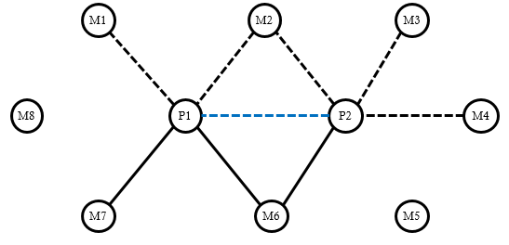

P = pair of collaborating departments (aka “collaborators”)
M = members of neighborhood
Dashed line = informal agreement
Solid line = formal contract

Panel B: Mapping Categories of Ties to Hypotheses

 | Formal | Informal
Exclusive | H1: Positive | H3: Negative
Mutual | H2: Negative | H2/H3: Negative

Figure 2 – Examples

Panel A: Exclusive formal ties in the network neighborhood encourage formality
Arma-Frontenac, KS
(2007) | (2009)
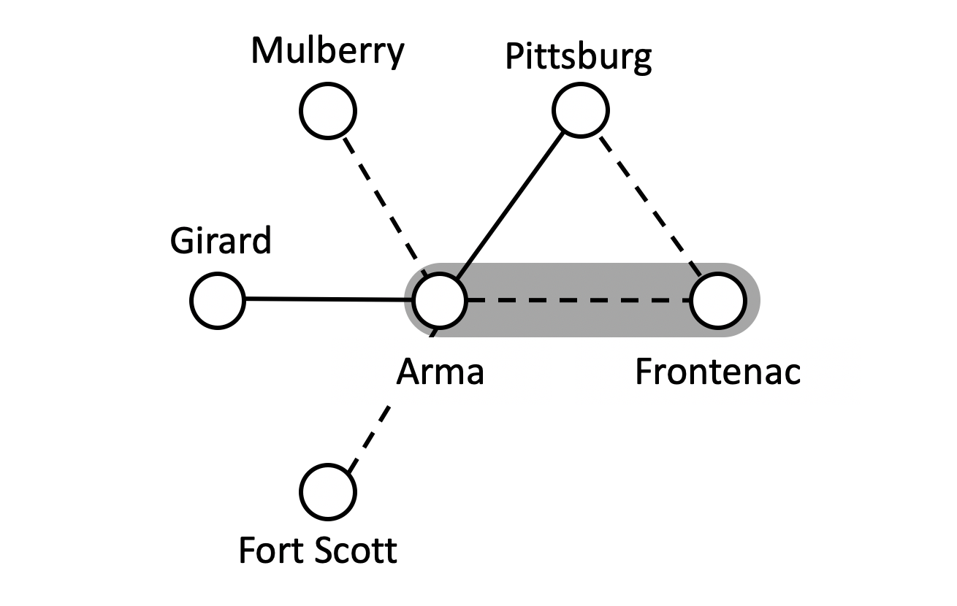 | 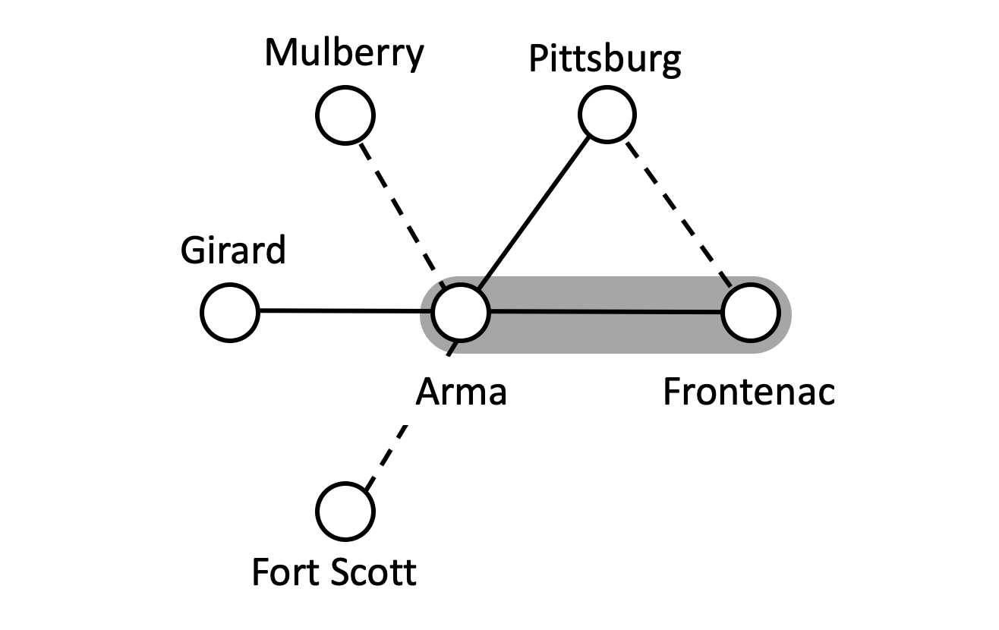
Panel B: Mutual ties to the network neighborhood resist formality
Formal  Mohawk-Copper Harbor, MI  (2000-2001) | Informal  Mongo-Howe, IN  (2000-2010)
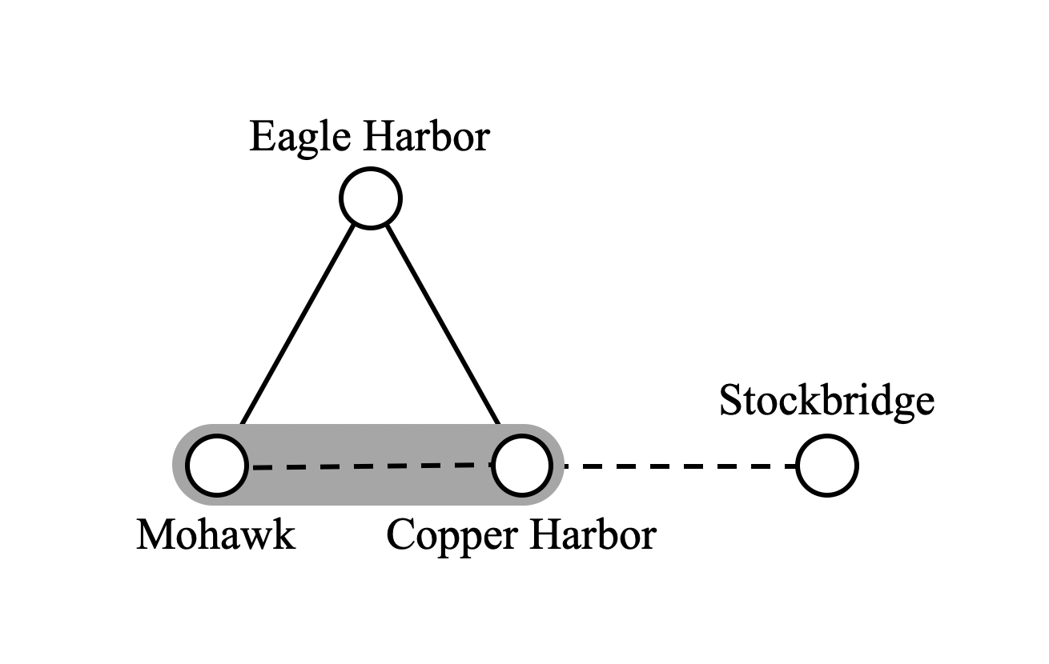 | 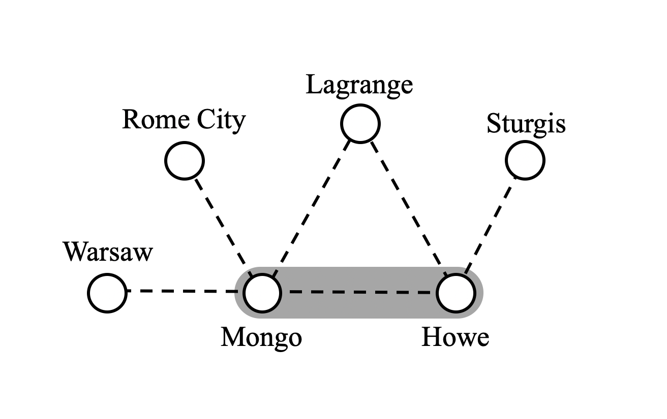
Panel C: Exclusive informal ties in the network neighborhood resist formality
Dyersville-New Vienna, IA
(2001) | (2010)
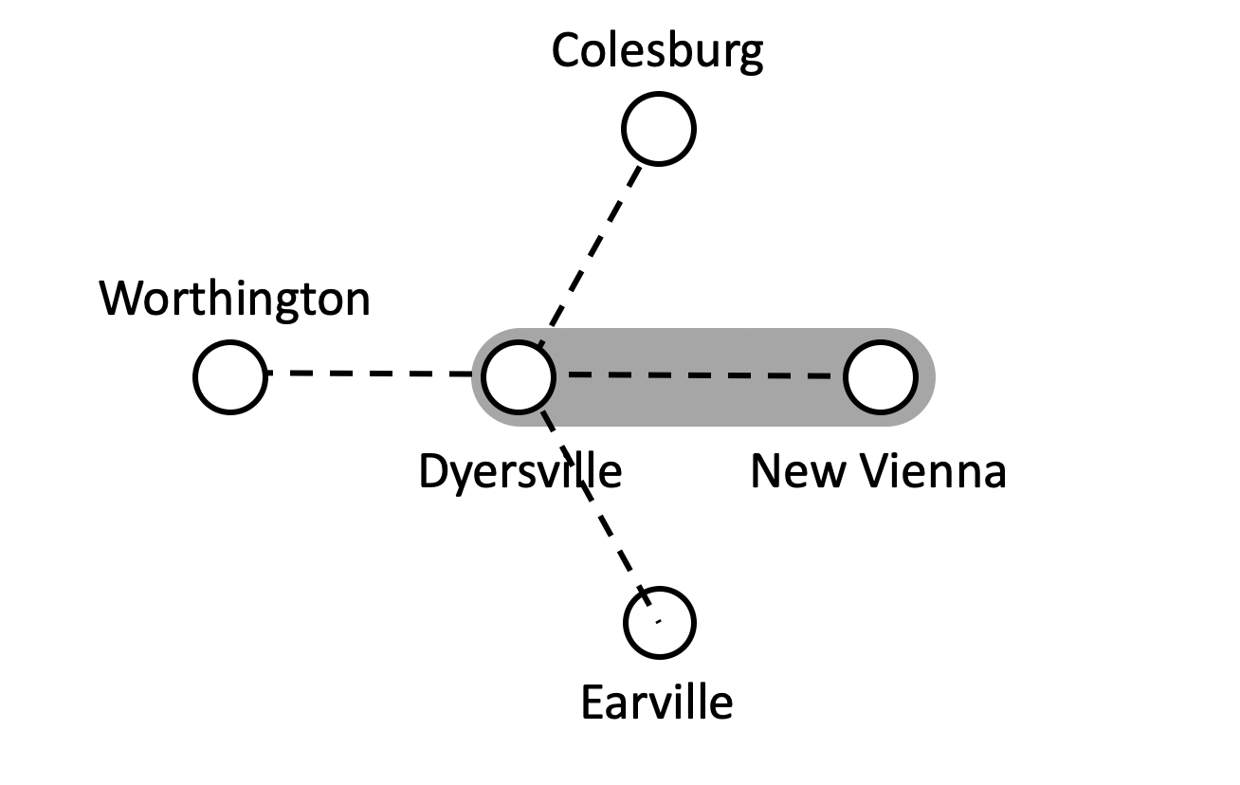 | 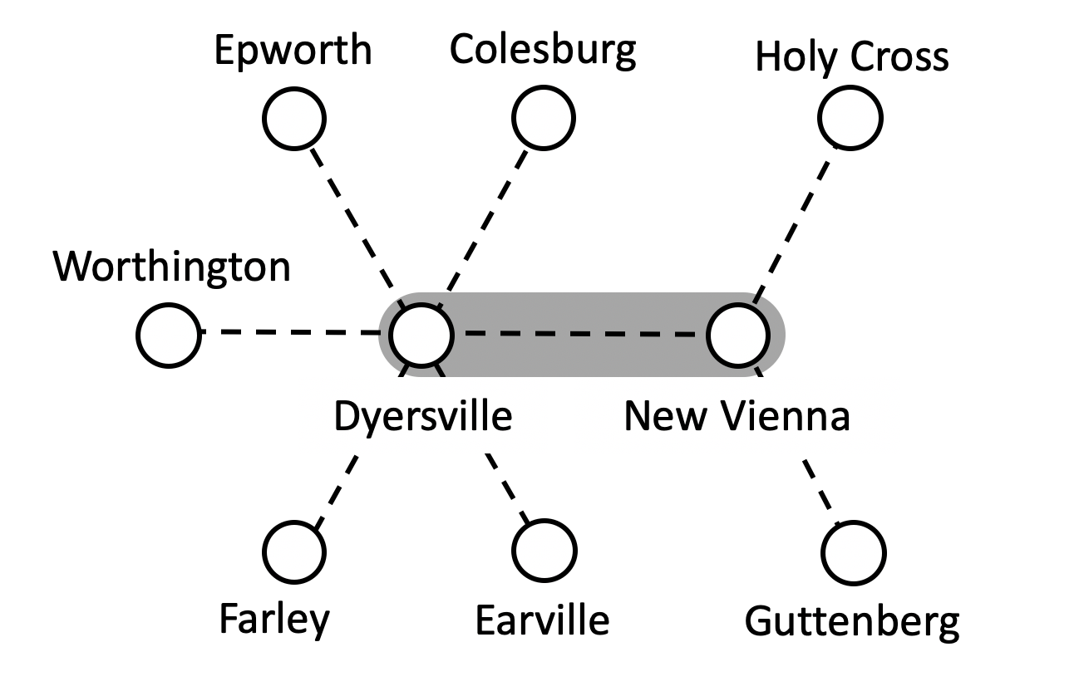

Note: Focal department pairs are highlighted with gray background. Dashed ties are informal and solid ties are formal.

Figure 3 – Probability that a collaborating pair switches to a formal contract based on the presence of formal ties in the network neighborhood

Panel A:  number of exclusive ties | Panel B:  number of mutual ties
Notes: the top figures plot the predicted probability of contracting using a simulation approach based on model estimated (King, Tomz, & Wittenberg, 2000). The bottom figures are histograms plotting the empirical distribution of ties on the x-axes. The long vertical bars plot the mean value of the variables represented on the x-axis. The short vertical bars plot the 95th percent confidence interval around the predicted probability.

Figure 4 – Probability that a collaborating pair switches to a formal contract based on the presence of informal ties in the network neighborhood

Panel A:  number of exclusive ties | Panel B:  number of mutual ties
Notes: the top figures plot the predicted probability of contracting using a simulation approach based on model estimated (King, Tomz, & Wittenberg, 2000). The bottom figures are histograms plotting the empirical distribution of ties on the x-axes. The long vertical bars plot the mean value of the variables represented on the x-axis. The short vertical bars plot the 95th percent confidence interval around the predicted probability.

Table 1. Spread of informal agreements and formal contracts

 | Either informal agreement or formal contract | # Exchanges of Help | Formal Contract
1999 | 5% | 0.12 | 0%
2000 | 10% | 0.23 | 2%
2001 | 19% | 0.49 | 4%
2002 | 28% | 0.78 | 7%
2003 | 37% | 0.96 | 10%
2004 | 46% | 1.15 | 14%
2005 | 55% | 1.43 | 18%
2006 | 65% | 1.60 | 21%
2007 | 75% | 1.79 | 25%
2008 | 84% | 1.91 | 29%
2009 | 92% | 1.82 | 32%
2010 | 100% | 1.98 | 35%
Unit of analysis is the dyad-year for which n = 280,338. The first column represents the percentage of all collaborating pairs that eventually work together under an informal agreement or a formal contract established by the indicated year. The second column represents the average number per year of mutual aid runs for a collaborating pair. The third column reports on the percentage of all eventual collaborating pairs that switched to a formal contract by the indicated year.
Table 2. Summary statistics
 | Mean | Stdev | Min | Max
Dependent variable
Switch to formal contract | 0.334 | 0.471 | 0 | 1
Explanatory variables
Exclusive informal ties | 10.296 | 7.460 | 0 | 66
Mutual informal ties | 1.560 | 2.197 | 0 | 23
Exclusive formal ties | 3.655 | 3.667 | 0 | 40
Mutual formal ties | 0.701 | 1.327 | 0 | 19
Relationship strain variable
Lopsidedness | 0.612 | 0.192 | 1 | 1.000
Partnership control variables
Prior interactions between collaborating partners | 6 | 18 | 0 | 1371
Concurrent interactions between collaborating partners | 0.593 | 0.785 | 0 | 5.981
Property damage ($000) on aid incidents | 118 | 1019 | 0 | 123,710
Size of network neighborhood‡ | 26 | 39 | 0 | 732
Located in different US states | 0.011 | 0.103 | 0 | 1.000
Distance in miles between collaborating partners† | 12 | 21 | 0 | 1,262
Collective department control variables
Prior interactions with neighbors | 57 | 96 | 0 | 2,344
Concurrent interactions with neighbors | 200 | 344 | 0 | 7,594
Property damage ($M) on all other incidents | 5 | 20 | 0 | 1,217
Total fires and other hazards | 277 | 614 | 0 | 27,378
Variability of incidents | 8 | 13 | 0 | 1,234

Unit of analysis is the dyad-year for which n = 280,338.
‡ Size of network neighborhood measure all departments at risk of collaborating as calculated by being within the 95th percentile distance of collaborating departments equal to a 25 mile radius from one dyad member.
† Department level controls are calculated as collective measures for both dyad members. Concurrent and prior interactions are for each department and all other exchange partners in their network neighborhood.

Table 3. Correlation table
 | 1 | 2 | 3 | 4 | 5 | 6 | 7
1. Contract | 1
2. Exclusive informal ties | -0.064 | 1
3. Mutual informal ties | 0.092 | 0.117 | 1
4. Exclusive formal ties | 0.428 | 0.272 | 0.225 | 1
5. Mutual formal ties | 0.176 | 0.113 | 0.702 | 0.316 | 1
6. Lopsidedness | 0.166 | -0.223 | 0.105 | 0.097 | 0.095 | 1
7. Prior interactions between collaborating partners | 0.272 | 0.003 | 0.156 | 0.154 | 0.206 | 0.107 | 1
8. Concurrent interactions between collaborating partners | 0.390 | -0.029 | 0.198 | 0.153 | 0.223 | 0.048 | 0.467
9. Property damage ($000) on aid incidents | 0.057 | 0.010 | 0.102 | 0.050 | 0.083 | 0.128 | 0.122
10. Size of network neighborhood | 0.011 | 0.108 | 0.112 | 0.071 | 0.099 | 0.014 | 0.022
11. Located in different US states | -0.019 | 0.032 | -0.039 | 0.001 | -0.032 | 0.000 | -0.015
12. Distance in miles between collaborators | -0.065 | 0.075 | -0.081 | 0.033 | -0.067 | -0.063 | -0.047
13. Prior interactions with neighbors | 0.181 | 0.281 | 0.179 | 0.422 | 0.240 | 0.016 | 0.219
14. Concurrent interactions with neighbors | 0.190 | 0.307 | 0.192 | 0.451 | 0.256 | 0.029 | 0.262
15. Property damage ($M) on all other incidents | 0.033 | 0.124 | 0.121 | 0.144 | 0.099 | 0.024 | 0.094
16. Total fires and other hazards | 0.063 | 0.133 | 0.062 | 0.191 | 0.077 | 0.009 | 0.156
17. Variability of incidents | 0.030 | 0.085 | 0.151 | 0.136 | 0.133 | 0.014 | 0.060
 | 8 | 9 | 10 | 11 | 12 | 13 | 14
8. Concurrent interactions between collaborating partners | 1
9. Property damage ($000) on aid incidents | 0.065 | 1
10. Size of network neighborhood | 0.028 | 0.003 | 1
11. Located in different US states | -0.022 | -0.005 | -0.017 | 1
12. Distance in miles between collaborators | -0.086 | -0.012 | -0.090 | 0.082 | 1
13. Prior interactions with neighbors | 0.229 | 0.046 | 0.101 | -0.002 | 0.034 | 1
14. Concurrent interactions with neighbors | 0.157 | 0.060 | 0.086 | 0.002 | 0.038 | 0.848 | 1
15. Property damage ($M) on all other incidents | 0.037 | 0.273 | 0.011 | 0.001 | 0.055 | 0.173 | 0.210
16. Total fires and other hazards | 0.129 | 0.034 | 0.069 | -0.005 | 0.020 | 0.373 | 0.349
17. Variability of incidents | 0.116 | 0.029 | 0.064 | 0.000 | 0.001 | 0.161 | 0.132
 | 15 | 16 | 17
15. Property damage ($M) on all other incidents | 1
16. Total fires and other hazards | 0.451 | 1
17. Variability of incidents | 0.152 | 0.245 | 1

Table 4. Regressions on the switch to a formal contract with each network variable

Dependent variable | 1(Formal Contract)
Model | Probit
 | (1) | (2) | (3) | (4)
Formal ties
Exclusive |  | 0.160*** |  | 0.177***
 |  | -0.003 |  | -0.003
Mutual |  | -0.112*** |  | -0.036***
 |  | -0.006 |  | -0.008
Informal ties
Exclusive |  |  | -0.032*** | -0.047***
 |  |  | -0.001 | -0.001
Mutual |  |  | -0.070*** | -0.089***
 |  |  | -0.003 | -0.005
Relationship strain
Lopsidedness | 0.233*** | 0.045 | -0.161*** | 0.233***
 | -0.041 | -0.039 | -0.044 | -0.041
Partnership control variables
Prior interactions between collaborating partners | -0.324*** | -0.349*** | -0.251*** | -0.324***
 | -0.009 | -0.008 | -0.009 | -0.009
Concurrent interactions between collaborating partners | 1.286*** | 1.190*** | 1.253*** | 1.286***
 | -0.011 | -0.01 | -0.011 | -0.011
Property damage ($000) on aid incidents | 0.020*** | 0.020*** | 0.020*** | 0.020***
 | -0.004 | -0.004 | -0.005 | -0.004
Size of network neighborhood | -0.030*** | 0.020*** | 0.009 | -0.030***
 | -0.005 | -0.005 | -0.006 | -0.005
Located in different US states | -0.136** | -0.111** | -0.143** | -0.136**
 | -0.058 | -0.053 | -0.063 | -0.058
Distance in miles between collaborating partners | -0.003*** | -0.001** | -0.002*** | -0.003***
 | -0.001 | 0 | -0.001 | -0.001
Collective department control variables
Prior interactions with neighbors | -0.062*** | 0.053*** | -0.007 | -0.062***
 | -0.006 | -0.007 | -0.006 | -0.006
Concurrent interactions with neighbors | 0.044*** | 0.224*** | 0.119*** | 0.044***
 | -0.007 | -0.008 | -0.008 | -0.007
Property damage ($M) on all other incidents | -0.098*** | 0.029*** | -0.042*** | -0.098***
 | -0.009 | -0.008 | -0.01 | -0.009
Total fires and other hazards | -0.045*** | -0.051*** | -0.079*** | -0.045***
 | -0.007 | -0.007 | -0.008 | -0.007
Variability of incidents | -0.003** | 0 | -0.002* | -0.003**
 | -0.001 | 0 | -0.001 | -0.001
Year fixed effects | Yes | Yes | Yes | Yes
LogLike. | -36,210 | -35,270 | -32,263 | -30,811
Pseudo R-squared | 0.287 | 0.305 | 0.365 | 0.393
+ p < 0.10, ** p < 0.05, *** p < 0.01. Robust standard errors in parentheses clustered on 53,814 pairs and 200,832 observations. Note that subsequent observations after contracting are excluded from sample.

Table 5. Regressions on the switch to a formal contract with network structure and form entered separately

Dependent variable | 1(Formal Contract)
Model |  | Probit
 | (1) | (2) | (3)
Informal ties |  | -0.053***
 |  | (0.001)
Formal ties |  | 0.131∗∗∗
 |  | (0.002)
Exclusive ties |  |  | 0.004∗∗∗
 |  |  | (0.001)
Mutual ties |  |  | -0.037∗∗∗
 |  |  | (0.002)
Full controls | Yes | Yes | Yes
Year FE | Yes | Yes | Yes
LogLike. | -36,210 | -31,913 | -36,026
Pseudo R-squared | 0.287 | 0.372 | 0.291
Increment to R-squared of model (1) |  | 0.085 | 0.004
+ p < 0.10, ** p < 0.05, *** p < 0.01. Robust standard errors in parentheses clustered on 53,814 pairs and 200,832 observations. Note that subsequent observations after contracting are excluded from sample.

Table 6. Regressions on the switch to a formal contract accounting for lopsidedness
Dependent variable | 1(Formal contract)
Model | Probit
 | (1) | (2) | (3) | (4) | (5)
Informal ties
Exclusive |  | -0.047*** | -0.039*** |  | -0.079***
 |  | (0.001) | (0.004) |  | (0.004)
Mutual |  | -0.089*** | -0.175*** |  | -0.225***
 |  | (0.005) | (0.011) |  | (0.015)
Formal ties
Exclusive |  | 0.177*** |  | 0.225*** | 0.280***
 |  | (0.003) |  | (0.007) | (0.008)
Mutual |  | -0.036*** |  | -0.243*** | -0.034
 |  | (0.008) |  | (0.020) | (0.026)
Lopsidedness | 0.290*** | -0.161*** | -0.307*** | 0.516*** | -0.171***
 | (0.037) | (0.044) | (0.058) | (0.052) | (0.063)
Informal tie interactions
Mutual x Lopsidedness |  |  | 0.169*** |  | 0.213***
 |  |  | (0.015) |  | (0.022)
Exclusive x Lopsidedness |  |  | 0.012* |  | 0.053***
 |  |  | (0.006) |  | (0.007)
Formal tie interactions
Exclusive x Lopsidedness |  |  |  | -0.114*** | -0.177***
 |  |  |  | (0.011) | (0.013)
Mutual x Lopsidedness |  |  |  | 0.224*** | 0.012
 |  |  |  | (0.030) | (0.040)
All other controls† | 20,355 | 14,545 | 18,123 | 17,462 | 14,758
Year fixed effects | Yes | Yes | Yes | Yes | Yes
LogLikelihood | -36210 | -30812 | -35194 | -32185 | -30580
Pseudo R-squared | 0.2871 | 0.3934 | 0.3071 | 0.3664 | 0.398

+ p < 0.10, ** p < 0.05, *** p < 0.01. Robust standard errors in parentheses clustered on 53,814 pairs and 200,832 observations. Note that subsequent observations after contracting are excluded from sample.

† Chi-squared statistic on test for joint significance of vector of control variables.

Table 7. Regressions on the switch to a formal contract with only control variables

Dependent variable | 1(Formal contract)
Model | Probit |  | LPM†
 | (1) | (2) | (3) | (4)
Partnership controls
Prior interactions between collaborating partners | -0.389*** | -0.395*** | -0.041*** | 0.070***
 | (0.008) | (0.008) | (0.001) | (0.001)
Concurrent interactions between collaborating partners | 1.241*** | 1.200*** | 0.170*** | 0.127***
 | (0.009) | (0.009) | (0.001) | (0.002)
Property damage ($000) on aid incidents | 0.021*** | 0.031*** | 0.003*** | 0.001*
 | (0.003) | (0.003) | (0.000) | (0.000)
Size of network neighborhood | 0.001 | -0.012** | -0.002***
 | (0.005) | (0.005) | (0.000)
Located in different US states | -0.103** | -0.107** | -0.010**
 | (0.052) | (0.052) | (0.004)
Distance in miles between collaborating partners | -0.001* | -0.001*** | -0.000*** | 0.000
 | (0.000) | (0.000) | (0.000) | (0.000)
Collective department controls
Prior interactions with neighbors |  | 0.009 | 0.006*** | 0.004***
 |  | (0.006) | (0.001) | (0.001)
Concurrent interactions with neighbors |  | 0.152*** | 0.009*** | 0.004***
 |  | (0.007) | (0.001) | (0.001)
Property damage ($M) on all other incidents |  | -0.032*** | -0.002*** | 0.002
 |  | (0.008) | (0.001) | (0.001)
Total Fires and other hazards |  | -0.027*** | -0.003*** | -0.002***
 |  | (0.007) | (0.000) | (0.001)
Variability of incidents |  | -0.001* | -0.000*** | 0.000
 |  | (0.001) | (0.000) | (0.000)
Year fixed effects | Yes | Yes | Yes | Yes
Pair fixed effects | No | No | No | Yes
Loglikelihood | -36,758 | -36,240
(Pseudo) R-squared | 0.276 | 0.287 | 0.166 | 0.153
+ p < 0.10, ** p < 0.05, *** p < 0.01. Robust standard errors in parentheses clustered on 53,814 pairs and 200,832 observations. Note that subsequent observations after contracting are excluded from sample.
† LPM stands for linear probability model which is estimated by ordinary least squares

Collaboration among fire departments is vitally important to fulfilment of the objectives of preventing casualties, preserving property, and operating efficiently (Barr & Eversole, 2006; Horwitz & McGahan, 2019). U.S. fire departments function as units of local governments. They operate their own firefighting forces, manage their own assets, and fight fires and respond to other hazards in service areas defined by the geographic boundaries of their political jurisdictions. They are funded by local tax revenues that are allocated through budgetary processes negotiated between fire chiefs and executives of local government. Fire departments are insured against liability and for casualties under policies purchased by their municipalities (Barr & Eversole, 2006). These policies cover the activities of firefighters responding to incidents both within their jurisdictions and in neighboring jurisdictions (Barr & Eversole, 2006).
Our results are not sensitive to this assumption. The lack of sensitivity arises primarily because our hypotheses deal with the structure and level of formality of the existing ties of part (a) rather than the potential ties of part (b). Nonetheless, we include the potential ties described in part (b) as a control to assess the density of the established ties, i.e., those accounted for in part (a) relative to the total (Knoke, 2009). The 25-mile criterion employed in the definition of the network neighborhood has no application to the identification of collaborating pairs. The analysis contains observations on all pairs of departments with a history of informal agreement, and only observations on pairs of departments with a history of informal agreement. We call these focal dyads “collaborating pairs” throughout this paper. A network neighborhood is identified for each collaborating pair.
If one partner did not produce NFIRS reports in years or there were other missing data the pairs were screened out.
Note that several variables are created using four periods of lagged values. The years on which the lags are calculated are dropped from the data set.
To include departments with sparse collaboration we increment the numerator and denominator by 0.00000001.

