Why Choose LTAs? An Empirical Study of Ohio Manufacturer’s Contractual Choices Through a Bargaining Lens
Forthcoming American University Business Law Review (2020).
Juliet P. Kostritsky* and Jessica Ice**

Abstract
This paper contributes to recent scholarship regarding Long Term Agreements (“LTAs”) by providing empirical evidence that suppliers are more likely to undertake the costs of an LTA if the transaction requires significant capital expenditures or the potential for large sunk costs. Through a survey of a random group of sixty-three Ohio supplier/manufacturers, the paper explores why supplier/manufacturers with a full range of contractual and non-contractual solutions might choose one set of arrangements over others. It then seeks to link its findings to a broader theory of how parties bargain to solve durable problems under conditions of uncertainty, sunk costs, and opportunism, while minimizing costs. Although only a small portion (seventeen percent) of our sample size indicated that they used LTAs in the majority of their transactions, this group indicated they were more likely to produce customizable goods and have significant capital expenditures. Such a finding is consistent with a model of bargaining in which parties in a transaction seek to achieve their overall goals of wealth maximization while minimizing costs under conditions that include bounded rationality, sunk costs, and opportunism. If a product is customized for a particular buyer, and the supplier invests sunk costs toward customization, that investment makes it difficult and costly to exit the relationship or resale to others. Where such vulnerabilities exist, the need for protection may justify the costs of LTAs. The non-adoption of LTAs by some suppliers demonstrates that the new organizational form of networked firms, governed by an LTA and straddling markets and hierarchies, has not captured all of manufacturing and reflects a diversity of arrangements. The non-adoption of LTAs may be one way suppliers respond to the stresses and frictions of the new architecture of supplier relations. Those stresses show that the new organizational paradigm is not static and suffers from the same hazards as an exchange relation. The willingness of suppliers to adopt an LTA when facing large sunk costs shows the continuing importance of sunk costs in institutional decision making and offers an additional reason beyond the need to collaborate under conditions of uncertainty to explain why parties adopt LTAs. The other type of risks of opportunism and vulnerability from investing large resources may be best handled by entering an LTA because it offers security, including implicit protections needed for the supplier to invest. The switching costs that lock parties into a mutual dependency and protect parties who have invested comes gradually but without the LTA, the supplier would be reluctant to undertake the initial investment.
The importance of sunk costs may also explain the choices of buyers to operate under an LTA. Since many of the benefits of LTAs, including information sharing, could be achieved by buyers hierarchically and imposed on suppliers, the explanation for adopting LTAs may lie not only with the need to collaborate under conditions of uncertainty and the benefits in terms of added value derived from “managerial contracting” practices, but with the need to protect large investments through the security offered by an LTA. Thus, there are two functions of LTAs: (1) how-to provisions to guide and improve production; and (2) provisions offering security of a continuing commitment either through express provisions or implicit protections. This article suggests that although information sharing protocols serve to ‘institutionalize learning’, help parties when there is an “inability” to know how to solve a production problem and offer more information to informally enforce new types of behavior that are non-compliant, these benefits might occur by means other than an LTA. For example, a quality manual may impose a quality assessment be done by the buyer at the supplier’s plant. Alternate means of obtaining the information outside an LTA raise the question of why LTAs are adopted.

Introduction
Recent scholarship has identified modern Long Term Agreements (“LTAs”), including information sharing protocols, as “novel” governance structures for innovative and collaborative ventures. Such scholarship has hypothesized that LTAs’ information-sharing provisions facilitate informal enforcement and help “endogenize” trust in heterogeneous relationships in the innovation sphere where none previously existed. Other scholarship has focused on how contract provisions “institutionalize learning” thereby “fostering innovation” and “establish processes of inter-organizational collaboration.” These functions are broadly useful for buyers. Professor Bernstein says that they are “designed to keep the law… out.” But the LTA fulfills a variety of functions including giving the Original Equipment Manufacturer (“OEM”) the option to buy combined with some legal protections such as unilateral termination rights, warranty, and IP protections. How buyers structure these hybrid arrangements depends on how the arrangement of provisions and informal enforcement facilitated by the information-sharing function operate to achieve the buyers’ varied goals, including maximizing profits. Many of the agreements studied by scholars, such as the OEM agreement, are drafted by the buyer/assembler.
In order to answer the comparative question of why suppliers choose an LTA in only some cases, the research team for this Article decided that instead of studying existing LTAs and hypothesizing what functions they could serve, it would survey a random group of Ohio manufacturers to see what kind of arrangements they used to govern their transactions. Through such a survey, together with qualitative interviews of firms, the research team hoped to learn why, with a full range of contractual and non-contractual solutions, suppliers might choose one set of arrangements over another. Empirical data gathered in this way might support the idea that parties choose their arrangements in a discriminating way to control contractual hazards while minimizing costs.
This Article first outlines the current view of LTAs within innovation scholarship and provides an overview of contractual and organizational choices under the increased de-verticalization of firms. The Article then outlines the current gap in the literature related to understanding LTA usage from the supplier’s perspective. To address this gap, the Article outlines its empirical analysis of supplier perspectives through a survey of Ohio manufacturers. Finally, the Article links its findings to a broader theory of how parties bargain to solve durable problems under conditions of uncertainty, sunk costs, and opportunism, while minimizing costs.
Ultimately our research suggests that the choices that parties make about whether to enter an LTA or not are driven by the same kinds of factors that affect whether parties use modularity, “learning by monitoring” or hedging. The contractual choice is one of many choices that will affect the economics of the exchange and the same lens should be used to analyze all of these choices. How to achieve the parties’ goals at the least cost, while minimizing contractual hazards, including opportunism, will drive all of these choices. Goals such as routinizing production and preventing mistakes can be achieved through “managerial contracting” provisions such as scorecards. However, those provisions could be imposed unilaterally through quality control manuals imposed by buyers on all suppliers or by an LTA.

LTAs Within the Innovation Scholarship Framework
Innovation scholars explain the LTAs as a rational contractual response to situations where it is difficult to reach a completely contingent contract to control production because of high uncertainty over the final product and the need to gain specialized knowledge held by external firms. LTAs differ from the traditional contractual focus and contain many provisions that are not geared to establishing a basis for a breach. Instead, firms use such “managerial provisions” to provide detailed processes for production that can prevent mistakes and increase quality.
This Article will first examine why many specific provisions exist in LTAs and describe the benefits for successful production. It will later examine whether there are alternative ways of organizing production to achieve similar benefits and examine how the need to protect sunk costs explains why parties such as suppliers enter into LTAs. It will also suggest that the drive to control opportunism and shirking of various types explains a firm’s choice to entering into an LTA. However, concerns about opportunism also explains a countertrend in the behavior of suppliers in their resistance to entering LTAs or to offer less than full cooperation with the LTAs by parties subject to opportunism.
The LTAs provide many benefits to companies dealing with uncertainty as they may contain protocols to share information and develop routines. Sharing these routines allows buyers and suppliers to “generate novel alignments of interest [with suppliers] that render collaboration more feasible and more necessary.” The “input of others” becomes critical when buyers develop or improve products and enhance production. Scholars of the new forms of production and organization have detailed how LTAs can facilitate simultaneous engineering and benchmarking, improve quality in production, “establish a pragmatic learning process between collaborators,” and “institutionalize learning.” These sharing protocols and collaboration can generate benefits that extend beyond improving production and can increase joint returns. When weighed against quality control through warranty enforcement, these production protocols are thought to be more effective ways “to better quality.” Thus, firms use industrial strategies to solve a problem: firms can no longer profitably acquire and maintain the required expertise in-house and need to collaborate to survive. That strategy affects whether firms make or buy products needed in production. That choice also affects how firms are governed: internally by bureaucratic fiat, by contracts of varying types with external firms, or by some other mechanism.
Where innovation requires both investment and collaboration, and investments may be asymmetric, information sharing in an LTA may foster informal enforcement by increasing transparency and observability. Professor Bernstein explains these LTAs as beneficial because they “create a space in which private order can flourish.” The iterative exchange of information and performance can deter opportunism and raise switching costs. As each party learns about the other, the costs of finding a substitute supplier or buyer increases for unknown parties. “Switching costs” acts as a deterrent to early termination.

Sourcing and Contractual Choices in the Age of De-verticalization: An Evolving Landscape

In the last several decades, the large integrated firm has de-verticalized. The pressure to cut costs, while keeping up with specialized expertise that is expensive to develop in-house, led large and complex firms to develop various types of arrangements with suppliers to source and organize production. One scholar has described a “multiplicity” of producer “sourcing structures”. The diversity of suppliers’ arrangements by producers responds to various pressures exerted by large and complex firms as buyers. Producers are struggling to respond to unpredictable and varying behavior by such buyers.
  - Collaboration
One arrangement in this de-virtualized economy that has received a great deal of scholarly attention is the pragmatic collaborative arrangement between large buyers and suppliers who participate in “learning by monitoring.” To enhance quality and prevent costly errors on the production line, buyers require suppliers to participate in root cause analysis, benchmarking, and other routines to enhance quality. Companies who may be dealing with “radical uncertainty” characteristics, such as the biotechnology industry, may share information about a yet unknown product or drug.
Often the parties enter into LTAs with information-sharing protocols and other provisions to encourage collaboration. Buyer/manufacturers and suppliers develop routines that allow manufacturers/assemblers/buyers to learn from suppliers and coordinate in ways that facilitate collaboration. Collaboration may be necessary for buyers because the cost of research and development for specialized expertise is too great, making collaboration a cheaper way of acquiring the needed expertise. The collaboration and sharing of information in networks of buyers and suppliers can benefit both “from joint discoveries.” This collaboration and information sharing between buyers and suppliers constitutes, according to some scholars, a new “organizational revolution” that stands between vertical integration and spot market transactions. Others have described these arrangements as “neither fully transactional nor fully relational.”
The sharing of information and new networks can occur in a variety of contexts. For example, when there is uncertainty, as in the biotechnology industry about what will be invented, or in traditional manufacturing industries where the uncertainty is about emerging improvements. The sharing takes the form of simultaneous engineering, benchmarking, root cause analysis, and routines all designed to improve the quality of the final product through incremental improvements. The decision to share information, in the innovation or industrial sector in a rapidly changing world with intense competition, might suggest that this networked approach with information sharing protocols is the “key to survival” and that companies will converge on this path and become locked into this approach.
  - Modularization
Of course, there are other ways to source production. Some suppliers become large tier mega suppliers who collaborate in the way described above. Sometimes OEM buyers pursue a modularization strategy with large suppliers becoming assemblers of “discrete subsystems or functional modules (example in an automobile: front end, cockpit, drive train, common chassis platforms, etc.).” Modularity, by reducing the need for coordination and collaboration, could reduce costs. However, modularization, at least in the automobile industry, has proven to be less successful as a sourcing strategy than originally anticipated. Because automobiles are necessarily integrated with one system affecting another, “to a degree that renders their separate design almost impossible without sacrificing performance,” modularization “along the lines of black box contract manufacturing is a difficult proposition.”
The adoption and then decline of modularization and the partial adoption and failures in networks (particularly the hedging by suppliers in response to opportunistic behavior by OEMs and the institutional blockages that hinder buyers from fully collaborating), demonstrate that organizational choices, are not static ones. Instead, organizational choices are contextual and driven by the economics of the exchange, including all of the transaction costs. Such organizational choices include whether to operate by a network, whether and how much to collaborate or withhold information, whether to adopt modularization as a sourcing strategy, or whether to resort to a discrete market transaction. The choices about how much knowledge to retain in-house may respond to a need by buyers/assemblers/manufacturers to gauge how well the suppliers are performing.
The choice to organize production by sharing routines in a collaborative network or to choose another way of sourcing production, such as modularization, is context-dependent. There is not one organizational solution to the problems that parties face. That same diversity of arrangements extends not only to the type of supply arrangement for sourcing production but also to the choice of whether to formalize those routines in an LTA, as well as to the choice of whether to opt-out of an LTA. These are all rational responses by buyers and suppliers to the particular circumstances in product development and sale, to the risks of failure, to the dangers of opportunism in settings of low or high asset specificity, and to the tradeoffs that each party is making to those risks and returns.
  - Opportunism and Sunk Costs
Empirical work by Professor Josh Whitford shows that the success of these federated collaborations between buyers and suppliers is only “partial.” OEM buyers remain “deeply cautious about genuinely relying on supplier firms,” and suppliers react to opportunistic behavior by OEM buyers by hedging and withholding information, thereby reducing joint returns. The choice of whether and how to organize production, whether to vertically integrate, operate by discrete market transactions or to form collaborative information networks and how fully to cooperate within these networks, is affected by transaction costs and the fear of holdup. For example, owners may vertically integrate to solve the holdup problem. A major driver of vertical integration is profit capture. A company vertically integrating decides to capture the profit that the supply company would otherwise accrue to the supplier’s shareholders. Vertical integration may also be done to deny competitive access from a supplier to another large OEM. Or a company may decide to produce, and not buy, because of the cost of transmitting to suppliers the knowledge of what is needed (“tacit knowledge”) makes it easier and cheaper to produce the goods.
The economics of exchange, profit, minimizing frictions, and transaction costs underlie organizational decisions about where the boundaries of the firm should lie. Those same economic considerations drive the coordination mechanisms adopted by OEM buyers to streamline the production process and promote innovation and expand the reach of informal non-contractual relations resulting in a decreased importance for delineating performance obligations under constant adjustment. The drive to economize on transaction costs will affect other decisions made by suppliers who will be subject to the same profit driver from the economic exchange.
Operating by network and sharing information with a supplier governed by an LTA “creates an information symmetricizing machine in which actors must keep each other abreast of their intentions and capacities.” The sharing of information also helps to curb opportunism as it raises switching costs for both parties in the supply chain. A “virtuous circle” may result in which parties learn more about each other’s reliability and competence, which reinforces collaboration. These information-sharing protocols are consistent with “Macaulay’s definition of contract as ‘devices for conducting exchanges.’”
The choices of contractual form, decisions about structure, the inclusion of detailed protocols, and cooperation during the relationship may also respond to behavioral proclivities to opportunism of one’s collaborating partner and changes in the relationship, such as the misuse of information by the buyer. The context affects how fully one party cooperates and those risks may also affect the decision to opt into or out of an LTA. Breakdowns may also occur due to “factional conflicts” within an organization of buyers that hinder collaboration and increase uncertainty for suppliers. The withholding of information or hedging by the supplier represents a private strategy to minimize the costs of opportunism. Instead of opting out of the agreement, the least cost response may be hedging.
The decisions of how to operate and what organizational mode to use, whether it is a network or a hierarchy or a market transaction, whether to hedge or not, and what contractual form to rely on (LTA or purchase order) for governing production, are all responses to durable problems that parties face in exchange relationships. One of the institutional choices suppliers make is what type of contract to agree to — whether to enter an LTA or to opt-out of such an agreement.
The same considerations that affect parties deciding how to structure their organization of the supply chain, whether in a collaborative network or a hierarchy or by market, affect the choice of whether to enter an LTA. Parties ask how can they increase joint returns and address durable problems while minimizing the frictions that affect exchange relationships. The empirical evidence from our survey demonstrates that the decision to enter an LTA is affected by the presence of large capital equipment costs, a sunk cost with asset specificity. In all of the networks that have been extensively studied in the automotive and innovation contexts, there are large sunk costs, uncertainty, and a need to de-verticalize to capitalize on the expertise of suppliers. Where such sunk costs are present, the parties cannot simply exit without being at risk for losing sunk costs. The parties devise structures and routines that are embodied in a long term contract to deal with uncertainty about the product and their partner’s reliability and competence. Those routines create a “roadmap” or “scaffolding” for guiding production, reducing uncertainty, and lessening the chances of shirking or substandard goods. Those routines also lessen the risk of opportunism by raising switching costs. As parties become embedded in these relationships, that embeddedness substitutes for trust. It cements the relationship, protects the sunk cost investments, and secures other protections, such as guaranteed fixed prices or an option of ordering that protect sunk cost investments.

Why Choose LTAs?

The decision by buyers and suppliers to enter into an LTA when the parties have sunk costs — a result revealed by the survey — constitutes one mode of protecting those sunk costs. When buyers and suppliers engage in joint projects that require either party to have significant capital expenditures, the parties may benefit from provisions in the LTA that encourage collaboration and efficiency and also benefit from implicit protections Empirical work looking at collaborative agreements and networks shows that provisions requiring shared information or cost reductions often arise in an LTA. However, if the sharing protocols deter opportunism and are costly to implement, then why would either the buyer or the supplier decide to enter or avoid a formal LTA and in what circumstances?
In answering that question, it may help to think about all the different ways that knowledge about the other party’s reliability and the information needed for error detection could be obtained and with what agreements. There is the further question of how collaboration affects the arrangements. First, in situations with multiple buyers, the supplier could develop a commodity good and operate purchase-order-by-purchase- order while remaining confident that it could exit and sell the commodity to others. Second, in a supply arrangement with limited large buyers and multiple suppliers, a buyer and supplier could exchange goods pursuant to a purchase order and reply. Knowledge about the other party’s reliability and competence would emerge gradually as the buyer continues to buy and the supplier continues to provide goods. No LTA would be required for that knowledge about reliability and competence to develop into trust. Third, in situations with a large buyer and multiple suppliers, a supplier could invest a large amount in capital costs but without collaborating with the buyer. In that case the supplier might insist on an LTA to guarantee that the buyer’s purchase obligations would defray the cost of the capital equipment. An LTA governs though there is no collaboration. Fourth, in highly innovative settings with a scarcity of suppliers (i.e. biopharmaceuticals), the parties might engage in a collaborative project and enter into an LTA with sharing protocols.
Thus, the desire to recoup sunk costs and a firm’s bargaining power, rather than innovation and uncertainty, is the distinguishing feature that may influence parties to enter into an LTA. That conclusion may be warranted because information obtained through an LTA could also be obtained by other hierarchical management techniques and the trust could be built up incrementally through the exchange of goods. Any buyer could draft a purchase order insisting that a supplier submit to information-sharing protocols. Trust about competence and reliability could build up over time. However, if the buyer, such as an OEM, is investing in a model car and a supplier is investing in a plant that will furnish a door for that model car, the buyer and the supplier both need the security of a long-term commitment.
What does the LTA provide that could not be provided by benchmarking or other routines? For the supplier there may be implicit protections against early termination or even explicit protections of a long-term purchase contract, even if qualified by contingencies such as meeting the competition’s pricing. That long-term contract may exist in combination with sharing protocols in which parties collaborate toward quality improvements or innovations. The buyer wants an LTA to guarantee a price and continuing supply, benefits that could not be achieved unilaterally or by “management technique[s].” The buyer may be reluctant to invest in a production facility without the benefit of an LTA guaranteeing price and supply. In each case parties trade off and determine which institution, contract, provisions, or organization will maximize joint benefits by achieving their myriad goals at the least cost.
Then, having entered a particular structure, the parties continue to make adjustments, such as hedging, in response to new pressures, such as opportunistic use of shared information. The decision about whether to enter a network subject to a formalized LTA is only one of the many choices parties must make. Parties and suppliers making tradeoffs in order to lessen the risks and costs of unremedied contractual hazards, but also decide on choices about how fully to cooperate and whether to resist or hedge by withholding information or failing to invest.
Where there are no sunk costs or large capital equipment costs by suppliers, suppliers may opt out of LTAs, perhaps deciding that the costs extracted by buyer in the LTAs outweigh any benefits of such agreements. In particular, one such reason may be the onerous burdens on suppliers to constantly reduce prices in response to buyer demands. Suppliers can simply exit to the market and find another buyer. LTAs may be the least costly alternative for organizing production in the supply chain, particularly when the suppliers seek to reduce uncertainty about the buyer by continuing to deal with the buyer.

The Survey Approach to Analyzing Why Firms Use LTAs
At least some of the benefits of an LTA could be imposed by buyers unilaterally or in a short terms and conditions section of a purchase order. Through such short term agreements, buyers can develop increased knowledge about reliability and competence of suppliers, and benefits such as informal enforcement, monitoring, and an increases in switching costs can occur without an LTA. The key question remains: why parties would enter into an LTA or decide not to do so? What mechanism or institution will achieve the parties’ goals and at what cost? Some industrial strategies, such as the LTAs with learning routines, respond to new pressures on buyers to enhance knowledge and improve quality under increased time pressures. When implementing strategies in particular contexts, including the types of contractual and non-contractual arrangements, parties consider how the institutions selected will respond, not only to knowledge enhancement and competitive pressures on quality and price, but also to problems of opportunism and other durable problems in the supply chain. Switching costs, with the resultant deterrence of opportunism, could be achieved in other less costly ways without a formal LTA agreement.
Current scholarship focusing on “exemplars,” or significant LTAs in the innovation field, has identified increased transparency from LTA information-sharing protocols as one reason to contract using an LTA. Ideally, as information is shared in an iterative fashion, pursuant to the LTA, parties’ uncertainties about each other are reduced and knowledge is enhanced. That knowledge leads to improvement in production and the development of new technologies. However, often it is the suppliers who are being asked to share information, so LTAs may reduce uncertainty only for the buyer.
This article posits that the LTA is a governance mechanism or a “machinery to work things out” that may not be necessary or cost-effective when there are no idiosyncratic investments. Thus, the form of contract is tied to the functions the parties seek to achieve, including the need to protect investments. That need could affect both buyers and suppliers in the supply chain. This article supports Oliver Williamson’s theories of contracting by providing empirical evidence that parties may undertake the costs of “specialized governance structures” such as LTAs where there is “considerable investment in transaction-specific assets.” As Williamson explains, the “specialized structures come at great cost, and the question is whether the costs can be justified.”
This Article offers another justification for the LTA that is separate from the “learning by monitoring” pragmatic collaboration that has been explored deeply by other scholars. While the “learning by monitoring” devices and routines in the newer forms of LTAs may be effective tools to deal with problems with performance based on an “insufficient understanding of the problem at hand, or even how to pose it in the first place,” they cannot completely eliminate opportunism in a supply relationship. When the problems faced by parties also include an “unwillingness” and “self-regarding motives,” the LTA offers security to protect parties who invest large resources and might lose that investment or be subject to holdup after making a large investment. A buyer might be reluctant to invest in a model car without the security of long-term sourcing and price assurances. The supplier might be reluctant to invest in building a factory to build doors for a customer without some security.
Studying existing LTAs and situating them within industrial and production strategies can elicit theories about the functions they serve, but such studies do not shed light on why parties prefer certain arrangements over others. By expanding the range to random manufacturers, the research team hoped to shed light on why and when parties adopt an LTA or opt out. Since parties could provide for submitting to collaboration outside an LTA (for example, through provisions of a quality manual) the question arises when and under what circumstances an LTA is a cost minimizing method of achieving the parties’ goals? The prior focus on LTAs themselves, instead of on the use or non-use of such agreements, means that important insights about contractual preferences based on factors like industrial variations, sunk costs, or firm size might have been overlooked. For instance, the research team discovered significant differences in LTA usage across industries (see graph below). Simply analyzing differing terms within LTAs across various industries would not have demonstrated industrial variations in usage, because such an analysis would not have gathered information from firms that do not use LTAs.

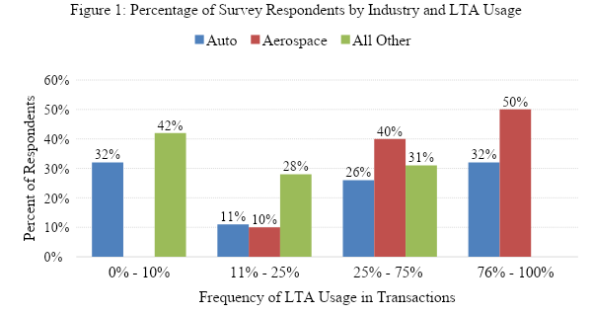

Therefore, instead of focusing on the terms of high profile LTAs like the agreement between Apple and SCI, or between Eli Lilly & Emisphere Techs Inc., the research team designed a survey to shed light on the types of agreements a random group of Ohio manufacturers/suppliers used in their transactions, including the choice to use LTAs or other arrangements. Using data from a random sample of manufacturers/suppliers allowed for empirical comparisons across industries and firm sizes. In most instances, the terms in agreements between buyers (often OEMs) and suppliers are drafted and dictated by the buyers to the suppliers. Thus, simply studying terms of an LTA may not shed light on supplier thinking.
Since many of these LTAs are drafted by large OEMs or other buyers, such as aerospace companies, and the information often travels almost exclusively from the supplier to the buyer, the question arises as to when and why LTAs will be either resisted or embraced by suppliers? When and why would an LTA be used and result in overall cost minimization for each party? Since the research team did not survey buyers in that capacity, we offer only tentative answers on buyers based on an analysis of some LTAs and current literature analyzing such agreements. Our results do shed empirical light on the choices by suppliers that suggest that the choice of contractual form is context dependent, tied to sunk costs and not a static choice, but one that varies as the pressures on suppliers increase or change. That decision to adopt or opt out of an LTA parallels other decisions suppliers make to “hedge” in order to protect themselves against buyer misuse of information.
In analyzing the myriad of choices of suppliers to enter an LTA, opt out, render less than full cooperation under the agreement, or protect against the risks of buyers licensing a supplier’s intellectual property by only furnishing older technology that is already patented, it helps to situate those choices within a bargaining model. Each party approaches an exchange with its own private goals (to solve durable problems such as opportunism) and the parties will reach a particular bargain only if the benefits of achieving those goals outweigh the costs. Similarly, firms will constantly look for an arrangement that minimizes their costs while controlling contractual hazards, thereby maximizing value. Once the entire universe of agreements is considered, including factors that incline suppliers to use an LTA or to operate under other documents, it becomes possible to tie the parties’ choice of form to a model of bargaining under conditions that include bounded rationality, sunk costs, and opportunism. Under this model, one considers how parties in a transaction seek to achieve their overall goals of wealth maximization while minimizing costs.

Survey Methodology

To evaluate the key question of why suppliers decide to use an LTA, the research team developed a survey of thirty-four questions about topics regarding why firms use LTAs, how often firms use LTAs, when firms engage in information-sharing between the buyers and suppliers, and the enforceability of LTAs and Master Supply Agreements (“MSA”). The survey was designed to determine if and when LTAs were used by manufacturers. The manufacturers in the survey predominantly represented suppliers in buyer and supplier arrangements.
To identify survey participants, our research team obtained a list of 1,875 Ohio-based manufacturers from the Mergent Intellect database. The research team identified manufacturers by using the super sector Northern American Industry Classification System (“NAICS”) codes related to manufacturing. Data from Mergent Intellect included each manufacturer’s name, phone number, physical address, and industry sub-sector. A paper-based mail survey was sent to the manufacturers obtained on the original list. After the first paper mailing, our team received fifty-eight responses either by mail or online.
The research team scrubbed the list to remove any duplicate companies or companies that had gone out of business, reducing the total number of “potentially active” manufacturers to 1,458. Then, the research team manually searched of all “potentially active” manufacturers online to find their email addresses for an online survey. Of the 1,458 “potentially active” manufacturers, the research team found email addresses for 667 manufacturers/suppliers and deemed them “likely active” manufacturers. An email survey was sent to the 667 “likely active” manufacturers. Sixty-nine manufacturers returned an additional eleven survey responses. Thus, the overall survey response rate was 3.7 percent for all companies in the original database, 4.7 percent for “potentially active” manufacturers, and 10.3 percent for “likely active” manufacturers.
In addition to the survey, the research team conducted several one-on-one interviews with manufacturers to gather more qualitative data on LTA usage. The in-person interviews were especially helpful in understanding how highly innovative companies use (or do not use) LTAs within the context of protecting intellectual property. Table 1 outlines the annual sales revenue of each of the five manufacturers interviewed.

Table 1: Annual Sales Revenue of Interviewed Manufacturers
Company | 2017 Annual Sales Revenue in USD
1 | $6.3 Billion
2 | $12.03 Billion
3 | $3.2 Billion
4 | $287 Million
5 | $20.4 Billion

- Survey Results
- LTA Usage
Our survey of Ohio manufactures indicated that the majority of respondents use LTAs infrequently. Only seventeen percent of respondents (eleven of sixty-three manufacturers) indicated that they used LTAs or MSAs in seventy-six percent or more of their transactions (see Table 2). Twenty-four percent of all manufacturers indicated that transactions with LTAs or MSAs accounted for seventy-six percent or more of their revenues (see Table 3). This tends to indicate that firms use MSAs and LTAs for high-revenue transactions disproportionately.

Table 2: Count of Manufacturers by LTA Usage as a Percentage of Transactions
LTA Usage | Manufacturers
0-10% | 21
11-25% | 13
26-75% | 18
76-100% | 11

Table 3: Count of Manufacturers by LTA Usage as a Percentage of Revenues
LTA Usage | Manufacturers
0-25% | 24
26-50% | 16
51-75% | 8
76-100% | 15

In addition, sixty-five percent of respondents indicated that they predominately produced customizable goods and twenty-nine percent of respondents indicated that they spent a significant amount of money on capital goods for a specific buyer in most of their transactions. However, when looking only at the subsection of manufacturers that indicated that they used LTAs in most of their transactions, seventy-three percent of manufacturers indicated that they predominately produced customizable goods and sixty percent of respondents indicated that they spent a significant amount of money on capital goods for a specific buyer.
LTA usage also varied significantly across industries. Thirty-two percent of automotive manufacturers and fifty percent of aerospace manufacturers used an LTA most of the time. No other industry indicated that they used LTAs in most of their transactions (see Tables 4 and 5).
Table 4: Percentage of Survey Respondents by Industry and LTA Usage
Industry | 0% - 10%  LTA Usage | 11% - 25%  LTA Usage | 25% - 75%  LTA Usage | 76% - 100%  LTA Usage
Auto | 32% | 11% | 26% | 32%
Aerospace | 0% | 10% | 40% | 50%
Other | 42% | 28% | 31% | 0%
All Companies | 33% | 21% | 29% | 17%

Table 5: Counts of Survey Respondents by Industry and LTA Usage
Industry | 0% - 10%  LTA Usage | 11% - 25%  LTA Usage | 25% - 75%  LTA Usage | 76% - 100%  LTA Usage
Auto | 6 | 2 | 5 | 6
Aerospace | 0 | 1 | 4 | 5
Other | 15 | 10 | 11 | 0
All Companies | 21 | 13 | 18 | 11

- Customizable vs. Fungible Good
Generally, companies noted that LTAs could be used as a shield against loss from investments in capital equipment. The most important reasons to use LTAs or MSAs in the event of a later lawsuit were: (1) to protect capital equipment costs or tooling costs; (2) indemnity for intellectual property infringement; and (3) as a damages cap. Recouping capital equipment costs is particularly important when the relationship between the supplier and buyer has terminated because the continuing purchase commitment would have ended prematurely. However, the top answer that manufacturers gave for entering LTAs, without the concern of a future lawsuit was “security of continuing commitment from the buyer.” Continuing commitment from the buyer would be particularly important where there were large sunk costs that could only be recouped by multiple purchases from the buyer over time. When the manufacturer is asked about what matters most, both in the context of a possible lawsuit and in an open-ended context, the protection of sunk costs or protection of a continuing purchase obligation features prominently. In both cases there seem to be large investments that require contractual protection.
The second most selected reason for agreeing to an LTA was the absence of any choice by the manufacturer due to the superior leverage of the buyer. Usually LTAs are used by the largest companies that purchase goods in large volumes. Large and complex companies often have increased internal coordination costs and will use management techniques to increase internal efficiencies. Many of these management techniques have analogous managerial provisions that can be found in LTAs dictating behavior between suppliers and buyers. Over seventy-eight percent of respondents said that the most common characteristic between industries that insist on LTAs or MSAs is a large buyer or an OEM. The size of the buyer may also indicate that more revenue is generated from sales to such buyers and those higher revenues may justify the LTAs’ higher cost. Large sunk cost investments by suppliers are also likely to be present with large OEMs as buyers. Thus, fifty percent of manufacturers frequently using LTAs said that the most important reason for signing an LTA was because it was dictated by the buyer.

- Diversity of Arrangements
As shown in Table 6, manufacturers that never, or seldom use LTAs, indicated they did not use LTAs primarily because they were already doing business under other documents. Terms and conditions and purchase orders were the most likely documents to govern the transaction if an LTA was not used. Although suppliers might reap the benefits from using an LTA as a shield to protect capital expenditures and to secure a continuing commitment, suppliers have less incentive to enter into LTAs if they are protected under other agreements. The greater cost associated with negotiating an LTA, including the onerous provisions imposed by buyers, the less companies may be able to justify using such a contractual arrangement. However, the company may be justified in using an LTA if it incurs large capital costs that can only be recouped through a specific provision in the LTA or through a continuing commitment to purchase.

Table 6: Primary Reasons for Not Using an LTA
Primary Reason | Percentage of Manufacturers Seldom Using LTAs | Percentage of All Manufacturers
Already doing business under other documents such as terms and conditions or purchase order | 39% | 29%
Terms too onerous | 36% | 45%
Price reduction requirements too onerous | 12% | 12%
Do not want to allow buyer a right to terminate for convenience | 6% | 5%
Other | 6% | 8%
Do not want to sign a competition out clause | 0% | 2%

Another important reason why manufacturers did not use LTAs was because LTA terms were considered too onerous. In many instances, the buyer unilaterally dictates the terms of the LTA to the manufacturer. Sixty percent of manufacturers said that they draft less than ten percent of the LTA when used and only twelve percent of manufacturers drafted the vast majority of their LTAs. Companies that more frequently used LTAs said that their primary reason not to sign an LTA was due to terms being too onerous, followed by not wanting to sign a competition out clause, and that they were already doing business under other documents. If a supplier operates in an industry where LTAs are the norm and are often dictated by the buyer, they might only refuse to engage in the LTAs if the buyer has a bad reputation for reneging on LTA terms or the buyer negotiated the terms to unilaterally benefit themselves. One of the respondents indicated that if they have a strong competitive position against the buyer they would not want to lock in prices with an LTA. Another manufacturer that often signed LTAs indicated that the company would be hesitant to sign an LTA if the buyer was known to constantly change or cancel LTA terms to benefit themselves.
- Information Sharing: How Does it Occur?
The survey revealed that generally suppliers are willing to share information within the context of an LTA; sixty-seven percent of respondents said they would share information about costs or quality if they signed an LTA. In addition, survey results indicated that manufacturers might be willing to share information outside of an LTA. If there is no LTA signed, companies are split on whether they would share information with their buyers, especially related to costs; fifty-six percent say they would share information. Seventy percent of respondents said that they were not required to attend any meetings because of the LTA, but seventy-four percent of manufacturers not required to attend meetings indicated that they would attend meetings with the buyer anyway.
Manufacturers indicated they would be more likely to share information if the government requires cost breakdown or they are working with an aerospace or large firm. For companies that frequently use LTAs, seventy-three percent of respondents noted that they would share information even if they did not sign an LTA, making them the most likely group to share information with buyers. Manufacturers that frequently used LTAs reported that they shared information because they were required to do so by the buyer and because it was an industry certification requirement. Sixty percent of respondents said that they need to prequalify as a supplier to sell their products even without an LTA most of the time. Purchase orders, terms and conditions, and LTAs can all require an ongoing quality assessment by the buyer. Seventy-one percent of respondents indicated that their products had to comply with a buyer’s quality or excellence manual under a purchase order or terms and conditions most of the time. An ongoing quality assessment is common under the buyers’ terms and conditions.
Hedging” is another type of response to the LTA. Instead of actually opting out of an LTA, suppliers sign them and then hedge to protect against buyer opportunism—another way suppliers have of minimizing costs. The hedging by suppliers is part of a pattern of holding back information to hedge and self-protect. Respondents noted they would not share information in cases where the buyer does not request it or there are no industry standards that make information sharing mandatory. Individual respondents from the survey noted that if they sold proprietary products, they would be more hesitant to share information with their buyers. Suppliers are worried about sharing information about anything that would allow the buyer to undercut the supplier and buy from someone else, including costs.
- Collaboration
Figure 2 displays the frequency of LTA usage by the frequency of collaboration. Few companies indicated that most of their products were co-designed in collaboration with the buyer. Of the respondents that collaborated, eighty-seven percent said that the collaboration with the buyer was at least moderately successful. However, the model of collaboration seemed to vary widely across respondents. Thirty-four percent of respondents said that buyers supplied them with blueprints less than ten percent of the time, but another thirty-seven percent of respondents said that buyers supplied them with blueprints over seventy-five percent of the time. Those that did collaborate seemed only slightly more inclined to use an LTA.

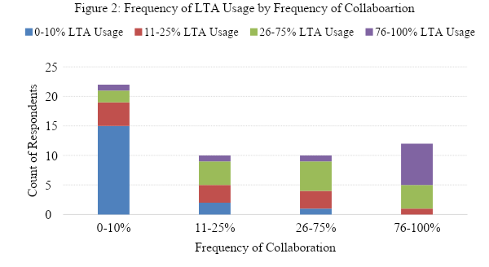

- Enforceability of LTAs

The presence of the quantity term ensures that the agreement is enforceable. Accordingly, a quantity term may be the best way to ensure that the continuing obligation to purchase is enforceable, thereby helping to defray the sunk costs. However, only forty-five percent of respondents said that most of the time when they signed an LTA it would include a quantity term (minimum or exact quantity). Many manufactures noted they were unsure if an LTA without a quantity term would be enforceable and twenty percent responded that they believed an LTA without a quantity term would not be enforceable. Forty-four percent of manufacturers believed that an LTA without a quantity clause would become enforceable at signing, while twenty-nine percent of manufacturers believed it would become enforceable when a purchase order was signed.
For manufacturers that use LTAs the most frequently, only thirty-six percent included a quantity term in most of their agreements. For the companies that used an LTA most of the time, forty-five percent believed the LTA would become enforceable when the first purchase order was signed. Twenty-seven percent believed it was enforceable at the time of signing the LTA. The discrepancy in responses between frequent LTA users and infrequent or non-LTA users might be due to a lack of awareness about the functioning of LTAs among firms that rarely use them.
Termination Clauses also impact a supplier’s ability to protect sunk costs in LTAs. Figure 3 shows the percentage of agreements with termination for convenience clauses. Thirty-eight percent of suppliers said that a buyer can terminate for convenience very rarely, while another thirty-two percent said a buyer can terminate for convenience most of the time.
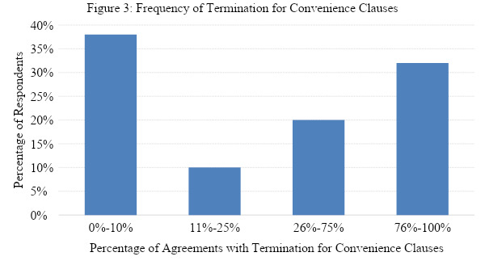

Many companies said that they would allow a buyer to terminate an agreement, even without a termination for convenience clause, if their tooling and investment costs had been repaid. Allowing termination for convenience or for decreased demand seems to shift that risk of fluctuations in demand to the supplier. This explanation suggests that parties will make adjustments that are not required, but only if there is reciprocal protection.. The supplier adjusts and allows for early termination, but only if the supplier is protected through repayment of the tooling and investment cost. These adjustments can be made outside the contract. As always, the parties weigh the benefits and costs of such adjustments. The supplier may be willing to accept that allocation because the supplier is better able to “redeploy[] manufacturing assets to another purpose” more easily than a buyer.
Although firms might elect the protections of an LTA, they are highly unlikely to use legal remedies in the event of a dispute between the parties. The vast majority of manufacturers , ninety-two percent, said they would almost never resort to suing over a dispute of an LTA. This finding supports the hypothesis that firms must derive some implicit benefit outside of legal protections for engaging in an LTA.

Analysis of Results
In general, our survey results revealed that the majority of Ohio manufacturers used LTAs infrequently. However, LTA usage varied significantly across industries. The high percentage of usage of LTAs by automotive and aerospace manufacturers may be explained by the leverage those buyers yield over suppliers, or the high collaboration costs associated with the industries. The presence of those sunk costs makes it important to control opportunism by the buyer in some manner since easy an exit is not possible as it is for fungible goods. This explanation is consistent with anecdotal feedback from a parts supplier who indicated that his company rarely used LTAs because as a catalog supplier, his products could be easily sold to others.
The fact that the majority of manufacturers that used LTAs in most of their transactions had customizable goods is an important finding. If a product is customized for a particular buyer, and is not fungible, the supplier may have invested sunk costs toward customization. That investment makes a resale to others and an easy exit difficult and costly. Where such vulnerabilities exist, the need for protection may justify the costs of LTAs. In particular, the supplier can negotiate contractual protections for sunk costs or a continuing commitment to purchase. This negotiation can help defray the sunk cost investment or some other implicit protection such as helping a supplier to enter a new line of business when the market for the buyer’s minivan collapsed.
While the most frequently selected reason that manufacturers gave for entering into LTAs without the concern of a future lawsuit was the security of a continuing commitment from the buyer, the second most selected reason was the absence of any choice due to the superior leverage of the buyer. This second factor may also be related to the presence of sunk costs. The larger buyers, such as OEMs in the automotive industry or airplane manufacturers, have the leverage to dictate their terms. Further, these relationships also likely require large sunk cost investments from their suppliers. Sunk costs that occur in the context of a buyer-supplier relationship are also likely to have the potential for opportunism because sunk costs are endemic and will occur when bounded rationality prevents a contractual control mechanism. The sunk costs lead to a fundamental transformation of the supplier relationship making exit costly or impossible. In the context of their relationship, controlling opportunism will be important, but difficult, because of all of the myriad ways in which a buyer or supplier may act opportunistically, but which cannot be anticipated. Because the contract will not be able to control the problem, there may be other governance strategies.
There are many possible solutions to opportunism when large sunk costs are present. One structural solution is vertical integration. Buyers could control external suppliers who could holdup buyers once the parties were locked in a bilateral dependent relationship through vertical integration. However, vertical integration has become less efficient as the specialized research and development (“R&D”) required for innovation is so costly that it makes sense to outsource it externally in other firms. Thus, the decision to outsource is driven by weighing the costs and benefits of vertically integrating, which includes the costs of R&D, the benefits of profit capture, and the possible holdup costs from outsourcing. As outsourcing increased, the cost of holdup has become less of a problem than once anticipated. Because suppliers do not want to jeopardize future business with buyers, since that would be “suicide,” they are reluctant to extort through hold-up.
However, the need to minimize frictions such as opportunism and facilitate coordination and control entropy remain current problems for both buyers and suppliers. The LTA, with its offer of implicit protections, security, and cementing relationships, offers an incentive for the supplier to invest in the relationship. The LTA operates as a protective safeguard that mitigates opportunistic behavior by buyers. This safeguard encourages sunk cost investments by suppliers and helps to minimize the cost of uncontrolled opportunism. The value of that safeguard may diminish if the supplier suspects that the buyer will renege on its implicit commitments or on contractual commitments or opportunistically claim that the goods are defective. The LTAs furnish other cost-minimizing features such as low-cost self-help when the product is defective or prices “competition-out” clauses to protect the buyers against the “China price”.
The fact that only approximately one-third of frequent LTA users in our survey insisted on a quantity term that would make the agreement legally enforceable indicates that the value of the LTA for suppliers may lie in other non-contractual protections offered by the LTA. This includes implicit contracts that prompt buyers to protect suppliers even when not legally obligated to do so. The absence of a quantity term might also indicate that the supplier is relying on other constraints, such as switching costs, that will make it difficult to terminate the relationship. Finally, even if there is no quantity requirement, and the supplier has large sunk costs, capital equipment, or tooling, once the first purchase order is issued, the agreement becomes enforceable. Additionally, there may be a specific provision on reimbursement for, or ownership of, equipment costs that is enforceable once the purchase order is issued. In these instances, the fact that the LTA may not contain an enforceable continuing purchase obligation may not be important because that would matter only if the cost of the capital equipment could not be otherwise recovered.

LTA Usage Within a Bargaining Lens of Economic Behavior
In order to understand the significance of the survey results, they must be situated within the context of a bargaining lens and a model of economic behavior including bounded rationality, sunk costs, and multi-faceted opportunism. The choice of a contractual form may best be understood in terms of how the arrangement responds to durable contractual hazards that each of the parties face. If contractual hazards remain uncontrolled either by contract or some governance mechanism, there will be price adjustments to reflect the uncontrolled hazard. Each firm will sacrifice some of its interests to accommodate the other party, but only if their bargain minimizes costs and advances other interests.
- Cost Minimization and Opportunism
The buyer faces uncertainty about the quality of the product from the supplier, and about the competence and ability of the supplier. The supplier faces uncertainty about potential opportunism. Opportunism could occur if the supplier invests large sunk costs and the buyer terminates early. Suppliers also face the prospect of buyers appropriating intellectual or other property. The parties’ agreements must also serve a planning and centralization of terms function. Each party faces the bargaining process with its own private goals and will reach an agreement only if the benefits of achieving those goals through a particular type or form of agreement outweigh the costs. Firms seek a combination of strategies, both contractual and informal, that will minimize its costs while maximizing its benefits. One party may enter a formal contract largely for the implicit contracts that form in the wake of the formal contract. Another party may enter the formal agreement because of particular benefits an LTA offers, such as shifting the risk of decreased demand to the other party through a termination for convenience clause. The strategies are not static as they may change in response to behavior by the other party that hinders goal achievement and they are contextual and respond to the different factors, such as asset specificity or large capital equipment costs.
In some ways, each party, while seeking to minimize its own costs to advance its projects and maximize value, realizes that it must help the counterparty minimize the costs of their project. The key is reciprocity. There is an implicit agreement that one party will minimize its costs and the counterparty’s costs, but only up to a point. When the costs of the accommodation to the other party are large, or the other party acts in an opportunistic manner, or there is a lack of trust, one party may take actions to protect itself and in doing so absorb less of the counterparty’s cost minimization needs. As one party attempts to cost minimize at the expense of the other, there will be less accommodation, or a party may self-protect, or hedge and share less information. At a certain point, cost minimization may actually result in litigation. When the demands of the counterparty are too great, litigation may be the only way to minimize costs.
  - Non-Contractual Cost Minimization Alternatives
It is important to understand that there may be non-contractual cost-minimizing solutions that lie outside the LTA or informal enforcement. For example, parties in the supply chain could use non-contractual mechanisms, such as insurance or a corporate structuring, that give buyers more control over their suppliers. To answer the question of why buyers would enter into LTAs, one must begin with a bargaining model in which each party weighs the cost of drafting against the risk of not drafting further and operating purchase-order-by-purchase-order. What are the various ways that buyers could achieve their goals in ways that would be least costly? What are the goals that they could accomplish using terms and conditions, a quality manual, and requirements of pre-certification or other means to assure the quality of supplier’s products and processes? Many of these provisions, such as supplier scorecards, International Organization for Standardization (“ISO”) Certification, and compliance with the buyer’s quality manual can all be imposed hierarchically in a top down manner through a purchase order or terms and conditions through an online portal without an LTA.
For example, buyers can dictate that suppliers must supply products that comply with their quality manual in their purchase orders or terms and conditions. Even without the consent of the supplier in an LTA, the buyer can stipulate that to even be considered as a supplier companies must comply with the buyer’s quality manual. Buyers might also require suppliers to warrant that their products comply with any buyer excellence or quality manual in their purchase orders or terms and conditions. The scorecards, ISO Certification, and the quality manual give the buyer low-cost ways of minimizing misunderstandings about quality and setting standards and help the buyer guard against shading by suppliers. They also give suppliers a low-cost way of bonding (furnishing a credible commitment of quality). Where there is a dispute about quality, the parties can often work out the issue informally, especially if the buyer has established quality metrics in its quality manual. In addition, LTAs may include managerial provisions that define dispute resolution procedures which can be cost saving for both parties. The desire for continued and future business will constrain all parties, especially when the parties are connected to a network. Shirking could result in negative reputational effects that would hinder the ability of the buyer and supplier to obtain future contracts.
  - LTAs as a Cost Minimization Strategy
Other goals may be harder to achieve in a unilateral hierarchical fashion, and thus require the contractual consent of the other party in an LTA. This would be particularly true in a long-term supply arrangement where, for example, the buyer wants the supplier to agree to reduce its prices five percent every year or agree to competition-out clauses. The standard purchase order or terms and conditions on the online portal govern all supply transactions. Annual cost reductions would only be needed for ongoing transactions where the buyer is subject to competitive price pressures that necessitate a guaranteed price reduction from its suppliers. The buyer weighs the risk of entering into a long-term contract to buy with a guarantee of a fixed price, against the risk that the future supplier prices will be too high if there are competitive pressures on the buyer to reduce its prices.
A buyer may also enter into an LTA because without such an agreement, a large buyer such as an OEM would be reluctant to finance the huge investment of producing a new model car without commitments from suppliers. Corporate management would be reluctant to assume such risks without assurances of price stability and commitments to furnish supplies. The LTA thus functions to protect the sunk cost investments made by the buyer. For example, one interviewee for a large OEM indicated that they would not proceed without an LTA.
The LTA may also be important for buyers because it can “signal continuity intentions.” In certain collaborative LTAs, the structuring of investments constitute examples and cement relationships of “reciprocity.” That may affect the price because price and governance are linked. The buyer would have to pay a higher price if there were no implicit continuity protection and the buyer might have a difficult time getting the supplier to invest sunk costs, such as the construction of a plant.
The supplier makes the same calculus, weighing whether the additional costs of entering an LTA are justified and considering how its overall costs and risks can be minimized. The survey results suggest that the subset of suppliers making primarily customizable goods or involving large sunk costs enter LTAs more frequently than the subset making primarily fungible goods or involving only minimal sunk costs. The supplier has to consider whether the extra drafting and negotiating costs and other risks of an LTA, such as the onerous provisions of annual price reductions and other pro-buyer terms, are outweighed by the greater security or commitment of a continuing purchase obligation — even if that purchase commitment is qualified or conditional or even terminable — that can be used to defray a large capital investment. That greater security can be achieved either by entering into an LTA [which] deters early termination by raising switching costs or providing other implicit protections, or by negotiating specific contractual protections. The expectation of implicit contractual protections from a buyer may affect the supplier’s calculus of whether the LTA is cost minimizing and value maximizing. The entry into the LTA together with the provision of a unique part that is integrated into the OEM’s production, gives “suppliers…some power in the course of carrying out a long-term contract” and explains the willingness to enter LTAs. As suppliers make large investments to meet the demands of the LTA, the buyer becomes locked into the supplier since other suppliers could not make the investments required in order to meet the buyer’s needs.
The importance of sunk costs demonstrated in the survey data helps to situate the scholarship on LTAs in a different framework — one that emphasizes asset specificity rather than uncertainty and innovation. The sunk costs that one or both parties must invest pose risks of opportunism. The bilateral LTA is one means of governance that acts as a contractual safeguard. Innovation scholars have deftly explored the ways that information transfer mechanisms in an LTA can deter opportunism. Our survey explains why these LTA provisions are important to suppliers with large sunk costs and why these safeguards are important and cost effective.
Since there is always a “braiding” of formal mechanisms (even with minimal contract documents such as purchase orders) and informal adjustment that leads to a buildup of trust and deters opportunism by raising switching costs as parties get to know each other, the question is why enter into an LTA when there are large sunk costs? The answer may be that there are implicit or explicit protections for the continuity of the relationship needed when sunk costs exist with an LTA that cannot be achieved by purchase orders, thereby providing a benefit to suppliers that justifies the higher costs. These protections include not only switching costs but other implicit protections against early termination or explicit protection for sunk costs if there is early termination.
This paper offers an explanation for why the costs of LTAs are justified, through an explanation tied to sunk costs, and a comparative cost analysis. Even where there is great uncertainty about the opportunism of the counterparty or the quality of the products, if the parties did not have to invest large asset-specific costs, the need for a contractual mechanism might not be cost-justified since the parties could simply exit. As Williamson explains, “an increase in parametric uncertainty is a matter of little consequence for transactions that are non-specific.”
- Information Sharing as a Cost Minimization Strategy
Recent scholarship has identified the information sharing protocols as a key feature of the modern LTA (or MSA) for both innovative manufacturing and biopharmaceutical industries. One question is how and why the informational protocols would be a cost minimizing strategy. Structured information-sharing allows parties to enter into an agreement when uncertainty about the innovation process and final product makes it impossible to enter into a completely contingent contract. It gives the parties a cost-effective way to build up trust. By each party extending oneself to one’s partner, a kind of overture and response, trust grows. Such provisions make parties contractually committed to “invest in producing information,” even if they cannot agree on the ultimate product. The exchange of this “highly revealing information” in the LTAs provides a basis for iterative investments by both parties that constrains opportunism. Information sharing may also occur if requested by a party to the agreement, since without it, the unanimity needed to go forward on the next stage of the innovative process may not be forthcoming.
This incremental exchange of information has several important benefits. It decreases uncertainty about the counterparty’s competence and increases trust in the counterparty’s capacity. The iterative exchange of information reduces uncertainty and therefore risk about the benefits of continuing a joint project. These observations and the knowledge of the counterparty raise switching costs for both parties. In addition, there would be negative reputational effects for leaving the relationship because it would be difficult to explain to a new party why the agreement failed.
This research team has two questions that arise from this iterative sharing of information through an LTA: (1) in a manufacturing setting, how can information sharing occur outside of an LTA? and (2) if parties share information without an LTA in ways that will be described below, then when would the additional costs and burdens of an LTA be justified? Answering that second question may offer additional insights into how parties structure their transactions to minimize risk, control opportunism, and provide for security for investment. The “braiding” that has been rationalized as a way for buyers to learn more about suppliers, to provide new bases on which to informally sanction suppliers, and for providing agreement on what constitutes a breach may have another important function for the supplier. The investment in information raises “switching” costs, thereby providing security for suppliers investing sunk costs. That protection may be further supported by implicit contracts to protect suppliers by providing them major new business when circumstances cause an early termination after a supplier has invested.
One goal of the survey was to ascertain whether information-sharing took place in the absence of an LTA. Our survey revealed that over half of all manufacturers indicated they would still share information without an LTA, and this was true of nearly three-quarters of those manufacturers who frequently used LTAs. This raises a further question: why would parties undertake the additional costs of an LTA if much of the required information could be obtained without one? The surveys prompted a further research outside the survey context into how various types of information may be obtained both through an LTA and through other means.
In the joint innovation context where one party is investing knowledge and another party is investing dollars, each party wants to know that the other is fully committed to the endeavor. Without that assurance there would be little reason to keep investing toward a joint innovation. The failure to comply with informational exchange would rarely be legally sanctioned except in blatant cheating or expropriation of another’s property. The iterative exchange builds up trust, creating it when it was not preexisting.
In the manufacturing context involving large buyers, it appears that there are a lot of mechanisms for securing information for a buyer from suppliers that do not depend on the existence of an LTA. Buyers can secure a large amount of information without ever entering into an LTA. Many of these mechanisms are designed to reduce uncertainty about the supplier.
One means of reducing that uncertainty is to require suppliers to prequalify. That can be done outside of an LTA. Also, instead of using an LTA, the parties can utilize a supplier quality handbook or manual to share large amounts of information at a reduced cost. There are a number of options the parties can use to share and assent to the quality manual processes, including customer specific processes and general arrangements that apply to all suppliers. One option is requiring all potential suppliers to acknowledge and certify that they are agreeing to the buyer’s requirements, such as the quality manual, code of conduct, and terms and conditions, as a precondition for conducting business with the buyer. In addition to utilizing a precertification process, the buyer may simply communicate that the quality documents are a requirement of potential and continuing business with the buyer and apply to all suppliers.
Quality handbooks or manuals may contain provisions requiring suppliers to gain and maintain ISO certification, establish minimum quality requirements, and require compliance with all relevant laws, orders, acts, and regulations. Additionally, the quality handbooks and manuals can require buyers agree to on-site assessments and audits, and supplier quality assessment or certification. While the quality manual places a number of requirements on the supplier it also provides support and guidance for each supplier.
In addition to the quality handbooks, buyers may unilaterally impose further conditions on suppliers such as requiring suppliers to complete online webinars, courses, or “Supplier Development Colleges” the buyer has developed for suppliers. The buyer may also develop online resources and courses to support the supplier but not specifically require completion as a requirement of conducting business. Further, the buyer may also require that the supplier participate in supplier performance management reviews, continuous improvement processes, and participation in supplier excellence programs.
The buyers’ purchase order and/or terms and conditions can thus provide protection for the buyer and result in the transfer large amounts of information to the buyer without an LTA. Buyers may also include in their purchase order or terms and conditions provisions that cover special tooling costs, buyer supplied equipment, inspections, and indemnification. The buyer’s standard purchase order may contain additional provisions governing disputes and governing law, product liability and insurance, and termination for cause or convenience. In the case either party terminates, the purchase order can contain clauses covering the termination process including inventory indemnification, special tooling, or capital expenditures. A manufacturing company’s purchase order may cover excess and defective goods, acceptance, modification, and payment. Thus, rather than enter into an LTA that requires compliance with the buyer’s quality manual or handbook, the buyer’s purchase order or terms and conditions can contain such provisions requiring compliance with both the supplier’s code of conduct and quality manuals or handbooks.
The mere availability of information about a supplier’s qualifications may not build trust in the same way that happens when procedures are implemented that cause the supplier and buyer to be linked, such as when the buyer sends an engineer to the supplier’s plant. That linkage helps to provide protection through increased switching costs that deter either party from switching. The LTA, or an informal arrangement, may also set up specific procedures that require benchmarking error and detection that help a buyer/assembler. An LTA may also provide implicit security that if the buyer has to terminate early, it will find a way to compensate the investing supplier. When that implicit assurance is degraded because of perceptions of opportunistic proclivities, the supplier may hedge or refuse to sign an LTA.
Even though the survey did not collect empirical data on reasons why buyers enter LTAs, the increased information from LTA’s may give buyers the means to identify new forms of misbehavior and to provide the architecture for demonstrating “how . . . to do business” and to furnish “contract administration mechanisms” which facilitate governance between firms much as the hierarchy functioned in the firm. This increased information has a similar advantage of avoiding the need for legal enforcement since the mechanisms do not relate to breach, but to “create a framework for growing relational social capital.” Since there are other ways to grow social relational capital between firms (incrementally, over time) that do not depend on an LTA, the question is why and when buyers would enter such agreements and under what circumstances and for what reasons. The larger and more complex the firm, the greater the internal coordination costs. Management techniques like leaning manufacturing or key performance indicators (KPI) can help reduce waste and costs in large and complex firms. Since they are engaging in cost reduction strategies internally, large buyers may have greater incentive to require suppliers to adhere to the same management techniques. Presumably buyers such as OEMs make the same calculus as suppliers do, choosing to enter an LTA when that particular arrangement minimizes their costs while controlling contractual hazards and thereby maximizing value.
Although some types of information about suppliers might be obtained in hierarchical means imposed outside an LTA, such as posting the quality manual on the web and mandating adherence to it or mandating compliance with ISO or other certification standards, or by posting a portal for suppliers to learn about the quality requirements, there are other benefits which cannot be obtained without an LTA, including a right to terminate suppliers. The investment in establishing elaborate private governance mechanisms in a setting where buyer assemblers have large fixed costs may be justified by the business planning benefits and control over the suppliers’ production processes and resulting trust and increased bond that facilitates “increasingly complex and innovative value-creating undertakings.” Where the investments by the buyer were not significant, the need to devise such mechanisms through agreements with suppliers would not exist, at least raising the possibility that sunk costs may explain why buyers are investing in elaborate LTAs. The LTAs may ensure a commitment to price reductions from suppliers.
The LTA may offer a roadmap or scaffolding for consultation during the course of a complex process. In each case the buyer would weigh what benefits an LTA can offer and whether those benefits can be achieved without an LTA. Most importantly, LTAs offer buyers the needed security of a guaranteed price and a commitment to supply. Without this security large and complex organizations such as OEMs could not plan or operate. The sunk costs of planning a car, for example, means that the buyer cannot simply exit and redeploy its assets. It will not be able to recoup its investment unless it produces the cars profitably, which cannot occur unless the supplier commits to supply the parts for the life of the production of the car at a fixed price. Those goals cannot be achieved without an LTA. A further survey could confirm whether the presence of the buyer’s large sunk costs help explain why the buyers enter into an LTA by assuring the buyer a continuing commitment but often not obligating the buyer to buy at all. It gives the buyer an option in effect.
- Self-Help Remedies
For the buyer, the additional costs of an LTA can be spread out over a myriad of transactions with suppliers. Also, many provisions in the LTA help to minimize costs for the buyer. Many LTA provisions give the buyer the ability to engage in self-help remedies that eliminate the need to resort to a legal solution for goods that do not comply with the buyer’s quality specifications. Instead of employing the buyer remedies in the Uniform Commercial Code (“U.C.C.”), the contract provides that the supplier can remove the unwanted part from the contract, relieving the buyer from any further obligation to buy. Other provisions give the buyer the ability to get reimbursed for correction of parts that do not conform, again without having to seek any remedy through the courts. Often, the buyer in an LTA is given the right to refuse goods that do not meet the buyer’s standards. The ability to operate outside of the legal system minimizes costs to the buyer and explains how the LTA can facilitate self-help and reduce buyer costs.
While there are many provisions that the buyer can impose on the supplier unilaterally and informally, other provisions, such as cost reduction provisions, may require the consent of the supplier. Of course, self-help accommodation may be possible if worked out individually between a supplier and a buyer when goods fail to conform. The LTA’s higher cost may be offset by a minimization of transaction costs. Instead of having to agree (extracontractually) to a self-help arrangement where the supplier agrees to discount the invoice for goods the buyer complains about, the buyer is given wide discretion to be relieved of any obligation to buy goods which do not meet the buyer’s metrics or standards. That mechanism relieves the buyer of having to negotiate each accommodation seriatim.
The self-help provisions of the LTA may also be cost minimizing for the supplier because the supplier’s willingness to sign an LTA with self-help provisions acts as a low-cost signal to the buyer — a kind of credible commitment — that the supplier will not furnish substandard goods or will readily comply with the self-help provisions of the contract. The supplier who signs such agreements may be eligible for more favorable prices than if the supplier insisted on compliance with the full regimen of the U.C.C.
- Sunk Costs and Cost Reduction Strategies
Another function of the LTA is related to the sunk costs involved in collaborative agreements. The buyer in these supply contracts may require the supplier to undertake expensive procedures such as root-cause analysis, or other large investments such as implementing a lean production methodology at the plant, or building an entire plant to manufacture a single component, such as a car door. The entry into the LTA may help to induce the supplier to provide the foundation that will cement the relationship and offer the supplier implicit protections even though they are not formally in the contract. That insight led one interviewee to respond that a large automotive supplier would not have undertaken the investment toward lean production without the protection of an implicit contract and security if they made the investment. That security could come in continuing purchase obligations either in the contract at issue or through help from the supplier in securing a different contract. Other provisions in an LTA impose on the supplier the need to engage in a cost reduction program that will redound to the benefit of the buyer. Cost reduction programs (often called the annual five percent letter) could not be imposed unilaterally on a supplier without the supplier’s express agreement.
In other instances, the LTA functions as a planning device. Parties refer to it to determine which party should be investing how much and issuing what reports. That planning function must occur in the context of an individually negotiated LTA so the standard terms and conditions or quality manual available on the web will not provide the needed blueprint for collaboration, thereby justifying costs of the individual agreement.
One remaining question is how the LTA, with its higher drafting and lawyering costs, could be a cost minimizing device for suppliers. Our survey revealed that manufacturers that used LTAs in most of their transactions tended to produce customizable goods and spend a significant amount on capital expenditures. This is an important finding, because if a product is customized for a particular buyer, and the supplier invested sunk costs toward customization, that investment makes an easy exit from the relationship or resale to others difficult and costly. Where such vulnerabilities exist, the need for protection may justify the costs of LTAs. The costs are especially justified if the supplier can negotiate contractual protection for sunk costs or a continuing commitment to purchase which can help defray the sunk cost investment. LTAs may protect against sunk costs in a variety of ways, such as by providing for the protection of large capital equipment and providing that if the relationship terminates, the capital equipment belongs to the supplier.
There are two primary differences that explain why and when suppliers use LTAs. They are likely to occur when the goods are: (1) customizable non-fungible; and (2) there are large sunk capital equipment costs involved in the manufacture. These two factors make it difficult for the supplier to exit and resell the goods. The greater sunk costs and accompanying vulnerabilities may justify the greater costs of an LTA, at least if the LTA offers greater protection to the party asymmetrically investing sunk costs, either through contractual protection for capital equipment or by implicit contracting or by switching costs, all of which function to protect suppliers.
Another way to protect sunk cost investments that can occur in an LTA is through the parties investing mutual sunk costs resulting in a mutual dependency. Mutual investment could occur when the buyer invests in training suppliers and suppliers invest in training to become excellent suppliers. This can occur in an LTA in which one party invests sunk costs in research and the other invests research dollars. When those sunk costs are not present, as for example when the supplier sells catalog items, the supplier may operate using less costly arrangements, such as a purchase order or terms and conditions. The supplier has less need for contractual protections because the supplier can simply exit and resell.
This outcome linking the greater use by suppliers of LTAs to greater sunk costs is consistent with the parties achieving their goals while minimizing transaction costs. The supplier who invests large sunk costs (either capital equipment or investments in procedures such as lean production or in building an entire new plant) faces the prospect of opportunistic behavior by a buyer who terminates early. The supplier may enter into an LTA which may offer some security to purchase goods over a period of time. The protection for the supplier that comes from entering an LTA can come through specific contractual protections for sunk costs or capital equipment in the LTA. It can also come through informal protections or implicit contracts that come once the supplier has invested sunk costs. Simply entering into the LTA may help to cement the relationship. The demonstration of competence may also deter the buyer’s exit from the relationship as finding other competent suppliers will take time.
Thus, where the sunk costs are large and the goods are not fungible, the ability to recoup or to protect such investment will depend on a variety of strategies, some informal and some contractual. If the sunk costs are low, the LTA may not be needed. Although the LTA may offer protection for the supplier, either through implicit protections, the buyer may find enough other benefits in the LTA to offer the cost of an LTA and make it cost minimizing for the buyer. Transaction cost minimization may help to explain other differences, as discussed below.
- Informal and Implicit Contracts
Even without a contractual provision protecting its sunk costs, a supplier may be relying on the iterative exchange of information and personnel to build up a relationship of trust. Such a relationship will serve to curb opportunistic behavior by the buyer. The information exchange leads to an incremental reduction of uncertainty about buyer opportunism. Moreover, as both parties learn more and become more comfortable as partners, switching out becomes less feasible. Entering a LTA and engaging in the exchange of information resulting in “braiding” becomes a private strategy to bind the parties together and also results in protecting the suppliers’ sunk costs. Implicit contracts then arise to protect the supplier. For example, when the Lear Company developed seats for a Honda minivan and that minivan was never made, each party accommodated the other. Lear agreed that the downturn in demand was an outside event that excused Honda from buying the seats. Honda, despite there being no enforceable obligation helped Lear enter the side mirror and other markets. These implicit contracts that arise from long-term partnerships help to explain why suppliers with large sunk costs are willing to enter into LTAs; the implicit contract protections serve as a private strategy of protection. The supplier may believe and rest on an implicit contract that the buyer will protect suppliers who invest large sunk costs, even without being obligated to do so. Another example of this occurred with Honda Motor Company and Donnelly.
Cost minimization as a tool for understanding supply chain arrangements can be understood in this way. Where there are large sunk costs being demanded of suppliers, the LTA may offer a cost-effective safeguard against opportunism. Some of these protections are implicit contracts to protect suppliers who invest for buyers. Other safeguards arise from the switching costs from iterative investments. Where sunk costs are low, the supplier can easily exit to protect itself and the costs of an LTA may not be justified.
The cost minimization explanation linking LTAs to large sunk costs by suppliers, may also explain another governance mechanism in the LTAs: the use of a veto. Professor Jennejohn explains the veto right contained in many LTAs involving intellectual property as a way of providing a “right to exclude”. The party wants a veto power to exclude the counterparty from appropriating his foreground intellectual property. The veto is a governance mechanism. The question is why it would be a cost minimizing way to deal with the threat of appropriation of intellectual property. The answer is that without the veto, there is the threat that the property may be shared and the boundaries improperly delineated. Once that occurs, it may be difficult to unwind and separate out the intellectual property. The type of governance mechanisms featured in the work of the innovation scholars that bind parties together and prevents an early exit or opportunism in the form of shading of quality may not work with protecting “foreground IP”. Once the property is shared, “U.S. patent law allows a joint owner to license and otherwise exploit jointly a jointly owned asset,” and the most cost-effective mechanism is to prevent the appropriation from occurring in the first place. Informal sanctioning would not work because there would be nothing to sanction once the intellectual property had been appropriated. Thus, the parties may agree to an LTA that contains a veto right since the problem of protecting foreground IP cannot be solved through informal sanctioning. In this situation, an LTA with a veto provision may be needed. The LTA veto provision responds to a risk that cannot be controlled with the informal sanctioning. Thus, the extra conduct provision is cost minimizing.
Another example of an LTA as a cost minimization strategy can be found with Apple and SCI. On their face, the extensive collaboration provisions reflected in the Apple and SCI Agreement may seem burdensome and costly. However, the costs of those undertakings by the supplier in a collaborative undertaking will be considered, along with the risk of multiple suppliers, and weighed against the greater switching costs if the supplier can demonstrate that it is a worthier, more collaborative supplier than other Apple suppliers. Then, Apple will bear the greater investment in collaborative efforts going forward because it would be loath to lose the worthy supplier as a partner. The supplier would consider the benefits of such loyalty and security along with the other benefits of the contract, including the initial three-year purchase commitment.
If the supplier encounters a circumstance that changes its calculus of whether the implicit contract will still offer protection without an explicit provision to do so, the supplier may no longer view the LTA as a cost minimizing strategy. Parties and courts constantly trade off these costs. Parties will no longer participate in the informal governance mechanism if the costs are not offset by greater benefits in achieving parties’ goals while minimizing costs. For example, the supplier’s willingness to enter into an LTA may depend on whether the supplier believes the buyer is trustworthy. When the supplier believes that the buyer is opportunistic and will renege on any obligations in the LTA, the supplier’s calculus changes, because the buyer’s propensity to act opportunistically will require additional protections. Once the buyer decides that it can cancel at will, the implicit protections afforded by iterative investment may no longer be effective.
Doubts about the buyer’s use of supplier information might lead to another cost minimizing strategy—hedging. In circumstances where the supplier has doubts about the buyer, the supplier may start to hedge and withhold some private information. That hedging strategy can be seen as a cost minimizing strategy by the supplier to control buyer opportunism when the contract itself does not constrain such behavior. The hedging strategy differs from opting out of an LTA. Instead of opting out, a supplier holds back information while technically complying with its obligations under an LTA.

Conclusion
Manufacturers seem to be making deliberate choices about whether to operate using an LTA or an alternative arrangement, such as a purchase order or terms and conditions. These deliberate choices are often tied to whether a manufacturer is likely to incur significant capital expenditures or the potential for large sunk costs as the result of the transaction. When a supplier does not have large sunk costs and is making a fungible good, and can easily exit the relationship without sacrificing large investments, the cost minimizing strategy may be to use an alternative to the LTA and rely on other arrangements.
Although the sample size in this study was small, our results provide additional insights into supplier (manufacturer) decision making regarding contractual arrangements. Our survey of Ohio manufacturers highlights that manufacturers have to weigh many considerations before entering into an LTA. Weighing these considerations leads to a diversity of contractual arrangements among manufacturers, with only a small minority (seventeen percent) using LTAs in most of their transactions.
Our empirical findings are consistent with a model of bargaining under conditions that include bounded rationality, sunk costs and opportunism. In instances where a supplier is requested to customize a product for a buyer, and such customization results in significant sunk costs for the manufacturer, then the manufacturer rationally may seek to protect itself through an LTA. Without the protection of an LTA, the buyer may exit the relationship easily and the overall transaction becomes costly for the supplier. LTAs can also provide additional frameworks, such as information sharing provisions, to help safeguard the supplier’s relationship with the buyer. These findings provided from manufacturer surveys serve as a useful compliment to current research reviewing existing LTAs and theoretical models exploring the potential use of such agreements.

Questionnaire for Suppliers Selling to Customers

Start of Block: Default Question Block

Requesting Participation in Survey Case Western Reserve University Dear Manufacturer,
I am a professor at Case Western Reserve University Law School. My special areas of expertise are Contracts and Law and Economics. I am studying the legal relationships between manufacturing companies and their customers in the supply chain. In order to complete this study, we are conducting a survey of various suppliers who manufacture goods or parts for their customers. Your response to this survey would be invaluable to the study. All responses will remain anonymous. You have been selected because you are a manufacturer in Ohio, Wisconsin or Michigan who produces products or parts used by customer/buyers who may use your input in a product they manufacture and sell. You are either in Sales and Marketing or the General Counsel’s office. If you receive this survey and another person at your company is better equipped to answer the survey, please redirect it to them. The purpose of this survey is to determine when manufacturing companies and their customers rely on various long-term or master supply agreements (LTAs; MSAs) to guide their interactions. Specifically, we are hoping to learn when companies use these agreements, what specific purposes the agreements serve, when companies use alternatives to an LTA or MSA (such as a purchase order, quote and acknowledgement or another arrangement such as acting as a contract manufacturer or entering a licensing agreement on a jointly developed product without using an LTA or MSA). Feel free to include any additional comments you deem necessary or relevant to our
study.

Background Questions

Q1 What are your company’s main products?

Q2 What percentage of your work for customers is a customizable good?
o 0-10% (1)
o 11-35% (2)
o 36-66% (3)
o 67-100% (4)

Q3 What percentage of your work for customers is a commodity or fungible good?
o 0-10% (1)
o 11-35% (2)
o 36-66% (3)
o 67-100% (4)

Q4 For what percentage of sales do you acquire capital equipment or tooling that will be used for a specific buyer that is significant in cost?
o 0-10% (1)
o 11-35% (2)
o 36-66% (3)
o 67-100% (4)

Lo ng Ter m Ag ree ment (“ L TA” ) / M a ster Supply Ag reeme nt (“M SA” ) o r Other Go v erning Do cu ments

Q5 If you use LTAs or MSAs, which of the following provisions is the MOST and LEAST important to you in terms of a possible lawsuit later on? Please organize the options for 1 MOST important to 6 LEAST important.
Provision to protect capital equipment costs or tooling costs (1)
Indemnity for intellectual property infringement (2)
Damages cap (3)
Indemnity for damages caused to a third party (4)
Warranty disclaimers (5)
Limitation of remedies provision (6)

Q6 In what percentage of transactions do you sign an LTA or MSA?
o 0-10% (1)
o 11-25% (2)
o 26-75% (3)
o 76-100% (4)

Q7 What percentage of firm revenues do transactions with an LTA or MSA represent for your firm?
o 0-25% (1)
o 26-50% (2)
o 51-75% (3)
o 76-100% (4)

Q8 If you sign an LTA or MSA, in what percentage is the agreement drafted by you?
o 0-10% (1)
o 11-25% (2)
o 26-75% (3)
o 76-100% (4)

Q9 What are the main reasons you sign LTAs or MSAs?
▢Security of continuing commitment from the buyer (1)
▢No choice; dictated by the buyer (2)
▢Establish an efficient system for information sharing to improve your product (3)
▢Demonstrate your commitment to the quality of your product or process (4)
▢Other, explain below: (5)

Q10 If you sign an LTA or MSA, are you required to share information with the buyer about engineering, costs and/or quality?
o Yes (1)
o No (2)
o No (3)

Q11 If you do NOT sign an LTA or MSA with the sharing of information, do you supply that information to your buyer anyway? Please explain your response.
o Yes, explain: (1)
o No, explain: (2)

Q12 If you do NOT sign LTAs or MSAs, please rank order the reasons you did not sign an LTA with 1 being the MOST important the 6 being the LEAST important.
Terms too onerous (1)
Do not want to sign a competition out clause (2)
Do not want to allow buyer a right to terminate for convenience (3)
Price reduction requirements too onerous (4)
Already doing business under other documents such as terms and conditions or purchase order (5)
Other, explain below: (6)

Q13 What type of buyers or industries insist on an LTA or MSA?

Q14 Do the buyers or industries that insist on LTAs or MSA have any of the following characteristics in common?
o Buyer is large in size or an Original Equipment Manufacturer (1)
o Buyer is engaged in intensive collaboration with us on innovated product (2)
o Other, explain below: (3)

Q15 Select the answer that best applies. Are the buyers who insist on using LTAs or MSAs: o In the top 20% of companies you work with in terms of size and/or revenue (1) o In the top 50% of companies you work with in terms of size and/or revenue (2)
o In the bottom 20% of companies you work with in terms of size and/or revenue (3)

Q16 In what percentage of your deals do you agree to manufacture a product without an LTA or MSA in place?
o 0-10% (1)
o 11-35% (2)
o 36-75% (3)
o 76-100% (4)

Q17 If you do agree to manufacture a product without an LTA or MSA, what document/s would govern this transaction? Pick all that apply.
▢Intellectual Property and Licensing Agreements (1)
▢Blueprints only; you act as a contract manufacturer (2)
▢Terms and Conditions (3)
▢Purchase order/quote/acknowledgement (4)
▢Other, explain below: (5)

Q18 If you sign an LTA or MSA, in what percentage of agreements does it contain a minimum quantity, percentage volume, or exact quantity term?
o 0-10% (1)
o 11-35% (2)
o 36-66% (3)
o 67-100% (4)

Q19 If the LTA or MSA has no quantity clause or no minimum quantity clause and no percentage volume commitment, would you consider the agreement at the time that it is signed to be?
o Legally enforceable (1) o Legally unenforceable (2) o Not sure (3)

Q20 If the LTA or MSA lacks a quantity term, when do you think the LTA or MSA would become enforceable?
o When the first purchase order was signed (1)
o When the LTA or MSA is signed (2)
o Another time, explain below: (3)

Q21 In what percentage of cases do you agree that the buyer can terminate for convenience as a clause in the LTA or MSA?
o 0-10% (1)
o 11-25% (2)
o 26-75% (3)
o 76-100% (4)

Q22 Suppose your LTA/MSA had NO termination for convenience clause. If your buyer indicated it no longer needed your parts and wanted to terminate 2 years into a 3-year contract, would you allow the buyer to exit anyway?
o Yes (1)
o No (2)
o In some cases only, explain below: (3)

Q23 In what percentage of cases do you need to prequalify as a supplier to sell your products to a buyer even if there is no LTA or MSA?
o 0-25% (1)
o 26-50% (2)
o 51-75% (3)
o 76-100% (4)

Q24 In what percentage of sales does the Purchase Order or Terms and Conditions from your buyer or Instructions on the Buyer’s website require your product to comply with a buyer quality or excellence manual?
o 0-25% (1)
o 26-50% (2)
o 51-75% (3)
o 76-100% (4)

Q25 If you are required to participate in an ongoing quality assessment program by the buyer, how is it required? Please select any that apply.
▢LTA or MSA (1)
▢Terms of a purchase order (2)
▢Terms and conditions of your customer (3)
▢Other, explain below: (4)

Interactions Between Manufacturer and Buyer

Q26 Are you required to attend any, or a certain number of, meetings with the buyer because of an LTA or MSA provision?
o Yes (1)
o No (2)

Display This Question:
If Are you required to attend any, or a certain number of, meetings with the buyer because of an LTA... = No

Q27 If not required to attend meetings with the buyer as required under the LTA or MSA, do you attend meetings anyway?
o Yes (1)
o No (2)

Product Design

Q28 What percentage of your products are co-designed in collaboration with the buyer?
o 0-10% (1)
o 11-25% (2)
o 26-75% (3)
o 76-100% (4)

Q29 If there is significant collaboration with a buyer, in what percentage of cases do you enter an LTA or MSA?
o 0-10% (1)
o 11-25% (2)
o 26-75% (3)
o 76-100% (4)

Q30 If you collaborated in design, how successful would you rate the collaboration?
o Not at all successful (1) o Somewhat successful (2) o Moderately successful (3) o Very successful (4)

Q31 In what percentage of cases does the buyer supply you with blueprints for the end product (or, together, you determine the blueprints for the end product) and your only job is to execute the blueprints?
o 0-10% (1)
o 11-25% (2)
o 26-75% (3)
o 76-100% (4)

Counsel and Disputes

Q32 In any arrangement with the buyer under a purchase order, LTA, or MSA, in what percentage of cases would you resort to suing the buyer because of a dispute?
o 0-10% (1)
o 11-25% (2)
o 26-75% (3)
o 76-100% (4)

Q40 Is there any additional information that you would like to share with us at this time?

Aggregated Survey Responses

Q1 - What are your company’s main products?
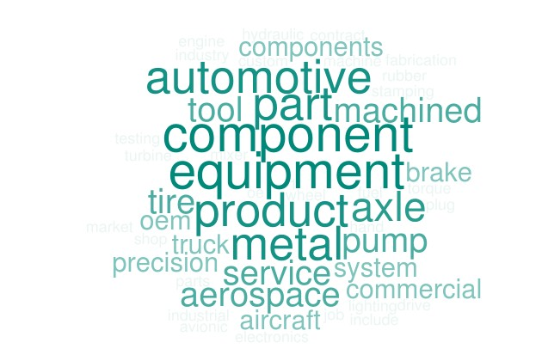

Q2 - What percentage of your work for customers is a customizable good?
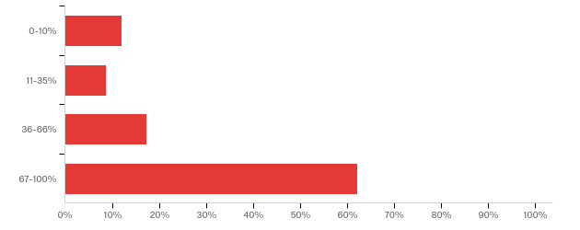

What percentage of your work for customers is a customizable good? | Percentage
0-10% | 12.1%
11-35% | 8.6%
36-66% | 17.2%
67-100% | 62.1%
Total | 58

Q3 - What percentage of your work for customers is a commodity or fungible good?
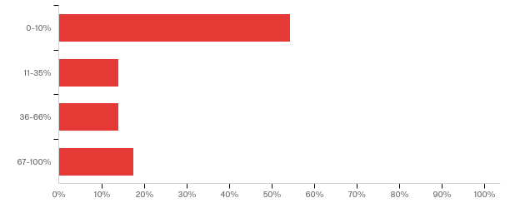

What percentage of your work for customers is a commodity or fungible good? | Percentage
0-10% | 54.4%
11-35% | 14.0%
36-66% | 14.0%
67-100% | 17.5%
Total | 57

Q4 - For what percentage of sales do you acquire capital equipment or tooling that will be used for a specific buyer that is significant in cost?
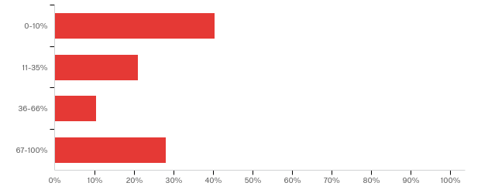

For what percentage of sales do you acquire capital equipment or tooling that will be used for a specific buyer that is significant in cost? | Percentage
0-10% | 40.4%
11-35% | 21.1%
36-66% | 10.5%
67-100% | 28.1%
Total | 57

Q5 - If you use LTAs or MSAs, which of the following provisions is the MOST and LEAST important to you in terms of a possible lawsuit later on? Please organize the options for 1 MOST important to 6 LEAST important.

Rankings | 1 | 2 | 3 | 4 | 5 | 6 | Total
Provision to protect capital equipment costs or tooling costs | 30.8% | 15.4% | 2.6% | 7.7% | 10.3% | 33.3% | 39
Indemnity for intellectual property infringement | 23.1% | 10.3% | 10.3% | 20.5% | 15.4% | 20.5% | 39
Damages cap | 17.9% | 15.4% | 28.2% | 20.5% | 7.7% | 10.3% | 39
Indemnity for damages caused to a third party | 17.9% | 12.8% | 20.5% | 23.1% | 17.9% | 7.7% | 39
Warranty disclaimers | 2.6% | 35.9% | 10.3% | 20.5% | 25.6% | 5.1% | 39
Limitation of remedies provision | 7.7% | 10.3% | 28.2% | 7.7% | 23.1% | 23.1% | 39

Q6 - In what percentage of transactions do you sign an LTA or MSA?
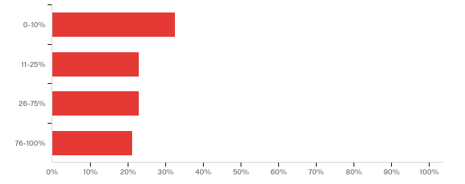

In what percentage of transactions do you sign an LTA or MSA? | Percentage
0-10% | 32.7%
11-25% | 23.1%
26-75% | 23.1%
76-100% | 21.2%
Total | 52

Q7 - What percentage of firm revenues do transactions with an LTA or MSA represent for your firm?
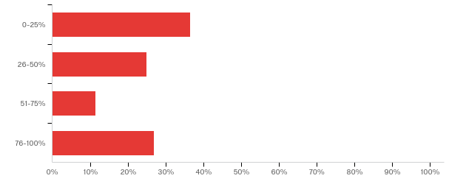

What percentage of firm revenues do transactions with an LTA or MSA represent for your firm? | Percentage
0-25% | 36.5%
26-50% | 25.0%
51-75% | 11.5%
76-100% | 26.9%
Total | 52

Q8 - If you sign an LTA or MSA, in what percentage is the agreement drafted by you?
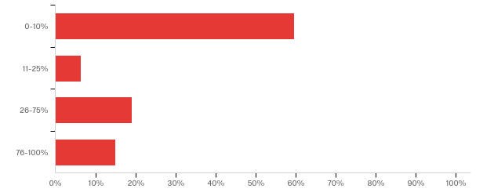

If you sign an LTA or MSA, in what percentage is the agreement drafted by you? | Percentage
0-10% | 59.6%
11-25% | 6.4%
26-75% | 19.1%
76-100% | 14.9%
Total | 47

Q9 - What are the main reasons you sign LTAs or MSAs?
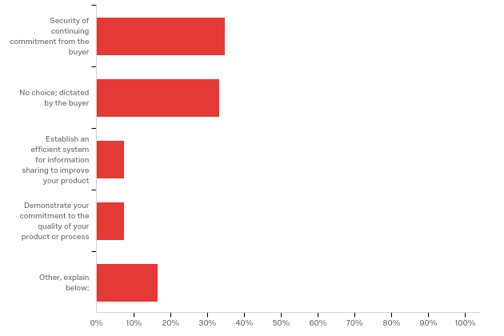

What are the main reasons you sign LTAs or MSAs? - Selected Choice | Percentage
Security of continuing commitment from the buyer | 34.8%
No choice; dictated by the buyer | 33.3%
Establish an efficient system for information sharing to improve your product | 7.6%
Demonstrate your commitment to the quality of your product or process | 7.6%
Other, explain below: | 16.7%
Total | 66

Q10 - If you sign an LTA or MSA, are you required to share information with the buyer about engineering, costs and/or quality?
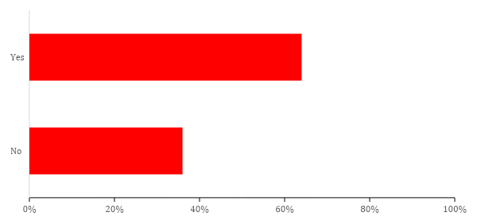
If you sign an LTA or MSA, are you required to share information with the buyer about engineering, costs and/or quality? | Percentage
Yes | 64%
No | 36%
Total | 44

Q11 - If you do NOT sign an LTA or MSA with the sharing of information, do you supply that information to your buyer anyway? Please explain your response.
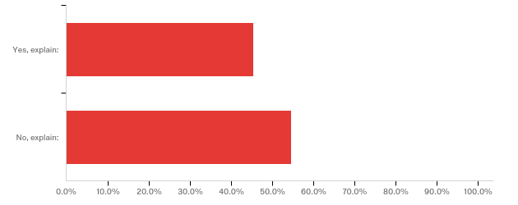

If you do NOT sign an LTA or MSA with the sharing of information, do you supply that information to your buyer anyway? Please explain your response. - Selected Choice | Percentage
Yes, explain: | 45%
No, explain: | 55%
Total | 44

Q12 - If you do NOT sign LTAs or MSAs, please rank order the reasons you did not sign an LTA with 1 being the MOST important the 6 being the LEAST important.

Question | 1 | 2 | 3 | 4 | 5 | 6 | Total
Terms too onerous | 23.8% | 38.1% | 26.2% | 11.9% | 0.0% | 0.0% | 42
Do not want to sign a competition out clause | 2.4% | 9.5% | 35.7% | 23.8% | 21.4% | 7.1% | 42
Do not want to allow buyer a right to terminate for convenience | 4.8% | 11.9% | 16.7% | 40.5% | 26.2% | 0.0% | 42
Price reduction requirements too onerous | 14.3% | 23.8% | 11.9% | 16.7% | 28.6% | 4.8% | 42
Already doing business under other documents such as terms and conditions or purchase order | 42.9% | 11.9% | 7.1% | 7.1% | 19.0% | 11.9% | 42
Other, explain below: | 11.9% | 4.8% | 2.4% | 0.0% | 4.8% | 76.2% | 42

Q13 - What type of buyers or industries insist on an LTA or MSA?
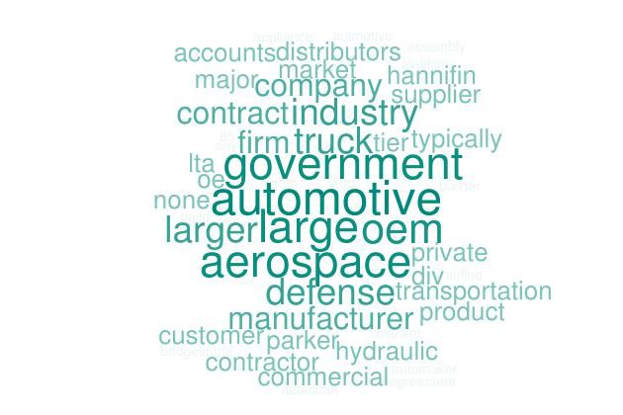

Q14 - Do the buyers or industries that insist on LTAs or MSA have any of the following characteristics in common?
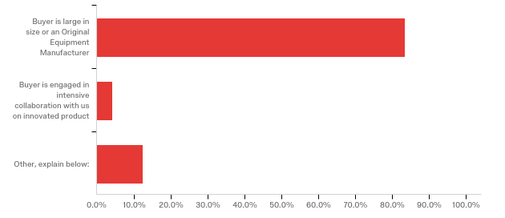

Do the buyers or industries that insist on LTAs or MSA have any of the following characteristics in common? - Selected Choice | Percentage
Buyer is large in size or an Original Equipment Manufacturer | 83.3%
Buyer is engaged in intensive collaboration with us on innovated product | 4.2%
Other, explain below: | 12.5%
Total | 48

Q15 - Select the answer that best applies. Are the buyers who insist on using LTAs or MSAs:
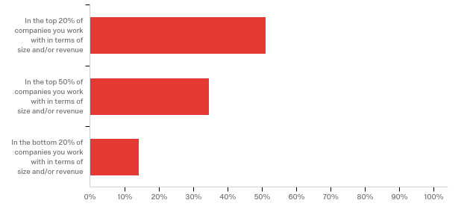

Select the answer that best applies. Are the buyers who insist on using LTAs or MSAs: | Percentage
In the top 20% of companies you work with in terms of size and/or revenue | 51.0%
In the top 50% of companies you work with in terms of size and/or revenue | 34.7%
In the bottom 20% of companies you work with in terms of size and/or revenue | 14.3%
Total | 49

Q16 - In what percentage of your deals do you agree to manufacture a product without an LTA or MSA in place?
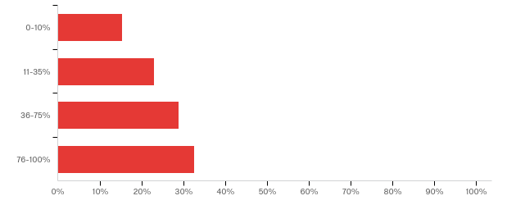

In what percentage of your deals do you agree to manufacture a product without an LTA or MSA in place? | Percentage
0-10% | 15.4%
11-35% | 23.1%
36-75% | 28.8%
76-100% | 32.7%
Total | 52

Q17 - If you do agree to manufacture a product without an LTA or MSA, what document/s would govern this transaction? Pick all that apply.
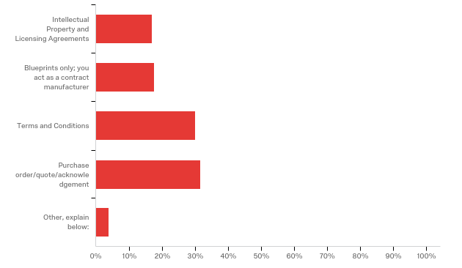

If you do agree to manufacture a product without an LTA or MSA, what document/s would govern this transaction? Pick all that apply. - Selected Choice | Percentage
Terms and Conditions | 30.0%
Purchase order/quote/acknowledgement | 31.5%
Other, explain below: | 3.8%
Intellectual Property and Licensing Agreements | 16.9%
Blueprints only; you act as a contract manufacturer | 17.7%

Q18 - If you sign an LTA or MSA, in what percentage of agreements does it contain a minimum quantity, percentage volume, or exact quantity term?
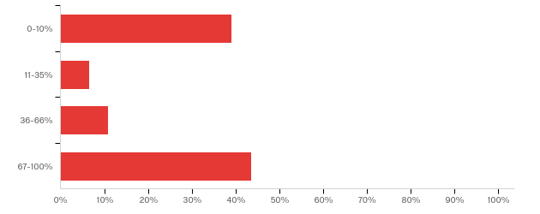

If you sign an LTA or MSA, in what percentage of agreements does it contain a minimum quantity, percentage volume, or exact quantity term? | Percentage
67-100% | 43.5%
36-66% | 10.9%
11-35% | 6.5%
0-10% | 39.1%
Total | 46

Q19 - If the LTA or MSA has no quantity clause or no minimum quantity clause and no percentage volume commitment, would you consider the agreement at the time that it is signed to be?
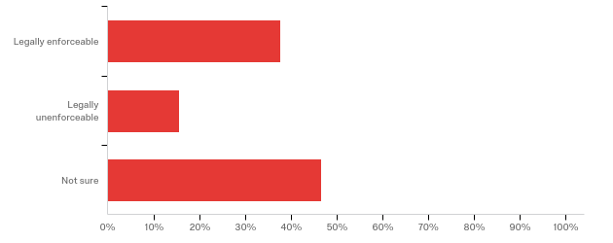

If the LTA or MSA has no quantity clause or no minimum quantity clause and no percentage volume commitment, would you consider the agreement at the time that it is signed to be? | Percentage
Legally enforceable | 37.8%
Legally unenforceable | 15.6%
Not sure | 46.7%
Total | 45

Q20 - If the LTA or MSA lacks a quantity term, when do you think the LTA or MSA would become enforceable?
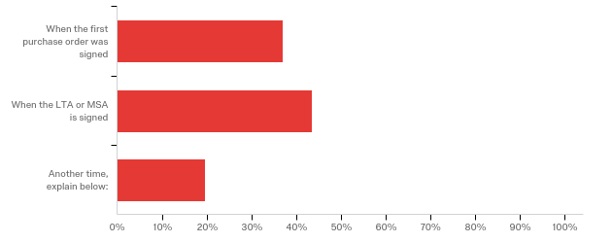

If the LTA or MSA lacks a quantity term, when do you think the LTA or MSA would become enforceable? - Selected Choice | Percentage
When the first purchase order was signed | 37.0%
When the LTA or MSA is signed | 43.5%
Another time, explain below: | 19.6%
Total | 46

Q21 - In what percentage of cases do you agree that the buyer can terminate for convenience as a clause in the LTA or MSA?
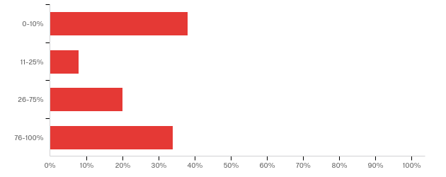

In what percentage of cases do you agree that the buyer can terminate for convenience as a clause in the LTA or MSA? | Percentage
0-10% | 38.0%
11-25% | 8.0%
26-75% | 20.0%
76-100% | 34.0%
Total | 50

Q22 - Suppose your LTA/MSA had NO termination for convenience clause. If your buyer indicated it no longer needed your parts and wanted to terminate 2 years into a 3-year contract, would you allow the buyer to exit anyway?
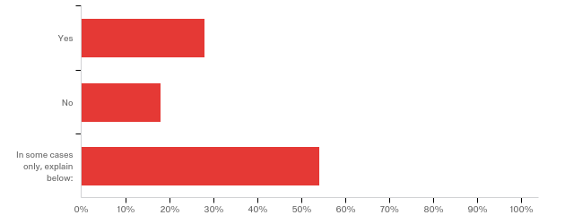

Suppose your LTA/MSA had NO termination for convenience clause. If your buyer indicated it no longer needed your parts and wanted to terminate 2 years into a 3-year contract, would you allow the buyer to exit anyway? - Selected Choice | Percentage
Yes | 28.0%
No | 18.0%
In some cases only, explain below: | 54.0%
Total | 50

Q23 - In what percentage of cases do you need to prequalify as a supplier to sell your products to a buyer even if there is no LTA or MSA?
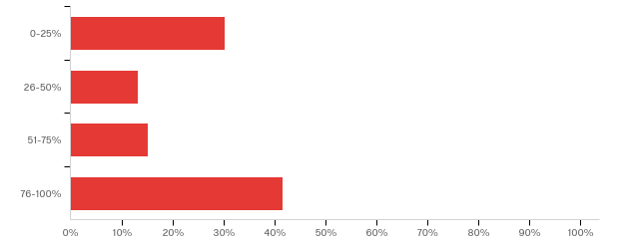

In what percentage of cases do you need to prequalify as a supplier to sell your products to a buyer even if there is no LTA or MSA? | Percentage
0-25% | 30.2%
26-50% | 13.2%
51-75% | 15.1%
76-100% | 41.5%
Total | 53

Q24 - In what percentage of sales does the Purchase Order or Terms and Conditions from your buyer or instructions on the buyer’s website require your product to comply with a buyer quality or excellence manual?
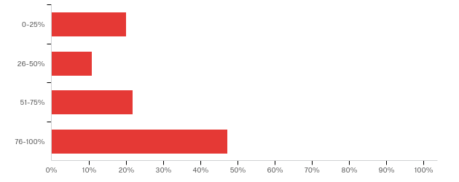

In what percentage of sales does the Purchase Order or Terms and Conditions from your buyer or Instructions on the Buyer’s website require your product to comply with a buyer quality or excellence manual? | Percentage
0-25% | 20.0%
26-50% | 10.9%
51-75% | 21.8%
76-100% | 47.3%
Total | 55

Q25 - If you are required to participate in an ongoing quality assessment program by the buyer, how is it required? Please select any that apply.
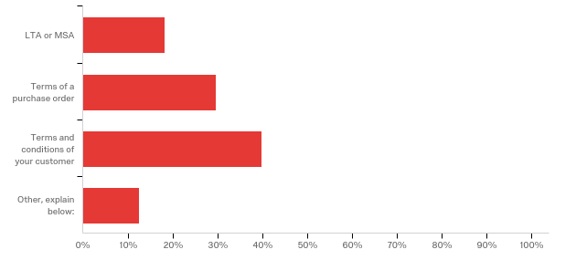

If you are required to participate in an ongoing quality assessment program by the buyer, how is it required? Please select any that apply. - Selected Choice | Percentage
LTA or MSA | 18.2%
Terms of a purchase order | 29.5%
Terms and conditions of your customer | 39.8%
Other, explain below: | 12.5%

Q26 - Are you required to attend any, or a certain number of, meetings with the buyer because of an LTA or MSA provision?
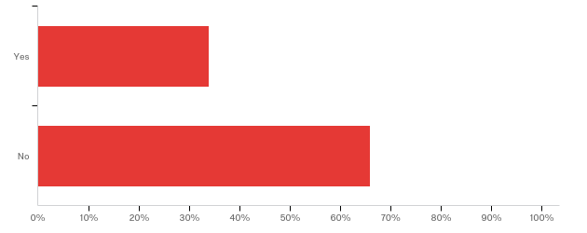

Are you required to attend any, or a certain number of, meetings with the buyer because of an LTA or MSA provision? | Percentage
Yes | 34.0%
No | 66.0%
Total | 50

Q27 - If not required to attend meetings with the buyer as required under the LTA or MSA, do you attend meetings anyway?
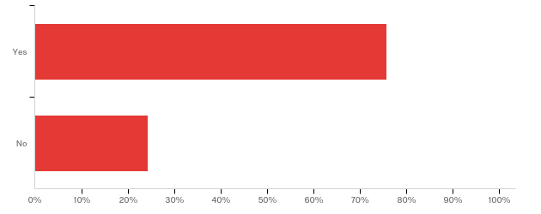

If not required to attend meetings with the buyer as required under the LTA or MSA, do you attend meetings anyway? | Percentage
Yes | 75.8%
No | 24.2%
Total | 33

Q28 - What percentage of your products are co-designed in collaboration with the buyer?
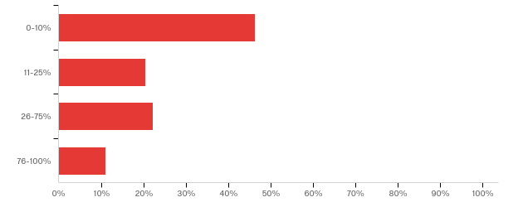

What percentage of your products are co-designed in collaboration with the buyer? | Percentage
0-10% | 46.3%
11-25% | 20.4%
26-75% | 22.2%
76-100% | 11.1%
Total | 54

Q29 - If there is significant collaboration with a buyer, in what percentage of cases do you enter an LTA or MSA?
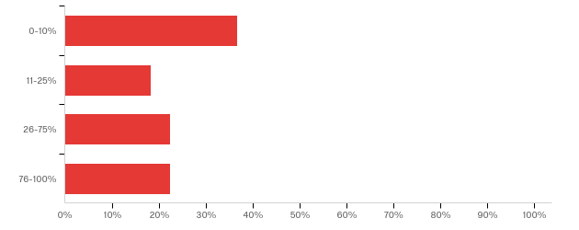

If there is significant collaboration with a buyer, in what percentage of cases do you enter an LTA or MSA? | Percentage
0-10% | 36.7%
11-25% | 18.4%
26-75% | 22.4%
76-100% | 22.4%
Total | 49

Q30 - If you collaborated in design, how successful would you rate the collaboration?
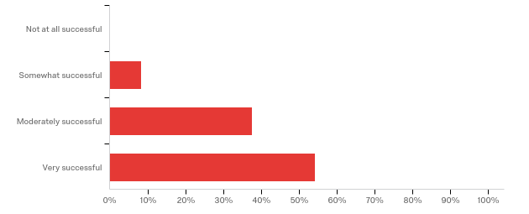

If you collaborated in design, how successful would you rate the collaboration? | Percentage
Not at all successful | 0.0%
Somewhat successful | 8.3%
Moderately successful | 37.5%
Very successful | 54.2%
Total | 48

Q31 - In what percentage of cases does the buyer supply you with blueprints for the end product (or, together, you determine the blueprints for the end product) and your only job is to execute the blueprints?
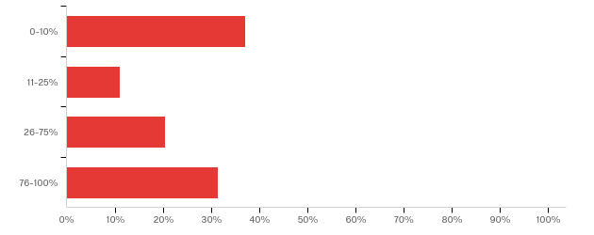

In what percentage of cases does the buyer supply you with blueprints for the end product (or, together, you determine the blueprints for the end product) and your only job is to execute the blueprints? | Percentage
0-10% | 37.0%
11-25% | 11.1%
26-75% | 20.4%
76-100% | 31.5%
Total | 54

Q32 - In any arrangement with the buyer under a purchase order, LTA, or MSA, in what percentage of cases would you resort to suing the buyer because of a dispute?
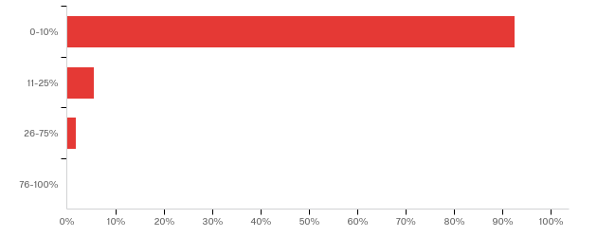

In any arrangement with the buyer under a purchase order, LTA, or MSA, in what percentage of cases would you resort to suing the buyer because of a dispute? | Percentage
0-10% | 92.5%
11-25% | 5.7%
26-75% | 1.9%
76-100% | 0.0%
Total | 53

* Everett D. and Eugenia S. McCurdly Professor of Contract Law and Center for Business Law, Case Western Reserve University School of Law. She would like to thank Professors William C. Whitford, Stewart Macaulay and Lisa Bernstein for inspiring her to do empirical research. ** J.D., Case Western Reserve University School of Law; M.A., University of Zurich; B.A., Jacobs University Bremen. She would like to thank Alexa Shook, Jillian Fox, and Stephen Kovacic for their excellent research assistance. Based on the comments provided by respondents, most survey participants seemed to be suppliers to buyers/assemblers.
See Charles F. Sabel, A Real-Time Revolution in Routines, in The Firm As A Collaborative Community: Reconstructing Trust In The Knowledge Economy 107 (Charles Heckscher & Paul S. Adler eds., 2006) [hereinafter Sabel, Real-Time Revolution] (discussing an “organizational revolution” distinct from the Chandlerian revolution of vertically integrated bureaucratic firms). The new ways of organizing follow from new ways of producing goods. Josh Whitford, The New Old Economy: Networks, Institutions, And The Organizational Transformation of American Manufacturing 15–17 (2005) (discussing the “new production paradigm”). There are other ways that supplier firms might respond to the stresses in the supply chain other than by opting out of an LTA. They might decide to refuse to engage in joint design with an OEM and instead furnish that OEM only with older technology that is already patented. That protects the supplier against the OEM licensing a supplier’s intellectual property to others. The strategy might be described as “patent the heck out of it” before working with an OEM. See also Interview (Aug. 8, 2018) (on file with author).[confidential interview with a company GC]
Sunk costs may also play a role in the willingness of large buyers such as OEMs to adopt LTAs.
Lisa Bernstein & Brad Peterson, Managerial Contracting: A Preliminary Study 1 (unpublished manuscript) (on file with author).
Matthew Jennejohn, Collaboration, Innovation, and Contract Design, 14 Stan. J.L. Bus. & Fin. 83, 83, 88 (2008). [hereinafter Jennejohn, Collaboration]. See also Susan Helper et al., Pragmatic Collaborations: Advancing Knowledge While Controlling Opportunism, 9 Indus. & Corp. Change 443, 468 (2000) (observing that collaborative firms inherently develop routines for evaluating and improving current processes).
These agreements are sometimes referred to as Master Supply Agreements or MSAs.
Jennejohn, Collaboration, supra note 6, at 83.
See Ronald J. Gilson et al., Braiding: The Interaction of Formal and Informal Contracting in Theory, Practice and Doctrine, 110 Colum. L. Rev. 1377, 1404 (2010) [hereinafter Gilson et al., Braiding] (“[Parties] write contracts in which they manifestly intend to establish a deeply collaborative relation, where little or none existed before, through a combination of formal and informal elements.”).
Jennejohn, Collaboration, supra note x, at 88–89.
John P. Esser, Institutionalizing Industry: The Changing Form of Contract, 21 Law & Soc. Inq. 593, 625 (1996).
Lisa Bernstein, Beyond Relational Contracts: Social Capital and Network Governance in Procurement Contracts, 7 J. Legal Analysis 561, 562 (2015) [hereinafter Beyond Rational Contracts]. But many provisions in LTAs deal with warranties and indemnities, provisions that are relevant only when there is resort to legal remedies. Thus, the effort to “keep the law” out remains partial.
Omri Ben-Shahar & James J. White, Boilerplate and Economic Power in Auto Manufacturing Contracts, 104 Mich. L. Rev. 953, 954, 957 (2006).
Our research did not specifically study other arrangements beyond the choice of using an LTA or not using one. There are other non-contractual choices (corporate ones). A buyer could decide not to buy externally from a separate firm but rather to organize the supplier into a separate subsidiary. The buyer might be particularly likely to choose that corporate arrangement if the part needed presented a high risk for the buyer if the part malfunctioned. By cabining the parts supplier into a separate subsidiary, the parent could oversee the operation but could also secure a large insurance policy to cover any risk if the part malfunctioned. The parent would be careful not to exercise control, but only oversight, in order to avoid veil piercing. If the company can organize in that manner and get an insurance policy to cover the risk, there may be no need for an LTA. Because these decisions are made internally and companies weigh the risks without an LTA, against the protection offered by an LTA, it might be hard to study the decision-making. However, the same process of cost minimization to control durable problems is at play. In some instances, the choice results in a subsidiary furnishing a part rather than the company securing an external supplier via an LTA.
See Oliver E. Williamson, Mechanisms of Governance 114 (1996) [hereinafter Williamson, Mechanisms] (identifying the drive to control contractual hazards, when sunk costs exist, in a cost-minimizing way as a crucial factor leading to the fundamental transformation of exchange relationships, which helps to explain the governance choices parties make, including whether to vertically integrate and how to structure buy transactions with external firms).
See generally Juliet P. Kostritsky, A Bargaining Dynamic Transaction Cost Approach to Understanding Framework Contracts, 68 AM. U. L. REV. 1621 (2019) (discussing durable problems explaining variety of supply chain arrangements).
See Lisa Bernstein & Brad Peterson, Managerial Contracting: A Preliminary Study 39 (unpublished manuscript) (on file with author) (explaining that the new agreements as reflecting a move away from “documents that focused primarily on the prevention of opportunism . . . to documents that devoted considerable attention to governing the contractual relationship.” In contrast, this Article sees the LTAs as serving both to streamline production and at the same time to constrain opportunism by cementing relationships, offering specific protection in an option to buy at a fixed price, or through implicit protections that arise from the LTAs in the form of switching costs); see also Gilson et al., Braiding, supra note 9, at 1383(discussing that the “managerial” provisions serve as a way to control opportunism by suppliers. However, these provisions also have the potential to introduce opportunism by allowing buyers to take information from suppliers to get a lower price).
See Gilson et al., Braiding, supra note x, at 1382 (discussing confluence of uncertainty and need for expertise from external firms); see also Kostritsky, supra note 16, at 1631–32. If the product is certain in the innovation context, other uncertainties such as uncertainty about a counterparty’s behavior and his or her potential for opportunism remain uncertain throughout all supply chain transactions. What other factors explain why the LTA prevails in some transactions but not others? This Article will offer an explanation based on sunk costs.
Bernstein, Beyond Relational Contracts, supra note x, at 562.
See Lisa Bernstein & Brad Peterson, Managerial Contracting: A Preliminary Study 3-4 (unpublished manuscript) (on file with author) (supra footnote 17).
These routines developed in collaborative networks between buyers and suppliers help to foster an “organizationally rooted trust as reliability.” This trust develops with the routines and differs from the early concept of a different type of trust rooted in a willingness of “the parties to a network [to] agree to forego the right to pursue their own interests at the expense of others.” See Whitford, supra note 2, at 98 (citing Walter Powell, Neither Market Nor Hierarchy: Network Forms of Organization (Barry Staw and L.L. Cummings, eds., 1990)).
Id. at 28.
Id.at 28-9.
See Gary Herrigel, Emerging Strategies and Forms of Governance in High Wage Component Manufacturing Regions, 11 Industry and Innovation 45, 52, 66, 71 (2004) (observing the increasing difficulty and necessity for firms to benchmark — “ keep abreast of and compare its own capacities to new developments” in the industry — in the new production economy.
Jennejohn, Collaboration, supra note 6, at 83.
Id. at 88 (noting that such contracts also result in a convergence of the parties’ interests. That result underscores a change in the contract away from risk allocation to “align[ing] interests . . . .”).
See Whitford, supra note 2, at 29 (quoting Helper et al., supra note 6, at 445) (“[O]nce the cooperative exploration of ambiguity begins, the returns to the partners from further joint discoveries are so great that it pays to keep cooperating.”).
Bernstein & Peterson, supra note 4, at 7 (citing American Society for Quality Control).
See Helper et al., supra note 6, at 445, 463; see also Whitford, supra note 2, at 98.
See Ann P. Bartel et al., Technological Change and the Make-or-Buy Decision, Colum. Bus. Sch. 7 (Mar. 27, 2012) (observing that the fraction of firms that find outsourcing more profitable increases with the pace of technological change); see also Robert Gibbons, Firms and Other Relationships Lecture Note 4, in The Twenty-First Century Firm: Changing Economic Organization in International Perspective 188 (Paul DiMaggio ed., 2001) (evaluating the make or buy decision in the context of “whether integration or non-integration facilitates the superior relational contract”).
See Section V.c. Diversity of Arrangements.
See Jennejohn, Collaboration, supra note 8, at 87 (discussing how transparency “largely eliminates opportunism.”); see also Helper et al., supra note 6, at 469–72 (explaining that pragmatic collaborations advance the collective knowledge of the parties and curb opportunism through the sharing of information).
Bernstein, Beyond Relational Contracts, supra note 12 , at 584 (observing that contracts, to maintain cooperation, often give parties rights to conduct a root cause analysis and monitoring which “condition on information that in their absence would not be observable . . .” thereby allowing for more informal enforcement possibilities).
Id. at 561 (noting however, presumably private order can flourish without LTAs as parties engage in iterative investments and develop a relationship).
Gilson et al., Braiding, supra note 9, at 1383–84 quoting Ronald J. Gilson et al., Contracting for Innovation: Vertical Disintegration and Interfirm Collaboration, 109 Colum. L. Rev. 431, 486-489 (2009). Of course, the iterative exchange of information may occur during a relationship between a buyer and supplier without an LTA. The parties can take small steps to accommodate another party and the other party may then respond in kind, in a kind of overture and response scenario. An LTA is not needed to accomplish this. Id. at 1384.
Id. at 1383
See, e.g., Whitford, supra note 2, at 18 (describing a “shift” in the production economy throughout the twenty-first century); Gillian K. Hadfield & Iva Bozovic, Scaffolding: Using Formal Contracts to Support Informal Relations in Support of Innovation, 2016 Wis. L. Rev. 981, 985 (providing a list of some of the “pervasive uncertaint[ies]” in present-day innovation contacts); Ronald J. Gilson et al., Contracting for Innovation: Vertical Disintegration and Interfirm Collaboration, 109 Colum. L. Rev. 431, 438 (2009) [hereinafter Gilson et al., Contracting for Innovation] (“[F]ear of holdups . . . no longer compels firms to vertically integrate.”); Herrigel, supra note 16, at 55 (discussing OEMs concerns in the “current environment of consistent vertical disintegration”).
See Gilson et al., Contracting for Innovation, supra note 36, at 439–40.
Herrigel, supra note 16, at 46.
See Whitford, supra note 2, at 99.
See Gilson et al., Contracting for Innovation, supra note 36, at 435, 448.
John Paul MacDuffie, The Road to Root Cause: Shop Floor Problem Solving at Three Auto Assembly Plants, 43 Management Science 479, 486 (1997).
See Herrigel, supra note 16, at 73–74. Fix the supra.
Whitford, supra note 2, at 42, 98 (noting one of the key benefits of the routines for information sharing and collaboration ideally lead to “jointly question” the production process and that questioning both disrupts and leads to improvements); Charles F. Sabel, Theory of a Real Time Revolution 107 (2003) [hereinafter Sabel, Revolution] (“[P]ermanent uprising against routine . . . [a] key to survival in otherwise unmanageably turbulent world.”) (unpublished manuscript) (on file with Columbia Law Review) cited in Whitford, supra note x, at 99 ; see also Jennejohn, Collaboration, supra note 8, at 101; Helper et al., supra note 6, at 472 (stating that disruptions can change “static rules” and thus lead to improvement).
See Whitford, supra note 2, at 28.
Helper et al., supra note 6, at 445 (“[The] pragmatic mechanisms . . . create and maintain the conditions under which two or more firms can sustain collaboration.”).
Id.
Whitford, supra note 2, at 99.
Bernstein & Peterson, supra note 4, at 1.
See Gilson et al., Contracting for Innovation, supra note 36, at 449 (“[W]hat we see emerging [is] . . . continuous improvement in product development and engineering.”); see also id. at 438 (“[F]ear of holdups . . . no longer compels firms to vertically integrate.”).
Sabel, Real-Time Revolution, supra note 2, at 107.
However, collaborative networking and the “forced openness of joint design and learning by monitoring” is not necessarily the last stage of organizational development as the collaboration itself is subject to failure for a number of reasons including “factional conflicts” in firms that undermine the collaborative strategies themselves and by opportunism in the form of misusing information. Whitford, supra note 2, at 99.
Id. at 61 quoting Gary Herrigel, Gary and Wittke Volker47 (2004). ‘Varieties of Vertical Disintegration: The Global Trend Toward Heterogeneous Supply Relations and the Reproduction of Difference in US and German Manufacturing’, in Richard Whitley, Glenn Morgan, and Moen (eds.), National Business Systems in the New Global Context. Oxford: Oxford University Press.
Henry Smith, Modularity in Contracts: Boilerplate and Information Flow, 104 Mich. L. Rev. 1175, 1177 (2006) cited in Matthew Jennejohn, 14 Stan. Bus. L. J.STAN. BUS. L. J 142 (2008). It is important/critical to retain the cited in language for letting the reader where I found this idea.
Whitford, supra note 2, at 62 quoting Herrigel, supra note 53, at 49.
Id.
Id. at 99.
Id. at 62–63 (noting the importance of knowledge retention to “evaluate the performance of suppliers”).
See id. at 100 (disputing Sabel’s description of the new collaborative networks as “an inescapable organizational revolution” by noting “it remains altogether partial”).
Id. at 31.
Id. at 100 (discussing suppliers’ strategy of hedging to withhold information and investment in response to “OEM unreliability”).
Williamson, Mechanisms supra note 15, at 16; see also Jennejohn, Collaboration, supra note 8, at 84–85.
See generally Anne Sraders, What is Vertical Integration and What are the Benefits?, The Street (Aug. 17, 2018), https://www.thestreet.com/markets/what-is-vertical-integration-and-what-are-the-benefits-14671684 (detailing the benefits of vertical integration).
John Paul MacDuffie & Susan Helper, Creating Lean Suppliers: Diffusing Lean Production Through the Supply Chain, 39 Cal. Mgmt. Rev. 118, 120 (1997) (“Extensive tacit knowledge can develop in the supplier-customer relationship, facilitating coordination of the respective expertise of the parties, particularly with respect to complex value-added tasks such as product development.”).
Helper et al., supra note 6, at 472.
Whitford, supra note 2, at 99.
David Campbell, What do We Mean by Non-Use of Contract, in Revisiting the Contracts Scholarship of Stewart Macaulay On The Emppirical and the Lyrical 166–67(Jean Braucher, John Kidwell, & William C. Whitford eds., 2013).
Whitford, supra note 2, at 103.
Id. at 99.
See id. at 100.
See Kostritsky Ice Survey, infra pp. [X].
See Kostritsky, supra note x, at 1675. see also Oliver E. Williamson, The Economic Institutions Of Capitalism: Firms, Markets, Relational Contracting 53 (1985) [hereinafter Williamson, Economic Institutions].
Bernstein & Peterson, supra note 4, at 1.
Hadfield, supra note 36, at 988.
See Gilson et al., Braiding, supra note 9, at 1405 (noting that parties contract to “motivat[e] the iterative exchange of private information”); Gilson et al., Contracting for Innovation, supra note 36, at 49–50 (referencing the Deere-Stanadyne agreement to show how parties today may enter long-term contracts for the sole purpose of assessing parties’ “capabilities.”).
Whitford, supra note 2, at 76 (observing that OEMs and suppliers can collaborate to reduce costs over time).
Anonymous Interview (June 16, 2017) (on file with author).
Id.
Jennejohn, Collaboration, supra note 8, at 87.
Whitford, supra note 2, at 100.
Id. at 81, 102.
See supra Part III.
See generally Gilson et al., Contracting for Innovation, supra note 36 (analyzing the reasons companies choose to enter specific LTA-exemplar contracts).
Whitford, supra note 2, at 99 (explaining that “the forced openness of joint design and learning by monitoring creates the conditions for a ‘virtuous circle,’” or a waltz).
Williamson, Economic Institutions, supra note 72, at 60 (coining the term “machinery to work things out”).
See Kostritsky Ice Survey infra p. 86 (noting empirical data was collected only on suppliers).
Williamson, Economic Institutions, supra note 72, at 60.
Id.
Gilson et al., Contracting for Innovation, supra note 36, at 448.
Charles F. Sabel, Learning by Monitoring: The Institutions of Economic Development 23 (Colum. L Sch. Ctr. Law & Economic Studies, Working Paper No. 102, 1993) [hereinafter Sabel, Learning by Monitoring], http://www2.law.columbia.edu/sabel/papers/Learning%20by%20Monitoring.pdf.
Id.
Interview (January 25, 2019 ) (on file with author). (anonymous).
Interview with Susan Helper, Professor of Law, Case Western University (Feb. 21, 2017) (on file with author); see also Kostritsky Ice Survey infra p. 86 (showing the aggregated survey responses).
See discussion infra Section IV.C (explaining that quality manuals dictate purchase orders or terms and conditions).
See Figure 1 (finding that, based on survey responses, aerospace companies are far more likely to use LTAs than other industries).
Apple Computer, Inc. & SCI Systems, Inc., Foundation Manufacturing Agreement (May 31, 1996) [https://contracts.onecle.com/apple/scis.mfg.1996.05.31.shtml [hereinafter Apple-SCI Agreement]; see also Gilson et al., Contracting for Innovation, supra note 36, at 463 (noting “SCI, was at the time [of the agreement with Apple] one of the largest contract manufacturers”).
See Eli Lilly & Co. v. Emisphere Techs., Inc., No. 1:03-cv-1504, 2006 U.S. Dist. LEXIS 23245, at *2 (S.D. Ind. Apr. 25, 2006).
See Kostritsky Ice Survey infra pp. 94–95 (showing the aggregated survey responses to Q8 and Q9 which in turn demonstrate the proportion of terms that manufacturers can dictate, and then the proportion of manufacturers who reported that the terms are dictated to them).
See Whitford, supra note 2, at 51.
See Kostritsky, supra note 16, at 1644–47 (discussing the problems parties face regarding opportunism and the appropriation of Intellectual Property); see also Interview (August 8, 2018) (on file with author).
See Kostritsky, supra note 16, at 1656–57.
The questions regarding information sharing also touched on collaboration between the manufacturers and the buyers. Recent scholars have tied the information sharing protocols in LTAs to the benefits of informal enforcement of parties’ arrangements. The survey and interview questions were designed to elicit whether information sharing took place in the absence of an LTA and if so, at what levels (i.e. did information sharing occur at the same rate as occurred with an LTA?). Although the information sharing and collaboration questions helped the research team identify companies that might be concerned about intellectual property, the majority of respondents did not indicate intellectual property or highly innovative collaborations were a major concern.
Part of the interest in framing the survey in this manner arose when a General Counsel I interviewed suggested that his company tried to avoid signing LTAs. See Interview (August 8, 2018) (anonymous) (on file with author).
North American Industry Classification System, United States Census Bureau 33–40 (2017), https://www.census.gov/eos/www/naics/ (referencing NAICS codes 31 through 33 and their subsector codes).
A selection of companies without email addresses were contacted by phone but the majority were out of business.
This subset consists of the eleven manufacturers that indicated that they use LTAs in seventy-six percent or more of their transactions.
See Kostritsky, supra note 16, at 1638, n.75.
See Kostritsky Ice Survey infra p. 96 (showing the aggregated survey responses to Q9).
The protection of sunk costs in manufacturing including capital equipment and investments in lean production or other specialized processes is analogous to the need to protect intellectual property for “incentivizing creative activity.” See Matthew Jennejohn, The Private Order of Innovation Networks, 68 Stan. L. Rev. 281, 284 (2016) [hereinafter Jennejohn, Private Order].
See Lisa Bernstein & Brad Peterson, Managerial Contracting: A Preliminary Study 3 (supra note 17).
Id.
See Kostritsky Ice Survey infra pp. (need page).
See Kostritsky Ice Survey infra p. (need page) (finding that this group of respondents indicated that they use LTAs in 25 percent or less of their transactions).
See generally Advantages of Long Term Contracts, UpCounsel (last visited Apr. 17, 2020), https://www.upcounsel.com/advantages-of-long-term-contracts (explaining the advantages and disadvantages of LTAs in different industries).
Suppliers indicated they would share information even without an LTA due to asymmetric bargaining power between themselves and the buyer.
See Kostritsky Ice Survey infra p. (need page). Q23.
See Ford Motor Company Global Terms & Conditions for Non-Production Goods and Services ¶15(a) (“Seller . . . will discuss with Buyer . . . any potential design, quality or manufacturing problems with Supplies Seller worked on or produced pursuant to a Purchase Order”); id. at ¶ 20(a)(ii) (clause permitting buyer to “view any facility or process relating to the Supplies or the Purchase Order, including those relating to production quality”); Apple Inc. Purchase Agreement Purchase Order Terms and Conditions ¶ 6 (permitting Apple to inspect, and test goods before acceptance); Eaton Terms & Conditions: Selling Policy 2 (permitting buyer to “witness testing” testing”at seller’s factory for an additional fee).
See Whitford, supra note 2, at 99.
See id at 103–04.
See Whitford, supra note 2, at 104.
see Matt Viator, Termination for Convenience |Can Your Customer Terminate You Without Good Reason?, LevelSet https://www.levelset.com/blog/termination-for-convenience/ (“When the customer realizes they’re going to run out of cash, it might be safer (and cheaper) to terminate the agreement before it’s too late.”) (last updated May 7, 2019).
See Bernstein, supra note 12, at 586.
See Ben-Shahar &White, supra note 13, at 954 (discussing “economic power” of original equipment manufacturers).
Informational interview with firm with over $10 billion sales (Feb. 22, 2017) (on file with author).
See Ellen M. Pint & Laura H. Baldwin, Strategic Sourcing: Theory And Evidence from Economics and Business Management 10 (Rand Corp., 1997) (“Contracts can protect transaction-specific investments to some extent, but bounded rationality prevents contracts from specifying all possible contingencies. As contracts become more flexible, they allow more potential for opportunism.”).
See generally Williamson, Economic Institutions, supra note 73, at 39. (providing helpful background information on vertical integration and a detailed analysis of the strategy).
See Marie-Laure Allain et al., Vertical Integration as a Source of Hold-up, 83 Rev. of Econ. Stud. 1, 1 (2016) (acknowledging that previous scholarship in the field has identified “vertical integration as a solution to hold-up problems” but ultimately disagreeing with aforementioned scholars regarding their characterization of vertical integration as a solution to the hold-up problem).
Ben-Shahar & White, supra note 13, at 975 (explaining that hold-up power of supplier is limited due to fear that hold-up will result in a loss of future business).
Id. See also Gilson et al., Contracting for Innovation, supra note 36, at 438.
Interview with supplier (Aug. 24, 2017) (on file with author).
Bernstein, supra note 12, at 567.
See Esser, supra note 11, at 594 (noting that parties with a pattern of collaboration rely on various implicit mechanisms to fill in contractual gaps).
This protection is important when sunk costs are present.
See Keith J. Crocker & Scott E. Masten, Mitigating Contractual Hazards: Unilateral Options and Contract Length, 19 Rand J. Econ. 327, 328 (1988) (suggesting that “the importance of [considering] the contractual hazards [when] . . . determining . . . the design of the contract has become increasingly apparent”).
See Williamson, Mechanisms , supra note 15, at 62 (explaining that “technology (k), contractual governance/safeguards (s) and price (p) are fully interactive and are determined simultaneously”).
This uncertainty is heightened in the case of collaborating on an innovative product, such as a new drug or medical device, since the parties cannot draft a complete contract that identifies the product.
Kostritsky, supra note 16, at 1647–49 (discussing the problems buyers and sellers alike face regarding opportunism); Gilson et al., Contracting for Innovation, supra note 36, at 438–39.
Kostritsky, supra note 16, at 1702–03 (observing the inadequacy of “low-powered sanction[s]” where a “party plans to end the relationship by appropriating intellectual property of the other party”); see also Ariel Porat & Robert E. Scott, Can Restitution Save Fragile Spiderless Networks?, 8 Harv. Bus. L. Rev. 1, 1 (2018).
Kostritsky, supra note 16, at 1673 (noting that ease of planning and centralization of decision making are benefits of LTAs); see also Esser, supra note 11, at 594. )
Esser, supra note 11, at 594.
See Matt Viator, Termination for Convenience | Can Your Customer Terminate You Without Good Reason?, LevelSet (last updated Mar. 13, 2020), https://www.levelset.com/blog/termination-for-convenience/ (“When the customer realizes they’re going to run out of cash, it might be safer (and cheaper) to terminate the agreement before it’s too late.”).
Ken binmore, natural justice 10 (2005) (discussing “rational reciprocity”).
Whitford, supra note 2, at 100.
Interview with M&A lawyer (April 4, 2017) (on file with author).
Supplier Handbook, National Instruments 13, http://www.ni.com/content/dam/web/pdfs/20181002_FINAL_32652_Supplier_handbook_2018_Ltr_WR.pdf (last visited Apr. 17, 2020) (stating that “Select Suppliers” are those that usually “appear on the National Instruments top 80 percent of National [annual] spend”); Supplier Handbook, Cummins Inc. 27, https://public.cummins.com/sites/CSP/SiteCollectionDocuments/StandardsandProcesses/SupplierQuality/Cummins%20Inc.-Supplier%20Handbook%20(Customer%20Specific%20Requirements).pdf (last visited Mar. 15, 2020) (stating that Cummins “use[s] the Supplier Balanced Scorecard to evaluate customer satisfaction with selected external production and service suppliers”).
Companies will often require that their suppliers obtain or be ISO certified (and that this certification was done by an accredited certification body). One example of an international accreditation body is the International Accreditation Forum and an example of a domestic accreditation body is NSI-ASQ National Accreditation Board. Supplier Quality Manual – Program Requirements, John Deere 6, https://jdsn.deere.com/wps/wcm/connect/jdsn/e68e89f6-cb3a-4306-8a0a-5beeabe61fab/english.pdf?MOD=AJPERES (last visited Apr. 17, 2020) (“[S]uppliers in the John Deere supply chain should become compliant to the ISO/TS 16949.”); Global Supplier Quality Manual, Kohler 8, http://resources.kohler.com/corporate/kohler/pdf/supplier/GlobalSupplierQualityManual_English.pdf (last visited Apr. 17, 2020), (“Kohler prefers suppliers of production materials with proof of certification to ISO 9001 or ISO/TS 16949 by an accredited registrar.”).
See Global Supplier Quality Manual, Kohler, http://resources.kohler.com/corporate/kohler/pdf/supplier/GlobalSupplierQualityManual_English.pdf supra note 146, at page(last visited Apr. 17, 2020) (“All suppliers of production materials, products and services to Kohler Co. are requested to certify (and acknowledge) compliance to the elements within Conducting Business.”); Supplier Quality Manual – Program Requirements, supra note 145, at page (stating that compliance with the JD Supplier Quality Manual is a precondition for all John Deere suppliers); Supplier Quality Manual, NCR Corporation 4, https://www.ncr.com/content/dam/ncrcom/content-type/documents/ncr-supplier-quality-manual.pdf (last visited Apr. 17, 2020) (“These Quality requirements apply to all Suppliers providing products, parts, modules, assemblies or components . . . to NCR plants or NCR contract manufacturers or, on NCR’s behalf, directly to NCR’s customers (each, an “NCR Designated Purchaser”); Integrated Supplier Quality, Navistar page 4. http://www.navistarsupplier.com/IntegratedSupplierQuality/QualityDocuments.aspx (last visited Apr. 17, 2020) (stating that all current and potential suppliers are expected to comply with the provided Quality Manual);Supplier Code of Conduct, Caterpillar 1, http://s7d2.scene7.com/is/content/Caterpillar/C10756688 (last visited Apr. 17, 2020) (“We expect suppliers to comply with the sound business practices we embrace.”); Bernstein, supra note 12, at 572.
But see Bernstein, supra note 12, at 563 (suggesting that the network governance is an alternative to the top-down hierarchy and achieves “many of the governance benefits of intra-firm hierarchy.”).
See John Deere Terms and Conditions, JD Supply Network page, https://jdsn.deere.com/wps/wcm/connect/jdsn/aa788ea4-de87-4e9a-803e-08baee3ca5b9/purchasing_terms_and_conditions_us_eng.pdf?MOD=AJPERES&CVID=mOVImsB (last visited April 17, 2020).
See Robert E. Scott, Contract Design and the Shading Problem, 99 Marq. L. Rev. 1, 8 (defining shading as “behavior that more accurately describes the vexing problems courts face in rooting out strategic behavior in contract litigation”).
See Bernstein and Peterson, supra note 17, 3..
See Bernstein, supra note 12, at 599.
See Whitford, supra note 2, at 86.
Id.
Interview anonymous (Jan. 25, 2019) (on file with author).
Id.
See Williamson, Economic Institutions, supra note 73, at 34.
See Bernstein, supra note 12, at 594.
Williamson, Economic Institutions, supra note 73, at 33–34.
Interview with Susan Helper, Professor of Law, Case Western University (Feb. 21, 2017) (on file with author).
See Kostritsky Ice Survey infra pp. 88–104
For example, many large buyers reserve the right to terminate for convenience. See Ben-Shahar &White, supra note 13, at 958; Ford Motor Company Global Terms and Conditions, supra note x at .19 ¶ 27.01? it reads, “The buyer may terminate the purchase order, in whole or in part, at any time and for any reason or no reason, upon written notice to supplier.”); Apple Purchase Order Terms and Conditions, supra note 116, at ¶ 14 (allowing Apple to terminate for any reason with ten days written notice).
See Interview with Susan Helper, Professor of Law, Case Western University (Feb. 21, 2017) (on file with author).
These might include protection for capital equipment costs or coverage for expenditures incurred up until the date of termination.
See infra Section VIII.e.
Ben-Shahar &White, supra note 13, at 973
See id.
See Jennejohn, Collaboration, supra note 6, at 85; see also Helper et al., supra note 6, at 444.
These take the form of capital equipment costs.
Williamson, Mechanisms, supra note 15, at 59.
James A. Breen, Jr., Message From the Chair: ISPE & Information Sharing, Pharmaceutical Engineering (Apr. 2019), https://ispe.org/pharmaceutical-engineering/march-april-2019/message-from-chair-information-sharing.
Of course, such iterative exchange of information can occur outside an LTA.
Gilson et al., Contracting for Innovation, supra note 36, at 476.
Id. at 435 (defining switching costs as “the costs one party to a contract must incur in order to replace the other party to the contract”); see id. at 482 (discussing how switching costs present a significant barrier where “learning about the quality of potential substitute suppliers and their products is time consuming and expensive”).
Gilson et al., Braiding, supra note 9, at 1383 n.10.
See Kostritsky, supra note 16, at 1659–60 (observing that transparency can help deter cheating where parties are collaborating on new products); see also Williamson, Economic Institutions supra note 73, at 57.
Gilson et al., Braiding, supra note 9, at 1377.
See Conducting Business, Kohler, https://www.kohlercompany.com/suppliers/conducting-business pp. 9-10 (last visited Apr. 17, 2020) (requiring suppliers to register and gree to the general supplier quality manual); Prospective Suppliers, Kohler, www.kohler.com/corporate/supplier/prospective-suppliers.html (last visited Apr. 17, 2020) (stating that those interested in becoming a Kohler supplier must register).
Criteria For Being a John Deere Supplier, John Deere, https://jdsn.deere.com/wps/portal/jdsn/Home/Welcome/!ut/p/z1/rZJfT8IwFMU_iw97LC3sD9O3iYpBmQ8mwPqydFu3FUdb2o6Jn96CRmMiEBL21Nt7d37npgdiuICYkw2riGGCk8bWCQ7S6fjufux6_Ti8nfgoeuhP4scXfxaM-nAGMcQ5N9LUMFkWmqcdzTQz1EG7ykG6lbJhVKUF21BlO1sHSWEoN4w06U83V_YfxchOTuasgEnf9QbD6xB5WR6WA9cPPVRmZVD4g6AMfZLD-d4bOvBFCOLj1uc71rER9D1wBJFYD8NDCtMnD76esdAJMf-SYsMLio3OW3Ny6mFs6NhyvcaRTZbghr4buLhEtCy4akT2FeuIZ25YQaxoSRVVvVbZ69oYqW8c5KCu63oFtZ1eLlYOohYnWgVsIQm3HJKJ1oClqDnYjzmoEIxXIGs141Rr0DFTg1b_urTH_7i10Ha9PzgoV6vQ3YK3Mo4ByULk-nLz8VxOjZ9cfQLW9jy3/dz/d5/L2dBISEvZ0FBIS9nQSEh/ (last visited Apr. 17, 2020) (indicating that compliance with the JD Supplier Quality Manual is a precondition for all John Deere suppliers, which is communicated to all potential suppliers as a required criterion in John Deere’s prospective supplier’s website).
Supplier Quality Manual— Program Requirements, John Deere, supra note 146, at 2, 6; Global Supplier Quality Manual, Kohler, supra note 146, at 6–7; Integrated Supplier Quality, Navistar, supra note 147, at page 6; NCR Supplier Quality Manual, NCR Corporation, supra note 147, at 4, 6.
See NCR Supplier Quality Manual, NCR Corporation, supra note 147, at 4–5, 13–14 (describing quality control requirements).
Supplier Quality Manual— Program Requirements, John Deere, supra note 146, at 2; Integrated Supplier Quality, Navistar, supra note 147 at page 6 (providing all suppliers with online modules, expected to be completed and understood by suppliers, which detail the requirements of suppliers); Supplier Quality Manual, NCR Corporation, supra note 147, at 4.
Supplier Connect, Supplier Development College, Caterpillar, https://supplierconnect.cat.com/wps/portal/catconnect/SDC (last visited Apr. 17, 2020)
Id.
Supplier Quality Manual— Program Requirements, John Deere, supra note 146, at 7 (stating that John Deere does not require participation or completion but has created a number of online resources including classes, manuals, and presentations to assist suppliers).
Id. at 39 (requiring suppliers to participate in the Achieving Excellence program); JD Supply Network, John Deere, https://jdsn.deere.com/wps/portal/jdsn/Home/Welcome/!ut/p/z0/04_Sj9CPykssy0xPLMnMz0vMAfIjo8zifd1dXN2NTQz9LJy8TA0c3Qy9_Dz8TcPMnA31vfSj8CsAmpCZVVgY5agflZyfV5JaUaIfkZVSnBdfnppUnFmSqmoA4qkaJBYU5GQmg-0tBonFJxflF-gXZEdFAgDM2k5_/ (last visited Apr. 17, 2020) (requiring suppliers to participate in the JD Crop program); http://s7d2.scene7.com/is/content/Caterpillar/CM20190326-783ea-8cfad Caterpillar Code of Conduct p. 13. ’s).
Terms & Conditions for the Purchase of Goods And/Or Services, John Deere page, https://jdsn.deere.com/wps/wcm/connect/jdsn/aa788ea4-de87-4e9a-803e-08baee3ca5b9/purchasing_terms_and_conditions_us_eng.pdf?MOD=AJPERES&CVID=mOVImsB (last visited Apr. 17, 2020) (listing a provision stating that buyers are not responsible for any excess goods, an indemnification clause, and a requirement that the seller bear the cost of special tooling).
Id.
Id.; Supplier Quality Manual, NCR Corporation, supra note 147, at 9, 18.
See Terms & Conditions for the Purchase of Goods And/Or Services, John Deere, supra note 186, at page.
Helper et. al., supra note 6, at 451 (noting that procedures implemented “without reliance on vertical integration or elaborate contracts.”)
See Bernstein, supra note 12, at 604 (discussing the “broaden[ing] [of] the type of misbehavior than can be policed.”)
Id. at 562.
Id. at 563.
Id.
Bernstein and Peterson, supra note 17, 32-37.
Id. at 10-14.
Id. at 27.
Id. at 578.
Id. at 589.
See Whitford, supra note 2, at 84-86 (noting that although the buyer may gain security through guaranteed price reductions and a supply commitment, perhaps at a guaranteed price, the supplier often does not gain parallel security).
See Bernstein, supra note 12, at 576–78, 589 (explaining that information exchanges encourage cooperation between parties by helping avoid misunderstandings about what performance is expected).
See Matthew C. Brown et al., Termination for Convenience Under the Uniform Commercial Code, ABA Com. L. Newsl., Mar. 10, 2014, at 3, 4 (explaining that termination for convenience clauses are “becoming increasingly popular in supply agreements.”).
See supra note 77 on cost reductions in LTAs.
See Whirlpool 2002 Strategic Alliance Agreement with Whitesell Corporation Section 6.3.(on file with author).
See Sabel, Real-Time Revolution, supra note 2, at 122.
Id. at 118.
Hadfield & Bozovic, supra note 36, at 988.
See Interview with Susan Helper, Professor of Law, Case Western University (Feb. 21, 2017) (on file with author).
See Whitesell Corp. v. Whirlpool Corp., No. 1:05–CV–679, 2009 WL 3270265, at *8 (W.D. Mich. Oct. 9, 2009) (stating that the defendant had a continuing obligation to “purchase all of Whitesell’s pre-approved inventory.”).
Gilson et al., Contracting for Innovation, supra note 37, at 476 (stating that the “mutual investment” serves as a safeguard against opportunism).
Kostritsky, supra note 16, at 1673 (stating how LTAs can control terms for suppliers across the board) ); s (last visited Apr. 17, 2020), https://www.zenventory.com/purchase-orders-help-control-costs/
Informational interview (June 17, 2017) (on file with author).
It is not actually necessary to enter an LTA to demonstrate competence since a supplier investing and producing could demonstrate that competence over time, leading to a lock-in effect. The question is what protection the LTA offers suppliers in terms of a security of commitment (legal or implicit) or in terms of protection for sunk costs, as for example a provision that obligates the buyer to pay for parts and sunk costs when the buyer decides to terminate.
Interview with Susan Helper, Professor of Law, Case Western University, February 21, 2017. .
Jennejohn, Private Order, supra note 111, at 324.
Gilson et al., Braiding, supra note 9, at 1410–11 (stating how parties use different governing mechanisms to lock each other into an agreement) and Jennejohn, Private Order, supra note 111, at 308.
Id.
See generally Sample Business Contracts Fountain Manufacturing Agreement – Apple Computer Inc. and SCI Systems, Onecle (May 31, 1996), https://contracts.onecle.com/apple/scis.mfg.1996.05.31.shtml.

