The Statutory Liberalization of Trust Law across 152 Jurisdictions:
Leaders, Laggards and the Market in Fiduciary Services
Adam Hofri-Winogradow∗
This article reports the findings of the first systematic overview of the statutory liberalization of trust law worldwide. Using a groundbreaking, manually collected, database of the trust legislation of every jurisdiction which has a trust regime respecting twenty-two trust law variables, I hand coded each jurisdiction’s treatments of each variable since 1925 for their relative liberality. Aggregating all jurisdictions’ scores regarding all variables, I produced a “trust liberality score” for each jurisdiction/year, expressing the extent to which trust law has been liberalized by each jurisdiction by each year.
Results show the United States to be the global leader in trust law liberality: seventeen of the twenty jurisdictions which have the most liberal trust laws are American states. Trust law liberalization in the U.S. is a result of the widespread adoption of the Uniform Trust Code, which includes many highly liberal positions, among the states, as well as of many states having followed an offshore dynamic in adopting highly permissive positions in order to draw users from out of state to resident service providers. The trust laws of many American states are more liberal than those of most small offshore island jurisdictions. Even the laws of such relatively conservative American states, on trust matters, as New York and California are quite liberal by global standards. Much of the recent global increase in trust law liberality occurred between 1988-2016.
Multivariate regression analysis of U.S. data shows that the statutory liberalization of trust law has had no effect on several indicia for the success of service provision to trusts as a commercial enterprise. It is especially clear that reforms seen as pandering, at great social cost, to trust users’ interests in order to create or sustain demand for professional services in the trust context, such as self-settled spendthrift trusts and perpetual trusts, have had no impact on any of these indicia. As an exception to the general finding of a null result, some findings with marginal statistical significance show that law reforms which reduced trustees’ exposure to liability and entrenched their entitlement to remuneration led to a decline in their earnings per trust. Those reforms are also weakly associated with an increase in trust income. It is therefore possible that reforms widely seen as preferring trustees over their clients have resulted in trustees providing a better service at lower cost.

Introduction
This article reports the findings of the first systematic overview of the statutory liberalization of trust law worldwide. Trust law used to be restrictive, with much of it unavailable in statutory form. Recently, however, it has become both more permissive and largely statutory. While some jurisdictions have been statutorily liberalizing their law of trusts since the 19th century, such liberalization has accelerated noticeably in recent decades, as well as spreading to many more jurisdictions. Using a groundbreaking, manually collected, database of the trust legislation of every jurisdiction which has a trust regime, 152 jurisdictions in all, respecting twenty-two doctrinal trust law variables, I hand coded each jurisdiction’s treatments of each variable since 1925 for their relative liberality. Most of the material was coded twice, by independent coders. Aggregating each jurisdiction’s scores regarding all variables, I produced a “trust liberality score” for each jurisdiction/year, expressing the extent to which each jurisdiction has liberalized its trust law by each year. I also produced an average trust liberality score for each year, expressing the average extent to which all jurisdictions covered have liberalized their trust laws by that year.
Results show that the United States is the global leader in trust law liberality: seventeen of the twenty jurisdictions which have the most liberal trust laws are American states. Trust law liberalization in the U.S. is a result of the widespread adoption of the Uniform Trust Code, which includes many highly liberal positions, among the states, as well as of many states having followed an offshore dynamic in adopting highly permissive positions in order to draw users from out of state to resident service providers and keep users from leaving. The trust laws of many American states are more liberal than those of most offshore island jurisdictions. Even the laws of such relatively conservative American states - conservative on trust matters - as New York and California are quite liberal by global standards. Much of the recent global increase in trust law liberality occurred from 1988-2016, a period during which many jurisdictions created liberal trust regimes in order to attract non-resident users to resident service providers, and, from 2002, many U.S. states enacted versions of the Uniform Trust Code.
One purpose of this article is sorting jurisdictions according to the extent to which they have liberalized their trusts law at each point in time, including the present. Another is portraying the global process of trust law liberalization across time, pointing out periods of acceleration and deceleration. A final purpose is testing, for the twenty-two variables examined here, how the market for trust services reacted to trust law liberality and (separately) liberalization. In a 2005 article, Sitkoff and Schanzenbach showed that a U.S. state’s abolition of the rule against perpetuities significantly increased, to 2003, the trust assets managed by fiduciary institutions resident in that state, so long as the state did not impose an income tax on trust funds attracted from out of state.
Multivariate regression analysis I conducted of U.S. data, reported below, shows that the statutory liberalization of trust law has had no effect on several indicia for the success of service provision to trusts as a commercial enterprise: trustee income per trust, attorney, accountant and tax return preparer income from trust-related services, total trust income (less loss), the amount of establishments in the “trust fiduciary and custody” sector, the amount of employees in that sector and annual payroll in that sector. It is especially clear that reforms seen as pandering to trust users’ interests at great social cost, in order to create or sustain demand for professional services in the trust context, such as self-settled spendthrift trusts and perpetual trusts, have had no impact on any of these indicia.
As an exception to the general finding of a null result, some findings with marginal statistical significance show that law reforms which reduced trustees’ exposure to liability and entrenched their entitlement to remuneration led to a decline in their earnings per trust. Those reforms are also weakly associated with an increase in trust income. It is therefore possible that reforms widely seen as preferring trustees over their clients have resulted in trustees providing a better service at lower cost.
My database, which runs to 2,824 observations, includes 152 jurisdictions’ statutory treatments of the 22 variables since 1925, or, if later, since each jurisdiction’s earliest statutory treatment of each variable, and until December 31, 2018. The database includes statutory materials applicable to trusts generally. While materials applicable only to specific trust types, such as charitable trusts or revocable trusts, are present in the database where relevant to legal development respecting a tracked variable, such materials were not themselves systematically tracked. I selected 1925 as a starting point due to the 1925 Trustee Act of England and Wales, which was transplanted to many other parts of the then British Empire. The 1922 Japanese Trust Act aside, pre-1925 legislation was omitted from the database, due to the inaccessibility of much older legislation, rendering coverage haphazard, and the difficulty of interpreting such legislation.
The 22 variables examined are key foci of recent legal innovation in the law of trusts. They are, with each variable followed by its serial number in the database, the powers settlors retain following trust creation (1), letters of wishes (2), the exclusion of trustees’ duty to act impartially between beneficiaries (3), the exclusion of trustees’ duty of care (or prudence) and/or of their liability for harm caused by its infringement (4), the exclusion of trustees’ duty of loyalty and/or of their liability for harm caused by its infringement (5), trustees having the powers of an absolute owner over the trust property (6), delegation by one of several trustees for the duration of an absence from the jurisdiction of management (7), delegation by the entire body of trustees (8), trustees’ personal exposure to debts arising from their activities as trustees (9), trustees’ right to remuneration (10), exclusion of beneficiaries’ right to information (11), holding under-diversified corporate stock on trust without trustees concerning themselves with the corporation’s management or results (12), trust protectors and the potential for neither trustees nor protectors being liable for a loss suffered by the trust fund (13), non-beneficiary enforcers (14), trust fund protection from beneficiaries’ creditors (15), maximum trust duration (16), the “decanting” of one trust into another trust with different terms (17), registration of trust data and trust instruments, and access to the data registered (18), whether trusts must be created in writing (19), blocking, in a trust context, the recognition and enforcement of foreign law and/or foreign judicial decisions by local courts (20), trustee removal (21) and trust modification (22).
The database does not include the non-statutory part of trust law. While this omission could conceivably produce misleading estimates of the liberality of each jurisdiction’s law of trusts at each point in time, it is justified by both substantive and practical considerations. Substantively, given my focus on the recent liberalization of trust regimes, a statutory focus is appropriate, since law reform in the trusts field has become increasingly statutory across most jurisdictions which have trust regimes. Significant legal change in the law of trusts is largely carried out by statute, while judicial development of the law is usually carried out within a relatively narrow compass of conceivable, and largely traditional, solutions. These generalizations hold across most of the jurisdictions that have a law of trusts: offshore jurisdictions reform their trusts law by statute so as to render it easily available to users abroad. Civil-law jurisdictions that have adopted trust varieties, from Latin America, through East Asia to Eastern Europe, typically use statute to effect legal change. Most of the American states have recently enacted statutes based on the Uniform Trust Code, giving statutory form to doctrines which were previously non-statutory while simultaneously, as is evident from the database, reforming their law to dramatic effect. Only among the onshore members of the British Commonwealth outside Africa – principally the Canadian provinces and territories, the Australian states, and the constituent jurisdictions of the British Isles – has the development of trusts law remained case law-based in significant part.
From a practical point of view, obtaining, interpreting and coding the judge-made part of the law of trusts of every jurisdiction which recognizes trusts requires an amount of human effort and expertise which is presently unavailable. While great strides have recently been made in the reading and coding of large bodies of case law by machine, existing technology does not yet permit machine classification of the doctrinal statements in trusts case law into groups distinguished according to their relative restrictiveness or liberality. While the compilers of the U.S. Supreme Court database have coded US Supreme Court decisions according to whether their “direction” was liberal or conservative in a U.S. political sense, I do not refer, in speaking of the liberality or liberalization of trust law, to the sense of the term “liberal” common in U.S. politics. The liberalization of trust law largely consists of the removal or loosening of restrictions which previously limited trust creators’ freedom to design their trusts as they like, and of protections which trust beneficiaries previously enjoyed from the power of their trustees. Trust law has been liberalized, for example, when restrictions on the maximum duration of trusts were removed, when trust creditors’ access to trustees’ own wealth was curtailed, and when non-beneficiaries were allowed to enforce trustees’ duties in lieu of beneficiaries themselves. If anything, trust liberalization trends conservative in U.S. political terms. The compilers of the U.S. Supreme Court database recognized the difficulty of classifying and coding private law doctrine by computer by coding the “direction” of all private law decisions as “unspecifiable”. This difficulty is amplified by the comparative character of my database. Comparative legal databases which attempt fine-grained analysis of doctrinal materials collected are few. The well-known CompLaw project, currently stalled, is hand-coded, and focused on questions of constitutional review. While future research may attempt to extend machine reading and coding of law into private law, my choice of human coding and the limitation of the database to legislation enabled me to read the entire database, an experience which improved my understanding of both its contents and the research results.
Finally, an exclusive statutory focus may create a misleading impression that a given statute changed the law, where that statute merely gave statutory form to a normative position which has previously been part of the law of the relevant jurisdiction in non-statutory form. I attempted to control for this risk by incorporating in the database a variable noting, regarding each observation, whether the statute in question changed the law or gave new form to pre-existing law. Populating this variable for each observation naturally required consultation of non-statutory legal sources.
The article proceeds as follows. Part II includes a review of the pertinent literature. Part III provides a detailed description of the research methods I employed. Part IV presents and analyzes my results. Part V provides a discussion, situating my findings in the normative trust law literature, and Part VI concludes.

II. Literature Review
While trusts are a key focus of traditional comparative law, that literature is not quantitative, and when applied to trust law is seldom concerned with legislation. Comparative studies of trusts legislation are few. Robert Sitkoff and Max Schanzenbach made several seminal contributions to the literature. In one, they tracked U.S. state legislation to 2003 concerning two aspects of trust liberalization: abolition of the rule against perpetuities and of the rule prohibiting self-settled spendthrift trusts. They found that a state’s abolition of the rule against perpetuities significantly increased the trust assets managed by fiduciary institutions resident in that state, so long as the state did not impose an income tax on trust funds attracted from out of state. In another, they tracked the liberalization of trust investment law in the U.S. and its influence on trustee investment patterns, showing that once U.S. states replaced the prudent man rule with the prudent investor rule in the 1990s, removing some constraints on trustee investment in stock, “trust institutions held about 1.5–4.5 percentage points more stock at the expense of safe investments”. They finessed this finding in a later contribution, finding that “adoption of the prudent investor rule primarily increased trust stockholdings by bank trustees with average trust account sizes in the 25th to 90th percentiles”. Another contribution by Sitkoff tracked U.S. legislation regulating the so-called “decanting” of trusts into other trusts with different terms.
Outside the law of trusts, quantitative comparative legal research tracking large numbers of doctrinal phenomena across many jurisdictions has recently been published by several scholars. Yun-Chien Chang collected data on the property law of 153 jurisdictions, tracking 205 doctrinal variables but not venturing into the law of trusts. Chang’s database differs from the database on which this study is built along several dimensions. While every country has some sort of property law, some countries do not have a law of trusts, even given a pluralist approach to the trust concept such as I adopted in the present study, treating francophone fiducies, Latin fideicomisos and the fiduciary property management regimes of Eastern Europe as close enough to trusts to be included. While Chang included the property law of only two U.S. states, New York and California, and none of the common law provinces of Canada, the dynamic development which has recently reshaped North American trust law necessitated including the law of every U.S. state and Canadian province and territory in the present database. Given the importance of offshore jurisdictions in the development of modern trust law, Caribbean and Pacific island jurisdictions loom large in my database, while Chang coded 12 south Pacific countries as one observation. While Chang included the law of many African countries, the law of only three such countries (South Africa, Malawi and Ethiopia) appears in the present database, as many African countries do not have trust legislation. Chang’s database also includes many more Asian countries than mine, since many Asian countries do not have a law of trusts. Further, while Chang’s database is based on both statutes and cases, the present database is focused on trust legislation, adverting to non-statutory law for the limited purpose of identifying which statutes changed the pre-existing law on a given topic, and which merely reformulated normative material which was already present in the law of the relevant jurisdiction in non-statutory form. Finally, while the present database extends back to 1925, Chang did not collect historical data, confining himself to current law. Chang recognized the advantages of panel, longitudinal, data in his study of convergence and divergence in property law, commenting that

rigorously testing convergence and divergence empirically would require a panel data set with 100 plus jurisdictions over the past several decades. Powered by such a panel data set, scholars could chart the evolution of property doctrines to examine whether they were the same or different in the beginning or became similar or dissimilar to one another over time. Unfortunately, no such data sets are available.

My database provides such a data set for trust law.

III. Research Methods
Comparing the laws of different jurisdictions along non-technical parameters, such as liberality or permissiveness, is a complex task. In this Part, I describe the method I adopted in order to achieve as objective as possible an assessment of the liberality of each observed statutory provision.
My database of trust legislation includes the great majority of the statutory materials enacted globally since 1925 regarding the 22 doctrinal trust law variables listed in Part I above. Jurisdictions where trust law does not exist on the statute books, though it may exist elsewhere, were excluded from the database, as were jurisdictions, such as India, which did not enact legislation on any of the 22 variables since 1925, though earlier pertinent legislation remains in force. Finally, I excluded the trust law of some African countries respecting which sufficient data was not available.

A. Sources
To create the database, I obtained and read pertinent statutory materials in English, French and Hebrew, using legal databases such as Lexis, Westlaw and Hein, jurisdictions’ official statutory collections, as well as treatises and other scholarly sources found in libraries in several countries. Unofficial statutory collections, such as Maurizio Lupoi’s mid-1990s collection, “Trust Laws of the World,” also proved useful. To locate the relevant statutory materials, I started with obviously relevant statutes such as common law jurisdictions’ Trustee Acts and civil law jurisdictions’ Civil Codes. I was familiar with some of the other relevant legislation; additional such legislation was located by a team of 17 advanced-year law students and law graduates, including eight Israelis, two Australians, two Canadians, and one each in Japan, the U.S., England, Jersey and Hong Kong. Latin American statutory materials in Spanish were translated by the staff of Estudio Malumian, an Argentinian law firm specializing in trusts. I used unofficial translations of several East Asian and East European statutes. Other East Asian statutory materials were translated by Ryoga Konno, a Japanese law student, supervised by Prof. Masayuki Tamaruya of Rikkyo University, Japan. Paolo Panico, Managing Director of a trust and corporate service provider headquartered in Luxembourg, kindly translated the fiducia provisions of the Romanian civil code. I obtained information on non-statutory law from treatises covering the trusts law of different jurisdictions.

B. Coding
Each statutory enactment respecting each of the 22 doctrinal variables, whether running to a single section or to many sections, counts as one observation. For each observation, I collected its contents, the date of approval, the date it came into force, and whether it changed the law on topic or merely gave new form to normative material which was already present in the law of the relevant jurisdiction before its enactment. As explained above, the last variable compensates for my focus on statutory law. 591 of the 2,824 observations were coded as following, rather than changing, pre-existing law. Where information respecting this variable was not obtainable, I coded the observation as changing the law on topic: absent information to the contrary, it is reasonable to assume that jurisdictions do not enact statutes merely to give new form to pre-existing normative materials. Because statutes which give new form to a previously-existing state of the law can increase awareness of that law and its uptake by users, I performed all of the analysis detailed in Part IV twice: once taking such ‘declarative’ statutes into account, and again without them. Much of the analysis appears in Part IV in both versions: once based on the full database, and again based on a restricted version of the database, from which statutes which merely gave new form to pre-existing normative materials have been excised.
In order to compare the relative liberality of each jurisdiction’s law regarding each variable at each point in time, notwithstanding the different vocabulary used in different jurisdictions, the different meanings ascribed to similar vocabulary, each jurisdiction’s pre-existing non-statutory law, and assumptions underlying each jurisdiction’s statute law regarding each variable, I developed a coding scheme for each variable, coding the most restrictive state of the law available internationally regarding each as 0. The more liberal a rule, the larger the number expressing it. I attempted to code in a jurisdictionally agnostic manner, refraining from understanding the law of some jurisdictions according to concepts and conceptual categories derived from others. Some variables were easy to code, especially those which examine the presence or absence, in the law of each jurisdiction, of some legal tool: the coding scheme for variable 2, ‘letters of wishes’, for example, merely runs to 0 = no statutory reference to such letters, and 1 = statute law permits use of such letters, not necessarily mentioning the term. Other variables were harder to code, such as trustees’ personal exposure to debts arising from their activities as trustees (variable 9). The traditional common law position, under which trustees are personally liable for all liabilities to external (non-trust) parties resulting from their activity as trustees, and may receive reimbursement from the trust fund where they did not breach their trust, was coded 0, while a position common to seven civil law jurisdictions, according to which trustees are never personally liable to external (non-trust) parties for trust-related debts, was coded 4.
The various intermediate positions apparent in the law of many U.S. states were coded as follows. A position under which trustees are not personally liable in contract if their acting in a fiduciary capacity was disclosed to the counterparty, or if the counterparty otherwise had knowledge of that capacity, while trustees are personally liable in tort only if at fault, was coded 1. A position under which trustees are not personally liable in contract if their acting in a fiduciary capacity was disclosed to the counterparty, or if the counterparty otherwise had knowledge of that capacity, and where personally liable they are automatically entitled to reimbursement from the trust fund if they did not breach their trust, was coded 2. Positions under which trustees are not personally liable in tort if the tort was a common incident, if the trustee was not at fault, or if the tort raised the value of the trust, positions under which trustees are entitled to reimbursement in such cases, and positions under which trustees’ own property is only available to trust creditors where the trust property does not suffice to repay the debt, and only to the extent not covered by the trust property, were all coded 3. Positions under which trustees are only liable to third parties where they expressly bind themselves personally were coded 3.5. As is apparent, the arithmetical difference between the codes representing each two sequential legal positions is arbitrary. The full codebook for all variables is available as part of the online supplement to this article.
1,502 of the 2,824 observations were coded twice, by independent coders, a practice which is understood to improve the validity of coding. The data was coded first by my Israeli research assistants, whose work I then carefully corrected, and then coded again by my other research assistants, who received non-coded data. My U.S. assistant, a law graduate, coded the data for the 50 American states; one of my Canadian assistants, a law graduate who came top of his class in trusts, coded the data for the Canadian provinces and territories; my two Australian assistants collaborated in coding the data for the Australian states and New Zealand; a Japanese student coded the data for Japan, South Korea, Taiwan and China; an English law graduate coded the data for England, Scotland, Ireland and Northern Ireland; my other Canadian assistant, fluent in French, coded the data for France and Luxembourg; and law graduates from Jersey and Hong Kong each coded the data for his or her jurisdiction of residence. Measures of inter-rater reliability are hardly appropriate for this coding strategy, given the different nature of the tasks with which my Israeli coders, on the one hand, and my other coders, on the other, were faced: while the Israelis coded what were, for them, foreign legal provisions, nearly all the non-Israelis coded statutory materials enacted by jurisdictions with the law of which they were wholly or relatively familiar. Given this dissimilarity between the two coder teams, a Cohen’s Kappa of 0.5751 indicates surprisingly substantial agreement. This figure represents an undercount of coder agreement, as coders often agreed that a given jurisdiction did not enact legislation respecting a given variable. Since such cases were not counted as observations, I did not count them as cases of coder agreement for IRR purposes. Data for jurisdictions not previously mentioned in this paragraph was only coded once. I coded the data for Central and Latin American jurisdictions myself. For data that was coded twice, I compared the work of the two coders, and where they reached different conclusions, decided between the two based on another review of the relevant statutory provisions.
Variables 18 and 19 are exceptions: they express dimensions of law where trust parties’ duties, liabilities and the restrictions on trust use have been multiplying rather than diminishing, as has been the case with the other 20 variables under examination. Registration requirements applicable to trust data and trust instruments (18) and requirements that trusts must be created in writing (19) even if they include no real estate have been multiplying in many jurisdictions. Accordingly, I multiplied the codes for these two jurisdictions by -1, so that they express the substantive direction of legal development, given my decision that the more liberal or permissive a state of law, the higher the code.
Two caveats should be recorded, lest my codes be read as conveying information which they do not express. First, given the relatively wide-ranging character of most codes, quite different statutes could receive the same code, and therefore new legislation which received the same code as the legislation it replaced is not necessarily identical to the earlier legislation and may include significant innovations. Second, codes express the degree of permissiveness of the contents of the legislation coded, not of the overall state of the law of the jurisdiction in question respecting the issue at hand. Specifically, codes do not express the degree of permissiveness of each jurisdiction’s non-statutory law regarding each of the 22 doctrinal variables. As a result, for example, codes according to which a certain structure or act was legally impossible in a certain jurisdiction at a certain point in time only mean that it was then impossible under the statute law of the jurisdiction in question. The structure or act in question may have been quite possible at that time under the non-statutory law of the same jurisdiction.

C. Creating the Trust Liberality Index
In order to construct, out of the codes established for each observation, a single trust liberality score for each jurisdiction in each year, as well as a single trust liberality score for all the jurisdictions in the database as of each year, the codes had first to be normalized. I normalized the codes for each variable using the min-max method, to have an identical range of between 0 and 1. Each code was attributed to the year the statute coded was enacted. This was a nontrivial choice, given my attempt in Part IV.3 below to identify relationships between trust law liberality, as expressed by my trust liberality codes or scores for each jurisdiction/year, and economic indicators assessing the state of the market in fiduciary services. In so far as changes in trust law liberality have an effect on this market, this effect may only be felt once a statute comes into force, which in many cases does not happen the year it is enacted. Still, given that some statutes have an effect on practice once word gets out that they may be enacted, some have such an effect once they are enacted, some only have an effect when they come into force, and some may not have an effect at all, I chose, as a simplifying assumption, to attribute each statute and the code or score expressing its relative liberality to the year it was enacted. I attempted to capture late effects of legislation on trusts practice by regressing the difference between years t and t-1 in each indicator I used for the state of the market in fiduciary services, on the difference in trust law liberality levels, for each jurisdiction, between years t and t-2.
Next, in order to construct a trust liberality index, expressing in a single number the relative degree to which each jurisdiction’s statute law respecting all 22 doctrinal variables was liberal in each year, the different variables had to each be given weights. I constructed the trust liberality index twice, with each iteration based on a different weighting technique. First, I gave all variables equal weights. Second, I used the Delphi method, conducting a survey of nineteen trusts experts hailing from jurisdictions around the world, asking them to give each variable a weight according to its relative prominence as part of the ongoing reform of modern trust law. I then averaged their responses, and weighted each variable according to the average weight the experts gave it. Unfortunately, the experts’ estimates were so diverse (Cronbach’s alpha = 0.427) as to render the averaged estimates uninformative: the average between-expert standard deviation of the experts’ estimated weights for each variable was more than twice as large as the between-variable standard deviation of the experts’ averaged estimates. The averaged estimated weights were also not very different from equal weights. An attempt to generate an alternate weighting scheme by performing principal component analysis was discontinued, as the first principal component explained only 33% of the variation in the database, and the resulting weight for variable 7 was negative, meaning that the more liberal was a jurisdiction’s statute law in a given year governing delegation by one of several trustees for the duration of that trustee’s absence from the jurisdiction of management, the lower, supposedly, was the overall trust liberality score for that jurisdiction/year.
Given these results, the analysis in Part IV is based on an equal weighting of the 22 variables. All 152 jurisdictions’ statutory liberalization of their law respecting the 22 variables is itself highly consistent: Cronbach’s alpha for each year’s observations respecting all 22 variables has been >0.7 since 1992, and was 0.877 for 2018, the final year for which data was collected.
Finally, to create a single trust liberality score for each jurisdiction/year, I created a variable entitled cum_minmax, expressing the cumulative minmax trust liberality score for each jurisdiction/year. This was calculated by summing each jurisdiction’s scores for the variables it had addressed statutorily until each year (inclusive). Where a jurisdiction addressed a variable statutorily more than once, only the statute in force in each year was taken into account in calculating that jurisdiction’s cum_minmax score for that year.

IV. Results and Analysis
A. Trust Law Liberality by Jurisdiction and Year
Table 1 presents the cumulative trust law liberality scores by jurisdiction for the year 2018, reflecting the relative extent of liberality expressed in the trust law of each jurisdiction in that year. Table 1 is based on the full database, which includes both legislation which changed the law and legislation which merely gave new form to pre-existing law. Figure 1 presents the same results, plotted on a world map. One key finding is that the United States is the global leader in trust law liberalization. Eight of the ten jurisdictions which have the most permissive trust law of all are American states, as are 17 of the top 20 jurisdictions. The highest-ranking non-U.S. jurisdictions are Brunei, Guernsey, Labuan, Samoa, Mauritius, the Bahamas, Niue, and Jersey, all offshore both geographically, being either small islands or seaside geographical enclaves, and in the functional sense of authoring some of their laws for use by non-residents.
That trust law liberality has advanced further in the U.S. than in other jurisdictions is apparent from the database. For example, while the validity of trust settlors reserving powers following trust creation has been statutorily confirmed in several offshore jurisdictions, most U.S. states have turned the settlor’s power to revoke or amend the trust into a default position. Another dimension of trust law liberality which is particularly advanced in the U.S. is trustees’ power to delegate: while outside the U.S., many jurisdictions only allow delegation of trustees’ investment or administrative functions, and do not allow delegation of their dispositive functions, many U.S. states provide that trustees “may delegate [any] duties and powers that a prudent trustee of comparable skills could properly delegate under the circumstances”. A third dimension of trust law liberality which is more advanced in the U.S. than elsewhere is trustees’ entitlement to remuneration. While jurisdictions outside the U.S. often merely provide that trustees have a right to have their remuneration set by the court, many U.S. states enacted statutory provisions saying that “if the terms of a trust do not specify the trustee's compensation, then a trustee is entitled to compensation that is reasonable under the circumstances”.
Some of the highly liberal nature of the trust law of many U.S. states is a result of the success of the Uniform Trust Code, the Uniform Law Commission’s recent attempt at unifying U.S. trust law as a whole. Enacted by 35 states and the District of Columbia, the UTC includes many highly liberal positions, including all three liberal positions mentioned in the last paragraph. The widespread adoption of the UTC thus resulted in a widespread adoption of highly liberal positions across the U.S. On top of the liberalization created as a result of adopting the UTC, some U.S. states have enacted additional liberal rules in order to attract non-resident clients to resident legal and financial service providers, rendering themselves offshore jurisdictions in the functional sense. Many practitioners and policy makers expect that enacting rules clients are likely to find attractive will attract non-resident clients to resident professionals. This expectation is rooted in the view that legal and financial service providers resident in each jurisdiction are better informed about its law than their competitors who reside elsewhere, as well as in the view that using local professionals may improve the likelihood of the choice of the client-friendly governing law being respected by a court. Among the U.S. states that have liberalized their law of trusts on the offshore pattern are the world leaders in trusts liberality, New Hampshire and Tennessee. Finally, another reason for many U.S. states’ high liberality scores is the relative paucity of reporting requirements applicable to trusts under American law. The U.S. income tax return for estates and trusts (Form 1041) requires the reporting of financial information, but not personal information regarding settlors or beneficiaries. The U.S. is also among the minority of nations that have not adopted the OECD’s Common Reporting Standard, which requires the annual reporting of considerable information regarding all the parties to the trust.
The bottom end of Table 1 is populated by jurisdictions which have enacted perfunctory statutes on trusts, running to only a few sections (e.g., Moldova, [European] Georgia, and the Philippines), jurisdictions which have retained the text of the English Trustee Act 1925 largely unchanged (e.g., Malawi, Malaysia), onshore British Commonwealth jurisdictions which retain traditional English trust law principles with relatively few changes (e.g., Ontario, Yukon, Newfoundland and Labrador) and civil law jurisdictions which enacted restrictive trust regimes, allowing relatively short-term commercial trusts exclusively (e.g., Costa Rica, Mexico).
Once legislation which merely gave new form to pre-existing law is excised from the database, limiting it to statutes which actively changed the law, the ranking order of jurisdictions changes slightly. Table 1a, available in the online supplement to this article, presents the cumulative trust law liberality scores by jurisdiction for the year 2018, based on the database version which only includes legislation that changed the law. While the ranking order is now led by Brunei, U.S. states still make seven of the top ten and 15 of the top 20 jurisdictions. It therefore appears that U.S. states have done more by statute to liberalize their trust laws than all other states, except a small group of offshore jurisdictions.
Once jurisdictions are ranked not according to liberality scores taking into account the state of their law on all 22 doctrinal variables examined, but according to liberality scores recalculated to express only legislation respecting those of the 22 variables which protect and empower settlors and beneficiaries, rather than legislation which protects trustees, 11 non-U.S. offshore jurisdictions top the ranking (led by the Bahamas, Guernsey and Labuan, in that order), with the highest-ranked U.S. jurisdiction, Missouri, in 12th place, immediately followed by New Hampshire. The top 20 jurisdictions, on this recalculation, include only six U.S. states. The difference between this recalculated ranking and the ranking in Table 1 is explained by several reforms which protect and empower settlors and beneficiaries having been adopted by non-U.S. offshores exclusively, notably legislative references to letters of wishes (variable 2) and so-called offshore “firewalls”, which block, in a trust context, the recognition and enforcement of foreign law and/or foreign judicial decisions by local courts (variable 20).

Table 1. Trust Law Liberality by Jurisdiction Accumulated to 2018 (inclusive)

Jurisdiction | Score
New Hampshire | 15.416667
Tennessee | 15.416667
Brunei | 15.333333
Missouri | 14.916667
Guernsey | 14.833333
Kentucky | 14.75
North Carolina | 14.75
Virginia | 14.75
Wyoming | 14.416667
Wisconsin | 14.25
Minnesota | 14.083333
New Mexico | 14.083333
South Dakota | 14.083333
Alabama | 13.916667
Florida | 13.916667
Michigan | 13.75
Ohio | 13.75
Arizona | 13.583333
South Carolina | 13.583333
Labuan | 13.5
Nevada | 13.416667
Samoa | 13.416667
North Dakota | 13.25
Colorado | 13.083333
Kansas | 13.083333
Mississippi | 13.083333
New Jersey | 13.083333
Oregon | 13.083333
Utah | 13.083333
Vermont | 13.083333
Mauritius | 13
Bahamas | 12.833333
Alaska | 12.75
Maine | 12.75
Pennsylvania | 12.75
District of Columbia | 12.583333
Washington | 12.583333
Nebraska | 12.416667
Niue | 12.25
Jersey | 12.166667
Massachusetts | 12.083333
Montana | 12.083333
West Virginia | 12.083333
Belize | 12
Maryland | 11.916667
Dubai IFC | 11.75
Oklahoma | 11.75
Turks and Caicos Islands | 11.666667
Arkansas | 11.583333
Delaware | 11.583333
Anguilla | 11.333333
California | 11.25
Texas | 11.083333
Indiana | 11
Malta | 11
Bermuda | 10.583333
Iowa | 10.583333
Illinois | 10.5
Georgia (US) | 10.416667
Korea | 10.166667
New York | 9.9166667
British Virgin Islands | 9.8333333
St. Christopher and Nevis | 9.8333333
Rhode Island | 9.5
Marshall Islands | 9.4583333
Idaho | 9.0833333
Isle of Man | 8.9166667
Hawaii | 8.75
Japan | 8.75
Grenada | 8.6666667
Antigua and Barbuda | 8.5
San Marino | 8.5
South Australia | 8.3333333
Louisiana | 8.1666667
Cyprus | 8.125
Connecticut | 8.0833333
Seychelles | 8
New Zealand | 7.91667
Nevis | 7.79167
Queensland | 7.75
Cook Islands | 7.5
Australian Capital Territory | 7.33333
Western Australia | 7.25
Hong Kong | 7.16667
Northern Ireland | 7.16667
New Brunswick | 7
Barbados | 6.95833
Saint Lucia | 6.95833
Puerto Rico | 6.83333
Cayman Islands | 6.75
Dominican Republic | 6.66667
Israel | 6.58333
Victoria | 6.58333
Saint Vincent and the Grenadines | 6.41667
England and Wales | 6.25
Taiwan | 6.16667
Singapore | 6.08333
New South Wales | 5.83333
Uruguay | 5.75
China | 5.66667
Saskatchewan | 5.66667
Dominica | 5.58333
Quebec | 5.5
Trinidad and Tobago | 5.5
Fiji Islands | 5.41667
Tasmania | 5.41667
Argentina | 5.16667
Manitoba | 5.16667
Czech Republic | 5
Liechtenstein | 4.91667
Ethiopia | 4.875
Northern Territory of Australia | 4.83333
Gibraltar | 4.66667
Romania | 4.5
Paraguay | 4.25
Hungary | 4.08333
Ireland | 4
Prince Edward Island | 4
Venezuela | 4
France | 3.91667
Panama | 3.91667
Ukraine | 3.91667
Nova Scotia | 3.83333
Honduras | 3.75
El Salvador | 3.66667
Papua New Guinea | 3.66667
Lithuania | 3.5
Malawi | 3.5
Malaysia | 3.5
Nauru | 3.5
Northwest Territories | 3.5
Nunavut | 3.5
South Africa | 3.5
Colombia | 3.41667
Alberta | 3.33333
Ecuador | 3.33333
Nicaragua | 3.33333
Georgia (Caucasus) | 3.25
British Columbia | 3.16667
Bolivia | 3.08333
Ontario | 3
Yukon | 3
Guatemala | 2.91667
Russia | 2.91667
Scotland | 2.83333
Newfoundland and Labrador | 2.75
Peru | 2.58333
Luxembourg | 2.16667
Moldova | 2.16667
Mexico | 2.08333
Costa Rica | 2
Philippines | 2

Figure 1. Trust Law Liberality by Jurisdiction, Accumulated to 2018 (inclusive).

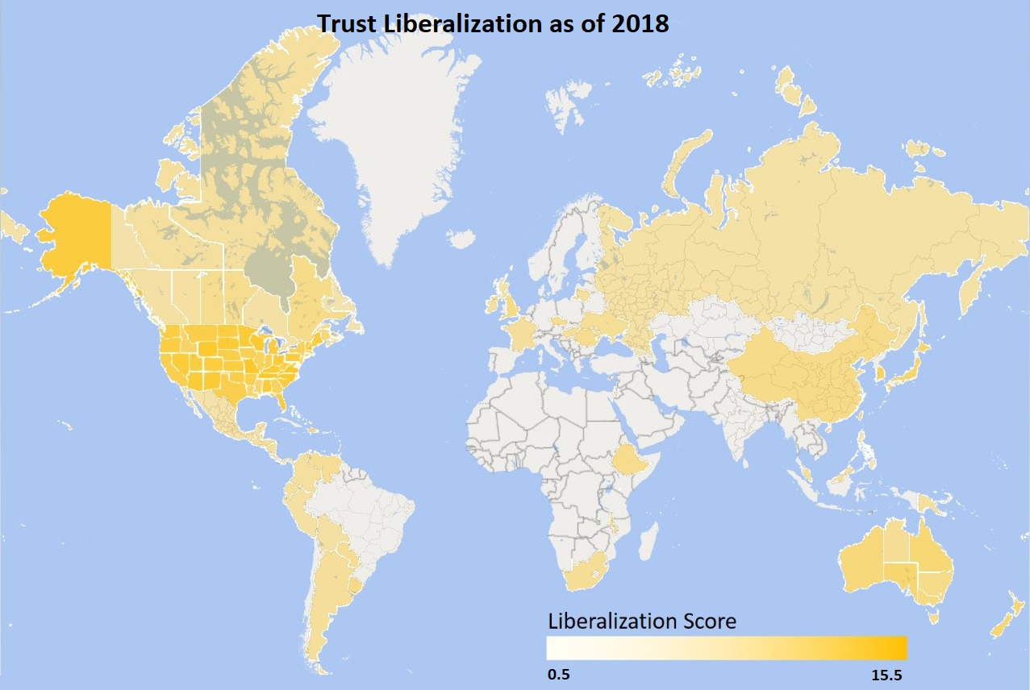

Outside the U.S., the expected difference between onshore and offshore is manifest. Using the cumulative trust law liberality scores for all the years in the database, Figures 2a and 2b demonstrate the clear difference in trust law liberality levels between England and Scotland, on the one hand, and three offshore Crown Dependencies surrounding the British isle. While trust liberality levels have been rising in all five jurisdictions, the pace of liberalization in England and (especially) Scotland has been slow, while that in the Isle of Man and (especially) Jersey and Guernsey reflects the frequent and dramatic law reform resulting from the dynamic contest for users characteristic of the offshore. These findings hold for the full database, which includes both legislation that changed the law and legislation which merely gave new form to pre-existing law, and is reflected in Figure 2a, as well as for the restricted database, which includes only legislation which changed the law and is reflected in Figure 2b.
The high liberality levels characteristic of the U.S. are evident even in those U.S. jurisdictions that are the most onshore in the functional sense of that term: those catering to a large resident user population. Figures 3a and 3b juxtapose the process of trust law liberalization in California and New York against that in England. Neither California nor New York having adopted the Uniform Trust Code, and despite their clear onshore character, they still experienced liberalization surges at different times between the 1960s and 1990s, leaving them with liberality levels exceeding that of England. While these findings are clearly apparent from Figure 3a, which reflects the full database, figure 3b, which reflects the restricted database, including only legislation that changed the law, renders New York trust law as having since the turn of the millennium been seemingly closer in the extent of its liberality to English law than to California law. This misleading impression results from much of the 1990s surge in the liberality of New York statutory trust law, apparent in Figure 3a, having consisted of statutes which merely gave new form to pre-existing law and are therefore absent from figure 3b.

Figure 2a. Trust Law Liberality by Year and Jurisdiction, Full Database: England and Environs

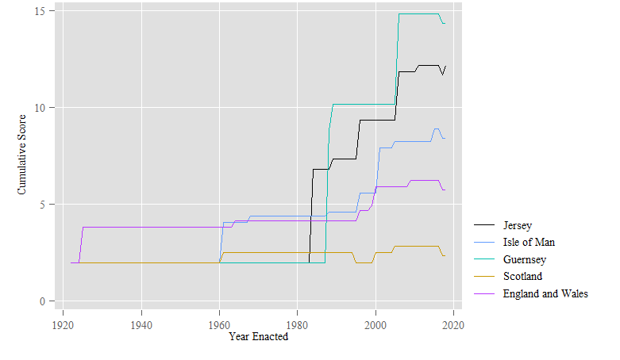

Figure 2b. Trust Law Liberality by Year and Jurisdiction, Restricted Database: England and Environs

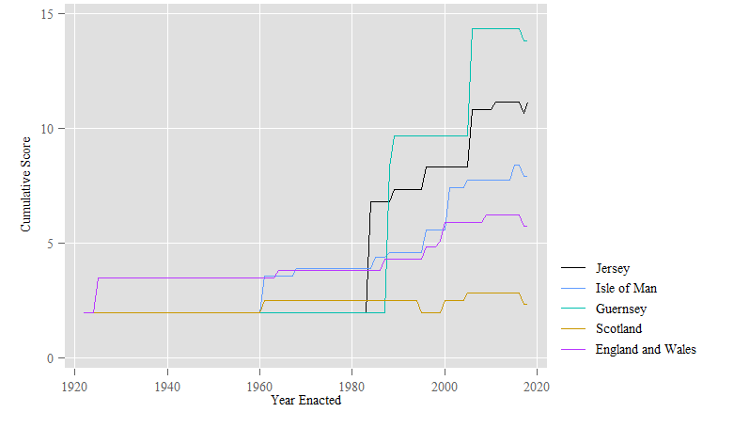

Figure 3a. Trust Law Liberality by Year and Jurisdiction, Full Database: England, New York and California

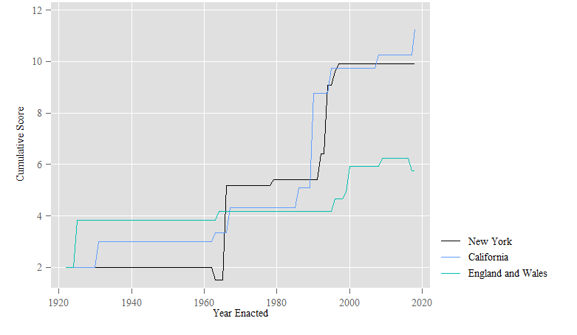

Figure 3b. Trust Law Liberality by Year and Jurisdiction, Restricted Database: England, New York and California

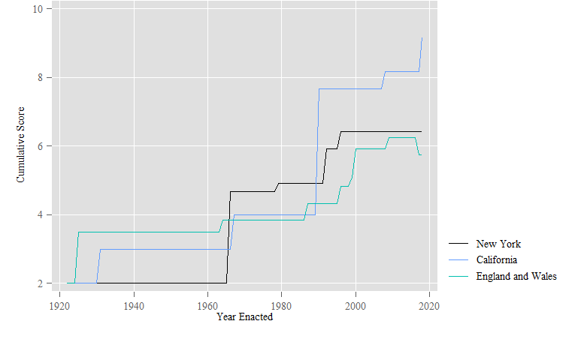

B. Global Trust Law Liberality by Year
Beyond the comparison of the extent, pace and timing of trust law liberalization in different jurisdictions, the timing of liberalization as a global process and its pace at different points in time are themselves of interest. In order to identify global trends in the speed of liberalization over time, I calculated an annual figure expressing an average of the non-cumulative liberality scores for the statutes enacted each year in all jurisdictions respecting all variables. Figures 4a and 4b describe the year-on-year differences in the resulting series of average annual scores from 1922-2018, based on the full and the restricted versions of the database respectively. The results show that while the statutory liberalization of trust law has been ongoing since 1925, the pace of the increase in trust law liberality has accelerated noticeably from 1988 to 2016. This period of accelerated liberalization resulted from the creation of liberal trust regimes in many jurisdictions competing for a piece of the offshore trust market, as well as in the many U.S. states which adopted the Uniform Trust Code after 2000. The negative year-on-year differences for 2017 and 2018 express many jurisdictions’ adoption, in these years, of the OECD’s Common Reporting Standard, which deepened reporting obligations applicable to trusts in adopting jurisdictions, resulting in low scores for variable 18.

Figure 4a. Year-on-Year Differences in Annual Average Non-Cumulative Trust Law Liberality Scores for All Jurisdictions: Full Database

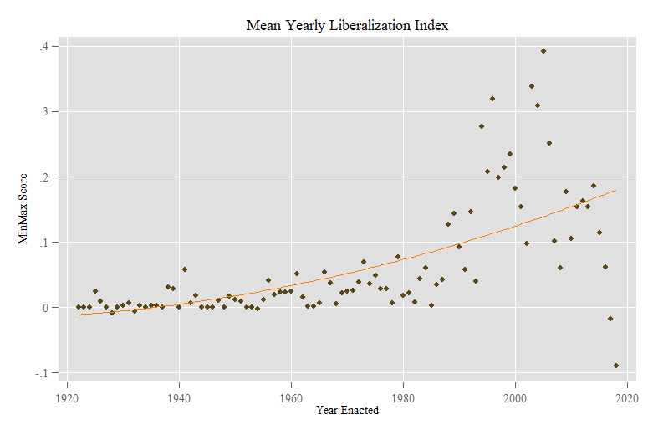
Figure 4b. Year-on-Year Differences in Annual Average Non-Cumulative Trust Law Liberality Scores for All Jurisdictions: Restricted Database

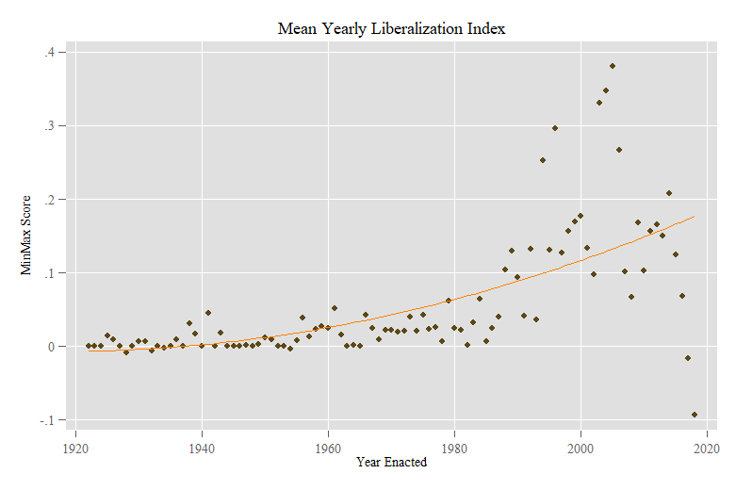
I next summed the cumulative liberality scores for all variables in all jurisdictions for each year. Figures 5a and 5b describe the course of the resulting global “cumulative liberalization index” from 1922-2018, with Figure 5a based on the full database and Figure 5b based on the version of the database that only includes legislation which changed the law. These figures permit a more accurate dating of the liberalization sprint on both sides of the year 2000: Figure 5b shows the speed of liberalization to have been at its highest during the years 1994-1996 and 2003-2006.

Figure 5a. Cumulative Trust Law Liberality Scores for All Jurisdictions: Full Database
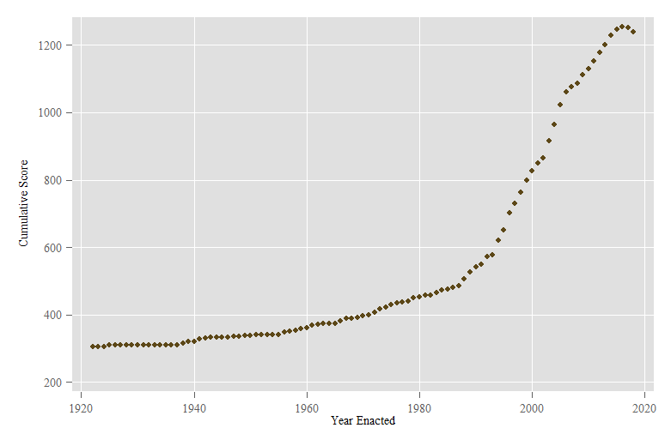
Figure 5b. Cumulative Trust Law Liberality Scores for All Jurisdictions: Restricted Database
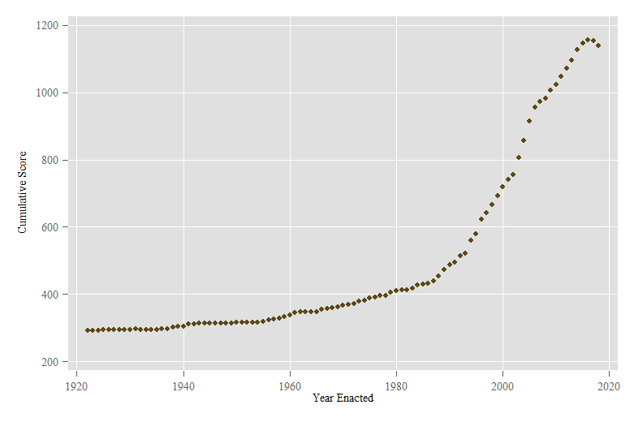

C. Trust Law Liberalization and the Market in Fiduciary Services
Given that many jurisdictions liberalized their law of trusts in order to assist resident professionals supplying services to trusts in obtaining and retaining clients, I conducted multivariate regression analysis to find out whether and how the permissiveness or liberalization of a trust regime is associated with economic trends in the market for trust-related services provided in the jurisdiction which enacted it. While use of trust-related services provided in a given jurisdiction does not necessarily imply that the law of that jurisdiction governs the trust in the context of which services were provided, what jurisdictions are seeking to encourage by liberalizing their trusts law is use of resident professionals, not use of their law.
I used three variables, based on data U.S.-resident trustees reported to the I.R.S. in 1997 and from 2000-2013, to assess the state of the market in trust-related services in each state: (1) fiduciary fees deducted from trust income in each state/year, divided by the number of income tax returns filed for trusts in that state/year (hereinafter: fiduciary fees deducted per return); (2) attorney, accountant and return preparer fees deducted from trust income in each state/year; (3) total reported trust income (less loss) for each state/year. All data covers, in U.S. tax parlance, both simple trusts, which must distribute all income to beneficiaries in the year it is accrued and may not distribute corpus or make charitable contributions, and complex trusts, defined as trusts which do not qualify as simple. I used U.S. data since as I have shown in Part IV.A, the liberalization of trust law has progressed further in the U.S. than elsewhere.
Regressing the above-mentioned data respecting fiduciary fees deducted per return on the trust liberality scores for each state/year, using the full database, including observations which reflect a pre-existing state of the law, and clustering standard errors at the state level, produced a marginally statistically significant result (p=0.087): for each increase of 1 in the cumulative trust liberality score for a given state and year, fiduciary fees deducted per return increased by $61. This result lost its statistical significance, however, when I substituted the restricted database, which only includes observations that changed the law, for the full version. The relationship between trust liberality, calculated from the full database, and fiduciary fees deducted per return also lost such statistical significance as it had when I introduced additional predictors into the model, showing its former significance to have been an effect of missing variable bias.
I introduced those additional predictors by modelling fiduciary fees deducted per return_{jt}, where j indexes state and t indexes year, as a function of the trust liberality score for the same state and year, the federal consumer price index (CPI) for that year (controlling for inflation), that state’s GDP for that year (controlling for economic growth), that state’s population for that year, the savings rate for that state and year, the tax rate applicable to fiduciary income in that state and year, and dummy variables for state and year fixed effects. I computed the savings rate by subtracting the quotient of aggregate personal consumption expenditures for each state/year divided by aggregate personal income for that state/year from 1. Employing an ordinary least squares (OLS) model, I assumed that

Fiduciary Fees Deducted per Return_{jt} = α + β Trust Liberality Score_{jt} + γ Federal CPI_{t} + δ GDP_{jt} + ζ Population_{jt} + η Savings Rate_{jt} + θ Fiduciary Income Tax Rate_{jt} + ι State_{j} + κ Year_{t} + Ε_{jt}
(1)

Regressions estimating the above model failed to identify a statistically significant relationship between the trust liberality scores and fiduciary fees deducted per return. Simpler models, omitting fiduciary income tax rates and the two sets of fixed effects from model 1, also failed to identify a statistically significant relationship between the predictor of interest – trust liberality – and fiduciary fees deducted per return. Replacing the dependent variable in model 1 with attorney, accountant and return preparer fees deducted from trust income in each state/year produced very similar results: while a simple regression of this variable on trust liberality, as estimated from the full database, resulted in an initial finding of a significant relationship, the relationship lost its significance once either trust liberality scores based on the restricted database were substituted for scores based on the full database, or additional predictors were added to the model, whether the full set of predictors in model 1 or parts thereof. Similarly non-significant results were obtained using total reported trust income (less loss) for each state/year as the dependent variable, as well as when I replaced the absolute values of each of the three dependent variables with year-on-year differences, and the absolute values of trust liberality scores with two-year differences (the difference between the liberality score for state j in year t and the score for the same state in year t-2). I used a larger lag on the predictor side to express the time some legal changes take to influence practice.
One possible reason for no statistically significant relationships between any of the three dependent variables and trust law liberality scores having survived the introduction of additional predictors into the model is the normative heterogeneity characteristic of the 22 doctrinal variables covered by the database. While all 22 variables were foci of recent law reform, they tend in different substantive directions. Doctrinal variables 3, 4, 5, 7, 9, 10, 11, 12 and 13 cover law reform efforts that tend to ameliorate liabilities which were earlier imposed on trustees, while variables 1, 2, 15, 16 and 20 cover law reform efforts which protect and empower trustees’ clients: variables 1 and 2 cover reforms empowering trust settlors to control or influence trusts after their creation, which they could not do under traditional law, variable 15 covers reforms extending beneficiaries’ immunity from their creditors, variable 16 covers reforms providing settlors and beneficiaries with tax advantages by way of increasing the maximal permitted duration of trusts, and variable 20 covers reforms protecting all the parties to a trust from claimants. Variables 18 and 19 tend to expose trust information to authorities and the public and restrict the creation and enforcement of secret trusts. Given the normative heterogeneity of the 22 doctrinal variables encompassed by the trust law liberality scores used to this point, law reform respecting different variables may have influenced fiduciary fees deducted per return, attorney, accountant and return preparer fees deducted from trust income, and trust income (less loss) in different directions, resulting in the composite liberality score having no clear relationship with these dependent variables.
Once I estimated model 1, as well as models which exclude some of the predictors in model 1, using liberality scores recalculated to only reflect those doctrinal variables which cover law reform tending to protect trustees from liabilities to which they were earlier subject, a marginally statistically significant relationship appeared between the differenced versions of the liberality score variable and fiduciary fees deducted per return. Estimating model 1 using the differenced versions of these two variables, I found that for each increase of 1 in the cumulative trust liberality score for state j over the two-year period ending in year t, fiduciary fees deducted per return for state j and year t declined by 3.655% compared to the previous year (p=0.078). The year-on-year decline increased to 3.825% when liberality scores were calculated from the restricted database, which only includes observations that changed the law, still taking only trustee-protective variables into account (p=0.059). Estimating model 1 using the differenced, year-on-year version of total reported trust income (less loss) as dependent variable, I found that for each increase of 1 in the cumulative trust liberality score for state j over the two-year period ending in year t, still calculated to only reflect law reforms protecting trustees, total reported trust income (less loss) grew by 6% compared to the previous year (significance was marginal at p=0.102). These results are reported in Table 2, in columns 1, 2 and 3 respectively.

Table 2. Empirical Models of Year-on-Year Changes in Fiduciary Fees Deducted per Return (Columns 1, 2) and Total Reported Trust Income (less Loss) (Column 3)
 | (1) | (2) | (3)
Difference in Trust Liberality Score between Year t - 2 and Year t | -.036*  (.019) | -.038*  (.019) | .06  (.035)
GDP | <0.001  (<0.001) | <0.001  (<0.001) | <0.001  (<0.001)
CPI | .008***  (.002) | .008***  (.002) | .008**  (.003)
Population | <0.001  (<0.001) | <0.001  (<0.001) | <0.001  (<0.001)
Savings Rate | -.447  (.457) | -.442  (.467) | -.232  (1.124)
Tax Rate imposed on Fiduciary Income | 2.978  (2.478) | 3.057  (2.461) | -3.095  (2.17)
State Fixed Effects | Yes | Yes | Yes
Year Fixed Effects | Yes | Yes | Yes
Intercept | -.586**  (.227) | -.594**  (.232) | -.722  (.480)
Observations | 286 | 286 | 286
R Squared | 0.168 | 0.17 | 0.428
Note. Cell entries are ordinary least squares regression coefficients, with standard errors, clustered at the state level, in parentheses.
*** p ≤ 0.01, ** p ≤ 0.05, * p ≤ 0.1

I further attempted to investigate the relationship of trust law liberality to the market in trust services by using two more sets of dependent variables. One set reflects trust practice outside the U.S: I used data submitted to the I.R.S. respecting “foreign” trusts with a U.S. owner, which is available on a country-by-country basis for selected tax years. The dependent variables used were number of returns filed, total trust income, trustee and advisor fees deducted, total assets and total net worth, as reported for each jurisdiction/year. Once additional predictors were introduced into the model, no statistically significant relationships were found between trust law liberality and any of these dependent variables. The final set of dependent variables I used included Census Bureau data on the amount of establishments, the amount of employees and annual payroll in the “trust fiduciary and custody” sector of each U.S. state, annually from 2002-2015. I used Census Bureau data on North American Industry Classification System (“NAICS”) code 523991, which the NAICS Association defines as “compris[ing] establishments primarily engaged in providing trust, fiduciary, and custody services to others, as instructed, on a fee or contract basis, such as bank trust offices and escrow agencies (except real estate.)” Once GDP, population, the savings rate, the tax rate applicable to fiduciary income, state and year fixed effects were taken into account in regressing these dependent variables on the liberalization scores, no significant relationships were found.
These results lend themselves to two different interpretations. On one view, given that even the relationships identified in Table 2 above are only marginally statistically significant, and that they are the only relationships that emerged despite my having fit a large number of models, my limited findings fail to disprove the null hypothesis – that the trust law reforms I examined had no effect on, and were not correlated with, trustee income per trust, attorney, accountant and return preparer income from trust-related services, total trust income (less loss), the amount of establishments in the “trust fiduciary and custody” sector, the amount of employees in that sector and annual payroll in that sector. That is a significant finding, given that many instances of liberalizing legislation in the trusts field were motivated by professionals’ arguments that such legislation is necessary to bolster the fortunes of the trusts services sector in the relevant state, or prevent them from declining. My null result casts a pall on the validity of those arguments, which were the principal supports for legislative innovations often seen as normatively undesirable.
Alternatively, the relationships identified in Table 2 above can be taken seriously despite their marginal statistical significance. It appears unsurprising that as jurisdictions change their trust law to protect trustees from erstwhile heads of liability, clients are prepared to pay less for trust services consumed, which makes economic sense given clients’ increasingly limited access to trustee liability. One should note, though, that some legal changes which protect trustees from liability are sometimes welcomed by settlors, as where a settlor wants to prevent trust information from flowing to beneficiaries (doctrinal variable 11), or to prevent trustees from meddling in the management of a family business settled on trust (doctrinal variable 12). From trustees’ perspective, the loss in fees earned per return may be counterbalanced, or more, by the reduction in liability risk they enjoy. Further, trust law changes protecting trustees from erstwhile heads of liability are also associated with increases in trust income per state and year. Increased income may result from an increased supply of trust services given law which provides trustees with increased protection. It may also result from trustees taking more risks in trust management, emboldened by the increased protection they enjoy.
Finally, regressing trustee income per trust, attorney, accountant and return preparer income from trust-related services and total trust income (less loss) on liberality scores calculated to reflect only those doctrinal variables that express law reform efforts protecting and empowering trustees’ clients (settlors and beneficiaries) permitted the identification of statistically significant relationships between the dependent variables and trust law liberality so long as only state GDP, the federal CPI, state population and the state savings rate were used as additional predictors. Those relationships lost their significance once state income tax rates applicable to fiduciary income, state fixed effects and year fixed effects were added to the model. It therefore appears that if law reform efforts intended to attract or retain clients by offering what are seen as legal features clients want, such as self-settled spendthrift trusts and perpetual trusts, are having any positive effect on fiduciary fees deducted per return, aggregate attorney, accountant and return preparer fees deducted from trust income, total trust income (less loss), the amount of establishments in the “trust fiduciary and custody” sector, the amount of employees in that sector or annual payroll in that sector, this effect is not caught by the analysis above.

V. Discussion
The analysis in Part IV.3 draws what may be a counterintuitive picture of the results of the statutory liberalization of trust law in the U.S., the world leader in such liberalization. On one reading of the results, far-reaching changes made to U.S. states’ law of trusts in order to bolster the fortunes of enacting states’ trust, legal and financial industries are found to have had no impact on several indicia of those fortunes. Given this finding, one wonders whether trust law liberalization by statute in fact benefitted enacting states’ trust, legal and financial industries. If trust law liberalization by statute did not benefit those industries, it appears to be a policy failure, since the commercial potential of trust liberalization for those industries has long been touted as its primary advantage. It could of course be that the purported commercial benefits of trust law liberalization were a red herring, and that the advocates of reforms such as the regulation of trust decanting and trust protectors wanted the substance of these reforms to take place regardless of any resulting commercial benefit. It could also be that such reforms benefitted the practitioners who advocated them, though not the relevant sectors as a whole. It could even be that reform advocates believed, pre-reform, that the reforms they promoted would benefit either themselves or the trust, legal and financial services sectors as a whole, only to be proven wrong once the reforms were enacted.
On an alternative reading of the findings in Part IV.3, which takes the relationships identified in Table 2 seriously despite their limited statistical significance, law reforms designed to benefit those providing trust services, if necessary at the expense of the trust fund, such as reforms allowing the exclusion of trustees’ duties of prudence and loyalty and/or their liability for harm caused by infringing those duties, reforms restricting trustees’ personal exposure to debts arising from their activities as such and reforms entrenching every trustee’s right to be remunerated, are found to permit trustees to produce more trust income while charging the trust fund less for their services. This result is not merely an artefact of good economic times: it is based on I.R.S.-collected data reflecting a period of time (2000-2013) which included two serious economic downturns, those of 2000 and 2008. Further, economic growth was controlled for by incorporating state GDP as a predictor. It therefore appears, on this reading of my findings, that some seemingly pro-trustee reforms to trust law actually benefit clients, a result which invites an intervention in the normative trust law literature. Many commentators condemned reforms such as turning trustees’ key duties and liabilities into mere default rules, arguing that they wrongly prefer professionals’ interests to those of their clients. It may of course be that these pro-trustee reforms do in fact harbor potential harm for trust funds and the beneficiaries entitled to them, despite this harm not having materialized to 2013. It may also be that despite the production of more trust income at lower cost, the reforms have in fact already harmed trust funds and beneficiaries by 2013, in ways not captured by the analysis in Part IV.3.
What is especially clear from the analysis in Part IV.3 is that law reform specifically designed to provide what some clients want, or are believed to want, and thereby assist service providers to trusts – trustees, attorneys, accountants and others – in attracting and retaining clients, such as reforms allowing self-settled spendthrift trusts and abolishing the rule against perpetuities, does nothing to increase the fees fiduciaries earn per trust, the fees attorneys, accountants and return preparers earn by providing trust-related services, total trust income (less loss), the amount of establishments in the “trust fiduciary and custody” sector, the amount of employees in that sector or annual payroll in that sector. Given that self-settled spendthrift trusts leave settlor-beneficiaries’ creditors, including spouses, tort victims and governments, empty handed and perpetual trusts leave the public fisc wanting, if even the professionals who lobbied for them are not enriched by them, it is unclear what merits, if any, they have.
One caveat is in order. While it may in principle be that the increase I identified in total trust income (less loss) for each increment of trust law liberalization protecting trustees resulted not from reform of the doctrinal variables I examined, but from changes in trustees’ investment practices, research by Rob Sitkoff and Max Schanzenbach makes this possibility unlikely. While Sitkoff and Schanzenbach found that trustees of FDIC-reporting “personal trusts” (including both private and charitable trusts) who had investment management discretion over their trusts substantially increased the proportion of funds under management invested in stock, at the expense of “safe[r] assets”, from 1990 to 1999, their data shows no further such increase, and some backtracking to “safe[r] assets”, in the years after 2000, and it is these later years that are covered by the I.R.S. data I used. It could of course be that trustees and others responsible for the investment of trust assets increased trust income earned after 2000 in some other way than increasing the proportion of assets under management invested in stock at the expense of safer assets, the increase having nothing to do with reform of the doctrinal variables I examined.
Finally, my results may appear surprising given Sitkoff and Schanzenbach’s 2005 finding that a U.S. state’s abolition of the rule against perpetuities (to 2003) significantly increased the trust assets managed by fiduciary institutions resident in that state, so long as the state did not impose an income tax on trust funds attracted from out of state. To approximate their study using my data, I regressed fiduciary fees deducted per return, aggregate attorney, accountant and return preparer fees deducted from trust income and total trust income (less loss) on my data for variable 16 (maximum permitted trust duration) for each state and year, replacing my multivariate liberality scores with scores for this single variable. Once the additional predictors in model 1 were included, no statistically significant relationships were found. My findings and theirs could both be true, given that the analysis in Part IV.3 covers a later period than that covered by Sitkoff and Schanzenbach, and trends could have changed. It is also possible that trust assets under management per state could increase without fiduciary fees deducted per return, aggregate attorney, accountant and return preparer fees deducted from trust income or total trust income (less loss) increasing; though if an increase in assets under management did not produce increased fees for professionals, one wonders whether the intense legislative activity documented in this article was worth it.

VI. Conclusion
This article reported the findings of the first systematic overview of the statutory liberalization of trust law worldwide. Results show the United States to be the global leader in trust law liberality: seventeen of the twenty jurisdictions which have the most liberal trust laws are American states. When jurisdictions are ranked according to the extent to which each liberalized its trust law by legislation, U.S. states still make fifteen of the top twenty. Trust law liberalization in the U.S. is a result of the widespread adoption among the states of the Uniform Trust Code, which includes many highly liberal positions, as well as of many states having followed an offshore dynamic in adopting highly permissive positions in order to draw users from out of state to resident service providers. The trust laws of many American states are more liberal than those of most offshore island jurisdictions. Even the laws of such relatively conservative American states, on trust matters, as New York and California are quite liberal by global standards. Much of the recent global increase in trust law liberality occurred from 1988-2016.
Multivariate regression analysis of U.S. data shows that the statutory liberalization of trust law had no effect on trustee income per trust, attorney, accountant and return preparer income from trust-related services, total trust income (less loss), the amount of establishments in the “trust fiduciary and custody” sector, the amount of employees in that sector or annual payroll in that sector. It is especially clear that reforms seen as pandering to trust users’ interests at great social cost, such as self-settled spendthrift trusts and perpetual trusts, all in order to create or sustain demand for professional services in the trust context, have had no impact on any of these indicia for the success of service provision to trusts as a commercial enterprise.
As an exception to the general finding of a null result, some findings with marginal statistical significance show that law reforms which reduced trustees’ exposure to liability and entrenched their entitlement to remuneration led to a decline in their earnings per trust. Those reforms are also weakly associated with an increase in trust income. It is therefore possible that reforms widely seen as preferring trustees over their clients have resulted in trustees providing a better service at lower cost.

∗ Montesquieu Chair in Comparative Law, Faculty of Law, Hebrew University of Jerusalem, adam.hofri@mail.huji.ac.il. I would like to thank my RAs in Israel (Hila Ben-Shabat, Gadi Weiss, Or Simantov, Ori Katz, Hadas Artzi, Daniel Ben-Amram, Asaf Swisa, Idan Ben-David, Guy Manor, Yazid Ersheid, Yuval Rabello) and elsewhere (Jingyi Huang, Annie Wood, Ryoga Konno, Eric Vice, Alvin Cheng, Eleanor Makeig, Timothy Cargill, Ellen McClure, Adele Browne); participants in my survey of trust experts; audiences at IDC Herzliya, the Singapore Management University Trusts and Wealth Management Conference 2019, the 2019 annual meeting of the Canadian Law and Economics Association, and the 2019 ACTEC symposium on empirical analysis of wealth transfer law, held at the U.C. Davis School of Law; Keith Dixon of Carey Olsen, Nicholas Malumian of Estudio Malumian, Maurizio Lupoi, István Sándor, Paolo Panico, the many providers of sage advice (including, int. al., Adi Leibovich, Yishay Yaffe, Moinuddin Yahya and Chris Elmendorf), and the U.C. Davis Law Review editorial team. This research was supported by the Israel Science Foundation (grant no. 367/15).
John H. Langbein, Why Did Trust Law Become Statute Law in the United States?, 58 Ala. L. Rev. 1069, 1073-1074 )2006-2007( (discussing trustees’ lack of powers, and burdens imposed on persons transacting with trustees, under traditional trust law); Jonathan Garton, Moffat’s Trusts Law 49 (6th ed. 2016) (“The first general [English, A.H.W.] statute on trusts was the Trustee Act 1850”).
For trust law’s increasing permissiveness, see Adam Hofri-Winogradow, The Stripping of the Trust: a Study in Legal Evolution, 65 U. Toronto L. J. 1 (2015); Lionel Smith, Give the People What They Want? The Onshoring of the Offshore, 103 Iowa L. Rev. 2155 (2018). For its increasingly statutory character, see Langbein, supra note 1.
For liberalization of English trust law in the 19th century, see, e.g., Garton, supra note 1, at 49; for the recent acceleration of trust liberalization and its spreading to additional jurisdictions, see, e.g., Smith, supra note 2.
See infra p. 14.
See discussion of these processes infra pp. 14-15.
See infra Table 1.
See infra Table 1 and pp. 19-20.
See infra Figures 4a, 4b, 5a and 5b. For the history of Uniform Trust Code adoptions across the U.S., starting with Kansas in 2002, see http://tinyurl.com/y6dke5nw (last visited Nov. 12, 2019, 7:59 PM).
Robert H. Sitkoff & Max M. Schanzenbach, Jurisdictional Competition for Trust Funds: An Empirical Analysis of Perpetuities and Taxes, 115 Yale L.J. 356 (2005) [hereinafter Jurisdictional Competition].
See infra Part IV.C.
See infra p. 32.
Trustee Act, 1925, 15 & 16 Geo. 5, c. 19.
For transplanted versions of the Act see, e.g.: Trustee Act (Northern Ireland) 1968, 15 & 16 Geo. 5, c. 23; Trustee Act 1925 (NSW) (Austl.); Trustee Law 1955, c. 193 (Cyprus); Trustee Act 1949 (Malaysia); Trustee Act 1967 (Malawi).
Shintakuhō [Trust Act], Act No. 512 of 1922 (Japan).
See, e.g., the judicial development of the English law governing the remedies available following mistakes and inadequate decision making on the part of trustees, discussed in Pitt v Holt [2011] EWCA Civ 197, [2012] Ch 132 (Eng.); [2013] UKSC 26, [2013] 2 AC 108 (U.K.). And see discussion in Adam S. Hofri-Winogradow and Gadi Weiss, Trust Parties’ Uniquely Easy Access to Rescission: Analysis, Critique and Reform, 82 Modern L. Rev. 777 (2019).
See, e.g., the Trusts (Jersey) Law, first enacted in 1984, during the takeoff of the local trusts industry, and amended seven times since. The statutory text is, unsurprisingly, easily available at https://www.jerseylaw.je/laws/revised/Pages/13.875.aspx (last visited Jan. 8, 2020, 6:57 PM).
See, e.g., Shintakuhō [Trust Act], Act No. 108 of December 15, 2006 (Japan); 2013. Évi V. törvény A Polgári Törvénykönyvrõ (Act V of 2013 on the Civil Code) ss. 310-330 (Hung.); Ley Numero 17 (de 20 de Febrero de 1941) sobre fideicomiso [Law no. 17 (of February 20, 1941) on Trusts], Gaceta Oficial, n. 8465, 6 de Marzo de 1941 (Panama); Código Civil y Comercial de la Nacion [National Civil and Commercial Code] arts. 1666-1707, Oct. 7, 2014 (Arg.).
See discussion infra pp. 14-15.
See, e.g., Donovan Waters et al, Waters’ Law of Trusts in Canada (4th ed. 2012); Denis Ong, Trusts Law in Australia (5th ed. 2018).
Harold J. Spaeth et al, Supreme Court Database (Sept. 13, 2019), http://supremecourtdatabase.org; Keren Weinshall et al, The Israeli Supreme Court Database, http://iscdbstaging.wustl.edu/home (last visited Nov. 12, 2019, 5:10 PM).
Spaeth et al, Online Code Book: Decision Direction, Supreme Court Database, http://supremecourtdatabase.org/documentation.php?var=decisionDirection (last visited Jan. 8, 2020, 5:27 PM).
See discussion in Hofri-Winogradow, supra note 2.
See, e.g., Rule Against Perpetuities (Abolition) Act, no. 55 of 2011, s. 3 (Bahamas).
See, e.g., Tenn. Code Ann. § 35-15-1010 (2010) (“a trustee is not personally liable on a contract properly entered into in the trustee's fiduciary capacity in the course of administering the trust if the trustee in the contract disclosed the fiduciary capacity”).
See, e.g., Nev. Rev. Stat. Ann. § 163.5505.2 (2017) (“A trust authorized by this section may be enforced by a … person appointed under the terms of the trust”).
See Spaeth et al, supra note 21.
Clifford J. Carrubba et al, An Introduction to the CompLaw Database (Sept. 25, 2012) (unpublished manuscript) http://perma.cc/MMA6-UBVR (last visited Nov. 12, 2019, 5:27 PM).
For comparative studies of trust law using traditional research methods see, e.g.: Pierre Lepaulle, Traité Théorique et Pratique du Trust en Droit Interne, Droit Fiscal, et en Droit International Privé (1932); David Hayton, Modern International Developments in Trust Law (1999); David Hayton et al, Principles of European Trust Law (1999); Maurizio Lupoi, Trusts: a Comparative Study (Simon Dix trans., 2000); J.M. Milo & Joan M. Smits, Trusts in Mixed Legal Systems (2001); Michele Graziadei et al., Commercial Trusts in European Private Law (2005); S.C.J.J. Kortmann et al., Towards An EU Directive On Protected Funds (2009); Nicolas Malumian, Trusts in Latin America (2009); Lionel Smith, Re-Imagining The Trust: Trusts In Civil Law (2012); Lusina Ho & Rebecca Lee, Trust Law in Asian Civil Law Jurisdictions (2013); Lionel Smith, The Worlds Of The Trust (2013); István Sándor, Fiduciary Property Management and the Trust (2015); Paolo Panico, International Trust Laws (2d ed. 2017); Vera Bolgár, Why No Trusts in the Civil Law?, 2 Am. J. Comp. L. 204 (1953); Hofri-Winogradow, supra note 2.
See, e.g., David Brownbill, The Role of Offshore Jurisdictions in the Development of the International Trust, 32 Vanderbilt J. of Transnational L. 953 (1999); Daniel Clarry, Fiduciary Ownership and Trusts in a Comparative Perspective, 63 Int’l and Comp. L. Q. 901 (2014).
Sitkoff & Schanzenbach, Jurisdictional Competition, supra note 9.
Id.
Robert Sitkoff & Max Schanzenbach, Did Reform of Prudent Trust Investment Laws Change Trust Portfolio Allocation?, 50 J. L. & Econ 681, 682 (2007).
Robert Sitkoff & Max Schanzenbach, The Prudent Investor Rule and Market Risk: an Empirical Analysis, 14 J. Empirical L. Stud. 129, 131 (2017) [hereinafter The Prudent Investor Rule].
Robert Sitkoff, The Rise of Trust Decanting in the United States, 23 Trusts & Trustees 976 (2017).
Respecting the good-faith purchase doctrine, Chang obtained data on 214 jurisdictions: Yun-chien Chang, 247 Jurisdictions in the World Get the Good-faith Purchase Problem Wrong: a New Economic Framework (NYU Law and Economics Research Paper No. 19-25), https://papers.ssrn.com/sol3/papers.cfm?abstract_id=3208458.
Yun-chien Chang, Wealth Transfer Laws in 153 Jurisdictions: An Empirical Comparative Law Approach, 102 Iowa L. Rev. 1915 (2018); Yun-chien Chang & Henry Smith, Convergence and Divergence in Systems of Property Law: Theoretical and Empirical Analyses, 92 S. Cal. L. Rev. 785 (2019); Yun-chien Chang et al., Drawing the Legal Family Tree: An Empirical Comparative Study of 108 Property Doctrines in 154 Jurisdictions (Oct. 2, 2019) (unpublished manuscript) (on file with author).
Countries without a law of trusts include, e.g., Germany and the Netherlands. Many non-trust jurisdictions have legal forms, such as the German treuhand and the Dutch bewind, that fulfill roles trusts fulfill in other jurisdictions. See, e.g., Hein Kötz, Trust und Treuhand: eine rechtsvergleichende Darstellung des anglo-amerikanischen trust und funktionsverwandter Institute des deutschen Rechts (1963); Donovan W. M. Waters, The Trust in Civil Law Jurisdictions -- The Dutch Experience, 7 J. of Int’l Trust and Corporate Planning 131 (1999).
Chang et al., Drawing the Legal Family Tree, text after footnote 9.
Chang & Smith, supra note 36, at 796.
Maurizio Lupoi, Trust Laws of the World (1996).
Where a jurisdiction has not enacted any statute respecting a variable, this absence was also treated as a 0 for computational purposes, except regarding variables 18 and 19, the law governing which has, as explained below, evolved in a restrictive, rather than in a liberal direction. For this reason, the absence of any legislation respecting variables 18 and 19 was coded as equal to the most liberal state of the law available internationally. As a result, absence of legislation respecting variables 18 and 19 was coded with the largest numeral code given to any legislation enacted on topic. Following normalization using the min-max method, absence of legislation regarding these two variables was coded as 1.
Adam S. Hofri-Winogradow, The Statutory Liberalization of Trust Law: Distribution in Time and Space https://osf.io/yf5p6/ (last visited Jan. 9, 2020, 4:15 PM).
For work following this practice see, e.g., Timothy Besley & Robin Burgess, Can Labor Regulation Hinder Economic Performance? Evidence from India, 119 Quarterly J. of Econ. 91 (2004); see their footnote 7 for their coding procedure.
See OECD, Handbook on Constructing Composite Indicators: Methodology and User Guide 28 (2008) for a description of this method.
For the disparate effects of regulatory reforms, whether statutorily expressed or otherwise, see, e.g., Julien Grenet, Is Extending Compulsory Schooling Alone Enough to Raise Earnings? Evidence from French and British Compulsory Schooling Laws, 115 Scandinavian J. of Econ. 176 (2013).
For work using a survey to estimate the weight of different aspects of a phenomenon in order to construct a composite index, see, e.g., Daniel J. Benjamin et al, Beyond Happiness and Satisfaction: Toward Well-Being Indices Based on Stated Preference, 104 Am. Econ. Rev. 2698 (2014).
A graph depicting Cronbach’s alpha for each year of observations is available as part of the online supplement to this article.
See, e.g., Jersey, Trusts (Jersey) Law, s. 9A; Guernsey, Trusts (Guernsey) Law, s. 15.
See, e.g., West Virginia Code Ann., c. 44d, s. 6-602.
See, e.g., Florida Stat. Ann., Tit. XLII, c. 736, s. 0807.
See, e.g. Ontario, Trustee Act, R.S.O. 1990, C. T.23, s. 61.
See., e.g., Oregon, R.S.A., s. 130.635.
Unif. Trust Code, Prefatory Note, at p. 1 (stating that the “Uniform Trust Code is the first comprehensive Uniform Act on the subject of trusts”).
See a current adoption count at http://tinyurl.com/y6dke5nw (last visited Jan. 9, 2020, 4:15 PM).
See supra text accompanying notes 48-52.
See, e.g., discussion of this process in New Hampshire in the source quoted in infra note 63.
For the highly liberal trust law of which see Christopher Paul, Innovation or a Race to the Bottom? Trust "Modernization" in New Hampshire, 7 Pierce L. Rev. 353 (2009).
For the highly liberal trust law of which see Brandon Crooks, Tennessee Emerges as a New and Important Trust State, The Wealth Advisor, https://www.thewealthadvisor.com/sponsored-article/tennessee-emerges-new-and-important-trust-state (last visited Jan. 8, 2020, 11:40 PM).
See U.S. Income Tax Return for Estates and Trusts, https://www.irs.gov/pub/irs-pdf/f1041.pdf (last visited Jan. 8, 2020, 11:36 PM).
OECD, Standard for Automatic Exchange of Financial Information in Tax Matters: Implementation Handbook 104-124 (2nd ed. 2018).
https://osf.io/yf5p6/ (last visited Jan. 9, 2020, 4:15 PM).
The relevant variables are 1, 2, 15, 16, 20 and 22. The recalculated ranking is available in the online supplement to this article, in Table 1b.
See, e.g., for Hew Hampshire, shown in Table 1 supra to co-lead the world in trust law liberalization, Michael Kitch, NH Trust Laws Undergo yet Another Alteration: is Competition among States a ‘Race to the Bottom’?, NH Business Review (Aug. 3, 2017), https://www.nhbr.com/nh-trust-laws-undergo-yet-another-alteration/ (describing a 2017 bill as “the latest of nearly a dozen refinements to the trust laws undertaken since the Uniform Trust Code was adopted in 2004 and the Trust Modernization and Competitiveness Act was enacted in 2006 with the express purpose of fostering “the best and most attractive legal environment in the nation for trusts and trust services,” which in turn promised significant increases in professional employment”, and later quoting a report by state Rep. Kermit Williams, who wrote that “each [statute amending New Hampshire trusts legislation] was touted as the ultimate solution to make our trust industry succeed and boost the state’s economy”, as well as a statement by Rep. Williams according to which “[n]o other part of our laws have been chewed and churned so much … It seems that these trust lawyers are forever looking for some magic formula that will make them a boatload of money.”).
Data for 2011-2013 was taken from the I.R.S. Statistics of Income Tax Stats, Fiduciary Income and Deductions by State and Entity Type, available at https://www.irs.gov/statistics/soi-tax-stats-fiduciary-income-and-deductions-by-state-and-entity-type (last visited Nov. 12, 2019, 7:59 PM). Data for 1997 and 2000-2010 was provided by Rob Sitkoff and Max Schanzenbach. The data includes some omissions and errors: data for D.C. only starts in 2011, 2007 data for Wyoming appears identical to that for 2006, and attorney, accountant and return preparer fees deducted for Louisiana in 2011 appear identical to the 2010 figure.
The coefficient on my liberality score variable was .0615, with a robust standard error of .0351 (clustered at the state level) and p=0.087. This coefficient translates into an increase of $61, given that the numerator in the fiduciary fees deducted per return ratio, the amount of fiduciary fees deducted according to fiduciary returns filed for a state/year, is expressed in thousands of dollars in the I.R.S. data.
The coefficient on the liberality score variable was here .046, with a robust standard error of .035 (clustered at the state level) and p=0.195.
I used Census Bureau population figures and data from the Bureau of Economic Analysis: Gross domestic product (GDP) by state: All industry total (https://apps.bea.gov/iTable/iTable.cfm?acrdn=1&isuri=1&reqid=70&step=1#acrdn=1&isuri=1&reqid=70&step=1), aggregate disposable personal income for each state (https://apps.bea.gov/iTable/iTable.cfm?reqid=99&step=1#reqid=99&step=1) and aggregate personal consumption expenditures for each state (https://apps.bea.gov/itable/iTable.cfm?ReqID=70&step=1) (all three webpages last visited Nov. 12, 2019, 7:59 PM). I extracted data on each state’s tax rate applicable to fiduciary income, for each year since 1991, from Westlaw. Given the complexity of many states’ tax rate structures, I used data from the 22 states that either imposed, during all the relevant years, no tax, imposed a flat tax, or imposed the rate I used on incomes above a threshold of $10,000 or less: Alaska, Colorado, Connecticut, Florida, Illinois, Indiana, Iowa, Massachusetts, Michigan, Nevada, New Hampshire, Pennsylvania, South Dakota, Tennessee, Texas, Washington, Wyoming, Alabama, Georgia, Mississippi, Missouri and Utah. My tax rate data are available in the online supplement to this article.
Regression results for all the analyses described to this point are available in the online supplement to this article, in a file entitled “Regression Results: IRS data on domestic trusts regressed on liberality scores (calculated from 22 variables)”.
While variable 20 covers law reforms that protect trustees along with settlors and beneficiaries, which disturbs the otherwise neat division of the 22 variables into those protecting trustees and those protecting and empowering their clients, this does not matter for the analysis in this Part IV.3, since I used U.S. data exclusively in the analyses reported to this point, and no U.S. state enacted any statute respecting variable 20.
Variables 6, 8, 14, 21 and 22 do not have a clear normative direction.
The data, reported on Form 3520-A, the annual return of foreign trust with U.S. beneficiaries, are available from the I.R.S.: https://www.irs.gov/statistics/soi-tax-stats-foreign-trusts (last visited July 21, 2019).
Regression results using these dependent variables are available in the online supplement to this article, in a folder entitled “Regression Results: IRS data on 'foreign' trusts regressed on trust liberality scores”.
https://www.naics.com/naics-code-description/?code=523991, last visited Nov. 13, 2019.
For some such arguments see supra note 63.
See discussion of the normative objections to some liberalizing amendments in infra Part V.
See, e.g., supra text accompanying notes 74-75.
See, e.g., the source quoted in supra note 63.
See, e.g., Melanie B. Leslie, In Defense of the No Further Inquiry Rule: A Response to Professor John Langbein, 47 Wm. & Mary L. Rev. 541 (2005); Melanie B. Leslie, Trusting Trustees: Fiduciary Duties and the Limits of Default Rules, 94 Geo. L.J. 67 (2005); Melanie B. Leslie, Common Law, Common Sense: Fiduciary Standards and Trustee Identity, 27 Cardozo L. Rev. 2713 (2006); Hofri-Winogradow, supra note 2; cf John H. Langbein, Questioning the Trust Law Duty of Loyalty: Sole Interest or Best Interest?, 114 Yale L. J. 929 (2005).
For normative criticism see, e.g., Stewart E. Sterk, Asset Protection Trusts: Trust Law’s Race to the Bottom?, 85 Cornell L. Rev. 1035 (2000); Stewart E. Sterk, Jurisdictional Competition to Abolish the Rule Against Perpetuities: R.I.P. for the R.A.P., 24 Cardozo L. Rev. 2097 (2003).
See Sitkoff & Schanzenbach, The Prudent Investor Rule, supra note 33, at 145, Figure 2.
These regression results are available in the online supplement to this article, in a file entitled “Regression results – US IRS data on var 16”.

