Civic Culture vs. Apolitical Social Capital: The Case of Moscow Apartment Buildings

Leonid Polishchuk, Alexander Rubin, Igor Shagalov

Extended abstract

- Introduction

Since Alexis de Tocqueville, social capital, broadly defined as a civil society-based capacity for collective action, was considered as a pre-requisite and driver of democracy. Putnam (1993) made this conjecture explicit by explaining the variation of democratic performance across Italian provinces and localities by inter alia, associational membership. Subsequent studies questioned such correlation by revealing a multi-faceted nature of social capital (Bjornskov, 2006), and by pointing out that social capital in some of its manifestations and forms could be inimical to democracy (Acemoglu et al., 2014). Civic culture and other similar stripes of social capital, such as the capacity to challenge elites, were shown to be more essential for democratic performance than associational activities and collective action per se (Welzel, Inglehart, Deutch, 2005). Polishchuk and Menyashev (2018) use evidence from Russian cities to argue that apolitical grassroots social capital, deployed as a substitute for public services expected, but not received, from governments, adversely affects the quality of governance, whereas civic culture that enables political participation, improves government performance. Other studies indicate that the interplay and relation between apolitical collective action and political participation is highly nuanced and context-specific, and hence need more in-depth analyses. One promising avenue of research is to see how civic culture interacts with apolitical social capital in advancing or impeding various types of collective action, depending on how ‘civic’ these actions are.
In this paper, we contrast two types of collective action in the contemporary urban setting, one of which is civic and the other is not. In the first one, tenants of an apartment building collectively manage funds designated for the building upkeep, and thereby exercise their civic rights and duties within the “micro-jurisdiction” of building residents (Borisova, Polishchuk, Peresetsky, 2014). In the second, tenants build fences and gates around their building turning it into a “gated community”, and thereby opting for a collective “exit” as a response to a lack of public safety and security and other governance failures in the surrounding municipality. This reaction is patently uncivic, as it dumps significant external costs onto the rest of the city, including fragmentation and loss of public space, restriction of mobility, segregation, crime displacement, and civic disengagement and apathy over city-wide public matters (Low, 2003; Low et al., 2011; Polishchuk, Sharygina, 2016). Social capital that powers up such collective action is of the bonding type (Putnam, 1993), advancing the interests of a close-knit group at a cost for the surrounding society.
We use a unique database of nearly 30,000 apartment buildings located in Moscow, Russia, to show that generic apolitical social capital in the tenant community in the absence of civic culture facilitates both types of collective action, the civic and the uncivic ones alike. However, civic culture plays different roles, augmenting generic social capital in the first type and impeding it in the second. Put differently, apolitical social capital and civic culture are cultural traits that reinforce (complement) each other in the case of a civic collective action, and counteract each other, when a contemplated collective action is uncivic. This explains why various facets of social capital could be interchangeable (as observed by Putnam et al, 1993) in explaining civic activities which “make democracy work”, but such affinity disappears when activities of interest are uncivic.

- Background and Data

In the empirical analysis, we use evidence-based measures of grassroots apolitical social capital and civic culture. The former is assessed by the earlier displayed capacity of the residents to collectively operate their apartment building as a condominium, or to collectively finance the construction of a building, and subsequently operate it as a co-op. Collective action is inherent in both cases, and if residents opt for one of these housing management regimes, they reveal substantial social capital in their community. To assess civic culture, we use voting support for a prominent opposition figure in the 2013 elections of Moscow mayor.

  - Russian residential housing regimes
In the Soviet times, most of the apartment buildings were built by and remained property of local governments or industrial enterprises. Apartments were allocated to residents for perpetual use, and this right was converted in the early 1990s into full-blown private ownership. Housing cooperatives, which have been in existence for many decades, were exceptions from this rule: they were financed and established by the tenants, who were also responsible for the building upkeep. Residential co-ops were and remain rare both against the dominant backdrop of government-supplied housing stock under the Soviet rule and of the commercial developers-driven construction of residential housing after the transition to free market. Such apartment buildings, established and maintained by neither market nor government, are clearly distinguished from the rest of residential housing by the tenants’ capacity for collective action.
Nowadays, individual apartments in multi-unit residential buildings other than co-ops are, as a rule, privately owned. However ownership and upkeep of common property, such as building infrastructure, was not clarified until a housing reform, implemented gradually from mid-1990s to mid-2000s, which introduced condominiums and management companies. Establishing a condominium requires a collective decision of residents; if no such action has been taken, the building is run by a management company, which more often than not is a successor to a Soviet-time municipal housing operator. Some management companies are de novo private firms, but due to a lack of oversight by apartment owners (reflecting insufficient social capital) and limited competition, such companies are commonly abusing their role and prerogatives and become capture tools by extracting revenues from apartment buildings without providing adequate services in return (Borisova, Polishchuk, Peresetsky 2014).
A condominium could also outsource building operation to a management company, but such outsourcing is usually initiated by the company itself without properly expressed consent of the residents. However, sometimes apartment owners establish bona fide condominiums, being confident in their collective ability to operate the common property, prevent capture attempts, and jointly run their buildings on their own. Such condominiums without a management company provide a yet another (in addition to co-ops) indication of higher than average social capital stock among the residents.
In what follows, we combine both housing types – co-ops and condominiums – in a single group, which comprises less than 8% of Moscow apartment buildings. Data on building status is available from Moscow residential housing registry. A dummy for this group is our indicator of the grassroots social capital.

2.2 The 2013 mayoral election
Election of Moscow mayor in 2013 took place in the aftermath of massive political protests across Russia and especially in Moscow against the rigged parliamentary (2011) and presidential (2012) elections, where no truly independent opposition forces were allowed to take part, and a lack of level playing field and massive fraud were alleged. As a concession and a means to placate angry voters, the leading opposition figure Alexey Navalny was allowed to run for Moscow mayor against the incumbent and “designated winner” Sergey Sobyanin.
It was expected by the regime that massive use of the incumbent’s advantages and resources, support of the federal government, control over the media, pressure on government-dependent voters, etc., would easily marginalize Navalny and deliver Sobyanin an easy victory in a relatively clean election. Contrary to such expectations, Navalny received over 27% of the popular vote, over Sobyanin’s 51%.
2013 election results are available from the official electoral statistics at the level of voting precincts. There are about 3,000 such precincts in the city of Moscow, with approximately the same numbers of registered voters. On the average, each precinct comprises less than 10 apartment buildings located near each other. The percentage of votes cast for Navalny (of all registered voters) in a precinct is our measure of civic culture for apartment buildings in the precinct. The distribution of this measure is presented in Figure 1.

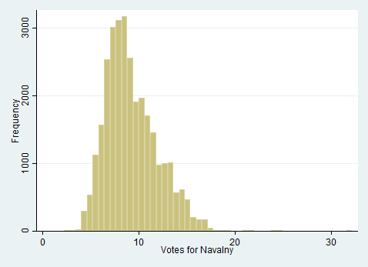

Figure 1. Distribution of votes for Navalny in 2013 Moscow mayoral election (% of registered voters)

  - Capital renovation of Russian residential housing
The Russian Housing Code requires that apartment owners make designated payments, included in the itemized utility and maintenance fee bills, towards capital renovation of their buildings. By default, such contributions are pooled in a regional (in the case of Moscow – city) capital renovation fund administered by the regional government at its discretion. Usually a lion’s share of the collected funds is spent to maintain dilapidated but still populated apartment buildings which are about to crumble. Recent media reports allege corruption, embezzlement and various irregularities in administering Moscow capital renovation fund.
The Housing Code offers an alternative to the above default option, whereby residents of apartment building set up their own bank account where their capital renovation fees are accumulated and spent solely for the respective building’s capital improvements and overhaul under the residents’ joint control. To select such option, the residents have to hold a meeting and pass by a required majority a necessary motion. This poses a collective action problem – both at a time when such decisions are to be made, and thereafter, when the collected funds are managed by residents. For most of Moscow’s apartment buildings, this collective action problem appears to be unsurmountable due to a lack of trust and confidence among building residents in their collective ability to handle capital renovations. According to the above referenced Moscow housing registry, segregated self-managed capital renovation accounts exist for less than 17% of all apartment buildings; the rest allow their contributions to be pooled (essentially sink) and used citywide.

2.4 Gating in Moscow
Surrounding apartment buildings by tall fences with gates and gate bars (usually manned by private security personnel or operated electronically) has become an increasingly popular pattern in Moscow residential housing. While in the US and some West European countries gating is usually an elite phenomenon, in Moscow it is adopted by the middle class in response to a general lack of public safety and security, poor enforcement of parking rules, and concerns about loitering by various “undesirables”.
To build a fence and/or a gate bar, residents have to pass a motion and seek an approval from an appropriate municipal authority. Most of the time such approval is promptly granted; furthermore the authorities cover the cost (partially or fully) of erecting a gate bar. Such generosity shows government’s preference for the “compartmentalized” security model with physical barriers, which offloads the responsibility for public safety onto communities, instead of solving the problem citywide by better policing, enforcing, monitoring etc. According to the data received by the authors from the city authorities, presently 9% of Moscow apartment buildings are equipped with barriers.

- Empirical Strategy and Results

We start with investigating the link between the grassroots social capital and civic culture in our sample. To this end, we estimate the following OLS regression model:

$$CC =α_{0}+α_{1}GSC+α_{2}X+ε,$$

where CC is the civic culture indicator representing the percentage of votes for Navalny in an electoral precinct, and GSC is the share of co-ops and condominiums in the apartment building included in the precinct. We use a set of controls X including building age, the number of apartments in a building, and the average educational level of building residents. We also control for Moscow administrative districts (a total of nine) which characterize geographic location (Central, Eastern, Western, Northern, Southern, North-Eastern, North-Western, South-Eastern and South-Western). Results of the estimation (not reported here) show that generic social capital is positively correlated with civic culture, and such correlation is significant at the 1% level, but its magnitude is low, and the maximal effect of grassroots social capital does not exceed one percentage point of the votes cast for Navalny.
Next, we proceed to our main regressions
$${CA}_{i} =β_{0}+β_{1}GSC+β_{2}CC+β_{3}GSC*CC+ β_{4}X+ ε,$$

where ${CA}_{i}$ is the dummy variable for collective action outcome ($i=1$for the segregated capital renovation account, and $i=2$ for a gate barrier). In these estimations, GSC is the dummy variable, which equals 1 if an apartment building is a co-op or condominium, and 0 otherwise, and CC is the same civic culture indicator, as in the previous estimation. We also include the interaction of civic culture and social capital, and the same as before set of controls. Since our data are nested (buildings within electoral precincts), we use multilevel regression models. We use various estimators (LPM, logit, probit) to check robustness, and get qualitatively similar results in all such specifications. In the following table, LPM estimation results are presented.

Table 1. Factor of civic and uncivic collective action

VARIABLES | Capital renovation account | Gate barrier
Grassroots social capital (dummy for co-op or condominium) | 0.4277*** | 0.1220***
 | (0.0364) | (0.0267)
Civic culture (votes for Navalny) | 0.0057*** | 0.0101***
 | (0.0011) | (0.0008)
Building age | -0.0016*** | -0.0004***
 | (0.0001) | (0.0001)
Average education level of building residents | 0.0472*** | 0.0823***
 | (0.0116) | (0.0088)
Log number of apartments | -0.0113** | -0.0106***
 | (0.0056) | (0.0041)
Eastern AD | -0.0328*** | -0.1836***
 | (0.0090) | (0.0069)
Western AD | 0.0678*** | -0.1307***
 | (0.0100) | (0.0077)
Northern AD | -0.0226** | -0.1386***
 | (0.0094) | (0.0071)
North-Eastern AD | -0.1456*** | -0.1430***
 | (0.0099) | (0.0076)
North-Western AD | -0.1138*** | -0.1554***
 | (0.0110) | (0.0084)
South-Eastern | 0.1006*** | -0.1580***
 | (0.0106) | (0.0081)
South-Western AD | -0.1237*** | -0.1561***
 | (0.0098) | (0.0075)
Southern AD | -0.0598*** | -0.1404***
 | (0.0104) | (0.0080)
Interaction of grassroots social capital and civic culture | 0.0128*** | -0.0088***
 | (0.0034) | (0.0026)
Constant | 0.0201 | -0.2681***
 | (0.1042) | (0.0773)
Observations | 26,064 | 28,462
R-squared | 0.1724 | 0.0846
Standard errors in parentheses
*p<0.1, **p<0.05, *** p<0.01

Our main variables of interest are the grassroots social capital, civic culture, and their interaction. When civic culture is absent, grassroots social capital facilitates both types of collective action. The interaction of grassroots social capital and civic culture is significant at the 1% level for both types of collective action, but has different signs, being positive for the segregated capital renovation account, and negative for the gate barrier. This confirms the above-formulated hypotheses that civic culture reinforces (complements) generic social capital in the case of a civic collective action, and counteracts it when a collective action is uncivic.
To make this finding particularly clear, we present the graphs of full marginal effects of grassroots social capital, inclusive of the interaction term, for different levels of civic culture. In the case of segregated account (civic collective action) this marginal effect is positive and significant for all civic culture levels, and rising in magnitude in civic culture. In the case of uncivic collective action (gate barrier) this effect is positive and significant for very low levels of civic culture, becomes insignificant for civic culture in the 10-15% range of electoral support for Navalny, and turns negative and significant for higher levels of civic culture.

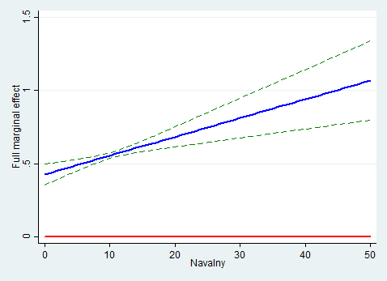 | 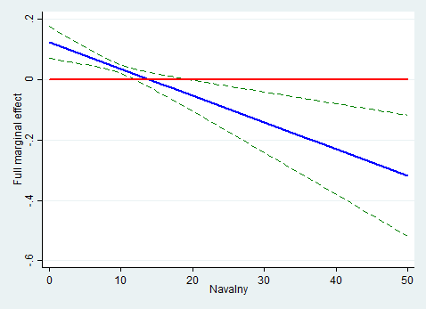
Segregated capital renovation account | Gate barrier

Figure 2. Full marginal effects of civic culture

References

Acemoglu, D., Reed, T., & Robinson, J. (2014). Chiefs: economic development and elite control of civil society in Sierra Leone. Journal of Political Economy, 122 (2), 319-368.
Bjørnskov, Ch. (2006). The multiple facets of social capital. European Journal of Political Economy, 22(1), 22-40.
Borisova, L Polishchuk, A Peresetsky. (2014) Collective Management of Residential Housing in Russia: The Importance of Being Social. Journal of Comparative Economics 42 (3), 609-629.
Helliwell, J., Putnam, R. (2007). Education and social capital. Eastern Economic Journal, 33(1), 1-19.
Low, S. (2003). Behind the Gates. New York: Routledge.
Low, S., Donovan, G., & Gieseking, J. (2011). Shoestring democracy: Gated condominiums and market-rate cooperatives in New York. Journal of Urban Affairs, 34(3), 279–296.
Olson, M. (1965) The Logic of Collective Action. Harvard University Press, 1965.
Polishchuk, L., Sharygina, Yu. (2016). Gating in Russia: Exit into private communities, and implications for governance. In: A. Lehavi (ed.), Private Communities and Urban Governance. Theoretical and Comparative Perspectives. Springer, 27-49.
Polishchuk, L., Menyashev, R. (2018) Social capital and governance: bright and dark sides. Mimeo.
Putnam, R. (1993). Making Democracy Work: Civic Tradition in Modern Italy. Princeton: Princeton University Press.
Welzel, C., R. Inglehart & F. Deutsch (2005). Social Capital, Voluntary Associations, and Collective Action: Which Aspects of Social Capital Have the Greatest ‘Civic’ Payoff? Journal of Civil Society 1 (2), 121-146.

https://www.reformagkh.ru/opendata
http://www.moscow_city.vybory.izbirkom.ru/region/moscow_city
All control variables are significant; notice the expected signs of education (known to facilitate collective action; see e.g. Helliwell, Putnam, 2007) and the number of apartments (growing number of participants makes a collective action more problematic; Olson, 1965).

