An Autopsy of Cooperation:
diamond dealers and the LIMITS of trust-based exchange

Barak D. Richman
Edgar P. & Elizabeth C. Bartlett Professor of Law and Business Administration
Duke University
PO Box 90360
Durham, NC 27708-0360
(919) 613-7244
richman@law.duke.edu

An Autopsy of Cooperation:
diamond dealers and the LIMITS of trust-based exchange

Both academic and popular representations of the diamond industry describe trust-based relations that sustain trade and support the industry’s private arbitration system. In recent years, however, trust among merchants has eroded, and merchants have correspondingly lost confidence in the industry’s arbitration. This article describes the events that have led to the breakdown of cooperative trust in the industry and derives lessons regarding the nature and limits of reputation-based exchange in the modern economy.

An Autopsy of Cooperation:
diamond dealers and the LIMITS of trust-based exchange

Contents

Introduction 3

I. The Cooperative Equilibrium 9

A. Industry Rules and Accurate Information Dissemination. 10

B. How It Works: Coordinated Punishments. 13

II. Disruption in Production and De Beers’ Changing Strategy 16

A. A New De Beers Strategy 20

B. Consequences of Changes in Production 21

III. Innovation and Segmentation in Retail 29

IV. Entry and Disruption to Diamond Intermediaries 32

IV. Trust Breaks Down & the Rise of Vertical Integration 38

A. The Erosion of Trust and the "Institutional Life Cycle" 38

B. Vertical Integration & the Institutional Economics of the Diamond Chain. 41

VI. The Future of the Diamond Chain and the Sustainability of Trust 46

An Autopsy of Cooperation:
diamond dealers and the LIMITS of trust-based exchange

“[W]hen I first entered the business, the conception was that truth and trust were simply the way to do business, and nobody decent would consider doing it differently. Although many transactions are still consummated on the basis of trust and truthfulness, this is done because these qualities are viewed as good for business, a way to make a profit.”
--Elderly diamond dealer, quoted in Bernstein (1992)

“It used to be like that. It’s not like that anymore.”
--Long-time diamond dealer, to author on 47th St. (2015)

Introduction

A New York Times reporter, writing about the city’s diamond district in 1984, marveled at how diamontaires “trust each other not to walk away with the world's most valuable, easily concealed commodity” and concluded that mutual trust was the “real treasure of 47th Street.” Writing eight years later, in perhaps the most important article written about the diamond trade, Lisa Bernstein (1992) similarly observed that obtaining access to a supply of rough diamonds requires “maintain[ing] a reputation for scrupulous honesty.” The romance of the diamond trade—trust among merchants, intimate intergenerational family businesses, communities built around the moral fiber of business ethics—has attracted several popular authors. Russell Shor (1993), a prominent diamond industry journalist, wrote “legal and moral accountability is the foundation for the very survival of the diamond trade.” (“Even if one percent of the dealers were dishonest,” a dealer tells Shor, “that trust would be destroyed and so would our industry.”) Renee Rose Shield captures in a beautiful ethnography of 47th Street the conventional wisdom that “formal contracts are unnecessary since informal contracts are heavy with moral weight and embody certain principles: to honor commitments, to produce a good product and to stand behind it, and to preserve reputation.” And journalist and child of diamond dealers Alicia Otulski echoes what the New York Times observed almost thirty years earlier: “At any given moment on Forth-seventh Street a dealer may be in possession of hundreds of thousands of dollars’ worth of another man’s diamonds. Usually, he has not paid the owner any collateral, only his word . . . In this business, everything works on credit, loan, and trust.”
This has been the diamond industry’s narrative. Mutual trust binds diamontaires to their pledges and to each other, and such trust-based exchange serves as a substitute for state-sponsored courts and conventional law. These stories of mutual trust illustrated how an insular merchant community can construct social networks that sustain mutually beneficial trade, despite the enormous risk posed by cheating. They served not only as the backbone for academic understandings of the industry, but as proof of how arbitration, reputations, social networks could fully supplant the state-sponsored legal system.
But gradually, the stories changed. Consider one typical telling from a diamond dealer in Antwerp, in 2013:
There are not many frauds, not many thieves. People trust and try to make deals work for both sides. But there are some people who cheat. … And they reenter the business, by putting the company in a relative’s name, by paying with cash and getting new contacts and new trust. That’s what happened to me, I was cheated and I see the cheater back on the streets here. There’s nothing I can do about it.

He tells this story only after repeating the familiar platitudes of trust among diamontaires, how earning and maintaining trust is necessary to succeed. But when he shares this recent and clearly painful experience, he opens up: he concedes he is urging his son and nephew to pursue alternative careers. The return of an undisputed cheater is difficult to reconcile with the traditions and norms of the industry in which he was raised and to which he has devoted many decades. Many other dealers share his deep disappointment in what has become of the diamond industry and agree that the deterioration of the proverbial bonds of trust mark a meaningful change in the world of diamond merchants.
Interviews with dealers and revelations in industry publications reveal that persistent and calculative cheating is becoming almost commonplace. Dealers either refuse or fail to pay for items purchased on credit and yet return to the industry. “Upgrading,” which occurs when a dealer purchases gems with certain GIA grades (on clarity, color, carat, and cut) and then convinces gem evaluators to give those same gems higher grades, is becoming increasingly common. A variety of laser treatments are used to enhance diamond color and clarity without necessary disclosures to subsequent buyers. And there are growing instances of synthetic diamonds, which have market values approximately 30% lower than corresponding natural diamonds, being mixed with and presented as natural diamonds. The growing deceitfulness prompted one longtime industry observer put it succinctly: “It doesn’t pay to be honest anymore. When you’re honest, you’re viewed as a sucker.”
Trust is even breaking down within what legal scholars might call the diamond industry’s crown jewel: its private arbitration system. Lisa Bernstein, whose work brought attention to the New York Diamond Dealers Club’s (DDC) arbitration, reported in the 1990s that the industry’s system of private dispute resolution “enables parties to resolve disputes and enforce judgments quickly, inexpensively, and secretly.” She further heralded the arbitration system for exhibiting expertise, accuracy, discretion, and fidelity. Other industry admirers lavished the DDC’s private legal system with similar praise. Renée Shield described the “courtly system of arbitration” as “the crowning achievement of the diamond business and is emblematic of how trust and reputation are the stellar symbols of the trade.”
Recent portrayals of the DDC have not been nearly as flattering. A report commissioned in 2011 revealed that the Club, from 2006-09, suffered from severe financial mismanagement, a failure of leadership, and many accounting irregularities. An accompanying exposé reported “unapproved or unjustifiable expenses incurred by the club’s president, the granting of questionable loans, and activities hidden from the board of directors.” These reports followed a particularly ugly internal legal battle, in which a Vice President of the DDC sued the Club and its President for engineering procedural maneuvers, including permitting select nonmembers to vote, to amend DDC bylaws and allow the then-president to keep the office for additional terms. Allegedly, the then-president’s central motivation for maintaining his office was to bestow favors to certain colleagues, including exempting membership fees and rigging arbitration decisions. DDC membership has declined over the past two decades, from approximately 2,000 members to less than 1,200, and one reason has been that diamontaires do not want to commit themselves to mandatory DDC arbitration, which is one obligation of membership. It seems that trust is not only eroding among diamontaires, but the institutions designed to sustain trust throughout the industry are losing credibility.
This article investigates the causes of why trust is breaking down—or, more precisely, why so many diamond dealers now find short-term strategies more attractive than long-term strategies associated with investing in and preserving a good reputation. Invoking prior scholarship, it first outlines how the diamond industry sustains cooperation and enforces executory agreements without relying on state coercion. It then reviews the many structural changes that have taken place in in the past twenty years to the industry’s production, retail, and middleman markets, and it investigates how these changes might explain how the benefits of cooperation no longer overcome the temptations for short-term gains. Since the diamond industry has been held as the paradigmatic industry in which reputations and private ordering govern exchange—a trust-based industry in which merchants have opted out of the state-enforced legal system—the article additionally aims to derive broader lessons from the diamond experience for the sustainability of self-enforcing governance and trust-based exchange.

I. The Cooperative Equilibrium

In order to understand the breakdown of cooperation in the diamond industry, one must first understand how the industry has managed to sustain cooperation. And to understand how cooperation was sustained, one must first understand why cooperation is necessary.
The most significant feature of diamond transactions is the unreliability of state courts in enforcing executory contracts. The typical diamond transaction is a credit sale or a brokerage arrangement— situations in which a diamond or cache of diamonds is in the possession of someone who is not the owner. Because diamonds are easily portable, virtually untraceable, and command high prices throughout the world, a potential thief encounters few obstacles in hiding unpaid-for or stolen diamonds from law enforcement officials, fleeing American jurisdiction, and selling the valuable diamonds to black market buyers. Accordingly, state courts can neither discipline parties nor seize stolen assets that escape their jurisdictional reach. Even sophisticated legal instruments, such as liens or other devices to secure assets as collateral, cannot reliably prevent diamond theft, which in the language of contract law is the failure to pay for a sale on credit. These important limitations on the capabilities of state courts force the diamond industry to depend instead on private mechanisms to enforce contracts. Hence, the industry relies primarily on an elaborate reputation mechanism resting on sustained cooperation.
The underlying mechanics of reputation mechanisms are well understood. Individuals make decisions to enter into relationships with others based on the past actions of their potential partners. In the commercial context, merchants will refuse to enter into contracts with, or will demand a risk premium from, individuals who have failed to fulfill their previous contractual obligations. In a cooperation-sustaining equilibrium, the prospect of losing future business opportunities (or paying future premiums) is sufficient to deter bad behavior, so the reputation mechanism—and the credible threat of coordinated punishment of individuals who earn bad reputations—is sufficient to induce contractual compliance and support reliable exchange.
However well-understood the theory is, the practicalities of implementing a reputation mechanism are daunting. The central challenges include (1) facilitating the prompt dissemination of accurate information so each merchant’s history is known to potential exchange partners and (2) imposing a credible and sufficiently painful punishment to deter misconduct. The diamond industry’s rules and structure enable a reputation mechanism that meets these challenges, induces contractual compliance, and thus supports transactional reliability where courts cannot.

A. Industry Rules and Accurate Information Dissemination.
The diamond industry’s central nervous system—the mechanisms that enable the industry’s use of reputations and support exchange—lies in its network of diamond bourses scattered throughout the world’s diamond centers. New York’s Diamond Dealers’ Club (DDC), located in Manhattan’s diamond district on 47th Street, is organized (like the others) as a voluntary association with by-laws and mandatory rules for its diamond merchant members. The DDC’s members organize the vast majority of America’s commercial traffic in diamonds, with most members acting as middlemen between the diamond producers who mine the stones and the diamond retailers who convert them into jewelry. Since most diamonds are bought and sold several times before they are ultimately purchased by a jewelry manufacturer, DDC merchants are active traders and transact with each other frequently.
As a voluntary association, the DDC has extensive rules and bylaws to which each member must agree upon his admission. Failure to comply with DDC rules would lead to a member’s dismissal. The DDC rules govern much of the members’ commercial activity, and the most important among these is the obligation to resolve all disputes before a DDC arbitration panel. Arbitrators are fellow DDC members who have been elected by DDC members ostensibly because of their industry expertise and respect among their peers. Arbitration rules empower arbitration panels to gather whatever evidence they believe is necessary and to swiftly deliver rulings.
The arbitration panel is at the fountainhead of the industry’s reputation mechanism. Once a panel has reached a conclusion, it announces nothing more than its judgment, which amounts to identifying the merchant against whom the panel issued a judgment, the date the judgment was decided, and the amount owed. The individual found to be liable has an opportunity to pay his debt to the merchant who brought the suit, and if he does so he remains a DDC member in good standing. However, if that individual fails to make payment immediately following the arbitration panel’s decision, he is dismissed as a member of the DDC. In addition, a picture of the individual in default is placed on the wall of the DDC’s central trading hall with a caption that details his failure to comply with the arbitration panel’s ruling, which immediately makes the default known to all DDC members. News of the individual’s default spreads rapidly throughout the global marketplace as similar pictures and captions are placed in the world’s twenty-two other diamond bourses as well. This formal dissemination of information supplements the transmission of news through the many informal information networks in the DDC and other bourses worldwide. Each bourse—which houses restaurants, prayer halls, and social areas where members congregate regularly—gathers merchants regularly and for most of each day, thereby creating a vibrant forum for collecting and disseminating valuable reputation information.
Thus, the DDC’s procedures—and the similar procedures of the world’s other diamond bourses—ensure that news of an individual’s default spreads quickly to future potential trade partners. The DDC, however, serves only an informational purpose. Its by-laws require nothing more than the expulsion of a member in default and the posting of his picture and his arbitration determined debt on the DDC’s wall. Even though former DDC members are prohibited from entering the DDC trading halls, nothing legally precludes them from remaining in the diamond business, and, more important, no law and nothing in the DDC By-Laws precludes other diamond merchants from dealing with individuals who were expelled from the DDC. Diamond arbitrators thus serve a purely informational purpose, with the power only to identify and publicize the individuals who have shirked their obligations to community members. Resting atop these industry-generated and disseminated informational proceedings are privately coordinated sanctions that execute a reputation mechanism.

B. How It Works: Coordinated Punishments.
Despite the absence of formal sanctions—other than being expelled from the DDC—against those who breach contractual obligations, expulsion substantially affects commercial opportunities. Merchants in default have tremendous difficulty obtaining further business, and current DDC members will not transact with merchants who were dismissed from the DDC because their own reputations would be discredited by dealing with breaching members. Therefore, maintaining a DDC membership in good standing becomes a signal to other merchants of a spotless past and a necessary prerequisite to continuing business in the industry.
How is such a cooperative equilibrium maintained? Rudimentary game theory suggests that the threat of coordinated punishment will deter misconduct only if the benefits of long-term cooperation exceed the value of a one-time defection. This tradeoff between long-term versus one-time payoffs is particularly stark for diamond merchants, since most diamond transactions offer a one-time defection opportunity—stealing a cache of diamonds—with an enormous payoff. Thus, an equilibrium of long-term cooperation is realized only if long-term payoffs are both assured and appropriately rewarding.
The diamond industry’s system of rewards and punishments, which is responsible for securing credible contract enforcement, works only because of who the diamontaires are. Diamontaires almost exclusively come either from family businesses or from homogeneous ethnic communities, and industry cooperation rests on a remarkable network of family and community institutions.
Family businesses form the backbone of the industry. Because a good reputation is essentially a prerequisite to enjoying profitable dealings, entry is largely limited to merchants who enjoy some reputational sponsorship and tacit insurance from existing industry players. Profitability is thus dependent on the quality of a family’s reputation and where family reputations are both inherited and bequeathed. Family connections create a valuable and otherwise hard-to-obtain entryway into the industry, and conversely, fulfilling contractual obligations and maintaining a good reputation both secures a lifetime of business and enables a diamontaire to confer a good reputation—and the opportunity to secure future business—to heirs. Merchants are thus induced to fulfill their contractual obligations throughout their lifetimes, and the industry overcomes what game theorists typically describe as an end-game problem.
These enforcement mechanisms—industry arbitrators that disseminate information and merchants and community leaders that coordinate punishment—highlight how the diamond industry’s reliance on private ordering differs dramatically from the conventional demand for private third-party arbitration. In most commercial settings, parties contractually agree on arbitration to reduce the collective costs of dispute resolution. When a dispute arises, the parties proceed to arbitration and receive a judgment, which the victorious party can then enforce against a noncompliant party in state-sponsored court. The Federal Arbitration Act (like similar statutes in other countries) requires that public courts defer to the arbitrators’ ruling, but the legal instruments of state-sanctioned coercion, such as asset seizure and property liens, remain available to enforce the arbitration judgment. Although these public mechanisms are useful for recovering identifiable and fixed assets, they are far less effective in recovering stolen diamonds, which can easily escape a court’s detection and jurisdiction. The diamond industry, therefore, has developed private instruments to enforce contracts and achieve transactional security. In short, whereas most commercial parties choose arbitration to reduce the costs of litigating in public courts, the diamond industry abandons public courts because they offer ineffective enforcement. And whereas the effectiveness of most commercial arbitration depends on ultimate state court enforcement, the diamond industry designs its own arbitration rules to harness its reputation mechanisms and coordinated punishments.
In sum, the DDC’s arbitrators identify merchants who have engaged in wrongdoing, and both formal and informal industry mechanisms disseminate the identities of those deserving of bad reputations. Industry and community norms then inflict coordinated punishment on wrongdoers by foreclosing future business to those who have failed to uphold their commitments in the past. Merchants comply with the DDC arbitration board not to avoid the brunt of the DDC penalties but instead to reap the benefits of having good industry and community reputations. They will only comply, however, so long as the incentives to remain active in the industry and profit from good reputations outweigh temptations to depart.
For much of the past century, this collection of industry and community institutions has sustained a sixty-billion-dollar industry that has avoided, has not required, and could not be supported by state court enforcement. Economic and political changes since the turn of the millennia, however, have strained the cooperative equilibrium.

II. Disruption in Production and De Beers’ Changing Strategy

Writing about De Beers’ approach to the year 2000, a Harvard Business School case study observed:
De Beers was accustomed to chaos. The company thrived on it, and had long ago learned to master it. But the millennium posed new challenges—serious challenges with the potential to undermine De Beers’s legendary power and compel a rethinking of its strategy.

The “chaos” is the vicissitudes of a volatile commodities market combined with the demand elasticity of luxury goods, and De Beers’ success throughout market rested on its ability to assert control over the diamond market. For nearly a century, De Beers enjoyed monopoly control over the sale and distribution of rough diamonds. It either owned or secured exclusive contracts with a majority of the world’s mining interests, and through its Central Selling Organization (CSO), it distributed its supplies deliberately through “sightholders,” a collection of approximately 125 carefully selected distributors chosen to receive and purchase caches of De Beers rough diamonds ten times each year. Sitting atop the diamond distribution chain, De Beers was able to control global supply of rough diamonds by carefully controlling what was sold each year, and it invested in sustaining global demand through creative advertising strategies and directing distribution chains. Whenever additional sources of rough diamonds threatened to enter the market, De Beers swiftly entered into exclusive purchasing arrangements with the new suppliers. Whenever supply began to exceed demand and threatened to dampen market prices for polished diamonds, the company would show its determination to be a buyer of last resort, stockpiling rough gems to sustain stable prices.
In the late 1990s, however, this decades-old strategy started to fray and changes to diamond supply “began to hint at a very different structure for the world’s diamond market and . . . De Beers.” Diamond mines discovered in Australia in the 1980s and in Canada in the 1990s began resisting De Beers’ control and started selling rough diamonds outside De Beers’ CSO in 1996; De Beers’ agreement to purchase Russia’s enormous production, formed in 1990 during Russia’s desperate need for hard currency, expired in 1995, prompting “leaking” of Russian diamonds that year marketing, and in 1996, Russian company Alrosa began distributing diamonds outside the CSO; Lev Leviev, an Uzbekistan-born Israeli diamontaire, began developing independent diamond distribution networks from Angolan and Russian sources in 1997; and rough diamonds were trickling into the global marketplace from war-torn Angola and Sierra Leone.
De Beers first responded to these new entrants with its traditional strategy of stockpiling rough gems and controlling global supply, and its inventory expanded in the 1990s from under $3 billion to nearly $5 billion, or 100% of the company’s annual sales. But De Beers’ directors soon realized it would not be able to sustain its historic degree of control over global supply, and that to the degree it sustained prices by maintaining large stockpiles, it was benefitting its competitors as much as itself. The company was simply unable to continue its century-old control over global production. Consequently, whereas De Beers and its CSO controlled over 80% of diamond supply as recently as 1989, its market share of rough production has since declined steadily. (See Figure 1)

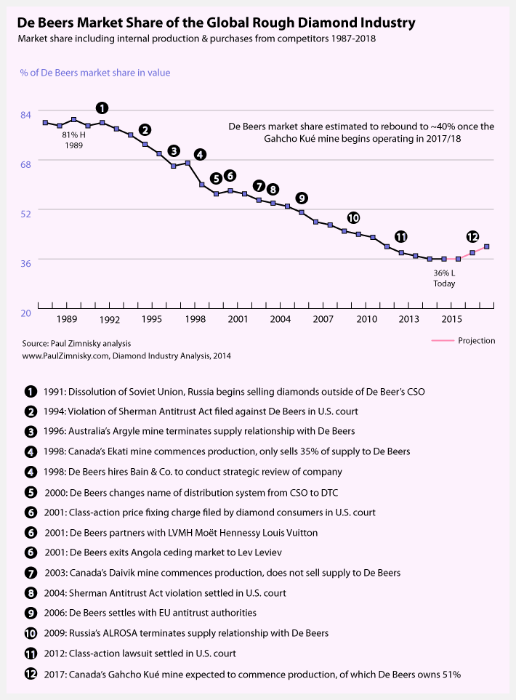
Figure 1: De Beers Declining Market Share Over Time

A. De Beers New Strategy
In 1998, Nicky Oppenheim—grandson of Ernest and son of Harry, the two preceding leaders of De Beers—was installed as chief executive as part of a new management team, and the new leadership retained Bain and Company to conduct a wide-ranging strategic review. (Nicky Oppenheimer later told an HBS case writer, “For any company that is long lived, there comes a time where you have to change, and cast your skin off.”) The company Nicky inherited not only competed in a different competitive environment from the one in which his father’s company dominated, but it also exhibited a radically different governance structure. Just before Nicky’s team took over, De Beers and Anglo-American were integrated together through complex crossholdings and were each closely held by the Oppenheimer family (the unwieldy structure was largely designed to cushion both companies first from the political hazards of cooperating with South Africa’s apartheid regime, and then from the hazards of the regime’s end). As the new management team took its place, the two companies spun off into separate firms. The reorganization consolidated all diamond-related industry assets and expertise into a fully integrated De Beers, with Anglo-American focusing on other mining interests.
The strategic review prompted a dramatic shift in corporate strategy: Rather than being the industry’s buyer of last resort, De Beers would position itself as an aggressive competitor in an increasingly crowded luxury goods market. In early 2000, the company announced that it would sell off its stockpiles and would directly enter the diamond retail market. It forged a partnership with luxury goods company Luis Vuitton Moet Hennessey, developed a ring box with a logo that models a Tiffany’s high-luxury style, and established a retail store in Manhattan. Finally, it revealed a new marketing strategy to promote the De Beers brand, abandoning its wildly successful slogan “A Diamond is Forever” for “Less than 1% of the world’s diamonds are eligible to become a Forevermark diamond.” The company is thus channeling its advertising might towards stimulating sales of De Beers diamonds rather than of all diamonds. Its core strategy is to make itself distinct from the rest of the industry.

B. Consequences of Changes in Production.
De Beers now produces approximately 35% of the world’s rough diamonds by value (around 25% by volume), with Alrosa (Russia’s production company) controlling approximately 30% (27% by volume), and three other competitors each producing between 2-10%. One might expect that because diamond production is no longer dominated by a monopolist and now involves several smaller players, diamond prices would be less stable and would sway with the vicissitudes of speculation and demand. Since the economic downturn of 2009, however, diamond prices have remained stable compared to other precious commodities. (See Figure 2).
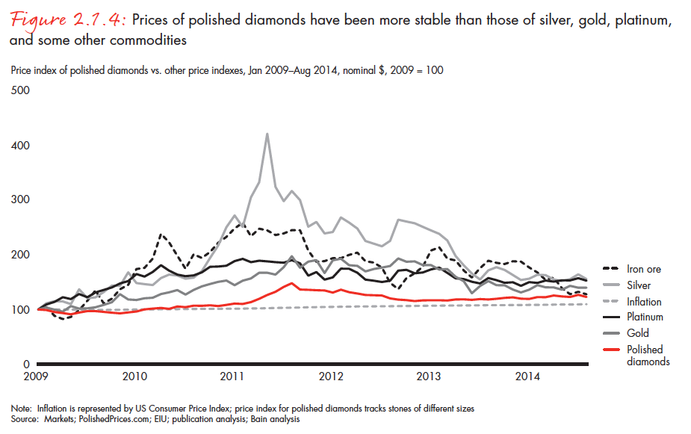
Figure 2: Relative price changes in diamonds vs. other commodities

Theory would also predict that a less concentrated market would yield lower wholesale prices and lower monopoly rents, but here too the opposite has occurred. As De Beers’ market share declined since the turn of the millennia, average prices per carat, for both rough and polished diamonds, have increased (see Figure 3), and average operating margins among leading diamond producers have also remained high, especially after the global downturn in 2009 (see Figure 4).

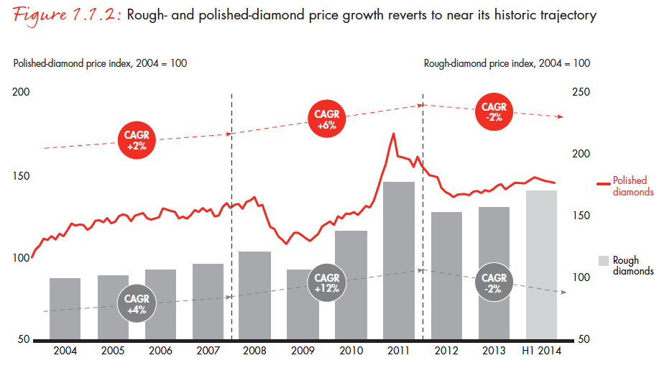
Figure 3: Rough and Polished Diamond Prices
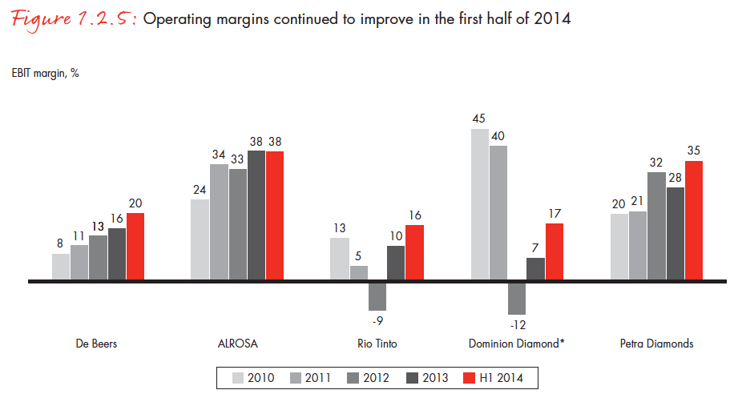
Figure 4: Operating Margins for Leading Diamond Producers

How has the diamond industry retained (and in some cases, amplified) monopolistic features even after the decline of De Beers’ notorious monopoly? Longtime industry watchdog Chaim Even-Zohar suggests that the diamond oligopoly is mimicking many of the pricing behaviors of the De Beers monopoly, in part due to collusion is at work. He notes that following each sight, detailed lists are distributed by DTC brokers revealing the price and composition of each purchased box of diamonds, with the intent of signaling prices for other producers. Zohar further points to instances in which the competing oligopolist producers have found ways to meet in private, including through the establishment in May 2015 of the Diamond Producers Association. The Association, founded by the seven leading producers that are collectively responsible for about 80% of global production, purportedly is to organize collective marketing efforts to sustain demand and to counter threats of synthetic diamonds. Even-Zohar ruefully observes that, given De Beers’ fraught history of antitrust violations, the producers until recently “have refrained from showing too close of a cooperation.”
Even-Zohar warns, however, that the new oligopoly has departed from the monopoly in one very important respect: “[T]he diamond producers have used their oligopolistic powers to the fullest, having successfully driven up rough prices to such an unrealistic level as to actually endanger the economic sustainability of their very own clients and other midstream and downstream levels.” This admonition of “unrealistic” pricing is echoed forcefully in an anonymously drafted and widely circulated email from simplesightholder@gmail.com:
dear all,

As a sight holder who has suffered like all of you a few years of no profitable and even loosing boxes, I encourage you, at this difficult period not to take any box which doesn't have the value of at least 10% gross profit after polishing.
Please, if your future, the future of your children and the future of your diamond business is important to you. Don't agree to take the boxes.

. . .

Don't be afraid to reject, nothing will really happen (unless some stupid sightholder will act stupidly and buy the boxes) they need our money, they need us and it is legitimate to expect a fair pricing which leaves also to our side some profit. If De Beers would make 300 million less a year in profit it would leave each of us (on average) with extra 3. Million dollars. What's bad and what's wrong in such a request??

Let's take care of our future, brothers.

I wish you all the best and I am happy to receive your comments.

Also please forward this to other sight holders .

Just a simple sightholder

Notice that Figure 3 supports this charge, showing that the price margin between rough and polished diamonds has narrowed since 2007.
It seems that the most consequential change stemming from De Beers transformation is not the company’s loss of market share or the market’s change from a centralized monopoly to an oligopoly. Rather, the most impactful change has come from De Beers’ corporate reorientation. The company is no longer a diamond company run by a longtime diamond family with a mission to provide stability to an entire industry. It now sees itself as an aggressive competitor in a crowded market for luxury goods with the priority of creating and assuring value for shareholders.
De Beers’ entry into the retail market reflects this new orientation and illustrates a sharp contrast to the company’s longtime use of sightholders. The company now dedicates many of its rough stones to produce De Beers-branded diamonds for retail sale, aiming to be a leader in luxury goods markets and refining its product lines to meet the demands of high-end consumers. It therefore is less reliant on seasoned diamond dealers either to provide market information or to direct diamonds to valuable targets. More significantly, it means that De Beers no longer aims to support an entire industry and its network of middlemen. The diamond value chain no longer reflects the longterm collaboration between De Beers and its sightholders—between upstream suppliers and downstream distributors—and the company’s relationship with these intermediaries has turned from collaboration to competition.
In fact, De Beers’ vertically integrated strategies help explain some curiosities of the prior strategy. Economic theory implies that an upstream monopolist maximizes surplus when downstream markets are competitive. Yet De Beers, in contrast to theory, sold only to handpicked dealers. Moreover, and similarly in contrast to theory, diamond merchants have clamored to become a sightholder atop the distribution stream, which suggests that De Beers sells diamonds to sightholders at less than the monopoly price and instead shares with them some monopoly rents. The reason for De Beers’ curious distribution strategy is that it relied on these merchants to ensure that rough stones were directed to their most valuable use. It therefore selected as sightholders merchants who were deeply familiar with the diamond trade to know how to cut, distribute, and market diamonds to create maximum value. In short, De Beers relied on downstream merchants’ market information and industry expertise, and the company implemented a pricing strategy that economically sustained these knowledgeable intermediaries.
The industry’s longtime intermediaries—especially mid-size and small operators who do not partner with leading retail chains—are both the primary victims of this new pricing strategy and the most vulnerable. Compared to the upstream production and downstream retail markets, this intermediate market for distributing and cutting rough diamonds has long offered the slimmest margins (see Figure 5), and producers’ pricing efforts have caused these margins to continue to shrink. Consequently, De Beers’ new strategy has had major reverberations throughout the diamond distribution chain.
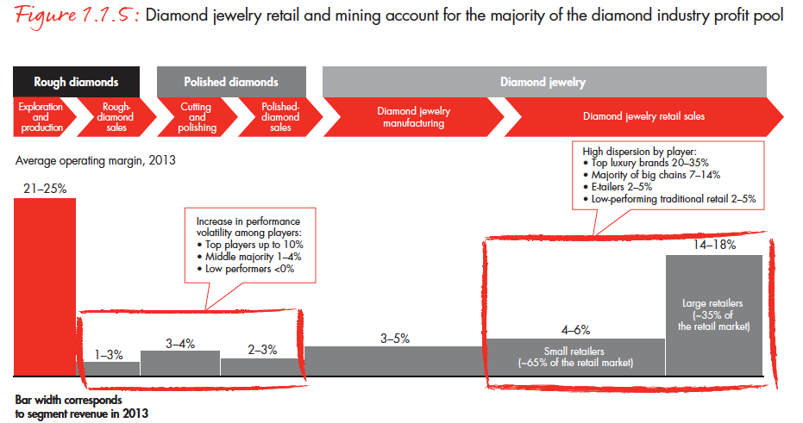
Figure 5: Profit Margins for Different Stages of the Diamond Chain

III. Innovation and Segmentation in Retail

A Forbes article entitled “Romance Killer” describes Mark Vadon, founder and CEO of Blue Nile, as “an unlikely party crasher in a business dominated by multigenerational family firms led by Orthodox Jews.” Blue Nile, founded in 1999 as part of the internet retail boom, is the world’s pioneer in internet diamond sales. The company serves as an exchange between consumers and diamond dealers, in which dealers describe the attributes of each stone—Carat, Cut, Color, and Clarity (the 4Cs)—in accordance with standardized Gemological Institute of America (GIA) metrics. Each stone has a GIA certificate confirming its metrics, and consumers can compare stones by price and quality.
Blue Nile is no longer a lone force in internet diamond retail, having been joined by Amazon, AliBaba, eBay, and other internet sites. Internet retailers constitute 13% of
America’s total jewelry sales, and although internet sales are not apparently growing faster than bricks and mortar retail sales, they are having a lasting impact on the diamond value chain by introducing transparency to diamond pricing. Bringing price transparency was key to Vadon’s retail strategy, but it is an anathema to an industry that relies on mystique, heavy markups, and careful in-person inspection.
The rise of internet retail has had only a modest effect on large, high-end stones, and it appears that high-end diamond retail markets remains distinct from the internet market. This is likely because luxury retail services provide valuable complementarities to high value stones – the expertise (and diction) displayed by the salesperson, the elite brand, the cozy retail space – and accordingly, very few large stones are sold by internet retailers. Internet sales and price transparency therefore have pulled down prices everywhere except for at the top, and prices for large, high-quality stones have risen over the past decade much faster than prices for smaller and midsized polished gems (see Figure 6).
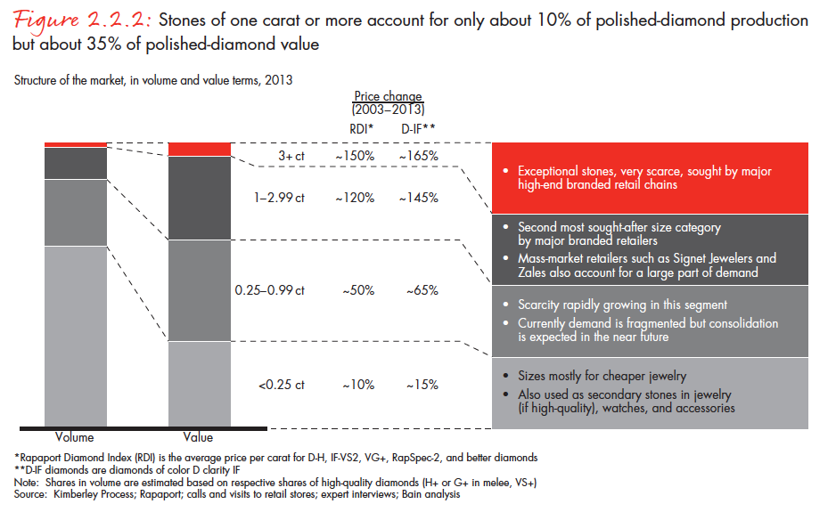
Figure 6: Price Changes for Polished Diamond, By Size

But internet sales have put meaningful downward pressure on prices for midsize and small polished stones, and the availability of price information is squeezing profit margins across much of the industry. Forbes unsympathetically reports:
‘Blue Nile is creating a race to the bottom,’ complains Alan Rehs, a wholesaler and cutter in New York. ‘This is bad for the industry.’ He says customers walk into stores brandishing Blue Nile printouts as bargaining chips. Horrors.

The new price pressures eliminate many of the margins that diamond dealers enjoyed as intermediaries, and the gap between rough prices and polished prices (for all but the largest stones) continues to narrow.
The spread of internet sales and the growing transparency of diamond retail prices have introduced an even more significant disruption to the diamond distribution chain. Previously, intermediaries were relied upon to direct stones to their highest value use, matching individual stones with purchasers who would pay the most. These seasoned diamontaires utilized their own market information and the information asymmetries they enjoyed over outsiders to channel stones towards purchasers who would yield additional margins. Their market information both provided a key step in the value chain and secured their profitable role within it. Now, that market information is widely available. Price transparency has not just introduced new price pressures, but it has obviated much of the value that intermediaries historically provided.

IV. Entry and Disruption to Diamond Intermediaries

Diamond dealers, as intermediaries between rough producers and purchasers of polished stones, have thus suffered twin pressures since 2000. Diamond producers have increasingly aimed to extract higher prices in rough diamond sales, and internet retailers have introduced downward price pressures for many polished diamonds. Both of these developments have diminished available margins for intermediary diamontaires, and they correspondingly have diminished the incentives to sustaining strong reputations in the trade. Yet while these developments occurred in the production and retail markets, even more dramatic developments took place in the intermediate stage of sorting, cutting, and brokering diamonds.
The emergence of Palanpuri Jain diamond merchants and the subsequent rise of India as the world’s capital of diamond cutting constitutes perhaps the most significant development in the diamond industry since the discovery of South African diamond mines a century ago. Jain merchants were able to develop networks that acquired rough diamond supply in Antwerp, orchestrated diamond cutting in Gujarat, and sold polished diamonds in New York and other retail centers. Their family and community relationships enabled executing the credit purchases and distribution of diamonds that is required for thriving in the diamond market.
Palanpuri Jains were especially well positioned to excel in the diamond industry because of their historical roots as diamontaires. India’s modern diamond era began in the 1880s when Palanpuri Jains constructed diamond networks that, by World War II, had established a presence in Antwerp. When Australia’s Argyle mines created a production boom in 1979, Palanpuri family firms – joined by some Marwaris, India’s traditional traders and bankers –dramatically expanded their operations. They set up thousands of cutting factories in Gujarat, employing mostly local Kathiawaris, who historically were farmers who migrated to Gujarat’s urban and industrial centers when work became available in Jain-owned cutting factories.
The influx of new Indian family businesses into the web of diamond intermediaries not only transformed the profile of the diamond trade but significantly changed the economics. The introduction of new intermediary networks made this segment of the industry more competitive and correspondingly caused margins to decline. But several aspects about the nature of this entry put additional strains both on the industry’s norms for cooperation and the incentives to sustain cooperation.
In time, Kathiawaris grew from factory workers to factory owners, and Kathiawari families now control over 50% of the diamond trade in Surat, with many Kathiawari companies becoming active purchasers of rough stones in Antwerp and Israel. But Kathiawari entrepreneurs were meaningfully different from their Palanpuri and Marwari counterparts. According to a 2011 study by Cambridge economist Kaivan Munshi, Kathiawari diamond merchants were younger, had fewer years of education, were less likely to be schooled in English, and were more likely to be raised far from urban centers. More significant, especially for the diamond trade, only 35% of sampled Kathiawari diamontaires, compared to 82% of Palanpuris and 76% of Marwaris, reported that their father was engaged in any type of business. Moreover, the percent of Kathiawari entrepreneurs entering the diamond industry with businessmen fathers declined significantly from 1980 through 2000, whereas the percent for entering Palanpuris and Marwaris largely stayed the same. For an industry that relies on intergenerational business to sustain longterm cooperation, the entry of Kathiawaris introduced an unfamiliar kind of entrepreneur.
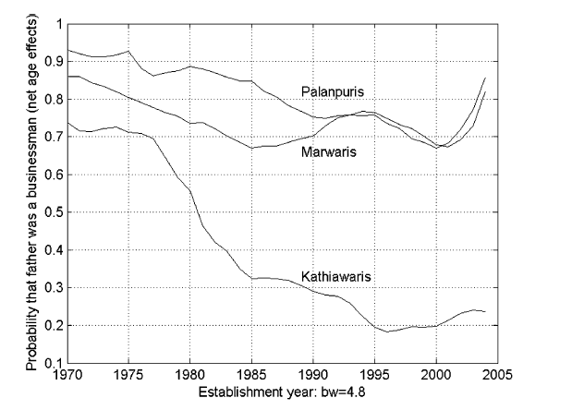
Figure 7: Family Background of Entering Entrepreneurs in India’s Diamond Industry.

Indian banking policies have further fuelled the entry of non-traditional business families into the industry. To encourage exports, the Indian government requires local banks to earmark a percentage of their credit to finance exporters. This financing is especially attractive because it must be offered at a reduced rate and in U.S. dollars. Since gems and jewellery are India’s second largest export and constitute approximately 14% of all Indian exports (and nearly 7% of India’s GDP), Indian banks—led by the Bank of India—found eager borrowers in the diamond sector.
Although Indian diamond firms were reliably lucrative and thus generally safe bets for banks, financing diamond operations is notoriously difficult to govern, and so the policies encouraging bank loans to diamontaires introduced a number of hazards. First, because diamonds are difficult to identify individually, unlike a car or real property, diamontaires were able to take out multiple loans for a single bundle of diamonds. Second, because diamonds are difficult to value accurately, especially by non-diamontaire bankers, diamond companies were able to borrow sums that exceeded the actual value of the diamonds they used for collateral. Finally, the loan subsidies encouraged entrepreneurs with diamond companies to use subsidized loans for non-diamond purposes, or even to reloan the borrowed money at market prices. These difficulties are why most diamontaires get their financing in the form of credit sales from fellow diamontaires, who understand the business and are better equipped at valuing stones.
These policies, many of which were mimicked by banks outside India, encouraged banks to overeagerly invest in the burgeoning diamond sector, extending generous lines of credit to diamond dealers and factory owners to purchase rough stones. They also caused the Indian diamond sector to grievously overextend itself. Outstanding debt belonging to diamond intermediaries grew from $7 billion in 2002 to about $16 billion in 2013, with 40% of the entire global industry’s banking debt now owed by Indian firms. Predictably, many are now insolvent, and the spread of bad loans have destabilized the sector. A former chairman of India’s Gem & Jewellery Export Promotion Council recently lamented:
The rash of bankruptcies among diamond processing companies today isn’t simply bad news for these companies and their creditors. It’s bad news for all of us. The banks don’t trust the industry any more, and today, even legitimate, well-run companies are being regarded with suspicion and are facing sharply tightened lines of credit.

In sum, the intermediaries—the dealers, cutters, and brokers—that traditionally directed diamonds from De Beers and other producers to jewelry manufacturers have watched their industry segment transform enormously in the past 30 years. The rise of Indian merchants greatly expanded competition and reduced margins. India’s longtime diamontiares, the Palanpuris, were soon joined by Kathiawaris that did not have family intergenerational businesses and thus had fewer historical pressures to sustain a flawless reputation. And Indian banking policies encouraged financial improprieties and introduced new financial pressures even to scrupulous businesses. These structural challenges to the intermediary segment of the value chain were well underway by 2000, when De Beers’ started pricing more aggressively and when internet retail placed downward pressures on prices for polished diamonds.

IV. Trust Breaks Down & the Rise of Vertical Integration

Until recently, the foundations of sustained cooperation in the diamond industry lay upon the motivations—or, in the language of an economist, the utility functions—of the individual diamontaires. Long-term, intergenerational workers in family businesses were motivated by sustained returns to themselves and their progeny. However, these diamontaires now see their expected payoffs from sustained cooperation diminishing, and simple game theory—the iterated folk theorem—illustrates why reports from industry insiders, the trade press, and 47th Street merchants reveal a breakdown of a cooperation.

A. The Erosion of Trust and the “Institutional Life Cycle”
Although this erosion of cooperation pierces the conventional understanding of the diamond trade, it has many historical analogs. Avner Grief offers several examples of what he calls the “institutional life cycle,” in which institutions that emerge to sustain cooperation eventually sow the seeds of their own demise. Genoa, for example, was a thriving commercial center in the 11th Century primarily due to the mutual interdependence and cooperation between its ruling commercial clans; yet the success of these clans generated such wealth that control of the city offered a reward that overwhelmed the certain shared gains from continued cooperation. Once a German emperor, who had presented a common enemy to the clans, no longer posed a military threat, the clans battled for complete control of the city and abandoned productive cooperation. Similarly, the merchant guilds of the 12th and 13th Centuries orchestrated self-enforcing multilateral reputation mechanisms that brought wealth to both merchants and their supportive rulers. But this success led to an expansion of trade that stretched the limits of reputation mechanisms and diminished the value to the crown to protect the marginal merchant from expropriation or unfair dealing. Eventually, peripheral traders could not rely on fair dealing, and trust broke down throughout the merchant populations. And the institutions that Grief calls the “Community Responsibility System,” which enabled impersonal intercommunity exchange in the 13th and 14th Centuries, also became victims of their own success. These cooperative arrangements had local authorities commit to punishing local residents who cheated foreigners in exchange for a commitment from distant authorities to reciprocally punished their own, thus sustaining credible cross-border trade. But, Grief explains, “[g]rowth in the number of traders and communities, the locations of trade, and intercommunity interactions reduces the cost of falsifying one’s community affiliation and increases the cost of verifying one’s identity.” Their growth also led to their demise.
It could similarly be said that diamontaires have been a victim of their own success. The lucrative opportunities as an intermediary attracted entry from ethnic networks and family businesses who were able to manage the diamond value chain. As the industry grew, it became more diverse, and the mechanisms that were historically relied upon to secure credible commitments—the prospect of bequeathing valuable reputations to the next generation—were not as effective. In a similar fashion, the industry amassed political power as it grew, enabling it to extract new and untraditional sources of financing, which inadvertently undermined the industry’s historical mechanism of securing credit and punishing defaulters. When production and retail markets changed because of exogenous geopolitical and technological changes, the thinning incentives to sustain cooperation were overwhelmed.
Another feature of the industry’s success has been the diamontaires’ affluence and thus acceptance into mainstream society. Whereas Amsterdam’s and Antwerp’s diamontaires in the late 19th and early 20th Centuries, most of whom were Jewish, always remained isolated and distinct from the dominant cultures, Jewish, Indian, and middle eastern diamontaires have fully integrated into the cultural polyglots that house the 21st Century’s diamond centers. With acceptance comes acculturation, and thus greater choices and economic opportunities, and many diamond merchants—like the Antwerp merchant interviewed in 2013, discussed above—have seen their children select different occupational paths. Intergenerational businesses and the forces that sustain the value of an honest reputation are central in supporting cooperation, and the diminishing role of children in family businesses meaningfully erodes the merchants’ commitment to longterm cooperation.
Grief’s historical lessons teach that trust breaks down even when only marginal merchants can no longer rely on credible commitments to punish wrongdoing and reward cooperative behavior. It recalls what a diamond merchant told Shor: “Even if one percent of the dealers were dishonest, that trust would be destroyed and so would our industry.” And game theory teaches that this breakdown naturally accelerates. Once some diamontaires begin cheating, then the industry’s overall credibility erodes, making it more difficult and costly for any one merchant to commit to trustworthy behavior. And once diamond merchants see dwindling profits in the future, the rewards to maintaining a trustworthy reputation decline. Indeed, a growing percentage of New York’s and Antwerp’s diamond merchants are seeing their children pursue careers outside the industry.

B. Vertical Integration & the Institutional Economics of the Diamond Chain.
Unless a cooperative equilibrium is restored—and lessons from history teach that once trust is lost, it is very hard to recover—the diamond industry will undergo dramatic structural changes. The breakdown of trust-based networks, and thus the erosion of a reliable distribution network from producers to jewelers, will mean that jewelry manufacturers will seek alternative mechanisms to procure diamonds. It also means economists will have to reassess their understanding of the economics of the diamond chain.
The diamond chain attracted scholarly attention from some pioneering organizational economists, and their early work put De Beers’ method of block booking—its practice of selling prepackaged caches of heterogeneous rough diamonds for a single take-it-or-leave-it price—within the cannon of institutional economics. Yoram Barzel, writing in 1977, argued that De Beers uses block booking to economize on measurement costs. “Had the contents of a particular bag been available for appraisal by all buyers,” Barzel explained:
“[E]ach would have spent resources to determine the properties of the diamonds. … The incentive for De Beers to engage in this peculiar form of trade seems to be that buyers are now in a position to spend on the actual purchase of the diamonds the amount they otherwise might have spent on collecting information.”

In other words, because buyers were spared the costs of evaluating individual stones, they were willing to pay De Beers more for the average stone.
Roy Kenny and Benjamin Klein, writing in 1983, similarly observed that “a precise estimate of the value of individual rough diamonds would require costly, duplicative examination costs.” De Beers engages in block booking “to prevent buyers from rejecting parts of a package of products that has been averaged priced” and in return, De Beers “pays a premium to its buyers by selling diamonds at less than (costless-search) market clearing prices.” In short, because buyers agree to purchase the entire cache, saving De Beers the additional burden remarketing rejected stones, De Beers is willing to charge less.
These related and contemporaneous analyses (despite the slight tension between them) stood as accepted wisdom for De Beers’ distribution strategy. By remaining exclusively upstream, De Beers created and benefitted from the efficiencies of avoiding the duplicative and effort-intensive measurement costs of evaluating individual stones. The block booking strategy created value both by economizing on search costs and by generating the efficiencies from a dis-integrated supply chain.
Recent organizational changes to the supply chain require rethinking these conventional explanations. Most significant of these changes is De Beers’ current implementation of a vertically integrated strategy. Though it continues to sell some rough stones to its sightholders, it retains many stones for itself, supervises their polishing, manages their placement in jewelry setting (and ensuring their uniformity, so as to market them as identical branded stones), and sells them through their own retail stores. It also has implemented a “Supplier of Choice” program in which it enters long-term, detailed contracts with select sightholders. De Beers gives these chosen distributors access to De Beers’ high quality stones and permission to market those stones as De Beers’ “Forevermark” diamonds, and in exchange the sightholder invests in and implements specific production and marketing plans. This program binds certain distributors and retailers more closely to De Beers than any previous sightholder.
Other producers are pursuing vertical strategies as well. Rio Tinto, for example, teamed up with Chinese designers and jewelry manufacturers to use the company’s Argyle mine stones to create products targeting the Chinese market. And Alrosa has been working with Christie’s and Sotheby’s to market polished diamonds directly to consumers.
Perhaps more significant, industry leaders from other segments of the distribution chain are also vertically integrating. Luxury retailer Tiffany & Co. created a wholly-owned subsidiary, Laurelton Diamonds, that purchases, cuts, and polishes rough diamonds. Laurenton has also entered into long-term contracts with De Beers, Alrosa, and Rio Tinto to procure steady supplies, and it has additionally contracted with smaller producers to purchase stones from individual mines. Chinese luxury retailer Chow Tai Fook has also integrated upstream, entering long-term supply relationships with major producers and operating major cutting and processing factories. And Signet Jewelers, owners of retail chains Zales, Jared, and Kay Jewelry (plus others), now operates polishing factory in Botswana. Major wholesalers—in particular, the highest volume sightholders and the major purchasers from the top producers—are integrating downward as well. Although the vast majority of the 5,000 firms that purchase, sort, polish, and sell wholesale diamonds are dis-integrated family firms, the largest 110 firms constitute 70% of the wholesale market and are increasingly integrated into polishing, jewelry manufacturing, and retail sales.
These recent organizational changes—the rise of greater vertical integration across the industry, and the corresponding end of the Barzel and Kinney & Klein models—is a direct reaction to the loss of trust-based cooperation in the industry. As retailers invest in their brands, they are increasingly vulnerable to the hazards that classically demark the diamond trade: mistakenly representing synthetic diamonds as natural diamonds, selling conflict diamonds, or selling laser-treated diamonds. When the dis-integrated distribution system lacks the trustworthiness it historically has had, vertical integration strategies arise to mitigate these transactional hazards.
This rise of vertical integration is consistent with the teachings of transaction cost economics, which states that vertical integration serves to secure exchange when transaction costs prevent market exchange. More interesting, these developments in the industry speak to a long-debated feud in economic sociology, both specifically over whether social or economic forces shaped the diamond industry’s structure and, more generally, about whether economic relationships are embedded within social structure or whether they are responsive to economic forces. In a famous exchange, Mark Granovetter argued that diamond transactions are “embedded in a close-knit community of diamond merchants who monitor one another’s behavior closely.” Oliver Williamson countered that “the appearance of trust among diamond dealers is deceptive. … [T]he organization of this market succeeded because it was able to provide cost-effective sanctions more efficiently than rivals.” In short, Granovetter argued that embedded social relationships created a framework for trust-based diamond transactions, whereas Williamson argued that diamond transactions were secured only by a credible system of punishments. To Granovetter, trust was an outgrowth of social relations. To Williamson, merchants calculated the benefits and risks of engaging in particular transactions, and what looked like “trust”—what Williamson calls “calculative trust”—was a market equilibrium driven by credible sanctions.
Recent changes in diamond relations seems to make Williamson the winner of this argument. The erosion of trust has occurred without any meaningful erosion in the associated Jewish or Indian communities. To the contrary, economic forces have reduced the benefits of trustworthy behavior and the economic rewards from a good reputation, and the loss of trust is much more of a consequence of calculated self-interest. In fact, Williamson observed in 1993 that changing technologies in the diamond industry revealed that “the bases for commercial trust has become more transparently calculative.” He observed that advances in communication and other modernizations made the diamond exchange look increasingly like other markets, and he might have been anticipating the limits of social relations—and the centrality of efficiency considerations—in determining the industry’s future.
To be sure, the loss of trust has triggered waves of vertical integration, and the structural changes are reshaping not just the diamond distribution network but the face of the entire industry. And presuming trust will be difficult to restore, one can expect more vertical integration to come. Large retailers, large mining operations, and a few elite intermediaries will likely gain greater control of the diamond value chain. They will market branded diamonds and spend little effort relying on the family-oriented diamond networks that sustained the industry for a century. One might say that 47th Street is going corporate.

VI. Conclusion: Lessons from an Autopsy and the Sustainability of Trust

Changes in the diamond industry have not gone unnoticed—there is palpable fear that growing distrust will erode the industry’s foundations—and many industry insiders have called for immediate action to stem the snowballing of uncooperative behavior. Critics of New York’s DDC hope that its new leadership will restore confidence in both the Club’s management and its arbitrators. Indian diamond business leaders have urged their brethren to use state-sponsored credit more responsibly, not just to avoid overexpansion and incipient bankruptcies but also to restore traditional mechanisms to govern credit and creditworthiness. And diamond dealers worldwide have called upon De Beers and other suppliers to price at what are called more “sustainable” and “realistic” levels, to ensure the long-term viability of the intermediaries that have been the companies’ historic partners. Perhaps reform both among producers and the diamond dealers will stem the attrition of trust and the collapse of the historical value chain.
But if Avner Grief’s historical analogies are apt and past is prologue, the industry’s cooperation will continue to erode. This autopsy of the industry’s decades of trust offers some lessons on both the economics of the diamond industry and the sustainability of trust-based exchange.
First, and most fundamentally, we have to rethink what has become the prevailing understanding of dispute resolution in the diamond industry. Seminal works by Bernstein, Shor, and others, describing an industry that relied on trust alone to resolve disputes and secure exchange, that could develop its own system of arbitration and did not need the supports of state-sponsored law and courts, now appear anachronistic. Revisiting that early work through the lens of history reveals they described only a temporary arrangement, that the cooperative frameworks they observed were dependent on a confluence of institutional and historical circumstances that did not sustain themselves in the long term. Because the industry’s reliance on arbitrators, privately constructed law, and reputation mechanisms have succumbed to conventional commercial relationships and legal enforcement, the efficiencies and praise accredited to those private need to be reconsidered.
Second, we have to reconceptualize the economics of the diamond chain. Like Bernstein and Shor, both Barzel and Kenney & Klein offered an understanding that became prevailing wisdom but no longer conforms with reality. The distribution system they explained through the lens of measurement costs is now being abandoned for vertically integrated strategies. These structural changes are not being triggered because measuring a diamond’s qualities has become less costly (there is no evidence measurement costs have declined) but instead are due to the waning reliability of the dis-integrated distribution chain. Those earlier works did not appreciate how much the distribution structure had relied on trust-based exchange among intermediaries, and the loss of credible reputation mechanisms along the supply chain has caused the distribution structure to change. In short, our economic understanding of the diamond industry—like our legal understanding—only improves when historical changes demonstrate that prior understandings are incorrect.
Third, consistent with transaction cost economics, we observe how trust-based relationships and vertical integration are substitutes for each other, and that vertical integration takes hold when trust breaks down. In fact, given that each diamond transaction presents a significant governance challenge, and that vertical integration is deemed the most reliable mechanism to secure exchange, it is remarkable that trust-based relations—built upon family relations, homogeneous ethnic networks, and repeat interactions—were able to sustain the diamond trade for as long as they have. Much more curious than the rise of vertical integration in the diamond chain might be how the industry was able to avoid such integration for so long. To be sure, trust, social networks, and family business can sustain trade while avoiding the bureaucratic inefficiencies of vertical integration, but it is hard to sustain relation-based marketplace in modern world.
Fourth, and perhaps most interesting, what could be described as the rise and fall of trust illustrates both the possibilities and the fragility of trust-based exchange. In other words, both the diamond industry’s capacity to sustain cooperation and the eventual demise of that cooperation offer lessons about the sustainability of trust-based exchange in the modern world. Reputation mechanisms and their underlying coordinated punishments are sensitive to their institutional environment, and changes in technology, geopolitics, and culture can disrupt a cooperative equilibrium. A lifecycle to trust-based exchange suggests that success often causes eventual demise as stateless networks to grow beyond their sustainable size.
It is indeed unfortunate to see dishonesty imbue an industry that had become the paradigm for trust. Alternatively, it is remarkable that institutional and historical circumstances enabled such trust to thrive for so long. In a world where cooperation is much more the exception than the rule, where coercive legal institutions are necessary to sustain cooperation and govern commerce, this one (albeit temporary) instance of trust-based exchange and self-sustaining cooperation illustrates the richness of private institutions and the possibilities of private governance.

Roger Starr, The Editorial Notebook; The Real Treasure of 47th Street, N.Y. Times, Mar. 26, 1984, http://www.nytimes.com/1984/03/26/opinion/the-editorial-notebook-the-real-treasure-of-47th-street.html.
Lisa Bernstein, Opting out of the Legal System: Extralegal Contractual Relations in the Diamond Industry, 21 J. Legal Stud. 115, 119 n. 5 (1992).
Russell Shor, A Profile of Diamond People and Their History, 12 (1993).
Id.
Renée Rose Shield, Diamond Stories: Enduring Change on 47th Street, 102 (2002).
Alicia Oltuski, Precious Objects: A Story of Diamonds, Family, and a Way of Life, 7 (2011).
One of the diamond industry’s great paradoxes is the admiration with which commentators speak of diamond dealers and the middlemen within the distribution chain, versus the vitriol with which other commentators speak of De Beers and mining interests that sit atop the distribution chain. For critical assessments of De Beers, see, e.g., Stefan Kanfer, The Last Empire: De Beers, Diamonds, and the World (1993); Janine Roberts, Glitter & Greed: The Secret World of the Diamond Cartel (2003).
See generally Barak D. Richman, Firms, Courts, and Reputation Mechanisms: Towards a Positive Theory of Private Ordering, 104 Colum. L. Rev. 2328 (2004). See also, Barak D. Richman, How Communities Create Economic Advantage: Jewish Diamond Merchants in New York, 31 Law & Soc. Inquiry 383 (2006).
See, e.g., Bernstein, supra note 2.
Interview with the author, Diamantkwartier, Antwerp, Belgium. (May 2013).
Id.
See, e.g., Martin Rapaport, Synthetics: The sale of synthetic diamonds as natural is challenging the integrity of our diamond industry – what should we do about it?, The Rapaport Group, Dec. 2013, http://www.diamonds.net/Docs/Synthetics/Sinthetics.pdf. See also Abe Sherman, Synthetic Diamonds: Opportunity or Problem?. Buyers Intelligence Group, 2014, http://www.diamonds.net/Docs/Synthetics/Sinthetics.pdf.
Interview with the author (June 2015)
Bernstein, supra note 2, at 148.
Id. at 153–154.
Shield, supra note 5, at 7.
Chaim Even-Zohar, DDC New York: A Bourse in the Service of its President, Diamond Intelligence Briefing, Sept. 21, 2011, https://www.diamondintelligence.com/magazine/magazine.aspx?id=9862.
Id., at 1.
See Abraham v. Diamond Dealers Club, Inc., 914 N.Y.S.2d 152, (N.Y. App. Div. 2011).
See Abraham v. Diamond Dealers Club, Inc., 896 N.Y.S.2d 848, 850 (N.Y. Sup. Ct. 2010).
See Declaration, DDC Membership Application, Diamond Dealers Club New York (at 4) available at http://www.nyddc.com/membership.html.
Much of this section is adapted from Richman (2004) and Richman (2006), supra note 8.
The diamond industry’s arbitrators therefore serve the same purely informational function that, according to a famous economic model, private judges played in the commercial fairs in medieval Europe. See Paul R. Milgrom et al., The Role of Institutions in the Revival of Trade: The Law Merchant, Private Judges, and the Champagne Fairs, 2 Econ. & Pol. 1, 4–6 (1990).
Family diamond businesses frequently employ community members that come from tightly knit, ethnically homogeneous communities (DDC members, for example, come predominantly from traditionally observant Jewish communities). Although these employees do not always invest in reputations to bequeath, they are motivated by unique noneconomic goods that the community offers. (See, e.g., Samuel Heilman, Defenders of the Faith, (1992). The diamond industry’s intimate connection with community institutions that distribute noneconomic benefits enable the industry to sanction community members who fail to adhere to industry obligations. See, e.g., Richman (2006), supra note 8, at 404–408.
Debora L. Spar, Forever: De Beers and U.S. Antitrust Law, Case 9-700-082, Harvard Business School, 2 (2000).
See Id. at 5.
See Id. at 5, 9–10.
Id. at 9.
See, e.g., Id. at 9.
See, e.g., Id. at 10–11.
See Id. at 22 exhibit 7.
See Id. at 10–11.
Paul Zimnisky, De Beers Market Share to Rebound to 40% with Canada’s Gahcho Kué Diamonds (July 8, 2014), http://www.paulzimnisky.com/de-beers-market-share-to-rebound-to-40-with-canada-s-gahcho-kue-diamonds.
Spar, supra note 21, at 10.
Spar, supra note 21, at 10.
See Id. at 10.
See, e.g., Barak D. Richman, Ethnic Networks, Extralegal Certainty, and Globalisation: Peering Into the Diamond Industry, in Contractual Certainty in International Trade: Empirical Studies and Theoretical Debates on Institutional Support for Global Economic Exchanges, 31, 42–43 (Volkmar Gessner ed., 2009).
This required De Beers to settle all outstanding antitrust convictions with the U.S. Department of Justice, which included a 1994 suit brought by the Justice Department that accused De Beers of conspiring with General Electric for fixing the prices of industrial diamonds, and a series of private class actions in 2001 that accused De Beers of manipulating the price of diamonds for 60 years. De Beers decided in 2004 to plead guilty to the government charges so it could reenter the US market and so its officers could travel to the US without arrest, and it similarly settled the class action in 2006, trying to—as a De Beers spokesperson said—“normalize” the company’s business in America. Only because these suits were settled could chairman Nikky Oppenheimer enter into the United States without fearing arrest.
Spar, supra note25, at 5; see also http://www.forevermark.com/en-US/our-diamonds/selection--expertise/
See, e.g., Bain & Co., Inc., The Global Diamond Report 2015, 10 fig. 11 (2015), http://www.bain.com/Images/FINAL%20bain_diamond_report_2015_01122015.pdf.
Bain & Co., Inc., The Global Diamond Report 2014, 22 fig. 2.1.4 (2014).
Id. at 5 fig. 1.1.2 (2014).
Id. at 11 fig. 1.2.5 (2014).
See Chaim Even-Zohar, A Splintering of the Pipeline: The Economic Threat of Synthetics on the Diamond Producers, Diamond Intelligence Briefing (July 7, 2015), http://www.thediamondloupe.com/depth/2015-07-20/splintering-pipeline-economic-threat-synthetics-diamond-producers.
See Id.
See, e.g., Barak D. Richman, The Antitrust of Reputation Mechanisms: Institutional Economics and Concerted Refusals to Deal, 95 Va. L. Rev. 325 (2009). See Generally, Barak D. Richman, Ethnic Networks, Extralegal Certainty, and Globalisation: Peering Into the Diamond Industry, in Contractual Certainty in International Trade: Empirical Studies and Theoretical Debates on Institutional Support for Global Economic Exchanges, 31 (Volkmar Gessner ed., 2009).
See Chaim Even-Zohar, supra note 44.
See Id. at 4.
On file with author.
The current Herfindahl-Hirschman Index (HHI), a common measure of market concentration and monopoly pricing power, currently is approximately 2400 for diamond production, about the same as the US market for breakfast cereal. When De Beers enjoyed an 82% market share, the HHI was over 6700. If classic economic theory were at work, the current market structure is unable to explain the persistence of high wholesale prices.
See, e.g., Barak D. Richman, Ethnic Networks, Extralegal Certainty, and Globalisation: Peering Into the Diamond Industry, in Contractual Certainty in International Trade: Empirical Studies and Theoretical Debates on Institutional Support for Global Economic Exchanges, 31, 42–44 (Volkmar Gessner ed., 2009).
Bain & Co., Inc., supra note 33, at 6 fig. 1.1.5.
Victoria Murphy, Romance Killer, Forbes.com, Nov. 29, 2004, http://www.forbes.com/global/2004/1129/016.html.
See Id.
See, e.g., Ronen Shnidman, Online Jewelry’s Growth Restraint: U.S. Jewelers Adapt to Online Challenges, The Rapaport Group, Feb. 27, 2013, http://www.diamonds.net/News/NewsItem.aspx?ArticleID=51502.
See Murphy, supra note 43 (noting that “Mark Vadon believes diamonds are just pork bellies waiting to happen”).
See Id.
Bain & Co., Inc., supra note 33, at 27 fig. 2.2.2.
See Murphy, supra note 43. The article colorfully illustrates how internet retail, with its emphasis on price comparisons, is in tension with many other forces that fuel the diamond industry: “Vadon’s success rankles many in the diamond trade. Some wholesalers won’t deal with him; some retailers refuse to order from those who do. One trade group recently advised jewelers to sell their engagement rings at a loss to blunt Blue Nile’s inroads . . . ‘We try not to sell diamonds as commodities,’ adds Jonathan Bridge of the 74-store Ben Bridge jewelry chain in Seattle, which has been peddling stones for 92 years. ‘Every diamond is different. There’s a certain amount of romance in that.’” Id.
See supra Part III and Part IV.
See ????
See generally, Karin Hofmeester, Shifting Trajectories of Diamond Processing: From India to Europe and Back, from the Fifteenth Century to the Twentieth, 8 J. Global Hist. 25, 44–47 (2013). See also, Barak D. Richman, How Communities Create Economic Advantage: Jewish Diamond Merchants in New York, 31 Law & Soc. Inquiry 383, 410–411 (2006).
See Hofmeester, supra note 52, at 44–47.
See, e.g., Id. at 45.
See Kaivan Munshi, The Birth of a Business Community: Tracing the Path to Entrepreneurship in a Developing Economy, 78 Rev. Econ. Stud. 1069, 1085 (July 2011).
See Russell Shor, A Profile of Diamond People and Their History ______ (1993).
Summit Khanna, After Years, Kathiawaris Outshine Palanpuris in India Diamond Biz, DNA India (March 18, 2008), available at: http://www.dnaindia.com/india/report-after-years-kathiawaris-outshine-palanpuris-in-india-diamond-biz-1156574; Jumana Shah, Palanpuris Have Rivals for Global Diamond Throne, DNA India (Oct. 22, 2008), available at: http://www.dnaindia.com/india/report-palanpuris-have-rivals-for-global-diamond-throne-1200102
See Munshi, supra note 55, at 1081.
Id. at 1081 tbl. 3.
See Id. at 1089–91.
Id. at 1091 fig. 6.
Edahn Golan, Financing in the Diamond Industry, Idex Magazine, Oct. 2013, at 106, available at http://edahn.com/images/Financing_in_the_Diamond_Industry-IDEX_Magazine_Oct_2013.pdf. See generally, Reserve Bank of India, Master Circular - Rupee / Foreign Currency Export Credit and Customer Service To Exporters, July 1, 2013, https://rbi.org.in/scripts/BS_ViewMasCirculardetails.aspx?Id=8132&Mode=0.
IBEF, Ministry of Commerce and Industry, Government of India, http://www.ibef.org/industry/gems-jewellery-india.aspx
See, e.g., Tanya Ashreena & A. Ananthalakshmi, Fearing defaults, banks rein in credit to jewellery firms, Reuters, Jan. 16, 2015, http://in.reuters.com/article/india-jewellers-credit-idINKBN0KP0M020150116.
See Bain & Co., Inc., supra note 33, at 39, 43.
Sanjay Kothari, Crunch Time for the Global Diamond Industry, GemKonnect, July, 2, 2015, https://gemkonnect.wordpress.com/2015/07/02/crunch-time-for-the-global-diamond-industry/.
See supra Part I and Part II.
See Avner Grief, Institutions and the Path to the Modern Economy: Lessons from Medieval Trade, 176 (2006).
See Id. at 217-68.
See Id.
See Id. at 91-123.
See Id.
See, e.g., Id. at 309–49.
Id. at 338.
See supra, note 10.
Shor, supra note 3, at ___..
Yoram Barzel, Some Fallacies in the Interpretation of Information Costs, 20 J.L. & Econ. 291, 304–5 (1977).
Roy W. Kenney & Benjamin Klein, The Economics of Block Booking, 26 J.L. & Econ. 497, 539 (Oct. 1983).
Id. at 506.
See generally, Debora L. Spar, Markets: Continuity and Change in the International Diamond Market, 20 J.Econ. & Econ. Perspectives 195 (2006).
See, e.g., Vinod Kuryan, De Beers Discount Deals Erode Diamond Prices, May Trigger Price War, GemKonnect, Oct. 27, 2015, https://gemkonnect.wordpress.com/2015/10/27/de-beers-discount-deals-erode-diamond-prices-may-trigger-price-war/.
See, e.g., Bain & Co., Inc., supra note 33, at 21
Id.
See Id. at 29.
See, e.g., Id. at 31.
Id at 29.
See, e.g., Id. at 17.
Id.
See Id. at 28. See also Id. at 29 fig. 2.25.
See supra note 74 and note 75.
The rise of vertical integration as a response to transactional hazards, such as the loss of credible trust-based exchange, is a central prediction of transaction cost economics. See Oliver Williamson, Markets and Hierarchies (1975). For a review of empirical studies documenting the robustness of transaction cost economics, see Howard Shelanski & Peter Klein, Empirical Research in Transaction Cost Economics: A Review and Assessment, 11 J. L. Econ. & Org. 335 (1995); Jeffrey Macher & Barak Richman, Transaction Cost Economics: An Assessment of Empirical Research in the Social Sciences, 10 Business & Politics 1 (2008). Williamson discusses the diamond industry as an instance in which social relations secure hazardous transactions that otherwise would require governance from vertical integration, see Oliver Williamson, Calculativeness, Trust, and Economic Organization, in Mechanisms of Governance (1996).
Mark Granovetter, Economic Action and Social Structure: The Problem of Embeddedness, 91 Am. J. Sociology 481, 492 (1985).
Oliver Williamson, Calculativeness, Trust, and Economic Organization, 36 J. Law & Econ. 453, 471-73 (1993).
Id. at 453.
Id. at 473.
See, e.g., Even-Zohar, supra note 17.
See, e.g., Sanjay Kothari, Crunch Time for the Global Diamond Industry, Gem Connect (July 2, 2015), available at: https://gemkonnect.wordpress.com/2015/07/02/crunch-time-for-the-global-diamond-industry/
See, e.g., supra notes 44, 49.
Lisa Bernstein, Opting out of the Legal System: Extralegal Contractual Relations in the Diamond Industry, 21 J. Legal Stud. 115 (1992).
Russell Shor, A Profile of Diamond People and Their History (1993).
Yoram Barzel, Some Fallacies in the Interpretation of Information Costs, 20 J.L. & Econ. 291 (1977).
Roy W. Kenney & Benjamin Klein, The Economics of Block Booking, 26 J.L. & Econ. 497 (Oct. 1983).
See supra Part VI.
See supra, note 102
For an explanation of the tradeoffs of alternative governance mechanisms, both specifically for diamond transactions and more generally, see Richman, supra note 8; see generally Williamson, supra note 102.

