Evaluation of Community-Driven Development in Nigeria’s Niger Delta Region: Use of the Institutional Analysis and Development (IAD) Framework

Mwangi S. Kimenyi, Temesgen T. Deressa, Jessica E. Pugliese, Andrew Onwuemele and Micah Mendie

About the Models of Development and Experiential Learning (MODEL) study:
The Models of Development and Experiential Learning study is a collaborative effort between AGI, PIND and NISER. The goal of MODEL is to identify, understand, document and share development models that address a broad range of constraints to economic growth and community wellbeing in the Niger Delta. Through the analysis of different development models, practitioners, policymakers, and communities can gain a greater understanding about various interventions that could be widely adopted in the region.

Abstract:
This first pilot case study of the Models of Development and Experiential Learning (MODEL) project evaluates the factors that contributed to the success of the Akassa Development Foundation (ADF), a bottom-up, community-driven development project involved in developing local capacity to manage development activities in the Niger Delta. The study is based on household survey data as well as focus group and in-depth interviews that were collected in August and September 2013 in the Akassa community located in Bayelsa State in the Niger Delta region of Nigeria. The Institutional Analysis and Development (IAD) framework was used to evaluate the ADF. Results from the descriptive statistics reveal that a majority of the respondents (the heads of households surveyed in Akassa) were satisfied with the design and implementation of the ADF. A probit model was employed to empirically test the evaluative criteria of the Akassa Development Foundation. The evaluative criteria, based on the IAD framework, are used by ADF participants or external observers to determine what aspects of the community-driven development project have a positive or negative impact on the likelihood of successful outcomes. The empirical results from the probit model indicate that the involvement of the respondent or respondent’s household in the project design and implementation; involvement of the respondent or members of the respondent’s family in setting goals of the project; and community member involvement in discussing and approving the rules of the project positively and significantly affect satisfaction with the design and implementation of ADF. As our preliminary results show, active participation of the Akassa community in the Akassa Development Foundation positively contributes to beneficiary satisfaction with the intervention. Thus, policies that promote community involvement in similar development interventions should be encouraged.

Contents
INTRODUCTION 6
EXISTING INSTITUTIONAL DESIGNS USED IN COMMUNITY DEVELOPMENT 7
Top-Down Approaches to Development 7
Mixed Government and Community-Led Projects 8
Community-Driven or Bottom-Up Approaches 9
METHODOLOGICAL APPROACHES TO STUDYING COMMUNITY DEVELOPMENT PROGRAMS 9
BACKGROUND INFORMATION ON THE NIGER DELTA REGION AND THE AKASSA COMMUNITY 10
Location of the Niger Delta 10
Geology, Relief, Drainage and Ecological Zones of the Niger Delta Region 11
Climate 11
Settlement Patterns 11
Occupations 12
Infrastructure and Social Services 12
Oil Production, Security and Environmental Degradation 12
The Akassa Community and Study Area 13
The Akassa Development Foundation Purpose and Structure 14
CONCEPTUAL FRAMEWORK OF ANALYSIS 15
DATA 18
Data Sources 18
Selected Attributes of the Community 18
Household Demographic Characteristics 18
Homogeneity of Respondents and Common Understanding 21
Social Capital and Political Representation 21
Evaluative Criteria of Akassa Development Foundation Action Situation, Interactions and Outcomes 22
Empirical Method and Model Variables 25
Empirical Model 25
Model Variables and Estimation Procedures 26
Education and Income 30
Interaction Terms 30
RESULTS AND DISCUSSION 30
Main Results 30
Discussion 31
Attributes of the Community Variables 31
Education and Income 31
Evaluative Criteria Variables 32
Marginal Effects Analysis 32
Interaction Terms 32
CONCLUSIONS AND RECOMMENDATIONS 33
OPPORTUNITIES FOR FURTHER RESEARCH 33
REFERENCES 35
Annex 1. Akassa Beneficiaries Household Questionnaire 40
Annex 2. Focus Group Discussion (FGD) Guide for Key Informants in Akassa 47
Annex 3. In-Depth Interview Guide for Akassa Model Project Operators (Management Interviews) 48

List of Figures
Figure 1. Maps of Nigeria and the Niger Delta States 11
Figure 2. Location of the Akassa Clan Territory 14
Figure 3. Institutional Analysis and Development (IAD) Framework 16
Figure 4. Level of Education of Respondents 19
Figure 5. Occupation of Residents 20
Figure 6. Perceived Impact of Akassa Development Foundation on General Living Conditions of the Community 25

List of Tables
Table 1. Basic Demographic Characteristics of Respondents 19
Table 2. Religion of Respondents 20
Table 3. Estimated Income Distribution of Respondents (Monthly, in Nigerian Naira and Current U.S. Dollars) 21
Table 4. Social Capital and Political Representation of Respondents 22
Table 5. Project Awareness and Participation of Respondents 23
Table 6. Comparisons of Mean Values of the Socio-Demographic Characteristics of Respondents Based on Reported Satisfaction and Involvement 24
Table 7. Parameter Estimates of the Probit 28

INTRODUCTION

Multiple interventions have been made to stimulate economic growth and reduce poverty in Nigeria at both the national and local levels (Holmes et al., 2012; Olugboyega and Kolawole, 2005). One of these local development initiatives is the Akassa Development Foundation (ADF) in the Niger Delta region of Nigeria. ADF is a community-driven organization that organizes the Akassa community and assists it with planning community development projects using participatory methodologies that involve all 19 villages of the Akassa clan territories (Statoil, 2007). The main focus of ADF is the implementation of micro-projects that span several sectors, e.g., health, infrastructure, education and natural resource management. Previous studies on the performance of development interventions in the Niger Delta region indicate that ADF has been successfully implemented and replicated over other sites (Frynas, 2005; Idemudia, 2009; Oluduro and Oluduro, 2012). Although these studies anecdotally describe the successes of ADF, they do not clearly identify and describe the factors responsible for the success. Moreover, these studies lack a clear theoretical and empirical framework of analysis. Thus, results from previous studies of ADF lack the information needed to either replicate or scale up this project in Nigeria in particular or sub-Saharan Africa in general. The analysis of the success or failure of local development interventions requires a detailed understanding of the socio-political and biophysical environments in which the projects are implemented.

The Akassa Development Foundation analysis is the first of two case studies featured in the pilot of the Models of Development and Experiential Learning (MODEL) project. The goal of the MODEL study is to identify, understand, document and share development models that address a broad range of development constraints. Through the analysis of different development models, development practitioners and policymakers can gain a greater understanding of various development interventions that could be adopted within a defined context. Eventually, if the MODEL study is continued beyond the pilot program, the ADF analysis and other case studies will be compiled into a database of analyses of development models for use by policymakers and development practitioners.

We used the criteria outlined in the Institutional Analysis and Development (IAD) framework to evaluate the success of the ADF. This evaluation was accomplished by identifying the external environment, the situation where the ADF takes place, interactions between actors, and the outcomes that contribute to the success of the project. The IAD approach, originally conceptualized by Ostrom et al. (1994), is a widely used framework for studying institutions that manage common pool resources. The advantage of this framework is that it includes the context in which local actors interact and allows researchers to study the institutional arrangements and interactions that influence individual actions and collective decisions to produce development outcomes (Andersson, 2006). We also employed descriptive statistics and a probit model to describe and empirically test the evaluative criteria variables that increase the likelihood of ADF’s success.

Our results show that a majority (nearly 93 percent) of the respondents (the heads of households surveyed in Akassa) are satisfied with the design and implementation of procedures of ADF. Additionally, while nearly 36 percent of the respondents described ADF as successful, 62 percent of the respondents described ADF as very successful. Further results show that involvement of respondents or their households in the design and implementation of the project; involvement of respondents or family members in setting goals of the project and community; and involvement in discussing and approving rules of the project positively and significantly affect the satisfaction of beneficiaries with the design and implementation the ADF across all the probit models. Moreover, parameter estimates of education and income from the probit model do not significantly influence the likelihood of respondents’ satisfaction with the design and implementation of ADF. This finding is contrary to the conventional wisdom that bottom-up community development projects are prone to elite capture, which often leads to the failure of these projects in developing countries.

The absence of evidence of elite capture and the significance of broad community involvement in the project cycle of ADF define the success of ADF. These findings lend support to policies of community development in developing nations that actively engage beneficiaries directly or indirectly to include them in setting priorities, rules, design and implementation of project activities.

This paper is organized as follows. Section 2 presents a review of literature on the existing institutional designs used in community development. Section 3 discusses methodological approaches to study community development programs. Section 4 describes the research area. Section 5 presents the description of the conceptual framework and analysis. Section 6 describes the data sources, data collection techniques and descriptive statistics. Section 7 presents the empirical model. Section 8 discusses the results, and section 9 gives conclusions and policy recommendations. The concluding section provides suggestions for further research.

EXISTING INSTITUTIONAL DESIGNS USED IN COMMUNITY DEVELOPMENT

Development intervention programs are based on three types of institutional arrangements: 1) implementation and organization by government or nongovernmental organizations (top-down); 2) a mix of government and community-led implementation and consultation; and 3) community-based or community-driven implementation (bottom-up).

Top-Down Approaches to Development

In the top-down arrangement, problems or priorities for intervention are selected by experts with little or no participation from beneficiaries. Rules and regulations are initially set by the implementing organizations and followed during the course of implementation. One of the arguments for the need of this type of institutional arrangement is that an external agent is necessary to prevent the “tragedy of the commons” (Imperial and Yandle, 2005).

The sector-wide model (SWM) and needs-based model (NBM) are two examples of top-down approaches. The SWM is coordinated jointly by governments and donors in sectors and/or countries that are highly dependent on funds from foreign countries. According to Farrington (2001), funding for the sector, whether internal or from donors, typically supports a single policy and expenditure program. The government has the greater share of ownership and control of its funding than the beneficiaries of the approach. The SWM aims to develop institutional processes for the community, including planning, management, accountability and finances associated with national sector policies. Thus, the SWM provides an integrated approach based on a regulatory framework to manage collective resources for equitable development (based on accessibility due to gender, geographic location, social group, etc.). The needs-based model assumes that community development should start with an outside evaluation of deficiencies in communities and external determination of how to fix the problems. In the process, experts quantify the needs for local services, schools, businesses, etc. Since poor communities are defined by these deficits, experts assess their needs and shortcomings using the needs-based model as a channel for breaking their cycle of poverty, dependency and despair, and achieving self-sufficiency. Technical assistance is delivered through top-down policies under the supervision of expert knowledge (Farrington, 2001).

The SWM and NBM have been widely adopted in the Niger Delta region. The Niger Delta Development Commission’s (NDDC) Regional Master Plan (2005) is an example of the SWM community development approach within the Niger Delta region. After more than a decade of existence of the NDDC Regional Master Plan, critics of the plan have questioned whether the quality of peoples’ lives has improved. They point to the increasing incidence of incomplete and abandoned development projects in the region (Wali, 2008). Additionally, critics emphasize that the top-down approach is prone to many operational and sustainability constraints. Some of the challenges with the top-down approach include: rent-seeking behavior when developing regulations; agency capture by rent-seeking groups; inefficiency in management; absence of accountability through government mechanisms; aid dependency syndrome; lack of local participation and failure of understanding local priorities; and a lack of sustainability when funding or technical assistance is no longer available (Imperial and Yandle, 2005; Kretzmann and McKnight, 1993).

Mixed Government and Community-Led Projects

The mixed community and government framework is usually applied when communities and government bodies share responsibilities on development projects. For instance, in school development projects, communities can engage in the building of schools either through the provision of funding or labor while governments place and pay teachers. These types of mixed approaches are common in development projects such as soil and water conservation, rural road construction and natural resources conservation (especially forest resources). The Community Based Natural Resource Management Programme (CBNRMP), supported and funded by the International Fund for Agricultural Development (IFAD), the federal government of Nigeria, the NDDC and the Cross River state government, is an example of the mixed approach. CBNRMP assists rural communities in the provision of wells, agro-processing equipment, road construction, seed nurseries and farm inputs (Cross River State, 2012).

Community-Driven or Bottom-Up Approaches

Community-driven or bottom-up approaches to development are based on the premise of community ownership and responsibility for the planning, implementation and monitoring of development projects (Gillespie, 2004). Community-driven development models are consistent with the theory presented by Ostrom (1994) that, given the right conditions, communities will effectively manage their common pool resources and avoid the tragedy of the commons (i.e., overuse or mismanagement). There are different versions of bottom-up models used in community development. Some of these include: the community-driven development/reconstruction approach (CDD/R), the asset-based community development approach (ABCD), the rights-based model (RBM) and the sustainable livelihoods approach (SLA).

CDD/R is the framework used by the World Bank group to reach the poor in the context of weak or fragile states, in post-conflict or post-disaster managements, or in areas with poor track records of service delivery within the government system (Wong, 2012). ABCD starts with an inventory of the community, such as the capacities and assets of local individuals, associations and institutions, rather than focusing on its needs or deficiencies. The idea behind ABCD is that the identification of assets and resources within a community can empower communities that have typically been viewed as needing help from outside the community (Kretzmann and McKnight, 1993). The RBM focuses on empowering communities to exercise and claim their rights, and enable those responsible to fulfill their duties. These rights include civil and political rights (such as freedom of speech, political affiliation and assembly) as well as social, cultural and economic rights (such as access to land, shelter, education and health) (DFID, 2001). Community participation and empowerment are the key aspects of the SLA approach. According to Krantz (2001), it emphasizes the use of household skills and assets to avoid, withstand and recover from any shocks.

One weakness of bottom-up frameworks include further marginalization of the poor: Bottom-up frameworks are prone to elite control and competition with government programs and so face difficulties associated with scaling-up and sustainability (Gunjan, 2011; Platteau and Gaspart, 2003). Problems with the bottom-up approach are mainly associated with the termination of external funding before projects become financially self-sufficient. Despite the weaknesses, recent development in the region has utilized the application of the ABCD and SLA models targeted at addressing the shortcomings of previous development models. The Akassa Development Foundation model is an example of the application of ABCD and SLA models in community development in the Niger Delta region.

METHODOLOGICAL APPROACHES TO STUDYING COMMUNITY DEVELOPMENT PROGRAMS

In the literature, there are three main approaches for conceptualizing and empirically testing community development project success. These approaches are the experimental (Beath et al., 2012; Casey et al., 2011), the quasi-experimental (Barron et al., 2009; Chase and Sherburne-Benz, 2001), and the Institutional Analysis and Development (IAD) framework approach (Andersson, 2006; Imperial and Yandle, 2005; McGinnis, 2011; Ostrom, 1998).

The experimental methods randomly select program participants and non-participants and assign treatments, such as technology packages or other inputs and services, to program participants. The quasi-experimental methods estimate counterfactuals and compare their outcomes with those of program participants or treatment groups. Although both the experimental and quasi-experimental methods rigorously analyze the impacts of participation based on outcomes or welfare measures (such as an increase in income, health, education, etc.), these methods have shortcomings. The main shortcoming in experimental and quasi-experimental methods is the challenge of quantifying and setting indicators for social values such as trust. The second shortcoming is potential political repercussions associated with the assignment of the treatment to some groups and not to others. Another problem associated with these models is that they are limited to comparing interventions to control groups or counterfactuals. In reality, there are many development projects undertaken by different organizations, and it is very difficult to attribute improvement to only one intervention alone (King, 2013). Moreover, it is difficult to differentiate control and experimental groups when development interventions are public goods, such as roads, bridges or schools, and thus difficult to exclude.

The IAD approach, originally conceptualized by Ostrom et al. (1994), is a widely used framework for studying institutions that manage common pool resources. The components of the IAD framework consist of physical environments, attributes of community, rules-in-use, action situations, actors, patterns of interactions, outcomes, evaluation criteria and feedback systems. The advantage of this framework is that it includes the context in which local actors interact to create the institutional arrangements that influence individual actions and collective decisions (Andersson, 2006).

BACKGROUND INFORMATION ON THE NIGER DELTA REGION AND THE AKASSA COMMUNITY

Location of the Niger Delta

This study was undertaken in the Akassa community located in Bayelsa state in the Niger Delta region of southern Nigeria. The Niger Delta region comprises the area covered by the natural delta of the Niger River. Its geographical coordinates are 4°49’60” N and 6°0’0” E and the geographic area is approximately 25,900 square kilometers. According to the Environmental Resources Management Ltd. (1997), the northern boundaries of the Niger Delta are close to the Niger River at Aboh, the eastern boundary is near the Benin River, and the western boundary is near the Imo River. In terms of political and administrative boundaries, the Niger Delta region refers to 75,000 square kilometers over nine states (Abia, Akwa Ibom, Bayelsa, Cross River, Delta, Edo, Imo, Ondo, and Rivers) (UNDP, 2006). Figure 1 shows maps of Nigeria and the Niger Delta region.

of Nigeria and the Niger Delta States
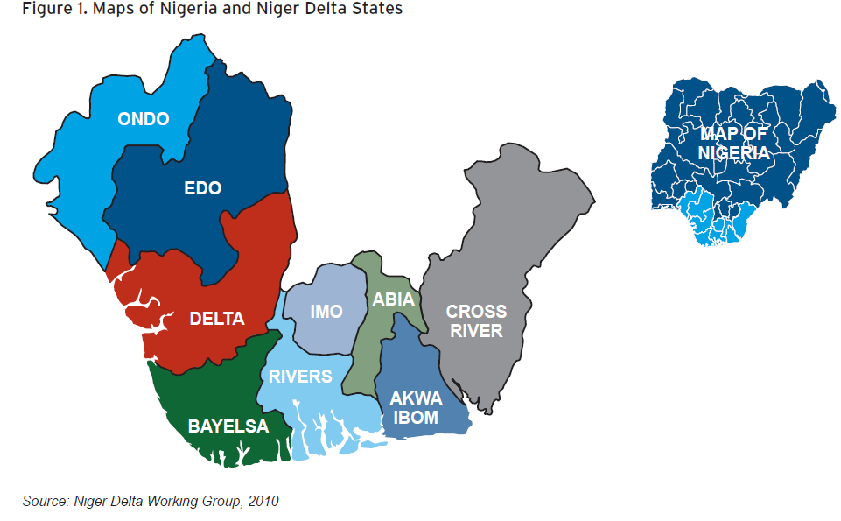

Geology, Relief, Drainage and Ecological Zones of the Niger Delta Region

The Niger Delta region is composed of sedimentary basin, and deposits in the delta waters are comprised mainly of sand, silt, clay, shale and peat. The region is mostly flat and swampy with a network of streams, creeks and rivers. The region exhibits a large amount of biological diversity, and there are five different ecological zones in the Niger Delta: the coastal sandy barrier ridge zone, the mangrove swamp zone, the freshwater swamp zone, the lowland rainforest zone and the montane zone (NDDC, 2005; UNDP, 2006).

Climate

Climate in the Niger Delta region is considered equatorial (UNDP, 2006). Temperatures in the region are typically high with high humidity, and the area experiences large amounts of rainfall nearly year round. Thus, flooding is common to the region.

Settlement Patterns

Flood patterns have influenced the way that humans have settled in the Niger Delta region (UNDP, 2006). The majority of settlements are small (less than 1,000 people). According to the NDDC Regional Master Plan (2005), there are 13,329 settlements in the region, and 94 percent of these have populations of less than 5,000. Only 98 settlements, or one percent of total settlements, can be regarded as urban centers, based on population size. The prevalence of scattered, remote, small settlements makes it difficult to promote sustainable human development in the Niger Delta (UNDP, 2006).

Occupations

Currently in the Niger Delta, agriculture, especially crop farming and fishing, accounts for about 44 percent of employment. The role of these two activities in employment generation and sustainability of households in the region has declined since the emergence of the oil extraction there. The informal sector is the main employer in urban areas, and trade is the major occupation contributing to 17 percent of overall employment in the region (NDDC, 2005). According to Francis et al. (2011), the current trend in the Niger Delta is for young people to seek work in urban centers and not to work in agriculture. Unemployment and underemployment are high in the Niger Delta region. Youth face unemployment rates of more than 40 percent, which has contributed to youth unrest in the region (Francis et al., 2011).

Infrastructure and Social Services

The status and availability of social services in the Niger Delta region are low, despite the region performing better than the national average in terms of poverty rates. Houses in the region are usually of poor quality, e.g., mud-walled houses with a stilt foundation (UNDP, 2006). School and health care facilities in the Niger Delta are severely deteriorated, and there are shortages of qualified teachers and basic health services. Critics, such as UNDP in the Niger Delta Human Development Report, have expressed concern that the Niger Delta region in general has suffered neglect at the hands of the government as well as the multi-national oil companies that, until more recently, did not contribute to socio-economic development in the region (UNDP, 2006).

Oil Production, Security and Environmental Degradation

The Niger Delta region is the hub of oil and gas production in Nigeria. According to the U.S. Energy Information Agency (2013), oil production in the Niger Delta reached its highest level in 2005 (2.44 million barrels per day). However, due to a hostile response by Niger Delta community militant groups to the presence of international companies and subsequent environmental degradation, production levels dropped over the next four years. An amnesty program for militants was established in 2009 that was attributed to improved oil production levels (EIA, 2013). However, last year the Niger Delta region experienced an uptick in security issues surrounding the sector, and production dropped again.

Oil spillages from deteriorated pipelines, illicit extraction (bunkering), and sabotage occur regularly in the region, destroying farm lands and water bodies—the most important livelihood assets of local communities. Ordinioha and Brisibe (2013) estimate that the oil spills could reduce food security by 60 percent and reduce the quantity of nutrients in foods that are grown in contaminated water. While oil spill estimates vary widely depending on the source, Amnesty International (2013) estimates that, among the three largest onshore oil companies (Shell, Agip and Total), more than 300 oil spills occurred annually from 2007-2013.

Ex ante to the current legal framework, companies negotiated and paid rent directly to land owners on whose land oil companies operated (Joab-Peterside, 2007). Recently, legal regimes have transferred oil revenues directly to the federal and state government instead of to land owners. The communities have typically not benefited from the oil rents. In addition, the communities suffer the loss of economic activities from incessant oil spillages leading to destruction of farm lands and water bodies that are the most important livelihood assets of the people. These problems are not adequately addressed either by the oil companies or the federal and state governments in the region. Thus, the Niger Delta region is in need of a development model that could cater to the needs of local communities that have lost their basic means of livelihood (Onwuemele, 2009; Onwuemele, 2012).

The Akassa Community and Study Area

The Akassa community and study area has a land mass of about 450 square kilometers and consists of 19 major towns and villages and about 121 satellite settlements (mainly local fishing ports). The Akassa clan occupies barrier islands and numerous wetlands. The forest land is estimated at 320 square kilometers, while the mangrove swamps are estimated at 60 square kilometers. Being a riverine community, the predominant occupation of the people is farming and fishing. However, due to the increasing pressure on the local fish resources by over exploitation and incessant oil spillages, members of the clan are forced to devise alternative livelihoods, including small-scale farming, canoe carving, palm wine tapping and basket weaving. Figure 2 shows the location of Akassa within the Niger Delta region.

of the Akassa Clan Territory
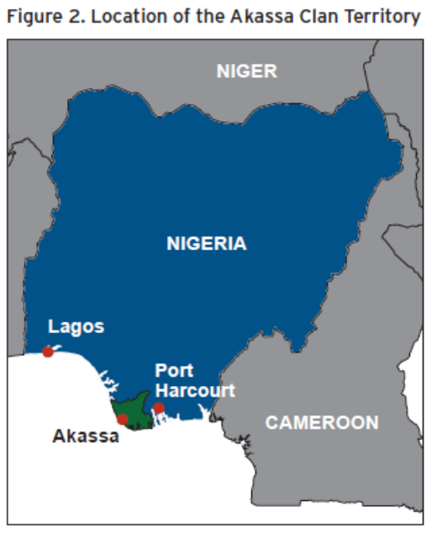

The Akassa Development Foundation Purpose and Structure

The Akassa Development Foundation manages improvements to Akassa area infrastructure, economic development and resources. The types of goods that it produces and manages vary, but can be defined for the most part as 1) public, which is a good that is non-rival with high costs of exclusion or 2) common pool, a rival good that exhibits high costs of exclusion, and vaguely defined property rights (McGinnis, 2011). As McGinnis (2011) notes, a non-rival good refers to a good whose enjoyment does not deteriorate with each use. Some examples of public goods that ADF has provided are community health campaigns and rural, public road and bridge improvements (ADF, 2006). Additionally, examples of ADF’s common pool resource projects include the Akassa Coast Conservation Initiative and the Sea Turtle Conservation (ADF, 2006). The package of development projects that the Akassa Development Foundation offers and the funding for these projects are also common pool resources, rival yet difficult to exclude from members of the community.

After StatOil/British Petroleum conducted an environmental impact assessment of the Niger Delta, the Akassa area was identified as the location that was most likely to face repercussions from oil spills and leakage. The company enlisted the nongovernmental organization Pro-Natura to introduce Akassa community heads to the concept of a community development management committee. The Akassa National Council of Chiefs entered an agreement to implement the concept in 1997 (Akassa management interviews, 2013). Under the Akassa Development Foundation, the community has a 38-member general assembly composed of one male and one female member from each of the 19 Akassa villages (ADF, 2006). These representatives hold the responsibilities of selecting, planning, and implementing development projects (usually infrastructure projects) each year. An eleven-member board of trustees is in charge of resolving conflicts. The board of trustees is elected from the members of the general assembly and serves a four-year term. Below the board of trustees is the steering committee, which is made up of the chairperson of the board of trustees and one representative from each of the subgroups of institutions in the ADF. The steering committee assists in policy formulation for the ADF. Next in line is the ADF secretariat (a five-member management committee) that handles the day-to day operations of the ADF.

Under the general assembly are eight institutions that further divide the sub-interests of the Akassa community:

• Akassa Clan Development Council (ACDC)
• Akassa National Skills Training & Resource Centre (ANSTRC)
• Akassa Clan Women Association (ACWA)
• Akassa National Youths Association (ANYA)
• Akassa National Savings Association (ANSA)
• Akassa National Health Consultative Committee (ANHCC)
• Akassa National Education Consultative Committee (ANECC)
• Akassa National Council of Chiefs (ANCC)

The decision making process in Akassa has been sectioned off into multiple layers. According to Ostrom (2010), this process in itself is a design feature of the institutions that are able to successfully manage common pool resources.

CONCEPTUAL FRAMEWORK OF ANALYSIS

As indicated in section 1, this study adopts the IAD framework (Ostrom et al., 1994) to analyze the institutional design of the ADF and to determine some of the evaluative criteria or factors that can provide insight into the reported success of the organization. Ostrom developed the framework to be consistent with both game theory experiments related to the tragedy of the commons and a large scale meta-analysis of case studies of communities that have successfully managed common pool resources over a long duration of time (Ostrom, 2010). Ostrom’s game theory research proved that isolated, anonymous users of a common pool resource will overharvest, but encouraging communication and collaboration among users reduces overharvesting of and increases mutual benefits from the resource. Ostrom’s case studies provided proof that the type of arrangements that evolved during the games also occurred in a field setting. Nearly 500 case examples showed that communities were able to successfully manage their common pool resources without external intervention from governments or NGOs. Via the case study project, Ostrom (1990) was able to compile eight design principles that characterize institutions that successfully manage common pool resources and avoid the tragedy of the commons. These institutional characteristics are summarized as follows: 1) clearly defined boundaries; 2) congruence with local conditions; 3) collective choice arrangements (users that are impacted by resources are involved in designing the rules governing that resource); 4) user-designated rules featuring graduated sanctions; 5) proper monitoring of resources and users; 6) inexpensive, local and fast conflict resolution; 7) government recognition of the rules; and 8) multiple layer decision making (Ostrom, 2011).

The IAD framework consists of three basic components: the external variables, action situation and the interactions that lead to outcomes. The three components are interconnected by direct links and feedback interactions (figure 3).

Analysis and Development (IAD) Framework
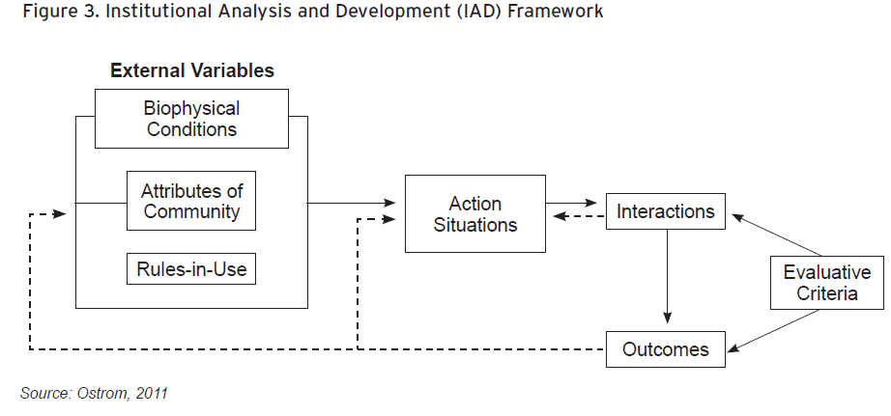
As indicated in figure 3, the external variables (also called the input category) consist of the nature of the good being managed in the action situation, as well as the biophysical conditions, attributes of the community and rules-in-use. The nature of the good refers to the description of the type of good that is under consideration by the community development project, e.g., private, public, toll or common pool resources. The biophysical conditions and the attributes of the community define the existing biological, physical, social and cultural contexts within which development program is undertaken. These extend to community characteristics such as trust, reciprocity, common understanding, social capital and cultural repertoire. Rules-in-use include the formal and informal rules used to govern a specific society. The action situation is the component of the framework where individuals obtain information, choose actions, interact and receive outcomes from their interactions. According to McGinnis (2011), the action situation is a “black box” where the community development policy choices are made. Outcomes are the results of the actions shaped by more controllable internal and less controllable external influences. Evaluative criteria measure the level of success or failure of the outcome based on beneficiaries and other stakeholder evaluations of the development intervention. These criteria include concepts such as efficiency, equity, legitimacy, participation, accountability, fiscal equivalence, consistency with normal values, adaptability, resilience, robustness or sustainability. A detailed description of these criteria is presented in McGinnis (2011).

Our study asked a series of questions posed to the beneficiaries of the Akassa Development Foundation in regard to attributes of the community, the rules-in-use, the action situation and the patterns of interactions that allow the ADF to manage development outcomes. The study also includes questions that asked beneficiaries to evaluate the action situation and development outcomes. The survey questionnaires can be found in annexes 1-3.

In order to understand the external variables for the Akassa Development Foundation, the MODEL study team conducted a background review that covered the biophysical conditions, attributes, and basic rules-in-use of the community (see section 4). The MODEL background research also identified what types of common property resources were managed by the ADF, such as natural resources, roads and public health education campaigns.

Survey questions helped gain more insight into the attributes of the community; these questions include the respondent’s age, gender, household size, marital status, level of education, religious preference, occupation and income level. Questions to determine the attributes of the community also extended beyond demographic questions. For example, respondents were asked whether they are involved in social networks or community groups. To determine the respondent’s level of political participation, they were asked whether or not they are registered in a political party, whether they vote regularly, and whether they feel their vote counts in the election of political office holders.

The remaining survey questions delved into the “black box” of the action situation, the patterns of interactions within it, and its outcomes. These are the evaluative criteria questions that ask the respondent to reflect on the structure and processes of the ADF. Questions about the action situation and patterns of interactions within ADF assess the respondent’s knowledge of the Akassa Development Foundation and their level of involvement. Respondents were asked if they or a member of their household were involved in the design and implementation of the ADF; if they or their family participated in setting the goals; if community members participated in management; and if community members discussed and approved the rules that establish functions, power and responsibilities in the ADF project.

Finally, a series of evaluative questions related to the outcomes of ADF were asked. The survey asked whether the respondents felt their level of participation was sufficient; whether the respondents were satisfied with the design and implementation of ADF; and what has been the state of general living conditions of the Akassa community since the implementation of ADF. Additionally, respondents were asked if the distribution of benefits from ADF was equitable.

DATA

Data Sources

The data for this pilot study is obtained from background research, focus group discussions, in-depth interviews, and a survey conducted by the Foundation for Partnership Initiatives in the Niger Delta (PIND) and the Nigerian Institute of Social and Economic Research (NISER) in collaboration with the Brookings Institution in August and September of 2013. With a population estimated of 18,000 people and 3,000 households, the Akassa community is distributed across 19 different villages. All of the Akassa villages were included in the survey for purposes of this study. The study targeted 10 percent of the Akassa clan households (300 respondents). From each village, 17 households were randomly selected and the heads of households were interviewed; thus, the total number of households interviewed was 323 (23 extra households were added to account for drop-off). A list of every household in every village was obtained, and the sampling procedure entailed assigning random starting numbers with intervals of five to every village. In addition to the household survey, three focus group discussions and five in-depth interviews were conducted to better understand the background and structure of Akassa community and the Akassa Development Foundation. The focus groups were composed of three groups: one group of men, one group of women, and one group of youth. The in-depth interviews were conducted with members of the Akassa steering committee. The focus groups and in-depth interviews were focused on open ended questions similar to the household survey. The household survey, focus group interview, and in-depth interview questionnaires can be found in the annexes 1-3.

The data collected in the surveys included background information, different social, economic and demographic attributes of the community, rules-in-use, and answers to questions pertaining to the evaluative criteria. The interviews provide information on the linkages between the ADF and the context of the Akassa community and the Niger Delta region, and help to inform the background information and context. The data presented in the descriptive statistics and the estimations are from the household survey.

Selected Attributes of the Community

Household Demographic Characteristics

The gender of the respondents (heads of household) is evenly distributed between male and female and the majority of respondents are married. Their average age is 42 years old. Typical to sub-Saharan African communities, the household size in the Akassa community is large, about seven persons per household (table 1).

Demographic Characteristics of Respondents
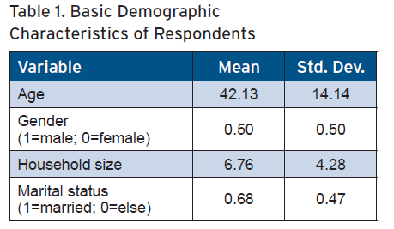

The majority of the respondents have completed secondary education, which means that the level of education of Akassa community is above the rest of sub-Saharan Africa, where one-third of young people fail to complete primary school (UNESCO, 2012) (figure 4). Christianity is the dominant religion in Akassa, accounting for about 96 percent of the community (table 2).

Level of Education of Respondents
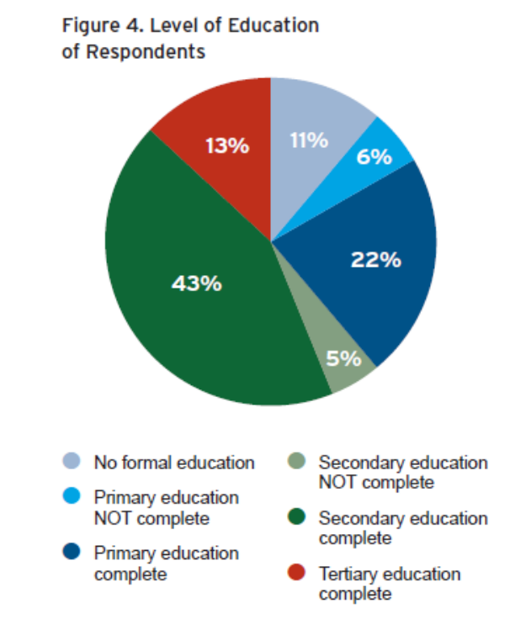

of Respondents
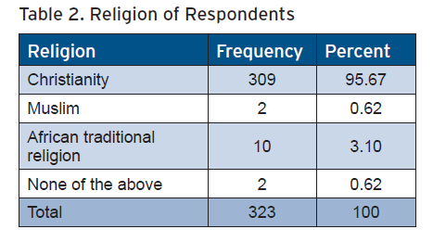
A majority of the respondents are engaged in fishing and trading as their occupation; these activities account for about 68 percent of occupations (figure 5). In terms of income, a majority of the respondents earn between ₦10,000 and ₦30,000 (₦, Nigerian naira) per month, an equivalent of between $60 and $180 per month (table 3). In terms of purchasing power parity for Nigeria, the majority of the respondents earned $3.56-$10.69 (PPP) per day, a figure above the international poverty line of $1.25 (PPP) per day (World Bank Data Bank, 2012).
of Residents
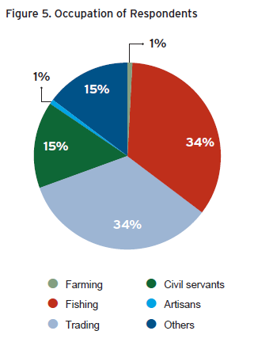

Estimated Income Distribution of Respondents (Monthly, in Nigerian Naira and Current U.S. Dollars)
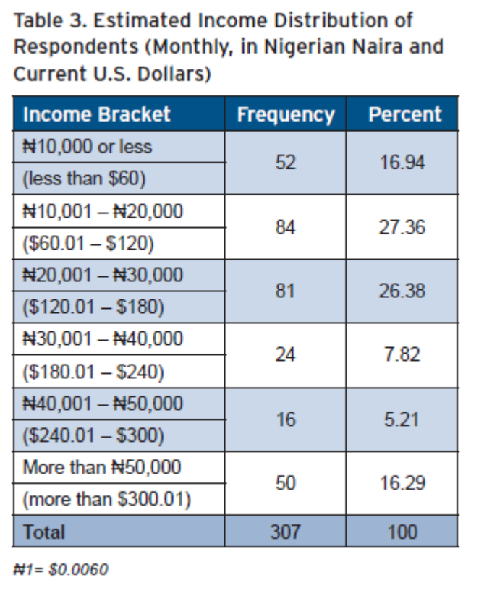

Homogeneity of Respondents and Common Understanding

Based on the descriptive statistics for the Akassa community, the community is fairly homogenous, especially in terms of occupation (most are involved in farming and fishing) and religion (most respondents are Christians). Shared religion can serve as a proxy for common understanding. In the IAD framework defined by McGinnis (2011), “common understanding” is the extent that members of a community share the same values, goals and vision. The Logic of Collective Action (1971), Mancur Olson’s seminal text on group theory, explains that a homogeneous group is more likely to gain consensus in decision making, and the costs of organizing the group are reduced. The IAD framework also notes that common understanding among group members increases trust and the potential for reciprocity. Dividing Akassa members further into eight sub-groups listed in section 4.9, such as the Akassa Clan Women Association, fosters homogeneous subgroups as well. The IAD framework terms this concept the “nesting of enterprise” (McGinnis, 2011). In theory, the subgroups facilitate decision making.

Social Capital and Political Representation

Belonging to social networks, registering for political parties and voting constitute parts of the attributes of community and rules-in-use from the IAD framework. More than half of the respondents (62 percent) indicated that they do not belong to social networks or community social groups in Akassa community. A social network is defined by McGinnis (2011) as stable interactions among members of the community. It is likely that the ADF acts as a good substitute, as it provides benefits that often come with other social networks and groups. Similarly, about 68 percent of respondents replied that they are registered for a political party, 54 percent vote regularly, and 69 percent have confidence in the effectiveness of their votes (table 4).

and Political Representation of Respondents
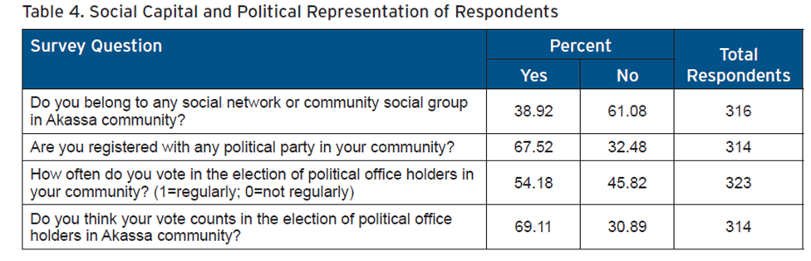

Evaluative Criteria of Akassa Development Foundation Action Situation, Interactions and Outcomes

The responses in this section are evaluative criteria related to the performance of internal processes within the action situation of the Akassa Development Foundation. The action situation describes the ways that actors (in this case ADF beneficiaries) get information, choose actions, interact with each other, participate in decisions and influence outcomes given the rules of the game (Ostrom et al., 1994). Evaluative criteria determine whether the action situation, pattern of interactions and outcomes are perceived to be successful by the respondents.

As expected, almost all of the survey respondents (98 percent) are aware of the ADF. More than half of the respondents (56 percent) reported that they or other members of their household were involved in the design and implementation of project. Fifty-nine percent of respondents or members of their families are involved in setting the goals of the project. Almost all of the respondents (97 percent) indicated that community members participate in the management of ADF projects. A majority of the respondents (about 91 percent) reported that community members were asked to discuss and approve the rules that establish functions, power and responsibilities in the Akassa.

In terms of survey questions related to outcomes, about 92 percent of respondents feel their level of participation is sufficient and a majority of the respondents (nearly 93 percent) indicated that they are satisfied with design and implementation of the project. In addition, nearly 86 percent of respondents reported that the distribution of project benefits was equitable. Table 5 gives a detailed description of the responses to the evaluative criteria questions. The high level of participation by the community members of Akassa is congruent with the “collective choice arrangement” design principle noted in Ostrom (2010). The high level of involvement of community members in the design and implementation, rule approval, and management of the ADF make it more likely that the project design will be congruent with the local social and environmental characteristics.

Awareness and Participation of Respondents
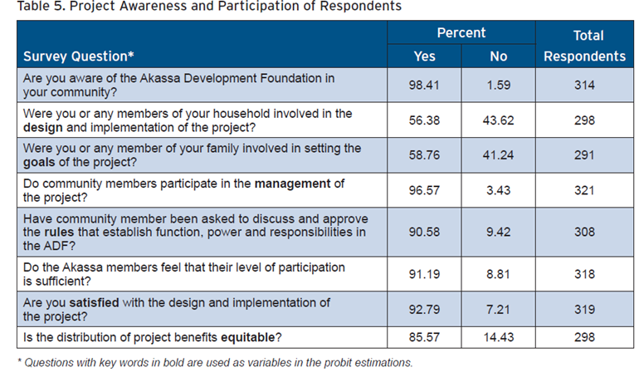

Table 6 shows that about 59 percent of the respondents who reported satisfaction with the implementation of the project also reported that they or their family members were involved in the design and implementation of the project. Forty-one percent of the respondents answered that they were satisfied with the design and implementation of the project, but they or their family members were not involved in the design and implementation of the project. This reveals that it is possible to be satisfied without being involved in the design or implementation of the project, which is evidence of the level of trust in the community. Only 2 percent or (4 heads of household) were not satisfied with the design and implementation and had been involved (or had family that was involved) in the design and implementation of the project, while 12 percent (16 respondents) indicated that they were neither satisfied nor involved with the design and implementation of the project.

Table 6 also gives details of the demographic characteristics of the households who were either involved or not involved in project design implementation in relation to their reported satisfaction with how the project was designed and implemented. There is not much difference among the average age of respondents. However, the group that responded that they were neither satisfied nor involved with the design and implementation of the project appear to be younger on average. Female respondents account for the majority of the satisfied and involved group whereas male respondents account for the majority of the not satisfied but involved group. Married respondents account for the majority of the responses of the neither satisfied nor involved category (although there are only 16 responses for this category, which makes statistical inference less meaningful).

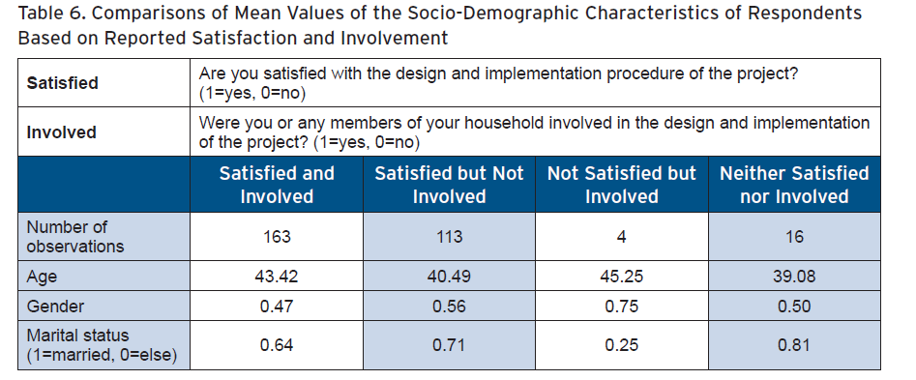

Respondents were also asked whether the Akassa Development Foundation has had an impact on the general living conditions of the community members. About half of the respondents (48 percent) indicated that ADF drastically improved the living conditions of community members; about 43 percent of respondents reported that the living conditions of community members improved slightly; and 9 percent reported no change (figure 6). Thus, a majority of respondents found at least a little improvement in the state of general living conditions of the Akassa community.

Impact of Akassa Development Foundation on General Living Conditions of the Community
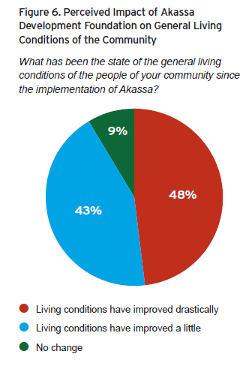

Empirical Method and Model Variables

Empirical Model

Binary choice models are commonly used when outcomes are divided into two categories. For this study, the probit model, which is one of the binary choice models, is adopted to analyze the impacts of socio-demographic (attributes of the community) and evaluative criteria variables on the success of ADF.

The probit model is specified as:

Where Pr denotes probability, Y represents the outcome variable, which is satisfaction with the implementation of ADF in our study. The outcome variable takes the value of 1 if the respondent is satisfied with ADF’s design and implementation and 0 otherwise. The variable X represents a vector of independent variables hypothesized to influence the outcome, φ is the Cumulative Distribution Function (CDF) and denotes the parameter estimates from the model.

The probit model assumes that there is a latent (unobservable) variable , Y*, that is expressed as:

The error term, ε, is normally distributed with mean equal to 0 and variance equal to 1, ε ~ (0, 1)

Although y* is not observed, y is observed as:

Equations (2) and (3) yield:

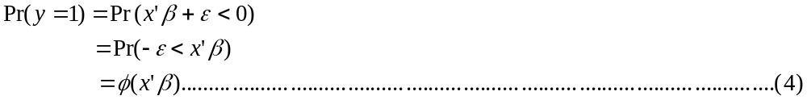

In addition to estimation of parameters, the marginal effects from the probit model that calculate the magnitude of change on the outcome variable induced by a unit change from the explanatory variables are calculated as follows:

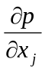= 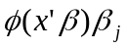 , j=1…n………………………………………….……………… (5)

Model Variables and Estimation Procedures

The dependent variable for this study is the opinion of the respondents on the outcome of ADF in terms of design and implementation. Respondents were asked if they are satisfied with the design and implementation of the project. This response is taken as a proxy for the outcome as described in the IAD framework. The dependent variable, satisfied, is a dummy variable which takes the value of 1 if respondents are satisfied with the design and implementation of the project or 0 if otherwise. The independent explanatory variables include the attributes of the community variables and the evaluative criteria variables.

In particular, age, education (1-6), gender (a dummy variable 1=male; 0=female=0), income (1-6) and marital status or married (a dummy variable 1=yes; 0=no) are included in the model. All of the attributes of the community variables are included in model 1 (attributes only) and 9 (with the evaluative criteria variables) (table 7).

The evaluative criteria variables are as follows:

- Design—Were the respondent or any members of the respondent’s household involved in the design and implementation of the project?
- Goals—Were the respondent or the respondent’s family members involved in setting the goals of the project?
- Management—Do the community members participate in the management of the project?
- Rules—Have community members been asked to discuss and approve the rules that establish function, power and responsibilities in the ADF?
- Equitable—Is the distribution of project benefits equitable?

The evaluative criteria are included in all probit regressions in all models except model 1. The marginal effects of the evaluative criteria that estimate the change in probability of the dependent variable with respect to a unit change in an independent variable are estimated in model 4.

Estimates of the Probit
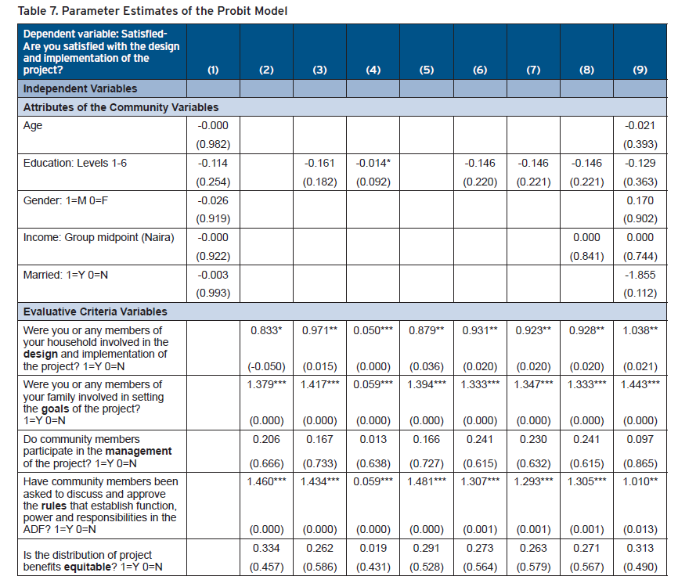
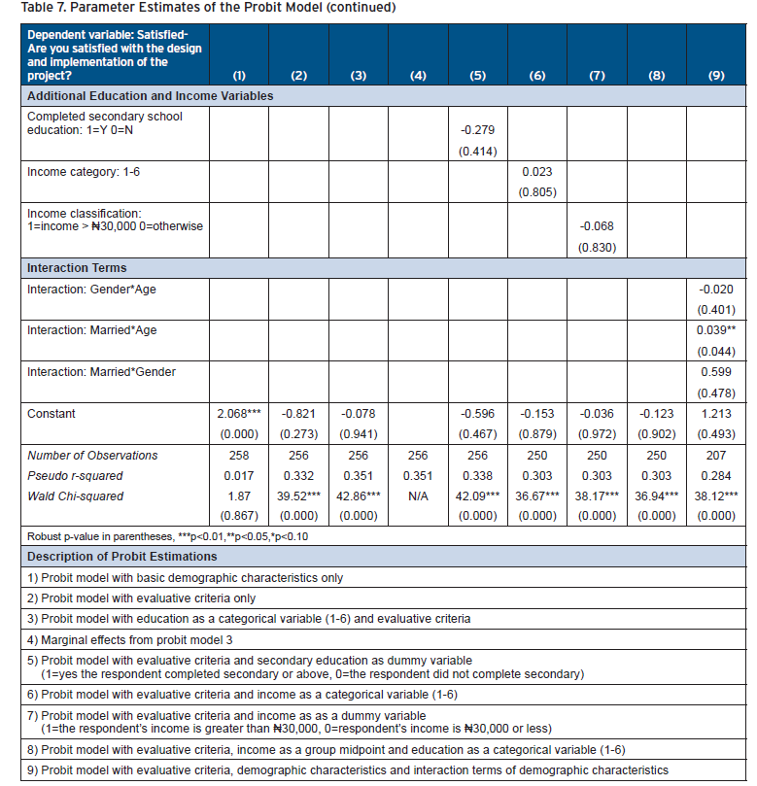

Education and Income

Variations of the education and income categorical variables were used as proxies for the respondent holding relatively elite status within the Akassa community. We run two different regressions to analyze the effect of education on satisfaction on the design and implementation of the project. First, we include education as a categorical variable (1-6) in the probit model (models 1, 3, 6, 7, 8 and 9) as well as the marginal effects estimation in model 4. Second, to denote elite status, the education categorical variable is divided into a dummy variable 1=secondary education complete or 0=otherwise. The dummy variable is used in model 5. The completion of the secondary level of education of the surveyed beneficiary can be viewed as a proxy for elite status because typically this level of education is correlated with elite status in the region.

In addition to education, we investigated the relationship between the income variable and whether the respondent was satisfied, as income is positively correlated with elite status (Argawal, 2001; Katz and Sara, 1997; Rao and Ibanez, 2003). We run different regressions to investigate the relationships between income and the satisfied variable. First, the income variable is included as a midpoint of each income bracket group; see models 1, 8 and 9. The group midpoint is used because it enhances interpretation of the income variable by providing a continuous value rather than a categorical value. We also included income as a categorical value and as a dummy with 1=income greater than ₦30,000 and 0=otherwise in models 6 and 7, respectively.

Interaction Terms

Interaction terms are also included in the model to test the relationships between various attributes of the community variables and the outcome variable. These interactions include: gender interacted with age, which becomes gender*age; married interacted with age, which becomes married*age; and married interacted with gender, which becomes married*gender. These are included in model 9.

RESULTS AND DISCUSSION

Main Results

Table 7 presents the results from the different probit models used to analyze the effect of attributes of the community and evaluative criteria variables on the dependent or outcome variable. All of the probit models were run by imposing a robust standard error estimation using the robust variance covariance matrix estimates (VCE robust) within STATA to control for potential heteroskedasticity of the error terms. Results show that the Wald statistics as indicated by chi-square (x2) statistics are highly significant (p<0.001) for all of the models, except model 1, which indicates that these models have strong explanatory powers. The pseudo R-square values of the models range from .0166 (model 1) to 0.351 (model 3) showing that independent variables explained 1.6 to 35 percent of the variation in the dependent variable, satisfied.

Results from the probit analysis also revealed that three of the evaluative criteria variables' parameter estimates were significant across the different models in which they were included: the involvement of respondents or their family members in setting goals (goals), involvement of community members in discussing and approving rules (rules), involvement of the respondent or members of the respondent’s household in project design and implementation (design). Additionally, the interaction term for age and marital status (married*age) positively and significantly affects respondents’ satisfaction with the design and implementation of the Akassa development projects (satisfied) (the interaction term can be found in model 9).

Discussion

Attributes of the Community Variables

The results from the probit analysis show that the variables age, education, gender, and whether the respondent is married (married) are not statistically significant when included in the probit models (models 1 and 9). The lack of significance across the variables age, gender and married may lend support to the theory that a homogenous group supports the decision making process in the action situation, thereby increasing the likelihood of respondent satisfaction with the design and implementation of the ADF. Basically, it is possible these variables are not significant because most of the participants are identical in demographic characteristics.

Education and Income

The parameter estimate from the regression with education as a categorical value is negative and insignificant statistically (model 3). Education is negative and significant at the 10 percent level only for the marginal effects estimation (model 4). The parameter estimate from the regression with education as a dummy variable is also negative and not statistically significant (model 5). In the regressions that use income bracket midpoint values, the results show that the parameter estimate of income is not statistically significant (models 1, 8 and 9). Next, we included income as a categorical variable (1-6) and also found that the parameter estimate of income is not statistically significant (model 6). The parameter estimate of the regression with income as a dummy variable is negative and not statistically significant (model 7).

Like education, the insignificance of income in influencing the outcome (whether the respondent was satisfied) is a very encouraging indicator of the success of ADF. The convention with bottom-up community development projects is that they are prone to elite capture, a chronic problem in community development interventions in developing nations (Mansuri and Rao, 2004). In the example of Rao and Ibanez (2003), wealthier and better-networked individuals dominated decision making in the researchers’ study of Jamaican participatory projects.

Thus, in the ADF, the results for the probit estimations for education and income provide evidence that elite capture does not impinge on respondent satisfaction with the ADF design and implementation.

Evaluative Criteria Variables

Model results also show that involvement of the respondent or the respondent’s household in the design and implementation of the project (design), involvement of the respondent or the respondent’s family in setting goals of the project (goals), and community involvement in discussing and approving rules (rules), positively and significantly affect the satisfaction of beneficiaries with the design and implementation the ADF across all of the models in which they are included (models 2, 3, 4, 5, 6, 7, 8 and 9). This is in line with the IAD framework that emphasizes that the level of participation and input from the community from project inception to implementation will influence the final outcome. The results from this study also support the concurrence of the community-driven development literature that participation has a causal link with project success (Agwu, 2013; Isham, Narayan, and Pritchett, 1995; King, 2013). However, given the nature of the outcome variable satisfied, the interpretation of results may differ slightly in that participation in Akassa is linked to respondent satisfaction and not necessarily to overall measures of success.

Conning and Kevane (2002) show that communities with egalitarian preferences and transparent decision making are more likely to achieve effective distribution of benefits than those that are less egalitarian and more opaque. Although not significant, the parameter estimate of equitable (equitable distribution of project benefits) is positive. Equitable distribution of the project benefits was hypothesized to positively and significantly influence the outcome of the project (Ostrom, 2010).

Marginal Effects Analysis

The marginal effects measure the expected change in probability of dependent variable with respect to a unit change in an independent variable is presented in model 4 of table 7. For instance, increasing education by one level (in this case one category, see annex 3, question B.4) decreases the likelihood of satisfaction negatively and significantly by 1.4 percent. This is further indication that elite capture does not hinder participant satisfaction; rather, participants with a lower level of education are more satisfied with the design and implementation of the project in the margin. Community consultation in the design and implementation of the project increases the likelihood of satisfaction with the implementation of ADF by 5 percent. Community involvement in setting project goals increases the likelihood of satisfaction with the implementation of the ADF by 6 percent. Community participation in discussion and approval of Akassa model rules increases the likelihood of satisfaction with the implementation of the ADF also by 6 percent.

Interaction Terms

Of the three interaction terms, the interaction married*age positively and significantly affects satisfaction with the design and implementation of the project (model 9). This could be due to the fact that the elderly and the stable married couples may have experienced previous projects that failed due to the absence of participatory approach in the design and implementation development projects, unlike the ADF.

CONCLUSIONS AND RECOMMENDATIONS

ADF is one of the many community development interventions in the Niger Delta. Preliminary studies indicated that ADF has been successfully implemented; however, these studies did not explicitly or empirically evaluate the reasons behind the success of ADF. To fill the gaps in knowledge, this study used data obtained from a household survey, focus group discussions and in-depth interviews conducted in August and September of 2013 by the Foundation for Partnership Initiatives in the Niger Delta (PIND) and the Nigerian Institute of Social and Economic Research (NISER) in collaboration with the Brookings Institution. The survey covered 323 households across all 19 villages in the Akassa community.

This study employed the IAD framework to conceptualize the drivers of successful outcomes in the ADF and the probit model to analyze the factors that influence respondent satisfaction. Descriptive statistics showed a high level of member satisfaction with the design and implementation of the project—nearly 92 percent of the respondents. The proxies for elite status, a high level of education and/or income, do not significantly impact the satisfaction of the survey respondents as revealed from the probit model results. Thus, there is no evidence that elite capture impinges on beneficiary satisfaction with the Akassa Development Foundation. Results from the probit model also showed that involvement in the design and implementation of the project, involvement in setting goals of the project, and community involvement in discussing and approving the rules positively and significantly affect the beneficiary satisfaction with the ADF. This is line with the “collective choice arrangement” design principle of successful institutions that manage common pool resources (Ostrom, 2010).

Based on this preliminary analysis, policymakers should place an emphasis on the importance of collective choice arrangements and a participatory approach when deciding to utilize the Akassa Development Foundation type of community development interventions. In the case of Akassa, the most significant predictors of participant satisfaction with project design are being involved in the design and implementation of the project, being involved in setting the goals, and discussing and approving the rules of the project. Further replications of the ADF model should consider how to retain these features from the original concept.

OPPORTUNITIES FOR FURTHER RESEARCH

As mentioned in the introduction, this case study is a the first case study of two in the Models of Development and Experiential Learning (MODEL) pilot case study project. The goal of the study is to help gain a better understanding of how various development interventions work. If the MODEL study is continued, eventually the case studies will be compiled in a database for use by policymakers and development practitioners.

The Akassa Development Foundation provides an opportunity to determine whether other design principles are relevant to the beneficiaries' perceptions of the success of the institution and the satisfaction of the members. For example, the Akassa Development Foundation features a series of nested enterprises that subdivide community interests. This feature appears to facilitate participation and decision making. Further analysis into the perception of Akassa beneficiaries related to nested enterprises (layered decision making) could further illuminate the components of Akassa that contribute to its success. In addition to nested enterprises, Akassa also features a board of trustees responsible for conflict resolution. The board of trustees could be analyzed further to determine what types of conflict resolution mechanisms are used by the ADF. Also, it would provide interesting information to determine whether the conflict resolution mechanisms of Akassa are working efficiently and contributing to member satisfaction. Beyond these examples, further examination of the Akassa Development Foundation’s coordination and decision making processes, and funding mechanisms could yield a more detailed list of successful design components for policymakers. In addition to the design features, further tests for the presence of elite capture could be conducted using a different outcome variable and refined survey questions.

Finally, the potential for future studies with the MODEL study that use the IAD framework and a refined questionnaire could potentially bring about more details about the relationships between satisfaction with the design and the implementation of ADF or non-perception-based outcome variables (e.g., income).

REFERENCES

Akassa Development Foundation. (2006). Akassa Development Foundation: Annual Report 2006. Retrieved from http://www.pronatura-nigeria.org/OLD-WEBSITE/adf/akassa.html, accessed February 2014

Akassa mangagement interviews. (2013). Focus group discussions of Akassa Management. Overseen by Case Study Coordinator, Andrew Onwuemele. August and September 2013.

Agwu, M.O. (2013). Community participation and sustainable development in the Niger Delta. British Journal of Education, Society and Behavioral Science, 3(1):33-46

Amnesty International (2013). Bad information: Oil spill investigations in the Niger Delta. Retrieved from, http://www.amnesty.org/en/library/info/AFR44/028/2013/en, accessed February 2014.

Andersson, K. (2006). Understanding decentralized forest governance: an application of institutional analysis and development framework. Sustainability, Science and Policy, 2(1), 25-35.

Argawal, B. (2001). Participatory exclusions, community forestry, and gender: An analysis of South Asia and a conceptual framework. World Development, 29(10), 1623-1648.

Barron, P., Humphreys, M., Paler, L., & Weinstein, J. (2009). Community‐based reintegration in Aceh: Assessing the impacts of BRA‐KDP. Indonesian Social Development Paper, 12. World Bank: Washington, DC

Beath, A., Christia, F., Enikolopov, R., & Shahim A. K. (2012). Randomized impact evaluation of phase II of Afghanistan’s National Solidarity Programme (NSP). Final Report. MIT, Harvard, New Economic School, February, 14, 2012.

Casey, K., Glennerster, R. & Miguel, E. (2011). The GoBifo project evaluation report: Assessing the impacts of community driven development in Sierra Leone. Final report. Brown University, Abdul Latif Jameel Poverty Action Lab, and University of California, Berkeley.

Chase, R. S. & Sherburne‐Benz, L. (2001). Household effects of African community Initiatives: Evaluating the impact of the Zambia social fund. World Bank: Washington, D.C.

Conning, J., & Kevane, M. (2002). Community-based targeting mechanisms for social safety nets: A critical review. World Development, 30 (3), 375-394.

Cross River State. (2012). Cross River State Ministry of Agriculture Website. Retrieved from http://crossriveragriculture.org/index.php/community-based-natural-resources-managemenet-programme-cbnrmp, accessed February 2014

Department for International Development (DFID). (2001). Sector wide approaches (SWAps). Key sheets. Eds. Farrington, J. and Mundy, P. Overseas Development Institute. Department for International Development. Retrieved from http://www.odi.org.uk/publications/2309-sector-wide-approaches, accessed February 2014.

Environmental Resources Management Ltd. (ERML) (1997). Environmental and Socioeconomic Characteristics of the Niger Delta. ERML: Lagos.

Farrington, J. (2001). Sustainable livelihoods, rights and the new architecture of aid. Natural Resource Perspectives, 69. Overseas Development Institute: London.

Francis, P., LaPin, D. & Rossiasco, P. (2011). Securing development and peace in the Niger-Delta: A social and conflict analysis for change. Woodrow Wilson International Center for Scholars Africa Program. Retrieved from http://www.wilsoncenter.org/publication/securing-development-and-peace-the-niger-delta-social-and-conflict-analysis-for-change, accessed February 2014.

Frynas, G. (2005). The false developmental promise of corporate social responsibility: Evidence from multi-national oil companies. International Affairs, 81(3), 581-598

Gillespie, S. (2004). Scaling up community-driven development: A synthesis of experience. International Food Policy Research Institute, Food Consumption and Nutrition Division, FCND Discussion Papers, 181.

Gunjan, D. (2011). Do community driven development (CDD) programs improve social relationships measured by perceived discrimination among different ethnicities in Nepal? Unpublished Master’s Thesis. Oregon State University: Oregon.

Holmes, R., Samson, M., Magoronga, W., Akinrimisi, B. & Morgan, J. (2011). The potential for cash transfers in Nigeria. ODI Project Briefing, 59. London: Overseas Development Institute

Idemudia, U. (2009). Oil extraction and poverty reduction in the Niger Delta: A critical examination of partnership initiatives” Journal of Business Ethics, 90, 91-116

Imperial, M.T. & Yandle, T. (2005). Taking institutions seriously: Using the IAD framework to analyze fisheries policy. Science and Natural Resources, 18, 493-509.

Isham, J., Narayan, D., & Pritchett, L. (1995). Does participation improve performance? Establishing causality with subjective data. The World Bank Economic Review, 9(2), 175-200.

Joab-Peterside, S. (2007). GREEN GOVERNANCE: The Case of Akassa Community Forests Management and Development Plan. University of California. Institute of international studies.

King, E. (2013). A critical review of community-driven development programmes in conflict-affected contexts. London: DFID / International Rescue Committee. Retrieved from, http://www.gsdrc.org/go/display&type=Document&id=5326, accessed February 2014.

Krantz, L. (2001). The sustainable livelihood approach to poverty reduction: An introduction. Swedish International Development Cooperation Agency: Stockholm.

Kretzmann, J. P. & McKnight, J. L. (1993). Building communities from the inside out: A path toward finding and mobilizing a community’s assets. ACTA Publications: Chicago

Mansuri, G. & Rao, V. (2004). Community-based and-driven development: A critical review. The World Bank Research Observer, 19 (1), 1-39.

McGinnis, M.D. (2011). An introduction to the IAD and the language of Ostrom workshop: a simple guide to a complex framework. Policy Studies Journal, 39 (1), 163-177.

Niger Delta Development Commission (NDDC). (2005). Draft Copy of the Niger Delta Regional Development Regional Master Plan. Directorate of Planning. NDDC, Port Harcourt.

Niger Delta Working Group. (2014). Map of Nigeria. Website Retrieved from, http://ndwgnews.blogspot.com/p/national.html, accessed April 29, 2014.

Olson, M. (1971). The Logic of Collective Action: Public Goods and the Theory of Groups. Harvard University Press: Cambridge, MA

Oluduro, O., & Oluduro, O. F. (2012). Nigeria: In search of sustainable peace in the Niger Delta through the Amnesty Programme. Journal of Sustainable Development, 5 (7).

Olugboyega, O. & Kolawole, O. (2005). Policies and programs for poverty reduction in rural Nigeria. An interim research report submitted to the African Economic Research Consortium (AERC), Nairobi for the second phase collaborative poverty research project.

Onwuemele, A. (2009). The non-farm sector as a catalyst for rural development: A case study of Isoko land in the Niger Delta, Nigeria. Unpublished Ph.D Thesis, University, Benin, Benin City

Onwuemele, A. (2012). Pathways for sustainable development under global environmental changes in the Niger Delta, Nigeria. Paper Presented at the Planet under Pressure conference held in London from 26st -29th March, 2012.

Ordinioha, B., & Brisibe, S. (2013). The human health implications of crude oil spills in the Niger Delta, Nigeria: An interpretation of published studies. Nigerian Medical Journal: Journal of the Nigeria Medical Association, 54 (1), 10.

Ostrum, E. (1990). Ostrom, E. (1990). Governing the Commons: The Evolution of Institutions for Collective Action. Cambridge University Press.

Ostrom, E. (1998). A behavioral approach to the rational choice theory of collective action. American Political Science Review, 92 (1) 1-22.

Ostrum, E. (2010). Beyond markets and states: polycentric governance of complex economic systems. The American Economic Review, 100: 641-672.

Ostrom, E. (2011). Background on the institutional analysis and development framework. Policy Studies Journal, 39 (1), 7-27.

Ostrom, E., Gardener, G., & Walker, G. (1994). Rules, Games and Common Pool Resources. University of Michigan Press: Ann Arbor, MI.

Platteau, J. & Gaspart, P. 2003. The ‘elite capture’ problem in participatory development. Centre for Research on the Economics of Development (CRED). Faculty of Economics Rempart de la Vierge, 8 B-5000 Namur Belgium.

Rao, V. & Ibanez, A. M. (2003). The social impact of social funds in Jamaica: A mixed-methods analysis of participation, targeting, and collective action in community-driven development, 2970. World Bank Publications: Washington, D.C.

Sara, J., & Katz, T. (1997). Making the rural water supply sustainable: Report on the impact of project rules. UNDP-World Bank Water and Sanitation Program.

Statoil. (2007). Akassa Model Website. Retrieved from http://www.statoil.com/en/environmentsociety/sustainability/2007/society/countrycases/nigeria/pages/akassamodel.aspx, accessed February 2014.

United Nations Development Program (2006): Niger Delta Human Development Report. United Nations Development Programme

United Nations Educational Scientific and Cultural Organization. (2012). One third of young people in Sub-Saharan Africa fail to complete primary school and lack skills for work. UNESCO Press. Retrieved from http://www.unesco.org/new/en/media-services/single-view/news/one_third_of_young_people_in_sub_saharan_africa_fail_to_complete_primary_school_and_lack_skills_for_work/, accessed February 2014

United State Energy Information Administration (2013). Nigeria: Analysis brief. Retrieved from http://www.eia.gov/countries/analysisbriefs/Nigeria/nigeria.pdf, accessed February 2014.

Wali, A. L. (2008). Oil Wealth and Local Poverty: Exploitation and Neglect in the Niger Delta. ProQuest. Dissertation for Master’s thesis in international relations. Webster University: Geneva, Switzerland.

Wong, S. (2012). What have been the impacts of World Bank Community-Driven Development Programs? CDD impact evaluation review and operational and research implications. World Bank: Washington, DC. Retrieved from http://documents.worldbank.org/curated/en/2012/03/16374801/impacts-world-bank-community-driven-development-programs-cdd-impact-evaluation-review-operational-research-implications., accessed February 2014.

World Bank Data Bank. (2012). PPP conversion factor (GDP) to market exchange rate ratio. Nigeria 2012 figures. Retrieved from, http://data.worldbank.org/indicator/PA.NUS.PPPC.RF, accessed May 5, 2014.

Annex 1. Akassa Beneficiaries Household Questionnaire

Introduction

The general purpose of the questionnaire administration is to yield quantitative data that will shed light on and complement findings stemming from the qualitative data relating to all issues and indicators pertaining to the Akassa Development Model in the Niger Delta region of Nigeria.

Data and information obtained through this questionnaire will be kept confidential and used only for research and planning purposes.

INSTRUCTIONS

1. The target respondents for this questionnaire are the heads of households in the communities where the Akassa Development Foundation Model was implemented.
2. Only one questionnaire may be administered to a household.
3. For each question with options, please tick the appropriate option(s) that fit the respondent’s answer(s).

Section A: Identification

Name of Enumerator

Enumerator Identification Number

Name of Supervisor

Household Identification Number

Name of Community or Village

Date of interview

A.1. State

A.2. Local Government Area (LGA)

A.3. Name of household head (respondent)

Section B: Households and Environmental Characteristics

B.1. Sex of respondents:
1. Male
0. Female

B.2. Age of respondent in years

B.3. Marital status of respondent
- Married
- Single
- Divorced/separated
- Widow/Widower
B.4. Level of education
- No formal education
- Primary education not completed
- Primary education completed
- Secondary education not completed
- Secondary education completed
- Tertiary education completed
B.5. Indicate your religious preferences
- Christianity
- Muslims
- African Traditional Religion
- None of the above
B.6. Household size, total number of persons:

B.7. Number of children (number male, number female)

B.8. Occupation of Household head
- Farming
- Fishing
- Trading
- Civil Servants
- Artisans
- Others, (Specify)

B.9. Estimated income of the respondent per month
  - Less than N10,000
  - N10,001 – N20,000
  - N20,001 – N30,000
  - N30,001 – N40,000
  - N40,001 – N50,000
  - More than N50,000
B.10. Do you belong to any social network or community social groupings in Akassa community?
- Yes
0. No

B.11. Are you registered with any political party in your community?
1. Yes
- No

B.12. How often do you vote in the election of political office holders in your community?
2. Regularly
1. Occasionally
0. Not at all

B.13. Do you think your vote counts in the election of political office holders in Akassa community?
1. Yes
0. No

Section C: Model Project Design and Implementation

C.1. Are you aware of the Akassa Development Foundation in your community?
1. Yes
0. No

C.2. If yes, were you or any members of your household involved in the design and implementation of the project?
1. Yes
0. No

C.3. What were the main problems in your community before the advent of Akassa Development models? (Tick all that apply)
- Unemployment among youths in the community
- Lack of basic amenities
- Environmental degradation
- Insecurity
- Poor skills among members of the community
- All of the above
C.4. What was the goal of the project in your community? (Tick all that apply)
- Provide employment for youth
- Provide social amenities
- Protect the environment
- Provide security
- Capacity building for members of the community
- All of the above
- Don’t know
C.5. Where you or any members of your family involved in the setting the goal of the project?
1. Yes
0. No

C.6. Who were the main stakeholders in the design and implementation of the project? (Tick all that apply)
- Men’s group in the community
- Women’s group in the community
- Youth group in the community
- Community based organizations (CBOs)
- Government agencies and representatives
- All of the above
- Don’t know
C.7. Who identifies the community project to fund in the Akassa Development model? (Tick all that apply)
- Men’s group in the community
- Women’s group in the community
- Youth group in the community
- Institutions in the Akassa model
- Government agencies and representatives
- All of the above
- Don’t know

C.8. Do community members participate in the management of the project?
1. Yes
0. No

C.9. Do the Akassa community members feel that their level of participation is sufficient?
1. Yes
0. No

C.10. Have community members been asked to discuss and approve the rules that establish functions, power and responsibilities in the Akassa model?
1. Yes
0. No

C.11. Are you satisfied with the design and implementation procedure of the project?
1. Yes
0. No

C.12. How will you describe the success of the project?
2. Very successful
1. Successful
- Don’t know

C.13. What factors in the design and implementation of the model projects brought about the successes in the project? (Tick all that apply)
- Popular participation
- Sufficient funding
- Bottom-top approach of the project
- Wide consultation
- Others (specify)

C.14. State three reasons why you think the project was successful
1.
2.
3.

Section D: Benefits of the Project

D.1. What has been the state of employment since the implementation of model project started in your community?
2. Improve drastically
- Improve little
0. No change
D.2. What has been the state of healthcare facilities since the implementation of model project started in your community?
2. Improve drastically
1. Improve little
0. No change

D.3. What has been the state of security of lives and property since the implementation of model project started in your community?
2. Improve drastically
1. Improve little
0. No change

D.4. What has been the state of the environment since the implementation of model project started in your community?
2. Improve drastically
1. Improve little
0. No change

D.5. What has been the state of access to educational facilities since the implementation of model project started in your community?
2. Improve drastically
1. Improve little
0. No change

D.6. What has been the state of the general living conditions of the people of your community since the implementation of model project started in your community?
2. Improve drastically
1. Improve little
0. No change

D.7. Has any member of your household received any benefits from the implementation of model project?
1. Yes
0. No

D.8. What kind of benefits were received?
- Credit facility
- Capacity building
- Free medical care
- Cash transfers
- Apprenticeship training
- Provision of livelihood tools
- Infrastructure
- Others (specify)
D.10. Do you think this project benefited both males and females?
1. Yes
0. No

D.11. Is the distribution of project benefits equitable?
1. Yes
0. No

Annex 2. Focus Group Discussion (FGD) Guide for Key Informants in Akassa

1. What in your view is the Akassa development model all about?
2. What are the features and elements in your community that necessitated the need for the initiation of the Akassa Development Foundation?
3. Who were the main actors in the design and implementation of the project in your community?
4. Were the community members involved in the design and implementation of the project in your community?
5. Did you play any role in the design and implementation of the project in your community?
6. Do the beneficiaries/community members have a say in decision making in the Akassa model?
7. How do community members express their concerns over decision making? (e.g., speak in meetings, legal ways, etc.)
8. What are the changes that came about because of this project in your community?
9. What do you see as the benefit of community participation and management in preparation and implementation of the model project?
10. What are the benefits for the community and how are they distributed?
11. What type of good is produced and managed?
12. What do you think contributed to the success of the Akassa development foundation model?
13. How would you describe the acceptability of the model project by the immediate communities and beneficiaries?
14. Is the model project community-led?
15. Kindly describe the ownership structure of the model project

Annex 3. In-Depth Interview Guide for Akassa Model Project Operators (Management Interviews)

1. What is the Akassa development model all about?
2. What are the philosophy and the main terms used in operating the model?
3. What are the institutional arrangements for the operationalization of the Akassa model?
4. What is the name of your institution in the Akassa model project and what type of governance is involved?
5. What is the hierarchy of the various institutions in the Akassa model?
6. What are the background features and elements in the communities that necessitated the need for the initiation of the model?
7. Could you highlight the goal and specific objectives of your institutions?
8. How many members do you have in your institution and how are they elected and their tenure limits?
9. What are their responsibilities?
10. Do members get compensated for their time?
11. How are they changed if incompetent?
12. How does your institution interact with other organizations like Government agencies, NGOs, etc.?
13. What is your view on the Akassa model in terms of whether it is complementing or substituting other projects from government and NGOs?
14. How is the Akassa development model project different from other development projects from Government or NGOs?
15. What are the procedures of the Model Projects that enable the efficient implementation of the Program?
16. How do you source for funds to carry out your responsibilities?
17. How do you identify community projects and who decide on the development projects to fund?
18. How do members resolve disagreements and competing needs?
19. What will you say are the factors which brought about success?
20. What are the benefits of the model and who are the main benefactors?
21. What are the perceived challenges facing the implementation of the models project?
22. Does the Akassa Development Foundation have an exit strategy from Pro-Natura?
23. How affordable is the model projects in terms of other smaller organization interested in replicating the model in other location?
24. How would you describe the acceptability of the model project by the immediate communities and beneficiaries?
25. Kindly describe the level of accessibility of the operational modalities of the model project to other development stakeholders within and outside the Niger-Delta.
26. Based on the social, cultural, political and environmental factors surrounding the model project, do you think this project can be replicated or adapted to other locations?
27. How would you describe the model project in terms of ease of operations?

