The Effects of Geography on Property Rights in the Commons:

Theory, Evidence and Implications

Eduardo Araral

Lee Kuan Yew School of Public Policy

National University of Singapore

469 C Bukit Timah Road, Singapore

sppaej@nus.edu.sg

The Effects of Geography on Property Rights in the Commons:

Theory, Evidence and Implications

I. INTRODUCTION
In the Northern Region of the Philippines can be found at least three different types of property rights in the same production system operated by the same ethnolinguistic group that has survived for long periods of time. To explain this puzzle, I provide a geographic risk model while controlling for Libecap’s (1989) contracting costs of property rights. I argue that these property systems essentially emerged, evolved and reached equilibrium overtime in response to these geographic risks.
In the tradition of Ostrom, I illustrate my model with a comparative study of ancient agriculture commons (irrigation) with markedly varying physical geography and structure of property rights. These are the 2,000+ year-old Ifugao highland rice terraces with their primogeniture system of property rights, the 400 year-old Zangjeras with their atar membership shares, and modern private property rights in the 50 year-old irrigation system in Cagayan Valley. These regions vary substantially in hydrology and water storage, topography, vulnerability to floods, droughts and typhoons, and dependence on forests or watersheds but not in terms of ethno-linguistic composition and variables associated with contracting costs for property rights.
My findings are consistent with the theoretical expectations that variations in geographic risks can explain variations in property rights while controlling for contracting costs. In the mountainous Ifugao region, where there is a need to maintain the ecological integrity of the watershed, the size of rice terraces, and kinship as basis of social order, the primogeniture system of property rights has developed in the last 2000 years. In the 400 year-old Zangjeras, where flooding and droughts require regular mobilization of labor, a unique property system of membership shares – atar – has developed. In the Cagayan Valley, where there is little risk of floods and droughts, typical modern private property rights have been adopted. The geographic risk model complements Alston, Libecap and Schneider’s contracting theory of property rights by highlighting how the physical attributes of the resource (geographic risks) can explain the emergence and evolution of property rights.
The paper has four theoretical, empirical and practical implications. First, the geographic risk model suggests that risk analysis should be incorporated into the study of the emergence and evolution of institutions in general and property rights in the commons in particular. Second, it helps explain the causes, consequences, diversity and vulnerability of institutions governing the commons. Third, the emergence, assignment, enforcement and transfer of property rights have important implications for the allocation of resources and the nature of production in the commons. Finally, understanding the effects of geographic risks has important practical implications for climate adaption in the commons and smallholder agriculture in particular. This is important because the livelihoods of more than a billion people worldwide depend on smallholder agriculture and the commons, which are highly vulnerable to climate change.
The paper has five parts. The next part reviews the literature, provides the analytic framework followed by an explanation of the rationale for the selection of the case study and a description of the methods for data collection and analysis. This is followed by a discussion and comparison of the three case studies. The concluding section summarizes the insights from the study and their theoretical, practical and methodological implications.
2. Literature and hypothesis
2.1 Literature
There are two strands of the literature examining the relationship between geography and property rights: the first are macro studies explaining the consequences of geography on economic and institutional development and the second are micro studies explaining the emergence and evolution of property rights.
Macro studies are associated with Acemoglu, Johnson, and Robinson (2001), Easterly and Levine (2002), Rodrik, Subramanian, and Trebbi (2002) and Sachs (2003). Sachs (2003) suggests that geography matters to the evolution of institutions through its effects on the suitability of locations for European technologies, the disease environment and risks to survival of immigrants, the productivity of agriculture and the transport costs between far-flung regions and major markets. Geography therefore has direct effects on production systems, human health, and environmental sustainability and institutional choices in the past. However, Acemoglu, Johnson, and Robinson, (2001), Easterly and Levine (2002) and Rodrik, Subramanian, and Trebbi (2002) argue using cross country regressions that the effects of geography on income per capita is mediated “predominantly or exclusively through the choice of institutions, with little direct effect of geography on income”.
The second strand of the literature focuses on the micro determinants of property rights. This strand is associated with scholars who examine the historical evolution of property rights (Mwangi, 2007), the effects of factor endowments, demand and technology (Andersson and Hill, 1975; Pejovich, 1973) and the most relevant for this paper, a contracting theory of property rights (Libecap, 1999; Alston, Libecap and Schneider, 1996),
Contracting theory of property rights
Libecap (1989) argues that the diversity and evolution of property rights can be explained following the contracting theory of property rights. The theory builds on Coase’s transaction costs and is based on several assumptions. First, parties are motivated by what they can get from the aggregate social returns for agreeing to a particular form of property rights distribution. Second, if the anticipated benefits make the parties better off compared to their status quo, agreement is more likely. Third, the larger the benefits of devising or modifying the old property rights, the more likely there will be an agreement. Fourth, if the parties are small in numbers, are homogenous, have frequent interactions and have shared norms, they are more likely to agree on devising or modifying old property rights.
Fifth, if the parties differ in terms of production costs or access to information regarding the value of the resource, then agreement on property sharing rule is more likely to be difficult. Sixth, if the number of bargaining parties is huge, this adds to the transaction cost of coming to terms. Seventh and finally, the physical characteristics of the resource –whether it is stationary like forests, or mobile like fisheries or difficult to observe like ground water – also determines the feasibility of assigning and enforcing property rights.

Building on the contracting theory of property rights, this paper focuses mainly on the physical characteristics of the resource specifically geographic risks. I argue that these property systems essentially emerged, evolved and reached equilibrium overtime in response to these geographic risks. I hypothesize that variations in geographic risks can explain variations in property rights while controlling for contracting costs of property rights. Physical geography presents risks for a production system - for example flooding and droughts - and actors adapt their system of property rights to mitigate these risks to achieve their production functions.
By geographic risk, I mean risks such as drought, floods, pests, and typhoons associated with agricultural production. By agriculture production system, I refer to an irrigated rice farming system, which requires inputs of land, water, labor and capital. Operationally, I refer to physical geography in terms of climate, topography and hydrology or availability of water, all of which are crucial factors in an agriculture production system. Finally, I refer to property rights in the sense used by Commons (1990) referring to a bundle of rights to a benefit stream, in this case the control for land and water resources. These bundle of rights can range from access rights, usufruct rights to ownership rights including the right to alienate or sell the resource to a third party.
In the literature on geography, the most relevant for this paper are the debates stemming out of environmental, economic and agricultural geography. Singh and Dillon (2004) provide a cogent review of the on-going debates of different models in this literature, namely environmental determinism, possibilism and interactionalism. Environmental determinism suggests that variations in the structure and functioning of agriculture can be explained by variations in physical geography such as terrain, soil condition, climate, access to water and forest resources, among others. Critics of environmental determinism generally argue that it ignores economic, social, historical and institutional factors but for its adherents, for instance Singh and Dillon (2004), physical geography has a decisive effect on the structure and functioning of agriculture.
Environmental possibilism on the other hand suggests that variations in the structure and functioning of agriculture vary with economic factors such as production and transport costs and price of farm outputs. In this model, physical geography is not taken into consideration although conceivably input and output prices are correlated with the distance to factor markets. Finally, environmental interactionalism provides a balance between environmental determinism and possibilism by suggesting that these two factors are more likely to have an interaction effect on the structure and functioning of agriculture.
This paper explores the hypotheses that variations in physical geography can explain variations in property rights as mediated by the production system and the contracting costs of property rights (Figure 1). The intuition is that geographic risks presents opportunities as well as risks to a production system and actors adapt their system of property rights in response to these risks subject to Libecap’s contracting costs.
Figure 1: Conceptual framework

3. Case Selection and Data Collection
3.1 Justification
To test my hypothesis, I need evidence showing that 1) physical geography varies with property rights; 2) this variation is mediated by the production system; 3) the production system explicitly depends the structure of property rights; 4) the production system has been functioning overtime to control for the effects of time; 5) the population in the region come from the same ethnolinguistic groups to control for the effects of culture; and 6) contracting costs for property rights (i.e. group size, homogeneity, frequent interaction, etc.) are controlled for. To meet the first and second conditions, I examined three case studies, each of which vary in terms of their physical geography and system of property rights while controlling for the type of production system, time and culture and contracting costs.
To meet the third condition, I chose to study irrigation systems as my unit of analysis because it is a production system that explicitly depends on property rights to land and water resources. As Ostrom (1998) puts it, “an irrigation system is the specimen of an institutional scholar what a fruit fly is to an evolutionary biologist.” This is because an irrigation system as a type of a production system explicitly requires a rule ordered system to allow for the study of how geography affects institutional choice and how these effects are mediated by the production system.
Fourth, to control for the effects of time and hence path dependence of property rights, I chose to study ancient irrigation systems - in this case the 2,000-year old Ifugao rice terraces and the 400-year old zangjera irrigation system while comparing their system of property rights with the most common form of private property rights in the Philippines as represented by the 50 year-old Magat River Integrated Irrigation System in Cagayan Valley.
Fifth, because institutions (property rights) are essentially mental constructs represented in the form of language, we also need to control for the possible effects of culture. I control for the effects of culture by studying the same set of ethno linguistic group, the Ilocanos, who inhabit the Northern regions of the Philippines. As a counterfactual, a comparison is also made with other regions in the Philippines with large concentrations of Ilocano migrant settlers to see if they have also brought with them their informal institutions.
Finally, to control for the effects of Libecap’s contracting costs of property rights, the case studies were chosen such that they do not significantly vary in terms of group size, homogeneity, frequency of interaction and face-to-face communication, among others.
3.2 Data and Methods
Various methods of data collection were employed for this study but all relied on historical records, which is central in the study of the evolution of property rights. For instance, in the Zangjeras case study, data collection involved a series of fieldwork from May to August 2008. The team was composed of the author and a field research assistant from the National Irrigation Authority Ilocos Norte Provincial Office. The president and officers of the Vintar-Bacarra Federation of Irrigation Associations as well as staff of the Irrigation Office were interviewed for the study.
Fieldwork involved key informant interviews and focus group discussion with farmer leaders and personnel of the government irrigation agency, walkabouts in the irrigation farms, ground photo-documentation, use of satellite imageries, as well as a review of historical and secondary records. The zangjera case study would not have been possible without the previous studies by Siy (1980).
Similarly, for the Ifugao case study, an extensive archival research was undertaken at the University of the Philippines (Baguio), which has the largest collection of the most authoritative studies on the Ifugaos (see Araral, forthcoming). The archival research focused on the works of experts of the Ifugao society and their rice terraces such as Conklin (1980) and Barton (1919) among others. Fieldwork covered the municipalities and districts of Banaue, Batad, Asipulo, Hengyon and Mayaoyao. Data collection involved focus group discussion with indigenous knowledge experts, mumbaki (village priests), NGOs and officials of local government. The aerial photography by Conklin and Javellana (2008) provided a visualization of the physical geography of the rice terraces.
For the Cagayan valley case study, data collection involved primarily secondary data from the National Irrigation Authority (NIA), which has a database of the physical and institutional features of the irrigation system - the Magat River Integrated Irrigation System (MRIIS). Satellite imageries were also collected to visualize the physical geography of the region.

4. Findings and Discussion

4.1 Overview of the case studies

Table 1 provides a summary of the variations in the physical geography and institutional features of the three case studies, namely: the Zangjeras, the Cagayan Valley and the Ifugao Rice Terraces. These case studies clearly vary in terms of their physical geography: their hydrology and water storage, topography, vulnerability to floods, droughts and typhoons and dependence on forest / watershed. They likewise vary in terms of institutional features such as the size of land-holdings, the system of property rights (the dependent main variable of interest in this study) and their key features and functional rationale for their choice as well as the relative sizes of the contracting costs for property rights these case studies. The relevant details of the case studies are discussed in Sections 4.2 to 4.4.

Table 1: Variations in physical geography and institutional features of the 3 case studies
Physical geography | Zangjeras | Cagayan Valley | Ifugao
Production system | Irrigated farming | Irrigated farming | Irrigated farming
Water storage | None / river run off | Dam | Watersheds
Topography | Flood plains | Valley | Mountainous
Vulnerability to flooding and droughts | High | Low | Low
Vulnerability to typhoons | High | High | Low - Moderate
Dependence on forest / watershed | Low | Low | High

Institutional / Demographic / Ethnographic / Contracting Cost Features
Average size of land holdings (hectares) | 0.3 ha | 1.3 ha | < 1 ha
System of property rights | Atar (shareholding);  Equal bilateral inheritance; | Private property | Primogeniture property rights
Examples of similar property rights around the world | None / unique to Ilocos region of the Philippines | Common in the Philippines and worldwide | Medieval Britain, Russia, India, France, Germany, other European countries
Key feature | Fairness and flexibility in the allocation of land rights and obligations among members; | Private ownership of land | Land is inherited by the eldest son
Hypothesized rationale for institutional choice | To mobilize labor quickly and fairly in response to flooding; redistribute risks in times of flooding and drought. | Private ownership | To preserve the ecological integrity of the watershed; size of land holding is a coveted status symbol to signal strength of the clan.
Divisibility and tradability of land rights | Yes through fractionalization of atar shares | Yes through deed of absolute sale of land ownership | No
Unitization of resource | Yes (water) | Yes (land and water) | Yes (land, forest, water)
Population density | High | Moderate | Low
Homogeneity | Homogeneous (Ilocano ethnolinguistic group) | Homogeneous (Ilocano /Ibanag) | Homogenous (Ifugao)
Group size | Small | Small | Small
Frequency of interaction | Frequent | Frequent | Frequent
Shared norms | Yes | Yes | Yes
Contracting costs of property rights | Low | Low | Low

The physical and demographic features of the case studies are visualized in Figures 2 to 5 in terms of satellite imageries and aerial photography. The case studies are all located in the Northern most part of the Philippines (Figure 2) within a few hundred kilometers of each other.

Figure 2: Relative location of the three case studies. Clockwise: Cagayan Valley, Ifugao Terraces and the Zangjeras (bottom left corner). Source: Google Earth.
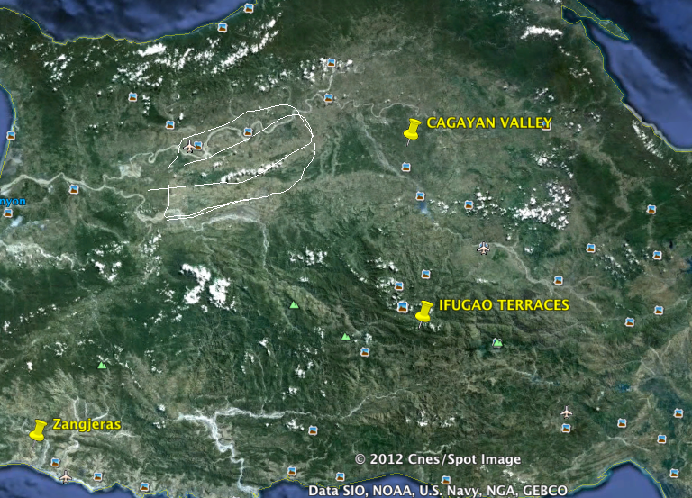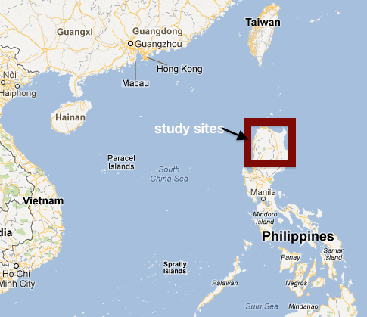

4.2 The Zangjeras Case Study

4.2.1 History, Demography and Physical Geography
Various authors have described the history, demography and physical geography of the zangjeras as follows (Siy, 1980; Coward, 1979). The zangjera, a Spanish term, refers to a cooperative irrigation society found only in the Ilocos Provinces in Northern Philippines and have been around since the early 16th century. The Ilocos Provinces are one of the most densely populated regions in the Philippine but has the least arable land per capita. For instance, three fourths of all arable lands are under 0.3 hectares compared with the national average of 1.45 hectares.
The physical geography of the zangjeras can be challenging. Araral (forthcoming) and Siy (1980), described these challenges in the following terms. First, the zangjeras are located “along a narrow strip of land - a flood plain - squeezed between the Cordillera mountain range (the headwaters of the Ifugao terraces) on the east and the South China Sea to the west.” Second, the production system of the zangjeras - irrigated farming - depends on an “unsteady, unpredictable and destructive river. The watershed on Vintar river is “vast and steep, which drains in the narrow and flat plains of the Ilocos region before draining in the South China Sea.” Satellite imagery (Figure 3) shows that the river “constantly shifts course making the task of constructing and maintaining the brush dam difficult.”
Figure 3: Satellite photo of the zangjera farmlands traversed by the Bacarra-Vintar River. Note the densely populated town center, small farm holdings and the heavily silted, expansive river, which makes a permanent dam infeasible. Heavy siltation and a monsoon climate is the main source of persistent flooding in the zangjeras, requires a reliable method of mobilizing labor for constant repair. During periods of drought, the zangjeras need a fair system to allocate scarce water. The atar system of property rights evolved to solve these twin problems. Source: Google Earth.
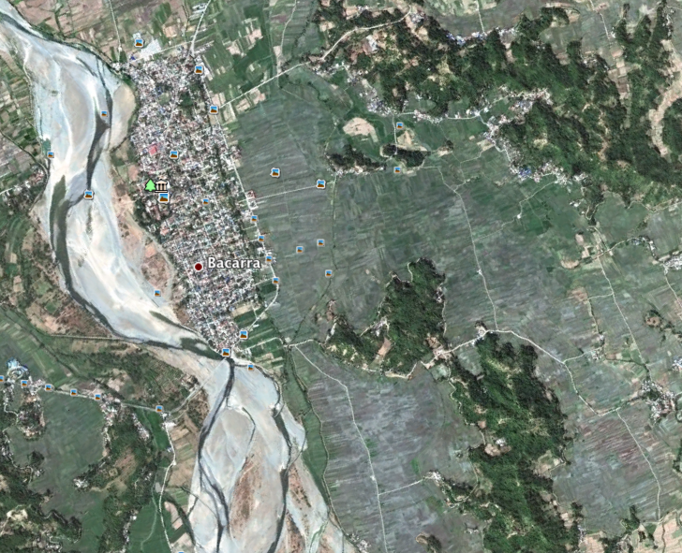

Third, as Araral (forthcoming) documents, frequent typhoons (average of 9 a year) and flooding regularly afflicts the Ilocos Region. These typhoons cause the rivers to “swell and easily wash away brush dams and wreak havoc to farms as a result of flooding”. Because of the breadth of the river -100 meters long - the only feasible way to control water is through the use of temporary brush dams which are made up entirely of sand, bamboo, banana leaves and rocks. Maintaining the brush dam after every typhoon requires the mobilization of substantial amount of labor.
Finally, during the dry months of January to April, water is very scarce in the zangjera averaging a paltry 2.6 mm compared to the 367mm during the wet / typhoon season of June to September. Consequently, during the dry months, the availability of water among the zangjeras is highly variable with the upstream areas consistently receiving adequate water compared with the downstream. During the dry months, farmers in the zangjera would have to devise mechanisms how to allocate this scarce water among its members.

4.2.2 Effects of Geography on Property Rights
A distinguishing and unique institutional feature of the zangjera is its atar property system, which is found only in the Ilocos region and nowhere else in the world. The atar system works as follows. At the time the zangjera irrigation is constructed, the rights to cultivate the land are given to the members who contributed to its development in the form of atar - or membership shares. Each atar is equivalent to one hectare of land. Thus, a 20 hectare irrigated farm would have the equivalent of 20 atar shares. A farmer who gets half a hectare gets 0.5 atar share. More importantly, the atar share corresponds also to the obligations of the shareholder. Thus, an atar holder who holds 1/20th of the benefits from the system (in terms of land area cultivated and water received) is also expected to contribute roughly 1/20th of the costs (labor, materials, cash). While the actual obligations would vary depending on the need, it will remain consistently the same overtime as a proportion of total costs as well as remain the same relative to other shares. Even if the atar shares are divided and subdivided as a result of leasing or inheritance, the amount of obligation stays the same relative to other shares. In this sense, the atar system is highly flexible to changing conditions, is fair to all because of the costs and benefits are in the same proportion and is self regulating with low transaction costs because it is easily understood and transparent.
In summary, the atar is an ingenious form of property system characterized by several principles of institutional design: flexibility, fairness and legitimacy, appropriateness and low transaction cost (also see Siy 1980). I argue that these principles of institutional design evolved out of the need to mitigate the risks of unpredictable water supply (flooding and drought) that directly affects the production system (irrigated farming) in the zangjeras. The way it works can be summarized as follows.
First, during times of flooding, there is always a need for the constant repair of the irrigation facilities and the brush dam. This would require a mechanism to regularly mobilize labor. For such a system to be sustainable overtime, it would have to meet three requirements: 1) flexibility i.e. labor requirements would vary depending on the severity of flooding; 2) fairness i.e. to ensure that individual members do not free ride in their contribution of labor to repair the infrastructure damaged by the floods, the allocation of labor costs and benefits would have to be fair; and 3) self-regulating i.e. the cost of mobilizing labor and enforcing compliance with organizational rules would have to be low cost - easily understood and with low enforcement costs - to be robust over the long term. It is in this sense that the effects of physical geography on institutional choice is mediated by the production system.
During times of drought, farmers in the zangjera adapt by shifting to crops that can cope during times of water scarcity. This is made possible because of the following institutional arrangements in the zangjera. First, when the zangjera was originally formed, the parcels of land of the founding members were distributed such that some parcels were located upstream, some midstream while others are located downstream. This way, when water is only available upstream during the dry months, the costs and benefits are fairly distributed among the members. This also gives everyone an incentive to more efficiently utilize water to ensure that their parcels at the tail end of the system are irrigated.
Second, the distribution of fertile and less fertile parts of the farm is also made equitable with this formula of rights allocation. Third, if there is not enough water for the whole system, the zangjera may decide not to irrigate particular blocks such that the farm size of all farmers are reduced proportionately since all will have parcels of land in that block. Finally, the atar shares in the zangjera are distributed as parcels of long strips of land perpendicular to the water source to enable farmers to better control water. This was designed to give them more freedom to select cropping patterns or schedules which suits his/her own capabilities and needs without having to conform to decisions of neighboring farmers since water does not have to flow from those parcels into his own. As a result, at any given time, the zangjeras can afford to have a diverse array of crops in different stages of growth as well as flooded parcels next to unflooded fields.
Therefore, this ingenious configuration of land parcels and the distribution of atar shares allow farmers to diversify their risks from pests, flooding, drought, prices, soil quality and hence make them highly adaptive to vulnerabilities. This is a second illustration of how the effects of physical geography (drought) on property rights and institutional choice (equitable allocation rules for land and water) are mediated by the need to mitigate the risks in the production system.
4.3 Cagayan Valley Region
4.3.1 History and Physical Geography
The Cagayan valley region in northern Philippines is one of the country’s rice granaries. The valley is kept productive year round by, among others, the reliable Magat River Integrated Irrigation System (MRIIS). It was built by the government some 50 years ago and the largest of its kind in the Philippines with a service area of 83,000 hectares. The Magat watershed has headwaters originating in the mountainous region supporting the Ifugao rice terraces to the east. The physical features of the valley are illustrated in Figure 4.
Figure 4: Satellite photo of irrigated farmlands in the Cagayan Valley served by the Magat Reservoir (top left corner). The Valley does not face the problems of flooding, droughts and land scarcity unlike in the Zangjeras. For this reason, there was no pressure for the local population to devise ingenious institutions to adapt to their physical environment. Source: Google Earth.
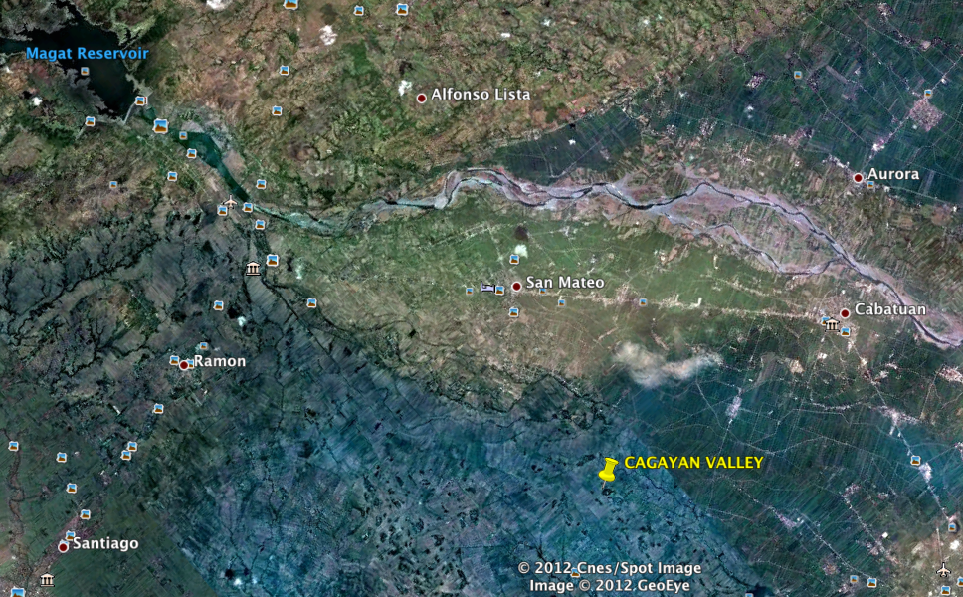

Because of the reservoir, the valley is not vulnerable to flooding and droughts unlike the floodplains in the arid region of the zangjeras. Consequently, farmers do not see the necessity for similar cooperative societies like the zangjera nor do they see the need for flexible labor arrangements and flexible property systems such as the atar system of property rights.
4.3.2 The Effects of Geography on Property Rights
As Table 1 above has shown, the institutional features of the Cagayan Valley region are markedly different from that of the Zangjeras and the Ifugaos. First, the average size of land holdings per household, at 1.3 hectares, is about four times that of the 0.3 hectares in the zangjeras. Unlike the zangjeras whereby the population has long been settled and where land is scarce, the population of the valley grew alongside the growth of agriculture where land was more abundant.
Second, and more importantly, the system of property rights in Cagayan Valley - private ownership of property - is typical for the rest of the Philippines, which is divisible through a deed of absolute sale. This is markedly different from the zangjeras in the Ilocos Region, which are owned collectively as a club with limited tradability and are not physically divisible but can only be traded in terms of shareholder rights.
These variations in the system of property rights is all the more notable because the population in both regions come from the same ethnolinguistic group, the Ilocanos, who also depend on irrigated rice farming as the foundation of their economy. However, the system of property rights and practices on inheritance in both regions are quite distinct from each other. In other regions of the Philippines where the Ilocanos also settled, for instance in the frontier provinces of Mindoro and Cotabato where land and water are not scarce, the atar system and the zangjeras are noticeably absent thus corroborating the hypothesis on the effects of geography on institutional choice.
4.4 The Ifugao Rice Terraces
4.4.1 History and Physical Geography
The Ifugao rice terraces are located in the mountainous region of northern Philippines, bordering the Cagayan Valley to the east and the Ilocos region to the west (see Figure 2 above). The Ifugao rice terraces - a world heritage site - have been around in the last 2,000 years. The UNESCO (1995) inscription reads as follows:
For over 2,000 years, the high rice fields of Ifugao have followed the contours of the mountains. The fruit of knowledge passed on from one generation to the next, of sacred traditions and a delicate social balance, they helped form a delicate landscape of great beauty that expresses conquered and conserved harmony between the humankind and the environment. - UNESCO, 1995.
Conklin (1980) reports that the terraces occupy an area of about 4,000 square kilometers in mountainous slopes as steep as 70 degrees and as high as 5,000 feet and with terrace embankments stretching some 20,000 km, equal to the distance halfway around the world, of which 7,000 km are stone walled. Figure 5 provides a visualization of the physical geography of an example of one of these rice terraces.

Figure 5: Aerial photo of an illustrative sample of the 4,000 square kilometer Ifugao Rice Terraces nestled along steep mountain slopes. The terrace embankments stretch some 20,000km (halfway around the world) of which 7,000km are stone walled. Photo by Department of Tourism (2008). Bananue District, Ifugao Province.
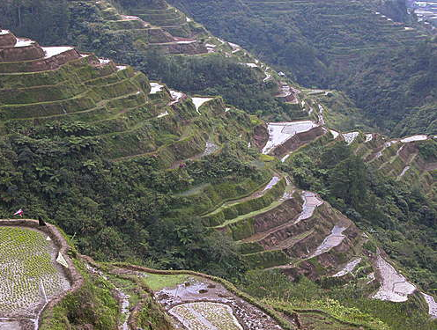
As Conklin (1980) adds, “operating and maintaining the terraces is a complex feat of structural and hydraulic engineering that requires constant repair, extension, restructuring and dynamic recycling of resources while trying to surmount a variety of uncertainties and shocks.” These challenges include 1) “unpredictable earthquakes of varying magnitudes, the Philippines being earthquake prone, which as a result often damage streams that feed the terraces and lead to their collapse; 2) frequent landslides due to monsoons and cloudbursts, as the Philippines averages 26 typhoons a year; 3) numerous pests and diseases associated with farming and 4) inherent conflicts over scarce resources such land, water and forests.” Under these conditions, rice farming can indeed be a risky feat. As I will argue in the next section, the Ifugaos have fashioned a set of informal institutions - woven into their culture - to overcome these geography induced risks.

4.4.2 Effects of Physical Geography on Property Rights
A key institutional feature of the Ifugao society is their property law which is based on the principle of primogeniture rights i.e. – the first born acquires the right to inherit the entire or substantial part of property of his parents while younger siblings would have to develop or acquire their own properties (Conklin, 1980). I argue that the mountainous physical geography in the Ifugao region influenced the development of the primogeniture system property rights in the following ways.
First, for the rice terraces to function properly and sustainably overtime, they need sufficient year round water supply to prevent the drying and cracking of the soil. Year round water supply in turn depends on the functioning of the life support system for the rice terraces - the muyongs or family forests and woodlots - which are located above the upper most part of the rice terraces. The muyongs are maintained as forest cover for the watersheds that supply the water needed to irrigate the terraces as well as a source of fuel-wood, timber and food.
Second, in order to maintain the integrity of the muyongs, an entire area is to be inherited and cannot be subdivided into a smaller area. If the muyongs are fragmented, it could spell problems for the sustainability of the terraces. Finally, the primogeniture system of property rights is central to maintaining kinship as the primary basis for social relations among the Ifugaos and a mechanism for balancing power among competing interests in the Ifugao society. As Barton (1919) notes:
It is preferable for the Ifugaos that a family has at least a powerful member around whom the kin may rally and to whom they may look for aid than to have the family property split into insignificant parcels that would affect little the property of all. The unity of the family is primodial and must be preserved at all times and at all cost.
The primogeniture principle of property rights, however, is not unique to the Ifugaos and was in fact commonly found in ancient laws in Athens, England, France, Germany, and other European countries. The rationale behind this principle was often associated with the need to keep the original land intact to support the mandatory military conscription of the eldest son during medieval times. However, in the case of the Ifugao rice terraces, their primogeniture system of property rights evolved independent of the European influence, mainly because the Ifugao people were never colonized during the Spanish era in the Philippines. The need to maintain the ecological integrity of the watershed to support the functioning of the terraces and the need to maintain kinship as basis of social order are more likely to be the rationale behind the primogeniture property rights in the Ifugao region. It is in this sense that physical geography affects property rigths through its direct effect on the Ifugao rice production system.
5. Conclusion and Implications
This paper sought to examine the effects of physical geography on property rights. Using three case studies and controlling for the effects of production system, time, culture and contracting costs, this paper compared how variations in physical geography vary with property rights. The study finds that, indeed, variations in physical geography are associated with variations in property rights. Physical geography presents risks and opportunities for a production system - for example flooding and droughts - and that actors devise institutions to mitigate these risks or take advantage of these opportunities to achieve their production functions.
In the Ilocos region, this is evidenced by the evolution of the zangjera cooperative society, the ingenious design of the atar system of property rights and the equitable allocation of land and water rights, all of which can be regarded as mechanisms to mitigate production risks posed by flooding and droughts. In the Ifugao mountainous region, the Ifugao farmers developed the primogeniture system of property rights, which cannot be divided nor traded or sold to outsiders. Its rationale is to protect the integrity of the forest and watershed in order to sustain the precarious functioning of the rice terraces over a long period of time (and hence mitigate the risks of drought). In Cagayan Valley, the Magat Reservoir effectively mitigated the risks of flooding and drought and hence there was no need for institutional mechanisms such as a cooperative society or ingenious systems of property rights like those found in the Zangjeras and the Ifugaos. These three examples have therefore shown how variations in physical geography are associated with variations in the institutional features of the same type of production system and ethno linguistic group.
The paper has four theoretical, empirical and practical implications. First, the geographic risk model suggests that risk analysis should be incorporated into the study of the emergence and evolution of institutions in general and property rights in the commons in particular. Second, it helps explain the causes, consequences, diversity and vulnerability of institutions governing the commons. Third, the emergence, assignment, enforcement and transfer of property rights have important implications for the allocation of resources and the nature of production in the commons. Finally, understanding the effects of geographic risks has important theoretical, empirical and practical implications for climate adaption in the commons and smallholder agriculture.

REFERENCES

Acemoglu, D., S. Johnson, J. Robinson.2001. The Colonial Origins of Comparative Development: An Empirical Investigation. The American Economic Review, Vol. 91, No. 5 (Dec., 2001), pp. 1369-1401
Agrawal, A. and G. Yadama. 1997. How do local institutions mediate market and population pressures of forest resources? Development and Change. 28 (3): 435–465.

Araral, E. 2011. What makes socio-ecological systems robust? Institutional design principles of the 2000 year-old Ifugao society. Working Paper. Lee Kuan Yew School of Public Policy. National University of Singapore.

Araral, E. (forthcoming). A Transaction Cost Model of Climate Change Adaptation: Insights from Coase, Ostrom and Williamson. Environmental Science and Policy.

Araral, E. 2009. What Explains Collective Action in the Commons? Theory and Evidence from the Philippines. World Development. 37 (3):687-697.

Alchian, A. A. 1950. Uncertainty, evolution, and economic theory. Journal of Political Economy, 58: 211–221.

Bardhan, P. 2005. Scarcity, Conflicts and Cooperation: Essays in Political and Institutional Economics of Development. MIT Press, Boston.

Barton, R. (1919) [1965]. Ifugao Law. University of California. Berkeley.

Boschma, R. and K. Frenken. 2006. Why is economic geography not an evolutionary science? Towards an evolutionary economic geography. Journal of Economic Geography. 6: 273–302.

Boschma, R. and K. Frenken. 2011. The emerging empirics of evolutionary economic geography. Journal of Economic Geography.11(2): 295-307.
Coase, R. 1960. The Problem of Social Cost. Journal of Law and Economics. 1(15): 8.
Conklin, H. (1980). Ethnographic Atlas of the Ifugao. New Haven, CT: Yale University Press.
Conklin and Javellana. 2008. Bird’s Eye View of an Enduring Rice Culture. Rice Today Magazine. Vol 7. No. 1.
Commons, J.R. 1990. Institutional Economics: Its Place in Political Economy. New Brunswick, N.J., U.S.A: Transaction Publishers
Cowan, R., Jonard, N. 2003. The dynamics of collective invention. Journal of Economic Behavior and Organization, 52(4): 513–532.
Coward, W. 1979. Principles of Social Organization in an Indigenous Irrigation System. Human Organization, Vol. 38. No. 1, pp 28-36.
Christie, E.1914. Notes on Irrigation and Cooperative Irrigation Societies in Ilocos Norte. The Philippine Journal of Science. 9 (2):1-44.
Easterly, W. and R. Levine. 2002. Tropics, Germs, and Crops: How Endowments Influence Economic Development. NBER Working Papers 9106, National Bureau of Economic Research, Inc.
Libecap, G. 1989. Contracting for Property Rights. Cambridge University Press. New York.
North, D. C. 1990. Institutions, Institutional Change and Economic Performance. Cambridge University Press, Cambridge.
Olsen, J. 2002. On the units of geographical economics. Geoforum, 33: 153–164.
Ostrom, E. 1990. Governing the Commons: Institutions for Collective Action. Cambridge University Press, Cambridge.
Ostrom, E. 1998. Competition and Cooperation: Conversations with Nobelists about Economics and Political Science. J. E. Alt, M. Levi, and E. Ostrom eds. Russell Sage Foundation, New York.
Poteete, A. and E. Ostrom. 2004. Heterogeneity, Group Size and Collective Action: The Role of Institutions in Forest Management. Development and Change. 35 (3): 435–461,
Putnam, R., R, Leonardi and R. Nanetti. 1993. Making Democracy Work: Civic traditions in Modern Italy. Princeton University Press, New Jersey.
Rodrik, D., A. Subramanian, and F. Trebbi, 2002. Institutions Rule: The Primacy of Institutions over Geography and Integration in Economic Development. NBER Working Paper 9305, October 2002 (Cambridge, Massachusetts: National Bureau of Economic Research).
Sachs, J. 2003. Institutions Don't Rule: Direct Effects of Geography on Per Capita Income. NBER Working Paper No. 9490.
Singh and Dillon. 2004. Agricultural Geography. Tata McGraw Hill in Education. Delhi.
Siy, R. 1980. Community Resource Management: Lessons from the Zangjera. University of the Philippines Press, Manila.
UNESCO. 1995. Rice Terraces of the Philippine Cordilleras. http://whc.unesco.org/en/list/722

