DOES INTERNATIONAL LAW MATTER?

Shima Baradaran,∗ Michael Findley,∗ Daniel Nielson,∗ and
J.C. Sharman∗

The importance of international law has grown in an increasingly global world. States and their citizens are interconnected and depend on each other to enforce and comply with international law to meet common goals. Despite the expanding presence of international law, the question that remains is whether international law matters. Do individuals comply with international law? And when they comply, do they comply because they fear penalties or because they desire to behave appropriately? This Article presents results from a randomized field experiment designed to investigate these questions. Major findings include that roughly one in seven international actors is willing to violate international law and the existence of penalties actually motivates some actors to break international law in greater numbers. In the first and largest global field experiment to date, this Article not only advances the scope of research methods generally, but also marks new ground by providing theoretical insights on the central questions of international law.
Table of Contents
I. Theories of Compliance 9
A. Rationalism 9
B. Constructivism 12
C. Weaknesses in Prominent International Frameworks 16
1. States Are Not Primary Actors 17
2. Compliance Studies Fail Without Robust Evidence 21
D. Testing International Compliance 24
1. Distinguishing Formal and Actual Compliance 25
a. Why Financial Transparency? 25
b. Testing Compliance with Financial Transparency 27
2. Three Tests of Formal Compliance 32
II. The Field Experiment 35
A. Why a field experiment? 36
B. Experimental Design and Treatments 37
1. Placebo 38
2. International Standards 38
3. Rationalism 39
4. Constructivism 39
C. Constructing the Sample 39
D. Blocking and Random Assignment 40
E. Conducting the Experiment 41
F. Coding Protocol 43
III. Results from a Test of Compliance 44
A. Experimental Results Across Treatment and Control Conditions 45
B. Compliance Rates with International Law Across Conditions 49
C. Discussion within International Theoretical Framework 52
1. Do Individuals Comply with International Law? 53
2. Who Complies with International Law? 55
3. Why Comply with International Law? 56
a. Soft Compliance 57
b. Hard Compliance 59
4. Conspirator Effect of Rationalism 60
5. Weak Penalty Effect 62
6. Potential Confounding Effects 63
Conclusion 65
Appendix 69

International law has grown both in significance and volume in recent decades. In this increasingly interdependent world, an important question is whether international law matters. Despite the criticisms aimed at the effectiveness of international law, and the challenges of its enforcement, there is a belief that international law matters. This shared belief underlies the work of international scholars and lawyers who debate about how to make international law more effective.
There is a vast literature focused on international compliance. This literature suffers from two major weaknesses in determining the effectiveness of international law. First, the current theories of international law inappropriately concentrate on states rather than individuals. Whether international law is ultimately effective in accomplishing its goals may depend less on whether a state complies and more on whether sub-state entitles act consistently with the goals of international law. This misplaced focus on nations as the primary actor in international law neglects the key players in international law: individuals and firms. Nations comply with international law by passing laws and enforcing those laws. Individuals and firms comply with international law by following rather than violating such laws. Indeed, even though international law imposes duties on nations, the effectiveness of international law ultimately depends on the actions of private individuals who ultimately determine whether international law is effective.
Second, there is no agreement on what motivates compliance with international law. Two major theoretical camps disagree fundamentally on what causes international compliance: sanctions or norms. Proponents of rationalism believe that nations comply because they fear sanctions or other repercussions when they do not comply. On the other side, constructivists argue that nations comply with international law because they want to follow norms and behave appropriately. These opposing frameworks offer two motivations for complying with international law: norms and sanctions. The same motivations arguably exist with private actors deciding whether to act consistently with international law. Testing these theories on actors to determine whether norms or sanctions induce compliance—and then exploiting those motivations—could potentially increase the effectiveness of international law.
Despite the importance of determining why actors comply with international law, no scholars have ever tested the motivations for private actors complying with international law. And while these two camps have robust theoretical bases to back their beliefs, they both lack strong empirical support. The existing studies cannot determine actual compliance because they suffer from selection bias and a myopic focus on nations rather than other actors. Indeed, neither theory of compliance has been tested internationally in ways that can establish causality.
Because of its ability to uncover causal effects, a large-scale international field experiment is one way to answer these questions. Thus far, however, no empirical studies have investigated key theoretical questions such as compliance with international law. Through a randomized international field experiment where we use aliases and pose as international consultants seeking a shell corporation, we assess the causes of compliance with international financial transparency laws through assigning more than 1,000 firms to a variety of treatment and control conditions. The results of this global experiment reveal several interesting and significant findings with potential importance for international law and policy.
In examining whether international law matters, our empirical findings include that compliance with international law is 51% at best. In considering why individuals comply with international law, it turns out that informing firms about the relevant international laws or norms to comply with these laws does not increase the likelihood that firms will actually comply. And surprisingly, informing firms about penalties actually increases the likelihood that the firms who respond will violate international law. Thus, norms do not seem to matter and penalties sometimes cause more international law violations. This study also demonstrates a disconnect between state compliance and private firm behavior and identifies what motivates firms to decide to act consistently with the goals of international law.
This Article unfolds in three parts. Part I sets forth the two dominant theories of compliance with international law and introduces the preeminent debate in international law: does international law matter? Part II sets forth the design and results of an experiment considering whether and why individuals comply with international law. Generally speaking, is compliance motivated by fear of sanctions or a sense of duty to accepted norms? We demonstrate, with systematic data whose results may be surprising to both camps of international law theorists that compliance is lower than expected, despite the importance of such laws on an international level. Part III examines the results of this field experiment in light of the theories of international law, juxtaposing the findings with potential explanations for the counterintuitive results we find. Informing firms about the relevant international law does not increase the likelihood that firms will actually comply and indeed the existence of penalties actually motivates some actors to break international law in greater numbers. To provide an explanation for these results we set forth two new theories of rationalism, which we call the conspirator effect and the weak penalty effect.

I. Theories of Compliance

While scholars have criticized the divisions used to explain international law and relations theories, many have relied on them to explain what motivates compliance with international law. The prevailing theories can roughly be divided into two opposing frameworks: rationalism and constructivism. Rationalists generally believe that nations comply with international law when faced with material sanctions. Constructivists believe that nations comply with international law when the international community sets norms that become broadly accepted. After providing a broad framework for these theories, we make a case that both theories have misplaced a focus on states as primary actors in international law.

Rationalism

Rationalists believe that nations only comply with international law when they seek to avoid sanctions or obtain material benefits. Rationalism relies formally and informally on rational choice theory, and an explanation of foreign policy through self-interested, goal seeking behavior. Instead of accepting a traditional belief that international law is a powerful check on state behavior, rationalists argue that international law is merely the result of states acting rationally to maximize their interests. Rationalists explain state compliance with international law as a result of a nation’s desire to profit materially or because they fear sanctions. Since states are treated like individual actors, rationalists argue that penalties motivate states to act.
Rationalists assume that states are the primary actors in the international system. As such, states are treated as individual actors that make rational decisions regarding international law and their relations with other states according to a cost-benefit analysis. Rationalists largely treat the effects of the international social structure on state interests as exogenous. Accordingly, state interests are best understood by analyzing the internal conditions or external threats or benefits faced by given states rather than outside social considerations.
Because self-interest guides nations’ decision-making, and there are only minor risks of international sanctions and weak, limited enforcement, some rationalists posit that compliance with international law is limited. Thus, as Goldsmith and Posner argue, “nations mouth their agreement to popular ideals as long as there is no cost in doing so, but abandon their commitments as soon as there is a pressing military or economic or domestic reason to do so.”
First, and fundamentally, critics claim that rationalism does not explain how a state determines its interest. Some perceive rational choice theory to be circular because the theory explains that a state acts the way it does because the state is pursuing its interests, but determines the state’s interest according to the actions that a state performs. Without guiding principles for a state acting the way it does, rationalism has little explanatory power.
Second, critics fault rationalism for failing to adequately explain why states consistently enter into and abide by treaties that offer little or no apparent benefit. For instance, many states accede to and abide by human rights treaties. While these treaties impose costs, they offer no material benefit to the state. It is unclear why a rational state would enter a human rights agreement: a state with a history of human rights compliance would receive no reputational gains, and one with a history of abuse would lose much from ratification. Thus, rationalists would not agree that a law would carry with it a moral sense of obligation to follow it.
Thus, according to rationalism, states comply with international law when doing so serves their interests by increasing benefits and avoiding penalties. International norms are not relevant except to the extent that following or violating them produces costs or benefits to the state.

Constructivism

Constructivism starts with the assertion that states obey international law due to norms. To constructivists, international law makes up the structure of the international system: a set of implicit rules upon which meaningful and binding formal agreements are framed. According to constructivists, states create and follow international law not because of the instrumental benefits or penalties from complying, but because of their moral and social commitment to ideas embodied in treaties.
While constructivists focus on social norms and structures, like rationalists, constructivists focus on states as the central actor in international decision-making. For constructivists, norms and laws exert a profound impact on state behavior, shaping how people think about their state’s role and obligations. Self-interest as the sole motivation is rejected, as constructivists instead believe that states determine their national interests and preferences through the social interaction of individuals, groups, and states.
Constructivists believe international law can modify state preferences. State interactions create a social structure, which in turn influences state interests. These structures have the ability to influence norms and preferences domestically, to the point where a state’s interests reflect the rules of international law. Accordingly, states are often not convinced that a solution is needed until standards are set by international organizations created and often run by states. Constructivists assert that state actors are persuaded by normative arguments that adopt new interests and change behavior. In a world where states operate in an environment of uncertainty, they will often imitate the solutions tried by other apparently successful states.
According to constructivists, norms must be accepted and internalized by the state before any action, or inaction, is attempted on the international level. The degree to which states are persuaded to accept norms is the degree to which they can influence the state’s actions in the international arena.
One of the most prominent constructivist theories on compliance is the managerial model propounded by Abram and Antonia Chayes. The managerial model posits that states affirmatively want to conform to international norms, as embodied in international law. Indeed, it is the normative effect of international law and not the fear of reprisal that leads to compliance. And noncompliance is the result of states’ lack of sufficient information or high cost of compliance, not a result of self-interested decisions. In consequence, Chayes and Chayes argue that persuasion and “managing” compliance are more effective than coercing compliance with international law. Managing compliance includes informing states of international laws that they must abide by and providing states with resources to comply. This process relies not on the threat of sanctions but the fear of “alienation” from international networks that have become central to most nations’ security and economic well-being.” Thus, according to the managerial model, the key to international compliance is informing states of the laws, persuading states of their normative import, and helping build capacity to comply with such laws.
Critiques of constructivism target three main flaws. First, critics claim constructivism fails to offer specific expectations of state behavior or explanations of how state decisions are made, apart from that states will join and comply with international law. Indeed, the mutually constituted relationship shared by state actors and international structures makes it difficult to determine the effect one has on the other. As such, it is difficult to validate causal arguments with regards to norms.
In a second related concern, a consistent critique of constructivism is its lack of empirical evidence to back its claims and inability to refute the alternative empirical evidence that contradicts constructivist claims. Indeed, critics claim that both constructivism and rationalism fail to predict behavior or connect adequately with evidence. Further, the empirical work that does exist flies in the face of conventional constructivist theory regarding norm internalization. Constructivists, of course, contest this assertion and point to a growing body of supportive empirical evidence.
Demonstrating the validity of an abstract theory of international relations is no easy task. Rationalism’s and constructivism’s claims thus etch the broad outlines of the debates of international law. While disputing many other issues, the two theories generally agree that states are the primary actors to measure in determining compliance with international law. We refute this assertion below and demonstrate why the key to compliance is actually found in the actual locus of compliance: the decision to obey international law.

Weaknesses in Prominent International Frameworks

A key point of agreement between constructivists and rationalists is that states are the primary actors to track in determining international compliance. We make the case that this myopic focus on state actors is actually a weakness in international law theory that has prevented the field from measuring actual compliance with international law and garnering the evidence necessary to support its claims. We address these points in turn. First, most areas of international law require an analysis of individual actors within states to determine actual, rather than pro forma, compliance. Second, relying solely on state actors to determine international compliance prevents data collection to support theoretical claims given that evidence about sovereign governments is limited. Further, the evidence collected often suffers from selection bias.

States Are Not Primary Actors

Focusing on states as the primary actors in international law does not accurately reflect the effectiveness of international law. If the focus of international compliance is states, the areas to examine include state actions such as legislation, regulation, and enforcement of the laws passed. Yet to measure compliance in many of the most important areas of international law—human rights, environmental law, global health, labor provisions, and financial regulation—the main locus of international standard compliance is not government. Instead, ordinary people and firms make specific decisions that aggregate into a pattern of compliance or violation. For example, an individual firm–not the government–makes the decision to comply with the anti-dumping provisions of trade agreements when selling goods abroad. Individual military , police, and correction officers make decisions to respect or violate the rights of their prisoners. And corporations and private individuals decide whether or not to pollutante, poach endangered species, or otherwise harm biodiversity in a way that violates international environmental agreements. In one of the landmark pieces on international compliance, Downs studied the maintenance of oil tankers to describe the key behavior of international maritime regimes, which is clearly outside the normal routine of national governments.
To be sure, the decisions of private actors occur under the umbrella of international laws established by independent sovereign governments coming together through international coalitions. And governments play a vital role in formal compliance with international law by enacting and enforcing domestic laws that implement international agreements. All of the state actions help to establish an environment of compliance within a state. The greater the enforcement of international law within a state, the more likely it is that private actors will follow such laws either because of norms or due to benefits or punishments.
States set up an environment of compliance (or noncompliance) through the ratification of international law and through the enforcement of domestic law aimed at fulfilling the goals of international agreements. In order to test the effectiveness of the environment of compliance in a nation, we can do one of two things. First, determine what laws states have passed, the resources they have placed into enforcing them, and how often the laws are enforced. This is formal compliance, which we look at. The second method is determining how private actors are reacting to the environment of compliance set up by the states and determining whether the laws in place are actually inducing compliance by those individuals who ultimately make the decision to comply. While the first gives us important information about what actions the state has taken, the method that really gets at the effectiveness of international law is examining individual decisions.
For instance, in examining Norway’s compliance with marine antidumping provisions, two options exist: formal and informal compliance. Formal compliance examines the domestic and international laws Norway has in place to stop antidumping, including examining the off-shore police force designated to enforce such laws. A test of informal compliance includes examining whether companies on Norway’s shores are actually violating these provisions. Thus, in this example, while formal compliance is helpful, only informal compliance gets to the heart of determining the effectiveness of international law. For this reason, our study looks at both of these—formal and informal compliance—formal compliance by states and informal compliance by individual private actors. Thus, we raise this point not to argue that states should be ignored as key actors in considering the effectiveness of international compliance, but to emphasize that the actual effectiveness of international law can only be measured through studying private actors.
We point out here that we are not necessarily measuring state motivations to comply through the actions of private actors. Since even states as governments are aggregate actors, in order to truly understand why states are complying with international law, the investigator must examine the motivations of all of the state actors who signed, ratified, and enforced international laws. Given the daunting archival and aggregation challenges involved, we sidestep state motives and instead measure private actors’ motivations for complying with international law. One weakness of this approach may be that private actors’ motivations are more likely to be solely driven by the balance of profit and risk while a state may have multi-faceted reasons for complying with international law. Thus, measuring private motivation will not accurately measure state motivation. This may be the case, but there is also a large body of support for the position that states often act indirectly out of profit motives, as frequently the laws enforcing international provisions are thwarted due to the lobbying of financially invested domestic parties. Thus, while states may not always be motivated by financial incentives, many are influenced by private actors within them that are indeed profit seekers. Measuring private motivation as a proxy for state motivation is an imperfect metric, but it may be superior to solely measuring state motivations because it is more likely to get us closer to measuring actual compliance–and therefore to improving compliance with international law.
Consequently, are we simply measuring the motivations of private actors to comply with international law or are we actually measuring the effectiveness of international law? We make the case that we are measuring the effectiveness of international law. If the international compliance decision is made by private actors, this is where we must measure the level of compliance and the motivations for compliance.
An example illustrates this point. If the goal is to stop the excessive number of terrorist shell companies from being formed, we would want to determine how well nations are complying with laws targeted at stopping the formation of such companies. We would also want to determine what motivates compliance with these laws so that we can increase compliance. One way is to examine the framework of laws put into place by state actors to stop the formation of these companies and determine whether these laws are enforced against such companies. But since what we really care about is whether these shell companies are being formed, we must examine the private bodies within the nation who actually form terrorist shell companies and determine why they are allowing the formation of such companies.
Since it is ultimately private behavior that we want to influence, we want to know whether private actors fear sanctions or realize there are international norms against formation of such corporations. Thus, the motivation of private actors to comply provides insight on how effective international laws are and what motivates compliance with such laws. We note as well that ultimately, state actors do not make the decision to comply–their private citizens do. Although we measure private actors, this gives us important insights into the environment of compliance that the state has established and how the state can alter its framework to improve compliance. Thus, when we determine that private actors comply more often with international law, we may reveal a greater motivation of that state for encouraging compliance with such laws, but we certainly demonstrate that international law is effective in that state.
Examining state action is important to measure formal ratification of international law and evaluate how effective the enforcement regime is in ensuring compliance. But to gain important insights into the effectiveness of the international law, measuring private action is vital. Thus, both rationalist and constructivist scholars have misplaced their emphasis on states as primary actors when obtaining a pulse on the true impact of international law often requires measuring private actors. With this improper emphasis on states, international scholars have largely failed to garner robust evidence to support their claims.

Compliance Studies Fail Without Robust Evidence

Though international scholars place a prominent focus on studying compliance with international law, they have in large part failed in garnering evidence to support their claims. A central unresolved difficulty of international law is whether international commitments arise from compliance and are thus subject to strong selection bias. Selection bias presents a problem where it is difficult to determine how unobserved factors limit the ability to establish causality. With compliance research, the fundamental problem with selection bias is determining whether countries that comply with international law are in some way fundamentally different than the countries that do not comply. Prior research on compliance with international law suffers from an inability to determine the effects of unobservable factors that create selection bias. For instance, in claiming that nations comply with international law due to strong norms, constructivists fail to account for the fact that nations may comply with laws that are easiest to comply with or the fact that nations complying with international law are fundamentally different than those who fail to sign on.
To explain the significance of selection bias in studying international law, we examine a prominent debate among leading international scholars in the managerial school. In their foundational article, Abram and Antonia Chayes argue that compliance with international law is the norm and noncompliance results due to ambiguities and a lack of capacity to comply with international law, rather than deliberate defiance. In response to the optimism of the “managerial” school, Downs brings to light the nontrivial challenges posed by selection problems. Compliance with international standards might be the norm precisely because states acceded to those standards that are easy to meet. If this is so, compliance is explained by selection bias rather than the constraining power of international law.
Founded on rationalist insights regarding compliance motivations, Simmons counters with a defense of compliance. With an empirical lens, she focuses on conventions prohibiting currency restrictions. She discusses the theoretical potential for endogeneity and selection problems , attempting an empirical correction. Simmons suggests that international standards foster compliance, but the effect stems from reputational issues that states face ifthey back out of an agreement. Employing observable variables to lessen the problem of non-random selection, she concludes that reputational factors do in fact induce compliance to agreements proscribing currency restrictions, especially when neighboring countries also commit to and abide by legal standards. Thus, from a rationalistic viewpoint, nations basically respond to the economic and social pressure generated by the actions of nearby countries and often observe such standards.
Tackling Simmons’ alleged failure to address selection bias, Von Stein analyzes the same set of conventions proscribing currency controls, finding that countries began complying with international standards long before acceding to international agreements. Thus, Von Stein’s reanalysis implies that countries signing on to international treaties are inherently different than those refraining to do so, which suggests selection bias. Apparently, numerous unobservable factors conditioned states for international compliance, and states joined international agreements only after undergoing this alteration. Von Stein’s work is quite compelling, but it fails to explain the actual causes of compliance with international standards, leaving the question vague, unresolved, and unobserved.
As the debate described above illustrates, much of the controversy surroundingthe causes of compliance turns on selection bias. Yet all present studies exclusively rely on conceptual arguments or tests that use observational data that cannot explain the causes of compliance. While by no means a panacea, field experiments have the potential to allow a better evaluation of the causes of compliance, particularly when combined with theoretical analysis and critique. This Article uses randomization in a field experiment to avoid the problem of selection bias that exists in previous tests of whether countries comply with international law.
Other fields have addressed selection bias by employing experiments that use random assignment to the treatment and control conditions. When correctly carried out, any outcome-based differences between groups are causally attributed to the intervention, because the randomization process balances and neutralizes the effects of any other observable and unobservable factor. The problem embedded in conventional international law analysis is clear: sovereign governments have typically been the objects of inquiry. This creates a misplaced focus as much of international law is complied with or violated by private actors rather than states. But as demonstrated above, the key to actual compliance with international law is private actors, who are observable. Furthermore, manipulating sovereign nations to gather solid empirical data presents serious practical and ethical difficulties. As a result, international law theory has been limited by a lack of robust evidence as to why nations comply with international law. And thus, in measuring state action as well as private compliance with international law through a field experiment, we can form a test of actual compliance with international law while avoiding the selection bias of traditional empirical analysis in this area.

Testing International Compliance

With the goal of determining the level of compliance with international law and the motivation for complying with such laws, we measure both formal and informal compliance. In other words, we measure what states claim to be doing to follow international law and what they are actually doing, and give insight as to why they are doing it.
While we hope to shed light on the two key questions in international law, we do not intend to affirmatively resolve the question of why nations comply with international law. To do so would require an understanding of the motivations of a large sample of state and private actors in a natural setting, which is impossible to do in one area of law, let alone every area of international law. Our aim is also limited by an imperfect metric of state action, which examines the environment of compliance in a state and the actions of private actors. Nonetheless, what we show tells us something very important about how effective international law is at capturing state compliance in one important domain, and it provides insight on why such compliance occurs.

Distinguishing Formal and Actual Compliance

Compliance occurs when nations behave as their governments have agreed to under international law. Conversely, violations of international law result when nations depart from agreed upon actions. To determine the effectiveness of international law requires examining compliance by the national government as well as the actions of private actors regulated by the international law at play. As discussed above, the two tests of international compliance are formal and actual compliance. Formal compliance with international law is relatively easy to determine. Formal compliance involves examining the regulatory framework that nations have put in place to enforce international laws. It looks strictly at what national laws have been passed and the level of enforcement of such laws. Actual compliance is much more difficult to ascertain. It examines whether private actors in these nations, which are the real targets of these laws, are actually complying with the regulations and thus fulfilling the goals of the laws. Since private bodies may not honestly admit to violating international law, we use a field experiment to test actual compliance.

Why Financial Transparency?

We choose international financial transparency as the area for our field experiment for several reasons. First, it is at the intersection of corporate law, global security, and international criminal law. Financial transparency law is an area where the world has allegedly come together with one voice to ratify global standards, with the belief that they are critical to stopping international terrorism and corruption. Particularly as it comes to money laundering and cross-border terrorism, the international community has purportedly committed to a collaborative approach to make headway against these crimes. Thus, in an area with substantial international agreement, we can examine whether private actors really comply with the laws set forth by their nations and what motivates them to comply when they do.
Second, international financial transparency law is an area of law that includes strong norms in following financial transparency laws, and it is also an area that generates sanctions for noncompliance. Financial transparency standards involve both hard, and soft laws, which may involve both sanctions for not complying and breaking of international legal norms. This provides a good testing ground for the theories of rationalism and constructivism, which disagree on the relative import of penalties and norms on inducing compliance. This creates an ideal testing ground to determine, in an area about which the international community claims to be serious, how determined governments in fact are and whether relevant private actors are motivated by strong norms or the threat of sanctions.
Finally, we test international transparency standards because one of the front lines of the war on terrorism is financial. Indeed, the laws at the heart of this article have powerful implications for security, crime, and international political economy. The first step in stopping terrorism sometimes includes stopping formation of suspect anonymous entities used to finance terrorism and launder money, leading to billions in damages each year. As such, international laws now require that to form a corporation, individuals must provide identity information.

Testing Compliance with Financial Transparency

As with most international laws, compliance with international financial transparency occurs when individual actors decide whether to comply with these laws. As such, when an individual tries to legally incorporate a company, international standards require the incorporation firm–a for-profit body specializing in setting up legal entities for others–to obtain important identifying information. International law requires these firms to obtain a notarized copy of the individual’s identification and proof of address, such as a utility bill. Non-compliance with financial transparency standards permits the formation of anonymous “shell” corporations that cannot be traced to the real person or people in control, facilitating corruption, organized crime, money laundering, and terrorism. According to the World Bank, some of the world’s most destructive and threatening activities are carried out through such shells. For instance, shell companies have been traced to recent rogue activities by Muammar Gaddafi in Libya, a covert nuclear program in Iran, Russian arms dealing, North Korean weapons stockpiling, and al-Qaeda terrorist activities.
Indeed, anonymous shell corporations have caused billions in damage to nations, demonstrating the harm of a lack of financial transparency and noncompliance with international financial disclosure. Thus, not only does our experiment shed light on whether international law is effective but it also may aid governments in stopping the formation of anonymous incorporation and help combat a range of financial crimes.
To test formal compliance with international financial transparency law, we examine applicable soft and hard international laws. The distinctions between soft law and hard law may not indicate one being more effective, stricter, or yielding greater compliance, but we use these distinctions to demonstrate the standards that apply. One applicable soft law we test is set by a non-state actor. The Financial Action Task Force (FATF), an intergovernmental body tasked with promoting international financial transparency. Its members consist of nation-states that set and monitor enforcement of regulations to counter both money laundering and terrorist financing. The FATF published 49 recommendations that countries should adopt if they are serious about not harboring unscrupulous financial activity domestically. These recommendations are in actuality enforced, and have been endorsed by the UN Security Council, and the Bretton Woods institutions. Specifically, the FATF, Recommendations 10, 22, and 24 require financial institutions to “undertake customer due diligence measures, including identifying and verifying the identity of their customers,” when “establishing business relations . . . [and] [where] there is a suspicion of money laundering or terrorist financing.” The FATF also requires nations to pass laws to sanction private institutions for noncompliance.
On the whole, the FATF requires financial institutions to identify their customers and verify the true owners when they establish business relations or where there is suspicion of money laundering or terrorism. The FATF explains that not only should countries formally comply with standards but that they should also demonstrate that they have been effectively implemented by private institutions in their country. And further, when a country signs on to FATF standards, it is obligated to impose mandatory requirements with sanctions for noncompliance with the FATF. Indeed, the FATF spells out that countries should ensure that “dissuasive criminal, civil or administrative sanctions” are available to deal with violators of FATF Recommendations, including for senior management of firms. Governments must also require their financial institutions to report suspicious activity in the creation of a corporation.
The FATF has enjoyed considerable success in diffusing its rules, with 180 countries committed to follow these international standards. Hold-outs have been publicly blacklisted such that otherwise recalcitrant states have been persuaded to incur domestic regulatory costs rather than risk reputational damage and possible disinvestment.
Beyond the FATF, there are a few notable hard international law conventions that require financial transparency. The United Nations adopted two agreements requiring identity disclosure of corporate owners which have been ratified by almost all UN members. For example, the UN Convention against Transnational Organized Crime (UNTOC) commits member states to compel identity disclosure in business dealings. Article 7 of the UNTOC states that parties “shall emphasize requirements for customer identification.” The other hard law that requires essentially the same information is the International Convention for the Suppression of the Financing of Terrorism. Specifically, Article 18 concentrates on combating anonymous corporations and explicitly requires parties to implement and enforce domestic legislation requiring firms to obtain “information concerning the customer’s name, legal form, address, directors and provisions regulating the power to bind the [corporate] entity.” While these hard laws have identity requirements like the FATF, they do not go as far in creating severe consequences, such as blacklisting and sanctions, as the soft law provisions of the FATF.
Taken together, the soft (FATF) and UN hard laws all require information on the identity of corporate owners in order to form a corporation. The countries that have signed on to the FATF have agreed not only as a nation to enact domestic legislation requiring financial transparency but they have also agreed to effectively implement these laws and require private bodies within their borders to comply. Thus, in this study we test both formal compliance by nations with FATF provisions and actual compliance by private bodies within these nations as the FATF requires both forms of compliance.

Three Tests of Formal Compliance

To determine formal compliance, we review the legislative, regulatory and enforcement structures put in place to implement FATF provisions. The FATF is the gold standard in international financial transparency, money laundering and counter-terrorist financing, and thus we start there in this test of formal compliance. We examine 100 countries who have signed on to the FATF and UNTOC to determine their level of formal compliance with international financial transparency laws.
To test formal compliance with international laws on financial transparency, we examine three areas. First, and most simply, we examine which countries have become members of the FATF, as 36 countries have done. Becoming a member of the FATF requires a country to demonstrate political support for the 49 FATF Recommendations and maintain a high level of compliance with them. We presume that countries that are FATF members may demonstrate higher compliance with its provisions than other nations that have simply signed on to comply with its standards. Second, we examine whether according to a multilateral peer review initiated by the FATF, FATF signatories achieve compliance with its financial transparency provisions. This evaluation determines the level of compliance by each country with all 49 Recommendations based on the regulatory framework and enforcement mechanisms they have put into place. Finally, we examine separately the domestic regulations each country has in place that requires identity verification upon incorporation.
On the first test, FATF member countries fare no better in a comparison of formal compliance than non-member countries. After an examination of extensive peer reviews, FATF member nations, who are required to exhibit higher compliance with FATF provisions than other nations, do not in fact demonstrate higher compliance. In fact, non-FATF members actually demonstrate higher compliance rates, though these results are not statistically significant. Against expectations, FATF members that have accepted higher obligations and that should be more likely to accept norms, show no better formal compliance than other countries.
Now we examine how FATF signatories overall fare with formal compliance with international FATF provisions. Thus far, more than 100 countries have undergone a mutual evaluation that examines how well the country has instituted regulations to enforce the FATF Recommendations. The average compliance rate internationally with all 49 FATF recommendations is 40%. Among the same countries, with the particular recommendations we are measuring in our field experiment, Recommendations 10, 22 and 24, the full compliance rate respectively is extremely low at 1.94%, 1.94%, and 7.76%. The rate for full formal compliance is extremely low, though for Recommendation 24 and 10, considering countries that have taken steps to comply but had not reached full compliance, the compliance rate jumps to 79.59% and 63% respectively. Overall, with this second test, there is some indication of low formal compliance with the FATF.
Finally, we examine the level of formal compliance with identity requirements for incorporation outside of the FATF framework. We do this by examining which countries by domestic law require identity information to create a corporation and whether they require notarized identity documents. This test actually demonstrates a high level of compliance. Of the 48 countries we examine, 79% require identity documents, though only 25% require these documents to be notarized. However, we note that most of these identity documents would not be subject to any verification and would not satisfy the compliance requirements for our field experiment.
Overall, the three tests of formal compliance provide no conclusive results and only give some indication of the level of formal compliance with international financial transparency laws. The goal of the FATF is to ensure that all international corporations are formed only after receiving identifying information. While many countries have signed on to FATF provisions and require corporate identities by law, full formal compliance with the FATF is low. The key question that is left unanswered is whether the level of compliance countries demonstrate is enough to achieve the goals of the FATF.
Even after analysis of formal compliance, the two key questions we began with still remain: is international law effective and if so, why? Given the varied levels of formal compliance, we cannot ascertain the precise extent of compliance with international financial transparency law. We can only reach this by examining actual compliance with these provisions by private bodies within these nations. Since private bodies are the ones who actually apply (or fail to apply) financial transparency laws (requiring identity documents or incorporating without such documents), they are the key to determining actual compliance with international law. And especially absent in this analysis thus far is the cause of such compliance. Do firms comply with international incorporation laws because they fear FATF sanctions or because it has become an accepted international norm? The analysis of formal compliance generally does not attempt to assess the causes of international compliance.
We demonstrate below how a field experiment is one approach that avoids this failure and helps shed light on whether international law is effective and why individuals comply with it.

II. The Field Experiment

The central controversies of international law compliance include whether committing to international standards induces compliance, or merely reflects a prior law-abiding disposition. Thus far, however, no empirical studies have investigated compliance with international law. And indeed scholars criticize field experiments for not addressing the larger and important theoretical questions, instead focusing on policy studies of “what works.” This field experiment is unique in that it targets the major theoretical questions in the international law and relations literatures. Whether and why international regulations are followed or flouted are important questions that strike at the heart of major disputes as to whether compliance with international law results due to sanctions or norms.
Through a randomized international field experiment where we use aliases and pose as international consultants seeking a shell corporation, we assess the causes of compliance with international financial transparency laws through assigning more than 1,000 firms to a variety of treatment and control conditions.
The experimental approach we employ provides the potential answer to the question of whether international law is effective and why individuals comply with it. After describing the nature and construction of the field experiment and sample, we explain the logic behind the placebo and treatments and explain how they test the two dominant international law theories. The coding procedure then outlines how we determine compliance rates. Finally, we present the findings in terms of response and compliance rates.

Why a field experiment?

An additional advantage of the field experimental design is that it ameliorates the external validity difficulties that have limited the usefulness of laboratory experiments, and it also addresses selection bias in a way that enables the identification of causal effects. While experiments offer a uniquely powerful method to identify causal effects, critics have challenged the external validity of such exercises when taking place in a lab. Our study sidesteps many of these dangers: incorporation firms are the actual subjects of interest, the subjects are unaware they are being analyzed, and no one is self-selecting into the experiment. This advance is quite significant because, to the degree that experiments have been employed in international law, they are almost all laboratory experiments.
This study promises comparatively high external validity because it draws subjects from almost every country in the world. Moreover, our web-based design allows us to break common geographical limitations. We also cluster the subject pool into major blocs of countries, such as the Organization for Economic Cooperation and Development (OECD), tax havens, and low-income countries. As a result, our international experiment does not require extrapolating findings from one region of the world to another and promises results that match what we can expect in the real world.

Experimental Design and Treatments

We use aliases and pose as international consultants seeking confidential incorporation in 182 countries. We assess the causes of compliance with international financial transparency standards through random assignment of more than 1,000 incorporation firms (hereinafter “firms”) worldwide to a variety of treatment and control conditions. These treatments and placebo conditions vary the information provided about international law and the rationale behind the standards. A large sample size is particularly important to uncovering significant findings in an international study, thus we rely on a large pool (N > 1,000) of firms worldwide.
Each experimental condition confronts firms with a decision to comply or refuse to comply with international financial transparency standards. Each e-mail makes an inquiry about incorporating abroad while seeking to safeguard confidentiality and limit tax and legal liability. We sent e-mails from aliases posing as consultants and containing a treatment or placebo to each service provider. All e-mails request confidential incorporation, which contravenes international standards. To determine compliance with international law, we examine (1) whether the firm responds to the e-mail and (2) whether or not the firm demands certified identity documents in accord with international law.
The experiment includes a placebo and three treatments that are described below. We examine the differences between treatment and control groups to assess the effects on firms’ propensity to (1) respond to the e-mail inquiry and (2) comply with international law by requiring the disclosure of applicants’ identity. The answers to these questions form the basis of determining soft and hard compliance.

Placebo

The placebo e-mails originate from aliases associated with relatively wealthy, low-corruption OECD countries, which we collectively call “Norstralia.” The placebo simply requests confidential incorporation with no mention of any international laws that may apply. In the placebo condition, the researcher purports to be from one of a basket of low-corruption countries (Denmark, New Zealand, Finland, Sweden, Netherlands, Australia, Norway, or Austria). We also varied the name and location of the consultant in case there were any differences in treatment based on a particular country or geographic proximity. This “control” group of nations, “Norstralia,” should typically be associated with fairly rigid practices, come from the least corrupt countries ranked on the Transparency International’s Corruption Perceptions Index (CPI) index, and generally not be perceived to be associated with international terrorism. All of the subsequent experimental conditions discussed below make use of the Norstralia countries.

International Standards

The first treatment invokes international standards. It seeks to test the regulatory power of an international institution, the FATF, which has broad support of the global community. The consultant then states that he would still like to maintain confidentiality and limit disclosure as much as possible. Like the control and other treatments, the alias then asks specifically what documentation may be required to form a corporation. The managerial school of international law would expect that service providers worldwide should be more likely to follow international standards when they receive a prompt about the existence of these standards. This treatment explains FATF requirements on disclosure of identifying information when forming a corporation. After explaining these requirements, the consultant goes on to say that he would like to limit disclosure if possible. This treatment is agnostic about why nations may comply with international law but assesses whether they are more likely to comply if they know of the existence of such laws and what they require.

Rationalism

The second treatment invokes rationalism as well as references international law. Like the first treatment, the second treatment informs the firm of the existence of the FATF, which sets standards of disclosure of identifying information when forming a company. To probe a rationalist mechanism, this treatment also indicates that legal penalties may follow with a violation of these standards. The consultant then goes on to state that he would still like to avoid disclosure of private information, subtly stating that he is willing to violate international law. This treatment probes how firms respond to rationalist references to international standards. This treatment considers whether firms are less likely to comply with international law when they run the risk of costly punishment. Rationalists expect that compliance with international law should increase here relative to the placebo due to existence of sanctions.

Constructivism

The final treatment is a constructivist one where the e-mail evokes norms of appropriateness and widespread conformity as the rationale for complying with international law. This treatment specifically informs the firm that most countries have signed on to FATF standards that require disclosure and notes that “as reputable businessmen” both the applicant and firm want “to do the right thing” by international rules. According to constructivists, actors act ethically to ensure their behavior conforms to generally shared conceptions of appropriate conduct. Thus, constructivism would expect that normative statements will make service providers more likely to comply with international law than the placebo condition.

Constructing the Sample

This experiment required extracting data to create a subject pool of firms willing to incorporate new businesses on behalf of a client for a fee. At the start of this experiment, no sampling frame for firms existed. We therefore built a non-random frame from available government data and internet information, which had not been catalogued or organized previously in a systematic way. Some firms exist primariliy as Internet entities. Others are long-established traditional companies that provide incorporation assistance, while still others are specialized law firms that offer incorporation as one of many services. The final result is a large subject pool of firms that is broadly representative of global incorporation firms that have an Internet presence.

Blocking and Random Assignment

Before randomly assigning our treatment and control conditions, we administered a “blocking” procedure on the dataset to improve the sample design. Blocking is a technique that places units of analysis into groups that are similar to one another. In such a situation, the experiment will better compare “like with like” and improve our ability to draw inferences from observed effects. Blocking is performed by taking covariates that are expected to influence the outcome of interest and using them to create natural groupings in the sample.
For the international sample, we used country groupings and service-type classifications to create the experimental blocks. We presume that countries falling into similar classifications should have more homogenous business practices. Countries were grouped according to OECD membership, tax-haven status, relative income, and ratings for ease of doing international business. First, we clustered OECD and tax haven countries into their own strata. To classify the remaining host countries in the sample, we formed three additional strata according to the World Bank’s Ease of Doing Business index; with subsets for high, medium, and low “friendliness” to business among the developing countries.
We then randomly assigned an alias (and country of origin), the text of the e-mail, and the subject line of the e-mail. We gave each treatment condition, alias, e-mail text, and subject line a unique identifying integer, and randomly assigned the integers within blocks for each corresponding condition.

Conducting the Experiment

We purposely conducted the entire experiment via e-mail, with firms receiving the placebo e-mail or one of the treatment e-mails. Each e-mail is from a professed consultant expressing a desire to incorporate a firm to enhance confidentiality while simultanesously limiting legal liability and tax obligations.
This experiment involves deception: we sent all e-mails under aliases to service providers. Researchers generated fictitious male identities for each country identified in the emails to use with the correspondence. While deception should be avoided when possible in research, the creation of fictitious personas enabled systematic variation of the placebo and the treatments. Furthermore, this low level of deception should help to create an environment in which subjects behave most naturally. This is an essential motivation for field experiments, especially where the behavior of subjects may be inappropriate.
Furthermore, we drafted 33 unique e-mails and randomly assigned them to each observation. We wrote each e-mail according to the same criteria but infused them with different language, style, and grammar to ensure uniqueness. Employing a wide variety of approach e-mails both minimized the possibility of detection and mitigated the outlier effects of any particular e-mail text. Furthermore, the strategy allows us to control for individual e-mail effects in our final analysis, ensuring that an alternatively-worded e-mail evincing strong fixed effects did not bias our results.

Coding Protocol

For full compliance, the FATF mandates that firms require certified identity documents from customers before creating a company. International standards dictate that firms should then maintain this documentation so that the company’s true owners can be uncovered by law enforcement if necessary. Without such identity documents, there is no way to determine who is really in control of the new corporation. The company becomes in effect anonymous and thus a perfect vehicle for engaging in a wide range of illicit activities.
We code responses to control and treatment e-mails as compliant, partially compliant, non-compliant with international standards, or as a refusal of service. Codes are also assigned for the specific documents that service providers request from the alias consultant. We categorize firms that require notarized/certified photo identification as “compliant”. We code subjects that only require a non-notarized/uncertified copy of photo identification as “partially compliant”. Finally, we classify firms that do not request any kind of documentation as “non-compliant.” For the subjects that refuse to provide assistance, we distinguish between non-respondents and refusal to provide service. This detailed coding scheme allows us to develop a categorical, unordered set of outcomes that captures more fully the levels of compliance with international standards.
Once we obtain the specified information about identity documents, researchers inform firms that their “needs have been met” and they no longer want to incorporate. To maintain the experiment’s security, all correspondence occurs through specially created e-mail accounts and telephone numbers to create and verify the accounts. We use proxy servers to randomly assign IP addresses around the globe (with a concentration in East Asia and Europe) to prevent firms’ determining that e-mails actually came from the United States. To maintain anonymity of subjects, once we receive the correspondence from the firm, we delete all identifying information and analyze subject companies using only their randomized identification numbers.

III. Results from a Test of Compliance

To accurately determine the effectiveness of international law, we must examine both response rates and compliance rates and formal and informal compliance with international law. First, we determine whether the international firms respond to an inquiry about confidential incorporation. Next, we test whether they comply with international laws requiring disclosure of identity. This test involves formal and informal compliance. Formal compliance comes through examining the acts taken by the sovereign nation to implement and enforce international financial transparency laws. To gain insight, we examine an earlier analysis of the international law commitments undertaken by the nations relating to financial transparency. This provides some useful information that demonstrates a nation’s willingness to comply with international law. But, as discussed above, formal compliance cannot tell the entire story. Despite laws and procedures, it remains to be seen whether anonymous shell corporations can still be formed in each nation. A test of actual compliance at the level of private actors measures the effectiveness of the nation in implementing and enforcing international law and disseminating such rules to the firms in the jurisdiction. To the extent these firms ignore international law, it is an indication that their nation is not conforming to global standards that require sanctioning of firms that do not comply with these provisions. After preliminary results examining response rates in Part III.A, Part B discusses compliance rates that indicate surprising results about the proportion of private actors likely to comply with international law. We discuss the implications of the results and compliance rates in the next section.

Experimental Results Across Treatment and Control Conditions

We now turn to an analysis of response rates across treatment and control conditions. We report experimental results for 1,015 firms here. The subject must make a decision to reply to an e-mail request in the first place, following which compliance with international requirements to demand identity documents is a second step. But that initial decision to respond can be analyzed in its own right and should indicate something important about the treatments’ effects on the willingness of subjects to correspond with the potential customers. After all, if firms do not reply, they cannot violate international standards. In a key way, then, non-response for some subjects may indicate a “soft refusal” to do business with a potential customer and is certainly less costly or bold than outright withholding of services. Our background interviews with service providers strengthen this interpretation. While many of the non-responses may result from disinterest or poor management of correspondence on the part of subjects, randomization across treatments should balance these tendencies across the subject pool. Any significant differences in response rates should then indicate meaningful treatment effects for subjects’ propensity toward soft refusal.
Table 1 lists the response rates and compliance rates for the placebo and treatment conditions. Figure 1 displays the response rates graphically in order of highest to lowest. Table 1 lists the response rates for the placebo and treatment conditions indicating statistically significant mean differences from the control condition. Figure 1 displays the response rates graphically in order of highest to lowest.

Table 1: Response and Compliance Rates across Experimental Conditions

Condition | Total | Responses | Response Rate | Compliant | Compliance Rate
Placebo | 268 | 153 | 57.1 | 82 | 53.6
Intl Standards | 232 | 126 | 54.3 | 66 | 52.4
Rational | 254 | 120 | 47.2** | 51 | 42.5***
Construct | 261 | 142 | 54.4 | 68 | 47.9

Figure 1: Response Rates across Experimental Conditions

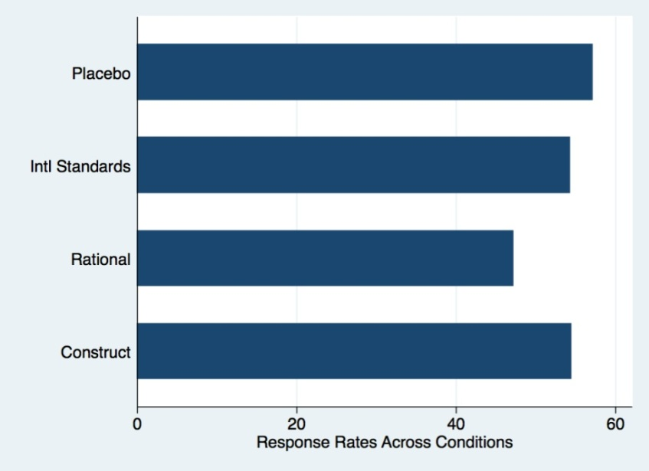

Notably, only the rationalism treatment led to a significant decrease in response rates compared to the placebo condition–with nearly 10 percent fewer responses. These differences in response rates suggest that some firms exercise discretion in their correspondence with potential clients. Apparently, if the subjects are primed about law and its consequences, a significant set of firms fail to respond to the request for incorporation. Counterbalancing this effect, however, the rationalist treatment also caused a significant decrease in compliance rates compared to the placebo, with compliance falling more than 11 percent from 53.6 percent in the placebo condition to 42.5 percent in the rationalist condition.
Interestingly, we find no statistically significant treatment effects for the other conditions. Mention of international standards and the FATF alone (without noting possible consequences) had no significant effect on response rates or compliance rates. Interestingly, the constructivist treatment, which explicitly mentioned that being “reputable businessmen” required compliance with international norms, did not induce differences in response or compliance rates compared to the placebo condition.
We now turn to examining response and compliance rates broken down by country groups, including tax havens, OECD countries and high, middle, and low income countries. In the overall sample, 27 percent of the service providers contacted and 51 percent of those who actually responded were willing to defy international standards in providing a shell company without requiring notarized proof of the customer’s identity.

Table 2: Response and Compliance Rates Across Country Groups
Country Group | Number of Firms | Responses | Response Rate | Compliant Firms | Compliance Rate
OECD | 246 | 137 | 55.7 | 69 | 50.3
Tax Havens | 254 | 172 | 67.7*** | 107 | 62.2**
Upper-Middle and Lower Income Countries | 514 | 231 | 44.9*** | 91 | 39.4**

*** Significant at .01 level compared to OECD in two-tailed t test; ** At 0.05 level

Figure 2: Response Rates Across Country Groups
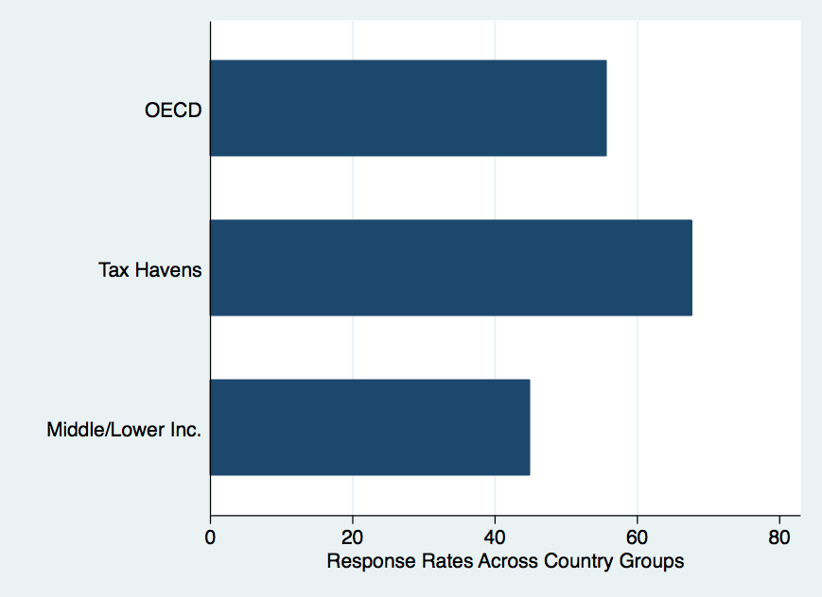
“Tax Haven” countries showed a 12 percent higher response rate than OECD countries, with the difference statistically significant at the .01 level. Upper-middle and lower-income countries, however, replied at rates nearly 20 percent lower than tax haven countries, again significant at the .01 level. Middle- and lower-income countries also responded at significantly lower rates compared to OECD countries, perhaps indicating that firms in wealthy countries are better equipped to deal with international requests for incorporation.

Compliance Rates with International Law Across Conditions

We first provide the raw results on compliance that do not incorporate response rates. Following, we estimate a selection model that permits us to adequately account for selection into the compliance analysis through an e-mail response. Finally, although we feel non-response likely reflects soft refusal, we also consider the chance that non-respondents were not “treated” and consequently estimate the potential treatment effect on the treated.
Beyond response rates, we also construct a measure that assesses how the treatments affect the propensity to comply with international standards. We undertake this analysis a bit more cautiously, however. It seems clear that compliance rates depend crucially on response rates. That is, if—as we suspect, a failure to reply to a request may–for some significant set of subjects at least–indicate a soft refusal of service, then any inferences drawn from rates of compliance must also consider response rates. Thus, an accurate analysis of compliance rates may require the inclusion of response rates.
We categorize both non-compliance (a failure to request any kind of identifying documents) and partial compliance (requiring only uncertified documents) as non-compliance and then score them 0 in a binary indicator of compliance. We do this because while requiring non-notarized documents is unquestionably better than not asking for any documents, photocopies of both drivers’ licenses or passports are notoriously easy to fake. Thus, firms employing such a relaxed application of international standards will likely facilitate many more untraceable shell corporations than firms requiring certified documents. Additionally, we categorize firms that refuse service or require notarized documents as “compliant”. Figure 3 below reports the results for compliance rates with international law comparing the experimental conditions with the control.
Figure 3: Compliance Rates across Experimental Conditions
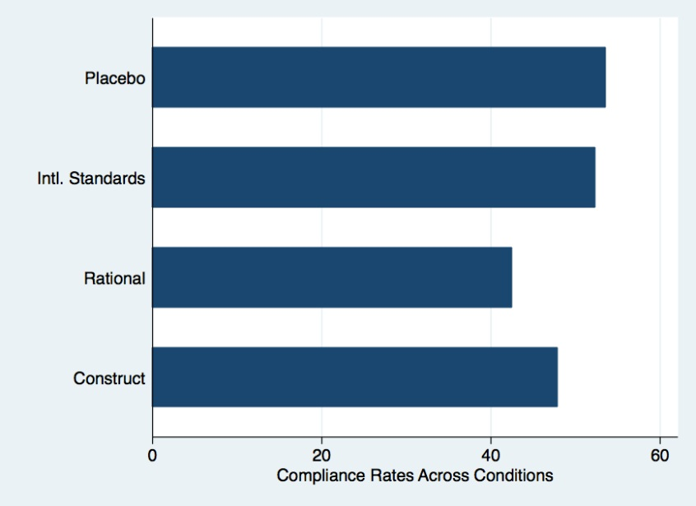

In analyzing compliance rates, the rationalist treatment, which combines mention of the FATF with a reference to possible legal penalties, has a significant effect on compliance rates as measured, and the effect is negative–it induces less compliance than the placebo condition. This result is unexpected and is discussed in Part III.C.
These results confirm the descriptive statistics showing that OECD countries have higher response and compliance rates generally. A similar effect occurs for the rationalism treatment in OECD countries. These results thus suggest some additional differences in the treatment effects, especially as it relates to country grouping that will be discussed in the next section.
These results also support the expectations developed in international law theory in some ways, but they are surprising in others. The expectation for results would be a lower response rate matched with a higher compliance rate. Some firms would react to the treatment information by not responding, while others would react by being more conscientious in requiring identity documents. Thus, the statistically lower response rate for rationalism, and lower response rates generally, indicate that the treatments may induce some soft compliance. But why do they not also simultaneously induce hard compliance? In other words, why is it that on the one hand the rationalism treatment makes firms more likely to comply with international law, but at the same time, less likely to follow international law? This is in essence what is happening with the mismatched response and compliance rates with the rationalism treatment. A few explanations of this phenomenon and other counterintuitive results follow below.

Discussion within International Theoretical Framework

To gain an understanding of how effective international law is, we analyze the nations’ formal compliance with laws (regulatory and enforcement mechanisms put into place to enforce international law domestically) and actual compliance (the actions of individual private firms). To test actual compliance with international law we must look to the private actors in these nations in a natural setting. Whether a group of firms comply with international law demonstrates whether the international law agreed to by their home nation is effective. Thus, the effectiveness of the law in this area is an accumulation of individual firms’ decisions that may result due to norms or incentives put into place by a nation and motivations of the firm. The decision of these firms to comply or not comply with international law expresses the weaknesses (or strengths) of the formal structures put into place by their nations and also sheds light on which international theory best determines compliance. Since firms are the key players in following or violating international law, their motivations prove significant in determining whether international law is effective and how effectiveness can be improved. With that, we now turn to exploring whether individuals comply with international law and what their motivations are when they do comply.

Do Individuals Comply with International Law?

International law requires identity information to ensure transparency while forming a corporation. The following reply to one our inquiries from a U.S. firm indicates the disregard of such international laws: “All that you need to do is to provide the name you want for your new company, that’s it.” The subjects respond to the inquiry to form a confidential corporation as the first step in determining whether nations comply with international financial transparency laws. To get a broad picture of overall international compliance, we review the results from a test of formal compliance, and examine actual compliance below.
To determine whether countries comply with international law, we compare formal compliance rates with actual compliance demonstrated by our field experiment. To get at both formal and actual compliance, we examine the national legal framework as well as the actions of private actors in each nation who carry out the obligation of the nation to comply with international laws. Next we briefly examine blocks of states (OECD members, tax haven, high-middle income and low-middle income states) to see if we detect any significant differences in formal and actual compliance between blocks of countries.
Overall, formal compliance results are mixed. Over 180 countries have signed and ratified the FATF and international transparency laws and have accepted its framework. Digging deeper, we examine the percentage of these countries that are actually complying with these laws. Formal compliance indicates mixed results. Ninety-six percent of countries have ratified national laws requiring identity documents upon incorporation. Yet FATF evaluations show that only 40% of countries comply with FATF provisions, though closer to 75% of countries are largely and partially compliant with these provisions. With formal compliance numbers, it is hard to determine whether countries are actually complying with international laws, since there is no way to know based on the legal landscape how easy it is to form a shell company in the particular jurisdiction. Thus, we turn to actual compliance to determine whether the aims of financial transparency laws are being met internationally.
To determine actual compliance, we examine the level of compliance by private actors with international laws. Our field experiment reveals a lower than predicted result; only half of countries (49%) complied with international law, which may surprise both rationalists and constructivists. The international laws at stake are relevant here. The laws tested here are the international standard of financial transparency, which have been ratified and deemed significant to the worldwide effort to stop corruption and the financing of terrorism. The importance of these laws and the consensus about the import of these norms suggest that we should see higher rates of compliance than ordinary international laws.
We first examine the rationalist and constructivist reaction to the moderate international compliance findings. Given the strength of the international norms supporting these laws, constructivists might expect high rates of compliance. Constructivists would be surprised that despite the high acceptance of these laws and norms of global cooperation surrounding these laws, that compliance with them is still weak. Constructivists would likely be most surprised by the relatively low levels of compliance by FATF member countries, who have agreed to uphold and thus should demonstrate the highest level of compliance among all of the signatories. However, these member countries actually demonstrate lower compliance rates in our field experiment compared to nonmember countries.
Some realists may also be surprised at the relatively high level of compliance with international laws, as they generally expect low compliance with international law. Realists might explain higher than expected compliance with the threat of potential sanctions that result for countries that fail to comply. And while the private actors here are not directly subject to such sanctions that are targeted at the national government, the compliance rate by private actors shows how important the fear of such sanctions are to that government. International law requires that governments sanction private bodies that do not comply with FATF provisions. Thus, governments that comply with such laws and fear sanctions for noncompliance would allow such fear to trickle down to the bodies that have the responsibility for implementing these international laws with sanctions. Overall, the results demonstrated by our field experiment of nearly 50% compliance with international law leave room for further debate by optimists and pessimists as to the significance of international law.

Who Complies with International Law?

After examining whether firms comply with international law, an important remaining question is firms in which countries tend to comply. While we do not undertake an in depth country-by-country analysis here, we present broad trends which challenge the premise of managerial theory. The managerial school theorizes that national compliance depends on relative wealth and resources and an ability to enforce international laws. Interestingly, our results refute managerial theory by demonstrating that relative wealth levels do not impact compliance rates. We find that when it comes to formal compliance, the results are just as the managerial school would predict—the highest compliance rates are among high-income countries, then middle income followed by low income countries. However, in examining actual compliance, tax haven countries show the highest response and compliance rates. Indeed, we demonstrate that tax havens actually have 12% higher response and compliance rates than OECD countries, and more than 20% higher response and compliance rates than developing countries.
High response rates from tax havens may be explained by the fact that these firms are almost exclusively focused on foreign customers, and so they may be more accustomed to responding to inquiries from abroad. Their counterparts in middle and low-income countries may be both less accustomed to foreign businesses and thus be less likely to follow up online inquiries. The greater response and compliance rates in tax havens compared to OECD countries demonstrate that there is not a strong relationship between income and compliance. This finding undermines managerialist school expectations, which maintain that violations are more likely to be a product of a lack of resources or knowledge rather than deliberate transgressions. Indeed, when we explicitly gave subjects information about international law in our experiment, it did not improve compliance rates–indeed, it decreased compliance, albeit not in a statistically significant way. The findings also suggest that the emphasis placed on improving international standards through “capacity building” or training may be misdirected. Thus, we find little consistent relationship between wealth of countries and compliance rates in our field experiment. Therefore, we explore an alternative explanation for differences in compliance rates.

Why Comply with International Law?

Our field experiment reveals varying response and compliance rates based on the international law theory expressed, and thus sheds light on why firms comply with international law. The results in this area are complicated and deserve some discussion. The discussion that follows first addresses response rates or “soft compliance,” then actual compliance rates, or “hard compliance.” While the last section discussed overall compliance, this section examines the effect of the various treatments—or theories of international law—and how they impact compliance.

Soft Compliance

We noticed soft compliance, as demonstrated by lower response rates, only with the rationalist treatment. One significant observation that supports rationalism is that individuals are more likely to demonstrate soft compliance with international law when prompted that it exists and are told that there are penalties associated with noncompliance. Another observation is that neither mention of international standards nor a normative rationale for following them (constructivist treatment) induced higher compliance than the placebo condition, where there was no mention of these standards. These findings are discussed in turn below.
International firms were more likely to demonstrate soft compliance with international law when informed about the existence of such law and when informed that penalties are associated with noncompliance with these laws. As such, firms responded at statistically significantly lower rates to the inquiry when penalties were invoked than when there was no mention of international law or mention of international law without warning of penalties. When we informed subjects that international laws had associated penalties (rationalism treatment) and told them about the law and what it required, subjects were less likely to comply. This is mixed evidence for the rationalist camp, which argues that nations are more likely to comply when informed of penalties or sanctions associated with international law, rather than when they are simply made aware of the law.
One set of subjects appeared to comply “softly” through no response. But among the rest of the subjects that did reply, they were significantly less likely to follow international law. What is more, these effects seem offsetting, suggesting that the very subjects failing to respond were those that would likely have complied if they had replied. Indeed, despite a prompt about legal penalties, it appears that a significant number of firms are willing to offer anonymous incorporation regardless of the threat of sanctions.
Surprisingly, firms were not more likely to show soft compliance with international law when they were informed that it was the international norm to comply with such laws. In the constructivist treatment, we explicitly mentioned the FATF and its disclosure standard, discussed that most countries have signed onto the standard, and remarked that we understood that we were operating as “reputable businessmen.” Notwithstanding these clear prompts and reference to widely accepted international norms, the constructivist treatment induced response rates statistically indistinguishable from the control condition and from simply mentioning the international standards. Thus, an appeal to shared norms and reputation makes little difference to firms when weighing whether or not to comply with international law. We find this result both surprising and quite interesting as it undermines constructivist accounts of compliance with international standards.
However, it is important to note here that appeals to international norms may be more persuasive to government representatives than private actors. Thus, if the subjects of our study were government actors, they may have been more likely to comply if they were informed of norms because they may place a greater emphasis on international reputation. This result may still demonstrate something important for obtaining better general compliance with international law. The ineffectiveness of appealing to norms may demonstrate that the government should favor threats and sanctions over appeals to norms for private actors. Overall, thus far, there is little support for the hypothesis that reputational concerns will prove sufficient to motivate compliance. Instead, this finding tends to support a realist view of rules and compliance as a product of power, as articulated by rationalists. The next section goes beyond response rates to determine hard compliance with international law, to determine why international firms that responded decided to comply with international financial transparency laws.

Hard Compliance

Thus far we have only discussed soft compliance, or whether the subjects refused to entertain our inquiry for a confidential corporation in the first place. Now we examine hard compliance to determine when subjects decide to comply or not comply with international law, why they do so. We arrive at this result by examining whether nations require the requisite information and documentation from the potential clients, as required by the FATF and other international law. Overall, the findings indicate—against our intuition—and rationalist expectations—that mention of legal penalties results in lower compliance with international law.
Compliance rates were highest when we made no mention of international law (control), followed by when they were prompted about the existence of international standards and, finally, when prompted about associated norms against noncompliance. Interestingly, firms were less likely to comply with international law when they were informed about penalties associated with such laws. At first blink, a rationalist would expect that a firm would be more likely to comply with international law when informed that there are penalties for noncompliance. However, the opposite result occurs, with lower compliance rates with the rationalist treatment.
There may be several explanations for why the threat of penalties produces both lower response rates and lower rates of compliance. As noted above, it seems that the firms’ initial choice of whether or not to reply creates a sub-set of firms that is more risk-acceptant or risk-insensitive than the initial sample. According to this logic, those most likely to be compliant with international standards, most attuned to the dangers of providing anonymous shell companies, or most uncomfortable with expectations of international law, choose not to respond in the first place, altering the sample of responding firms to favor those who may be less likely to comply. Firms seem to respond to risk by refusing service, rather than by changing their propensity to apply international standards. If a firm is content to accept a customer, they then follow their standard customer due diligence procedure–which may be little or nothing. While this explains low response rates at the outset, it does not explain why compliance rates are actually lower when the firm is informed about penalties for noncompliance. We offer explanations for this counterintuitive result in the form of two theories.

Conspirator Effect of Rationalism

One way to explain the discrepancy between higher compliance at the outset followed by lower compliance once responses are received is by what we call a conspirator theory of rationalism. The high soft compliance (low response) followed by lower compliance may provide information about what the firm believes that the potential client knows, and the firm’s potential fear (or lack of fear) of being caught. What the firm believes the client knows affects the firm’s decision. A noncompliant firm once placed on notice by a client that it is being asked to do something illegal has received a signal that the client is a coconspirator and less worried that it will be reported to the authorities. Indeed, this signal that the client is willing to violate international law is strongest with the rationalism treatment because under that treatment the client wants to violate international law even though she understands and explicitly acknowledges that penalties may result from doing so. On the other hand, if the potential client were naïve and realized that she had been asked for something illegal, she may be more likely to report the violator (the firm) to the authorities.
So the dishonest firm, which is aware of international law, feels safer with the conspirator’s request and is more likely to offer services that do not comply with the law to that individual than the naïve client. This may explain why the rationalist treatment induces lower response rates than the other treatments. This first step weeds out the firms that are either uncomfortable with what international law requires or are honest and do not want to deal with a client who appears to be willing to violate international law. But, once the firm responds, the rationalism treatment also leads to lower compliance rates by firms.
Under the conspirator effect, the logic here is that once the firm knows it has a dishonest client who is willing to conspire in violating international law, the firm is now more willing to violate international law—even in the face of legal penalties. Thus, the conspirator effect is greater when the firm is certain that the consequences for violating international law are serious (i.e. penalties), and thus follows the signal that the client will have no problem violating the law. This then explains why the mention of legal penalties leads to lower compliance with international law among the firms that respond to the query.
This conspirator effect gains support in the difference in results between OECD countries and non-OECD countries. OECD countries actively participate in an international forum on best economic practices and are generally wealthier countries with sophisticated markets. The OECD is comprised of a set of countries required to preserve international economic order through strict regulation. Because OECD countries are arguably more invested in international financial stability and their international reputation for upholding financial regulations, their citizens are more likely to comply with such laws—particularly when they perceive them to be serious (i.e. connected with penalties for noncompliance). Presumably, among the country blocks, they are less likely to be baited by an open conspirator who is willing to violate international law. This is exactly the result we find. Our results indicate that citizens of OECD countries are more likely to comply with international law when informed of penalties for noncompliance than non-OECD countries. Indeed, the OECD countries have a reputation for accepting international norms and complying with international financial regulations. However, other countries—less wealthy and with an arguably less sophisticated regulatory regime—are more likely to fail to comply with international law when they are confronted with a willing conspirator, because they have less fear of hypocrisy upon getting caught or less fear of sanctions due to noncompliance.
As this section makes clear, the conspirator theory of rationalism suggests that individuals are more likely to break international law when dealing with another open, willing violator of international law. We see the effects of this theory as a significant sub-set of firms are more likely to violate international law when they are informed of penalties for violating international law than when they are not informed about penalties. The conspirator effect has less of an influence with actors in more sophisticated markets, such as those in OECD countries. Where nations are a part of creating international norms, their private actors are less likely to conspire to break those norms. Thus, the conspirator effect is mitigated with prominent international players that set international norms.

Weak Penalty Effect

Another potential explanation of the contradictory rationalism compliance rate is that weak international penalties induce lower compliance than a lack of international penalties. Some individuals who are informed that penalties accompany noncompliance are deterred from responding to the client query compared to the placebo condition where no laws or penalties are mentioned. But those individuals who do not comply may not be violating rationalist logic. The rationalism treatment may receive a lower hard compliance rate than the other two treatments (though a lower response rate) because of the low perceived fear of actual penalties under international law.
The firms who decide to ignore the potential penalties may not fear actual penalties for two reasons. First, the firm who receives the query may disregard the potential penalties they are informed of because they have never heard of the FATF or the international penalties invoked and know based on experience in the field that such penalties are either light or not enforced in their country. Rather than indicating that this individual is contradicting her self-interest by failing to avoid penalties, this may simply be a statement on the lack of fear of any actual penalties that may result from violating international law. Of course, the firm here is not violating international law but this fear of sanctions indicates the level of a state’s compliance. This theory has some support in the finding that middle- and lower-income countries responded at significantly lower rates compared to OECD countries, perhaps indicating that firms in wealthy countries were more likely to be aware that the FATF is soft law and garners no real sanctions.
Second, the individuals may do some very quick research to see whether there are in fact legal penalties and how high they may actually be. They may soon realize that penalties that may apply in not requiring disclosure are in fact light or so far removed from her firm (and generally apply only to the national government) such that she is willing to take the risk of incorporating as normal, despite such standards. Thus, the lower compliance rate in the rationalism condition may be an indication that many individuals perceive international penalties for noncompliance to be weak or unlikely and cause them to behave worse than they would without this knowledge. So it appears that individuals may be less likely to comply with international law when there are weak international standards than when they are uninformed about international law. Indeed, the existence of weak penalties may create a disincentive to comply rather than a greater incentive to comply with international law.

Potential Confounding Effects

An issue that needs to be addressed is that potentially these treatments are marrying client type and international law type and creating a confounding effect. This argument is that potentially the three treatments are signaling that there is a particular type of customer: the uninformed customer, the disobedient customer, and the obedient customer. Arguably, the responses by the firm are based on the signal received from the three customers rather than on the three international law responses: international standards, rationalism, and constructivism. Thus, what we are measuring is not the firm’s proclivity to comply with international law but simply their response to the signal given from the different customers. In other words, some firms may be sophisticated enough to calibrate their responses based on the information they receive from prospective clients.
In response, we argue that, first, international law primarily governs the nation and then the firm, not the individual customer. This may even include sanctions on the firm for noncompliance. So, the firm may be watching for signals but ultimately must still consider what international laws bind them. Additionally, assuming that the treatments effectively combine client type with international law compliance, this may not pose a problem for this analysis. We are testing the effects of client type on firms' willingness to follow international law. But international standards explicitly enjoin nations (and their private entities) to scrutinize customers based on their profile (and relative risk), which is significant as the potential customers are all seeking to avoid complying with international law. And as far as the FATF, all the treatments express the same knowledge of international law and the same inquiry, so the knowledge level and request to learn about document requirements are consistent across treatments. Thus, while we cannot separate subject’s judgments about client type from their decisions to comply with international law, we hold enough constant across the international standards, rationalist, and constructivist treatments to make a good case that the treatments are measuring the target causal effects, if any.
Another issue may be that the firm may say anything or agree with the potential client and then make them comply with international law after they have received a commitment for service. Thus, the firm may state up front that they would not require any documentation, because the client’s letter indicates that he values privacy. Then, after receiving fees for incorporation, the firm may then state that due to domestic or international law it must have the following documents in order to incorporate. This bait-and-switch approach arguably could be used by firms, though our research indicates that this is unlikely. Judging from interviews and previous research in international transparency, we know that providers request a fee and documents at the same time, not sequentially. Thus, the bait and switch approach is unlikely to play a role here, and even if it does the tendency should be balanced across experimental conditions by randomization.
The implications of these results are individuals are not more likely to comply with international law if informed about the existence of the law, if they aware of norms to follow such law, or confronted with sanctions for failing to comply. Indeed, as it turns out, many firms are actually less likely to comply with international law, particularly when they are made aware of penalties that may follow. Two different rationales indicate that less compliance rates in the rationalist treatment may be due to the fact that firms who are fully aware of penalties under international law will still violate those laws when conspiring with a willing and open violator of international law or when they anticipate that international sanctions will be weak. Additionally, nations more closely involved in creating international law, with more sophisticated markets, are more likely to comply with international law when informed about penalties for noncompliance.

Conclusion

So, as a whole, does international law matter? The answer depends on whether we examine formal state compliance or informal compliance by private actors. As far as formal compliance with international regulations, most states require some financial transparency for incorporation, though most only partially enforce key international laws. A look at informal compliance exposes results that may be encouraging to some cynics: about two-thirds of the time, firms complied with international standards. This informal test also provides a more accurate test of financial transparency by actually addressing whether firms in such nations are willing to violate international standards targeted at terrorist financing. This informal test resulted in a much less reassuring finding: roughly one in seven international firms are willing to form anonymous corporations capable of major corruption or terrorism. And nearly half of those who responded were willing to violate international law by failing to require identity documents or refuse service, thus enabling the easier formation of anonymous shell companies.
Beyond the overall picture of international compliance, an analysis of our field experiment provides several significant findings. It appears that reference to legal penalties significantly lowers response rates . However, while referencing penalties reduced response rates (as might be expected), it also decreased compliance with international transparency standards. Thus, mentioning penalties that would apply for not following international law actually made some firms less, not more, likely to follow the law. This finding is at odds with the idea that threats of sanctions increase compliance, which is at the core of the rationalist theory that actors are guided by fear of penalties and maximizing self-interest. Though with a conspirator effect of rationalism and a theory based on perceived weakness of international law, we provide potential explanations of why information about sanctions results in lower compliance. Actors may be more likely to violate international law when they know that their client is a conspirator, and thus open to ignoring international law, and also when they perceive international penalties to be weak rather than when they learn nothing about penalties. Understanding these motivations can help increase compliance with international law in the context of financial transparency and in other areas. These findings may also aid governments in stopping the formation of anonymous shell companies that have caused billions in damage worldwide, and aid in combating a range of financial crimes, including terrorism.
Second, compliance with international law is unrelated to national capacity or wealth. Surprisingly, as a general rule, the level of compliance in low and middle-income countries is not significantly lower than that in wealthy countries. This runs counter to the managerialist presumption and conventional wisdom that compliance is at least in part a matter of having the expertise and wherewithal to implement international standards. The positive implication of this finding is that if low-income countries can secure a high level of compliance, most other countries should be able to do likewise without major expense. The negative implication is that many countries with a low level of compliance have simply chosen not to follow the rules.
Third, and of greatest significance to international law scholars, compliance with international rules is no higher when nations are prompted about the existence and contents of these rules or international norms to comply with such rules. This is a major blow to both the constructivist and managerial school. The managerialist school argues that ignorance, rather than opportunism, may underpin much non-compliance, as actors are simply unaware of what they should be doing. At least in the case of international financial transparency law, however, more information about the standards has no effect on compliance rates. And prompts about international norms to comply with international law had no significant effect on response or compliance rates.
Finally, we articulate a rationale and demonstrate with evidence that states are not the most important actors when it comes to determining whether international law is effective. We show that international compliance is not a straightforward product of formal domestic or international regulations and enforcement, but a consideration of informal compliance by private firms and individuals. If compliance were purely driven by whether or not domestic law mandated collecting identity documents for those forming shell companies, we would expect near-perfect compliance from jurisdictions with such a law, and near-zero compliance from those without. However, we see substantial variation as firms in various nations comply or choose not to comply with international standards that their nations has agreed to. And overall, formal compliance with international law by any of the measures does not usually match actual compliance. These differences indicate that compliance with international law cannot be measured solely by examining a nation’s regulatory framework, but must consider how individuals and firms—at the locus of compliance—in fact behave. Thus, against the prominent frameworks of international law, we conclude that states may not be the only primary players in determining whether international law is effective. Indeed, the private actors within them may significantly determine if—and why—international law matters.

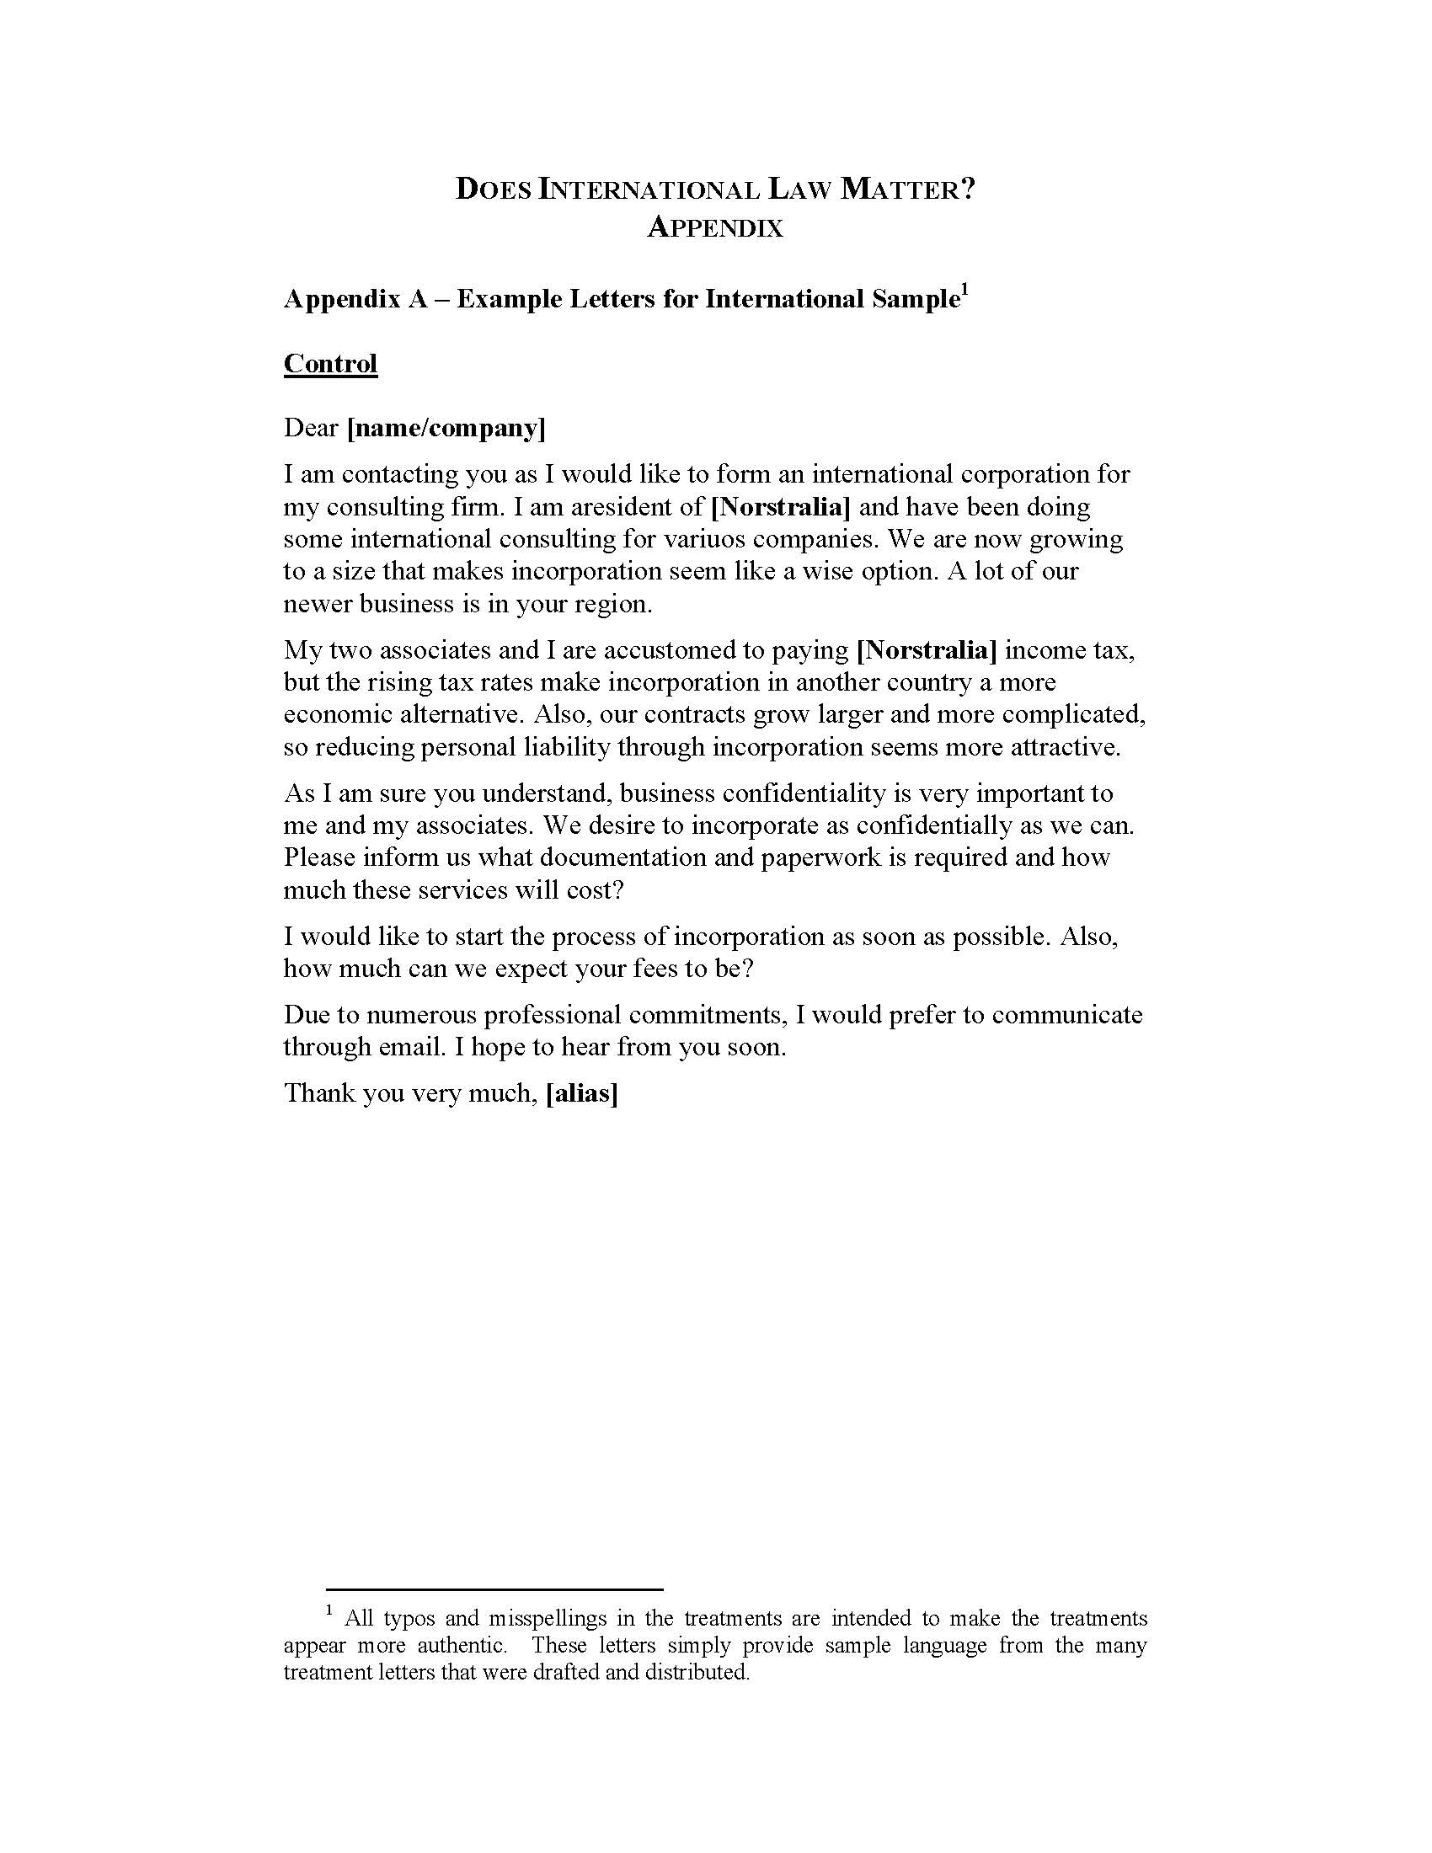
Appendix


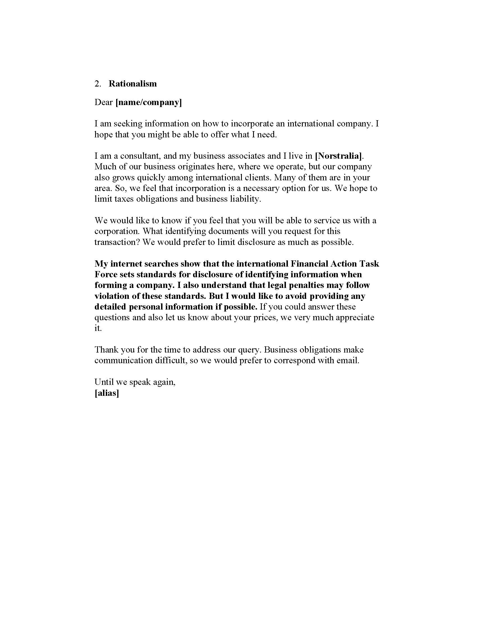

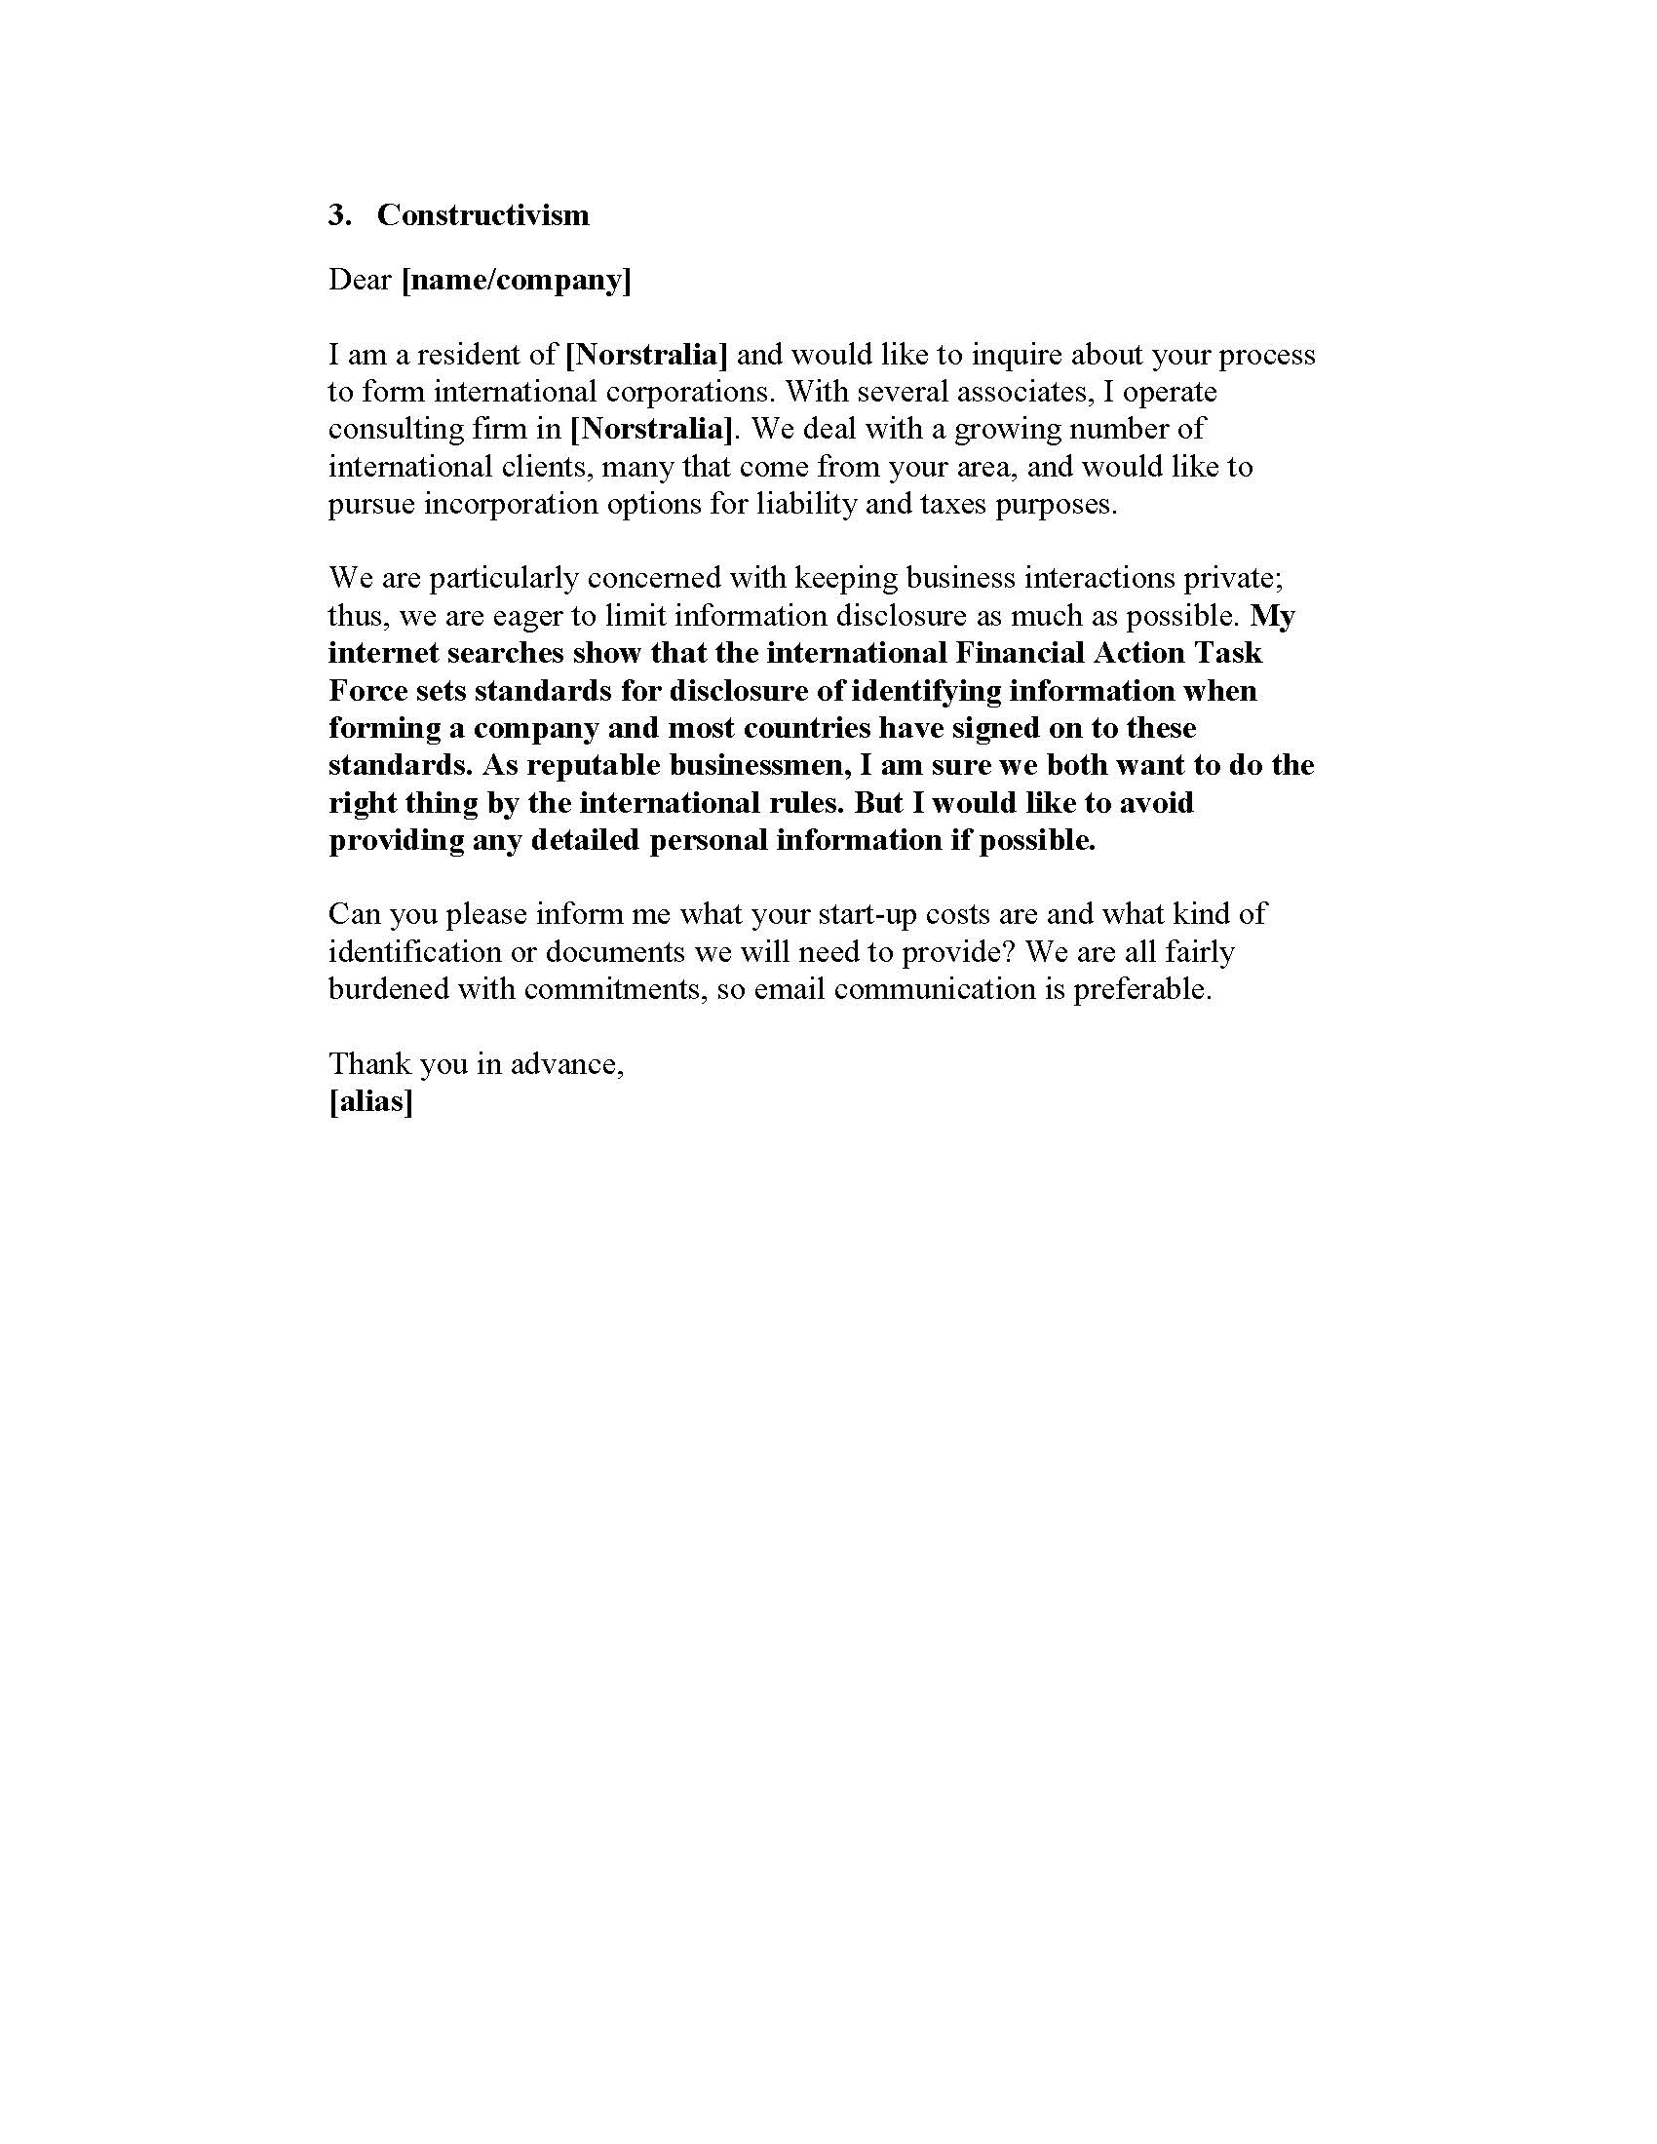

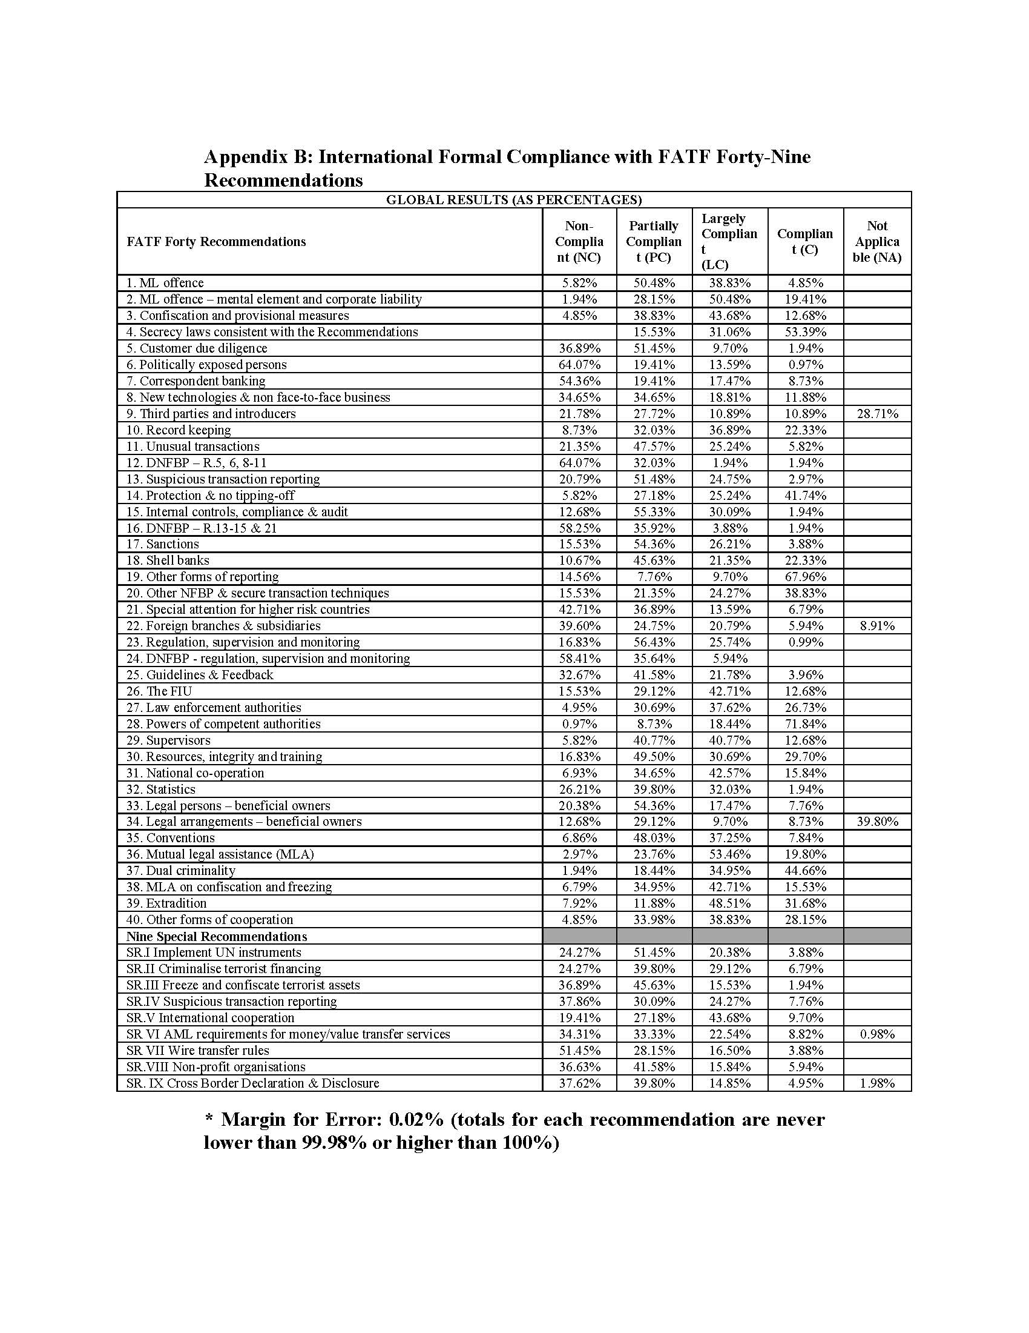

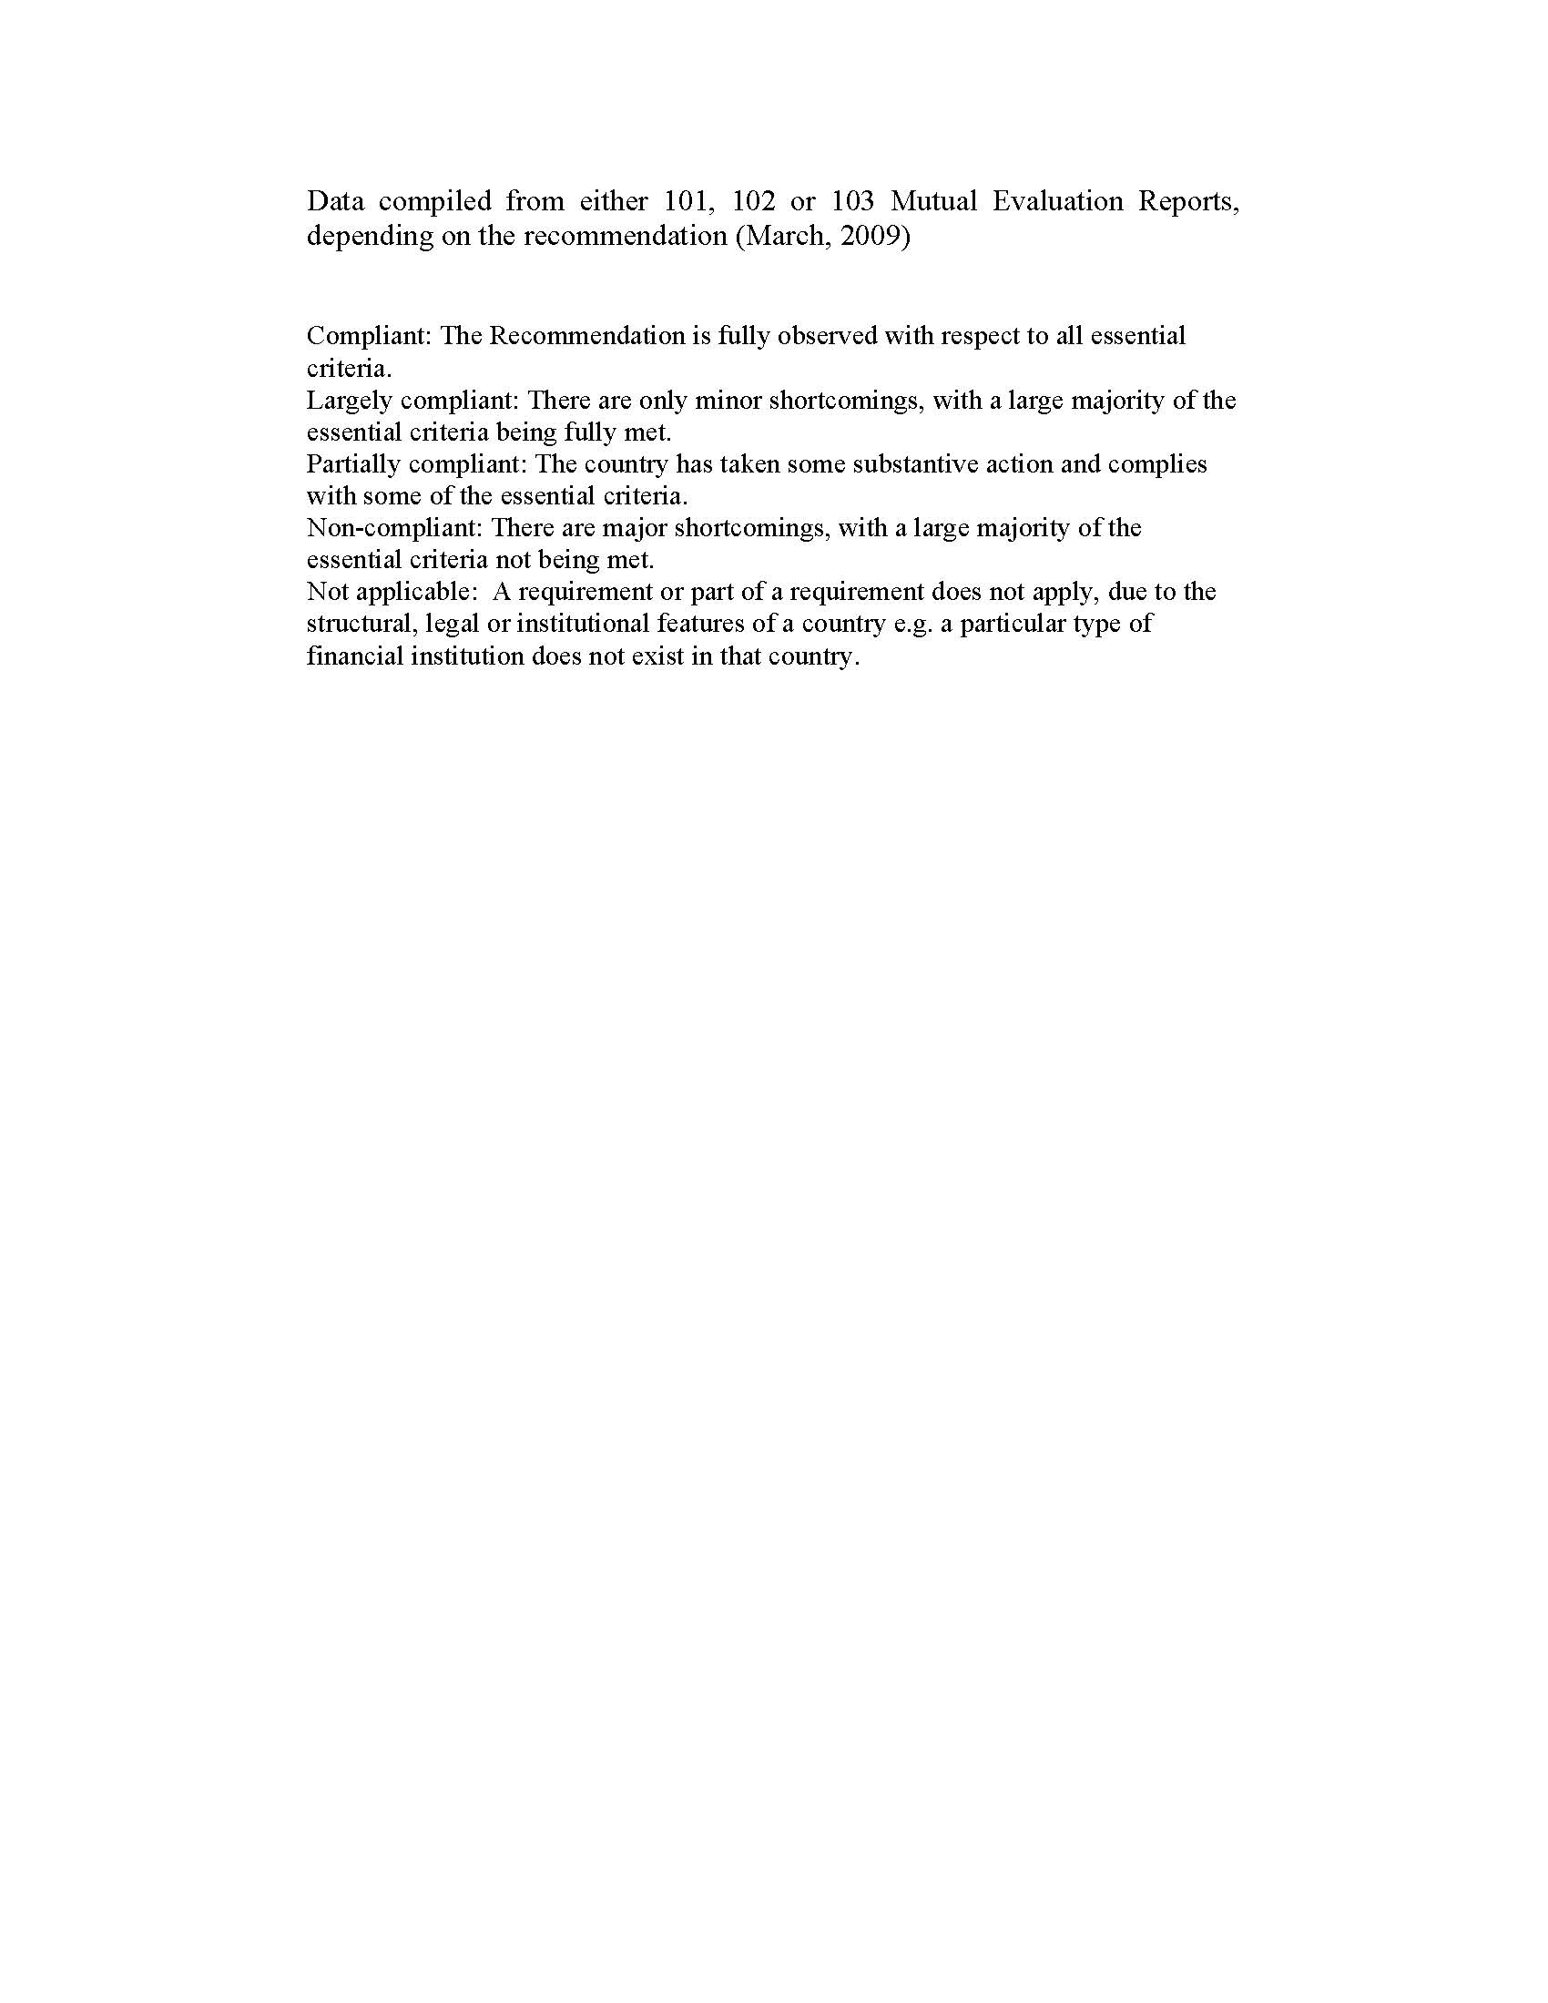

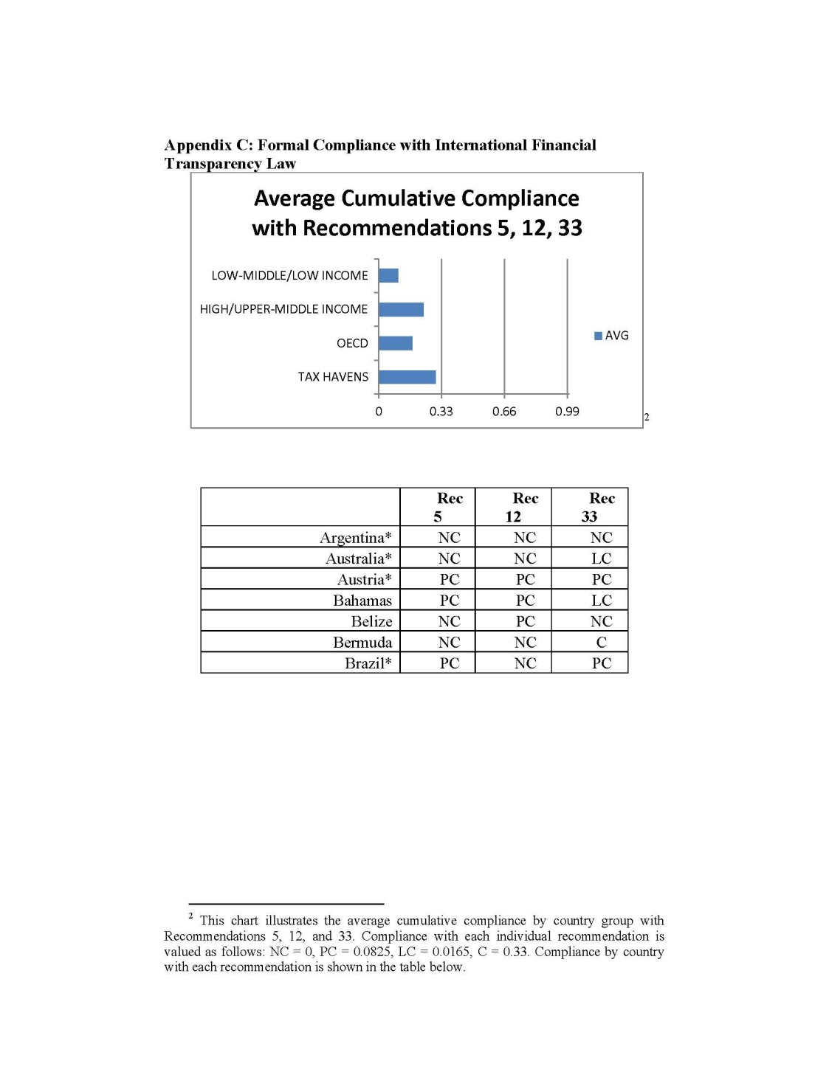

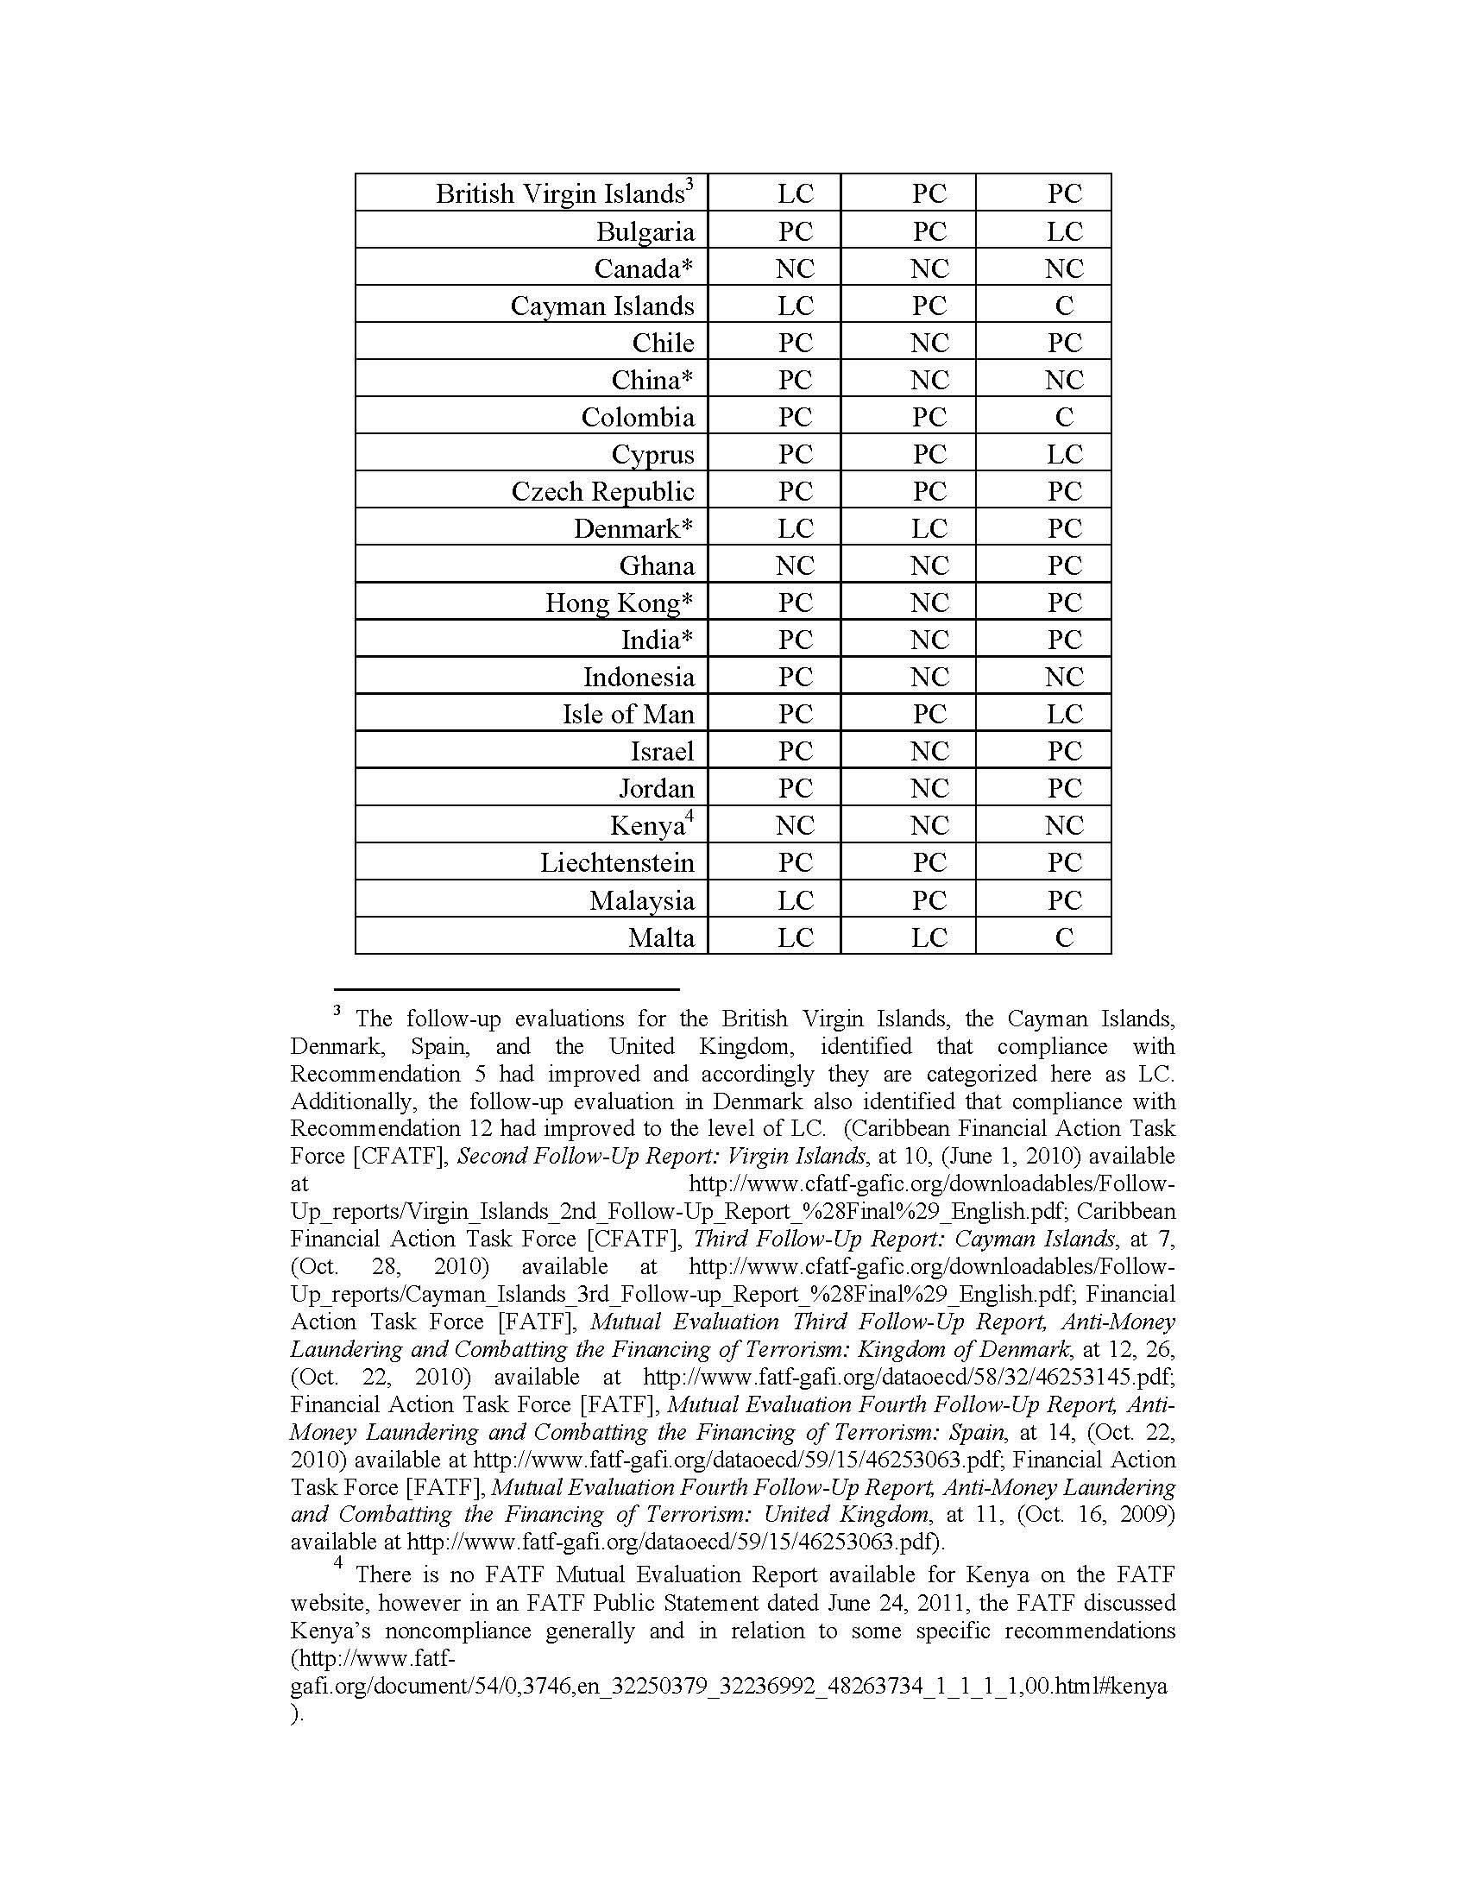

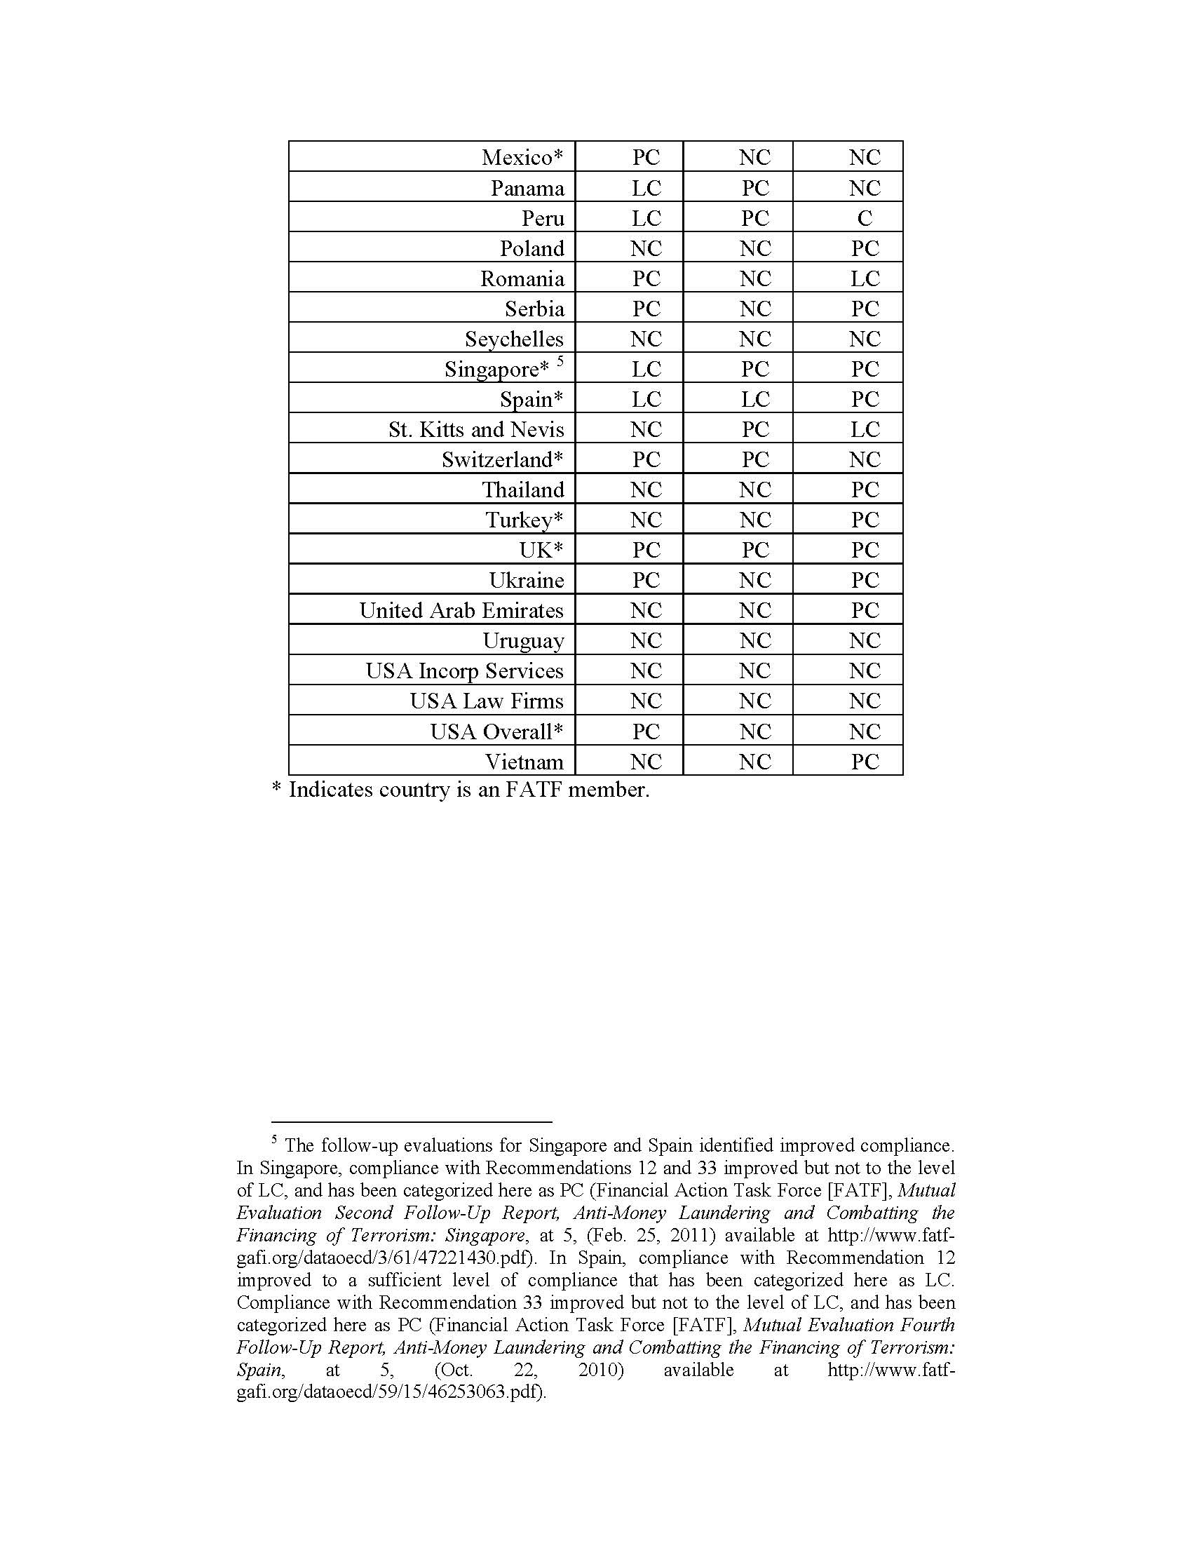

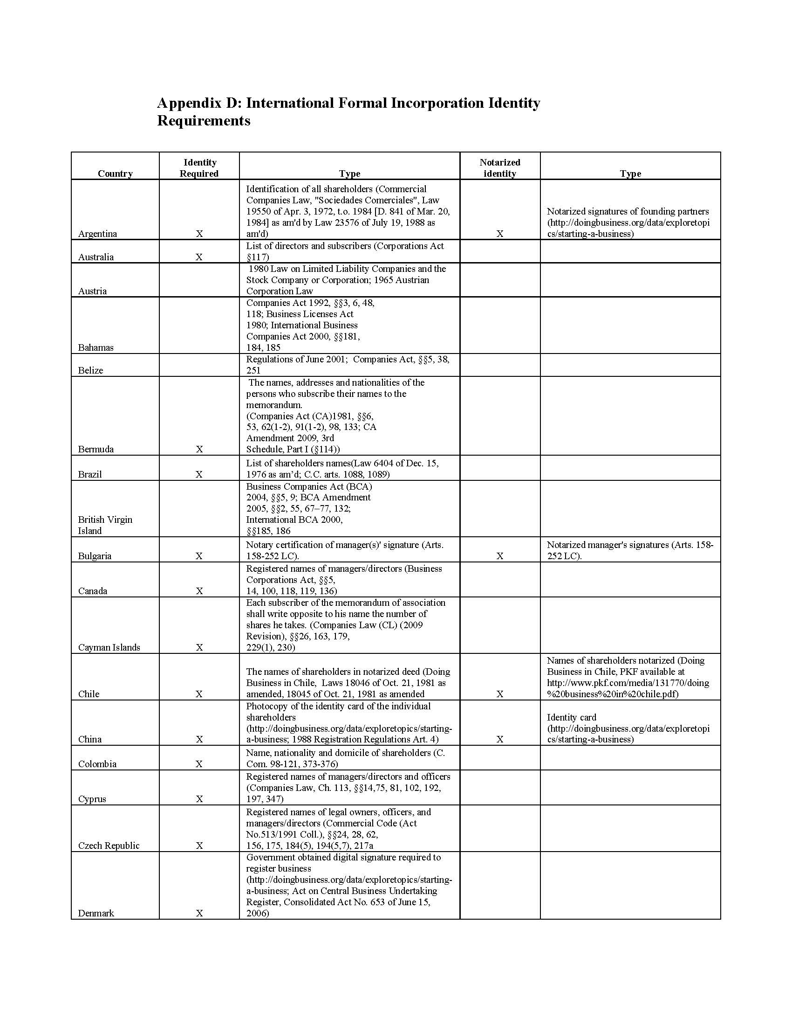

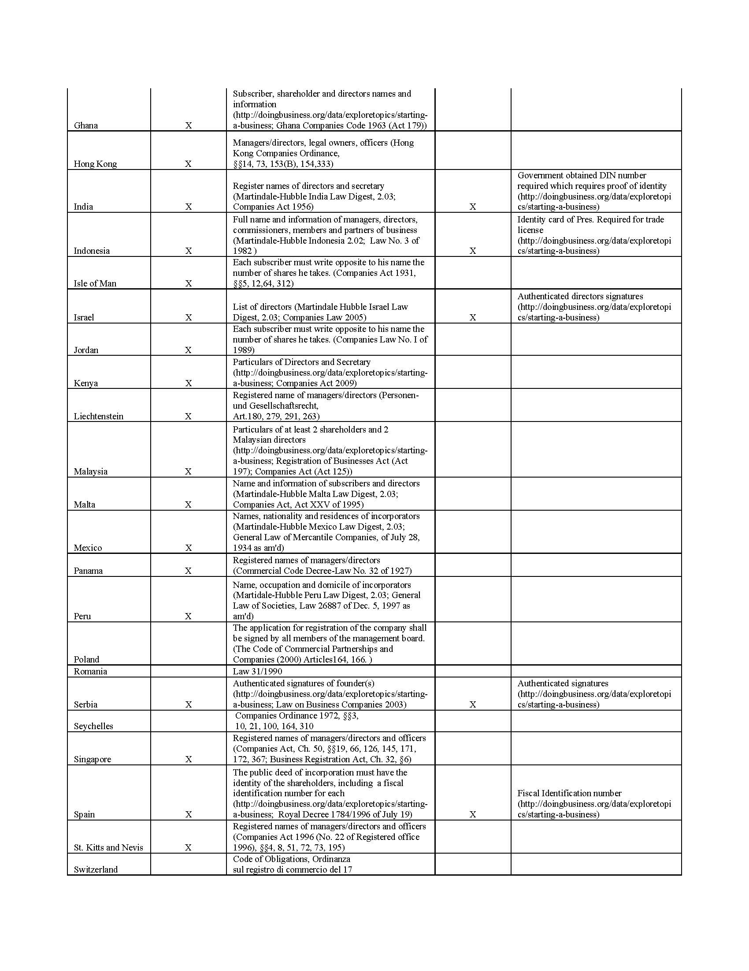

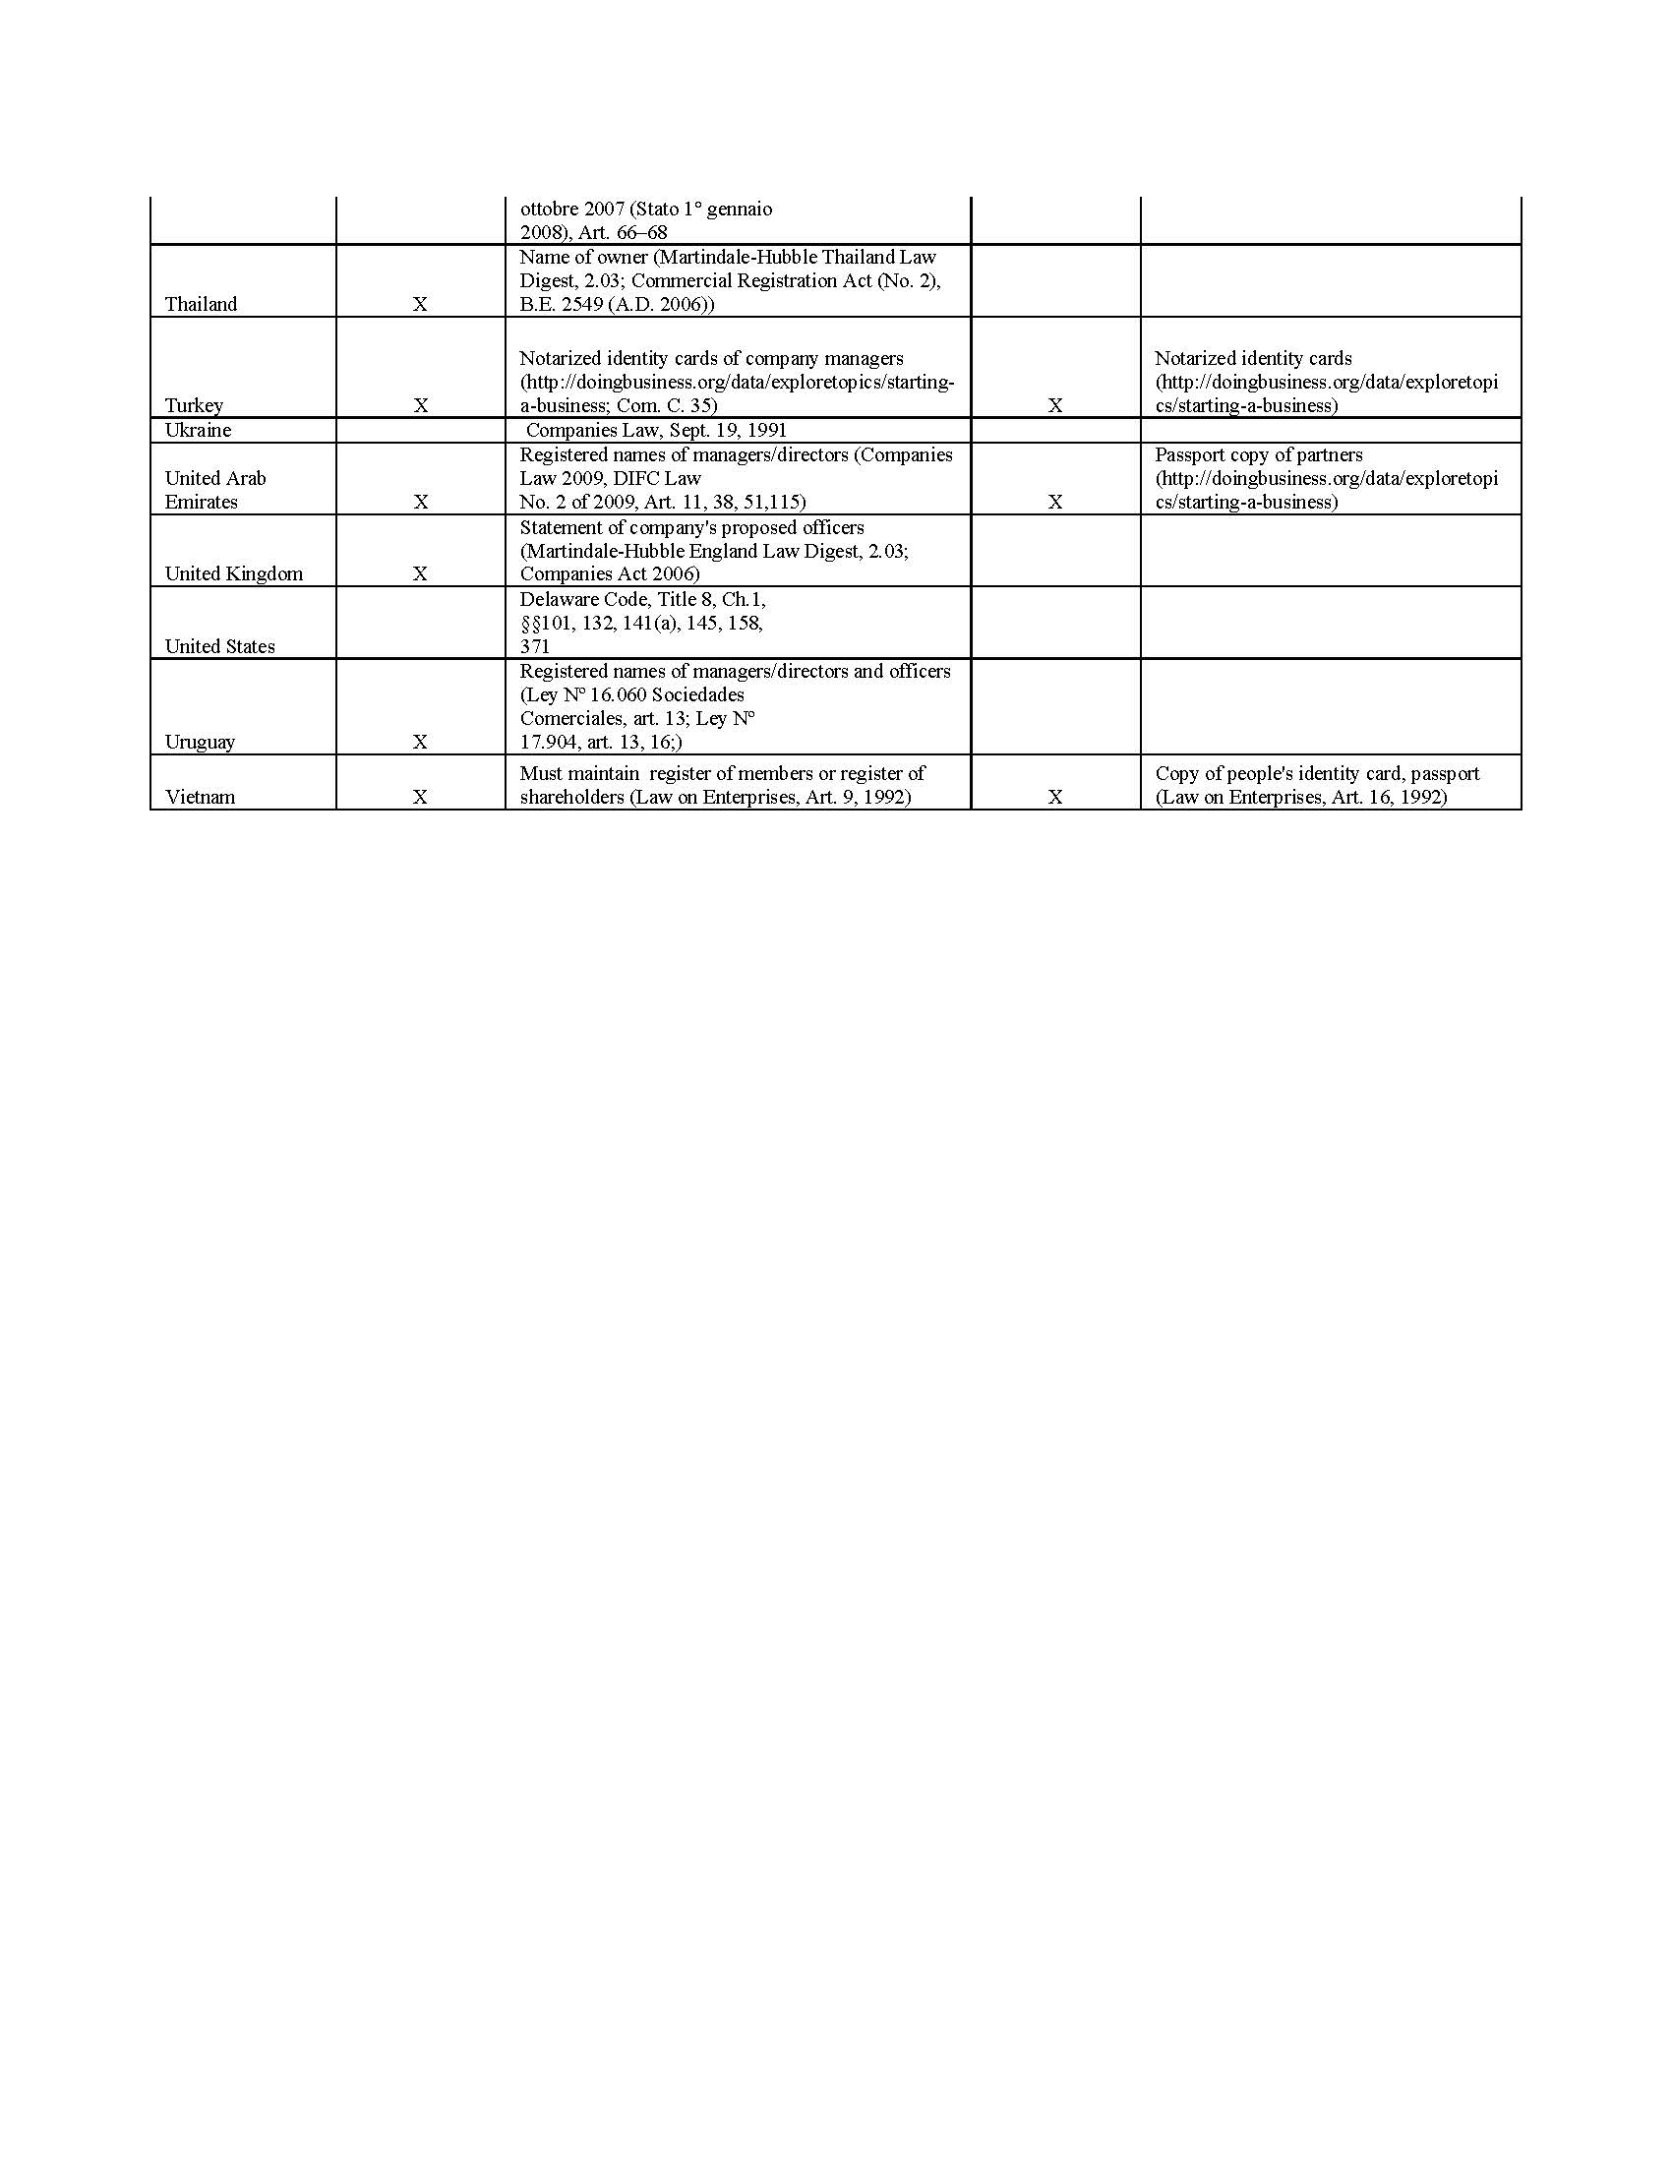

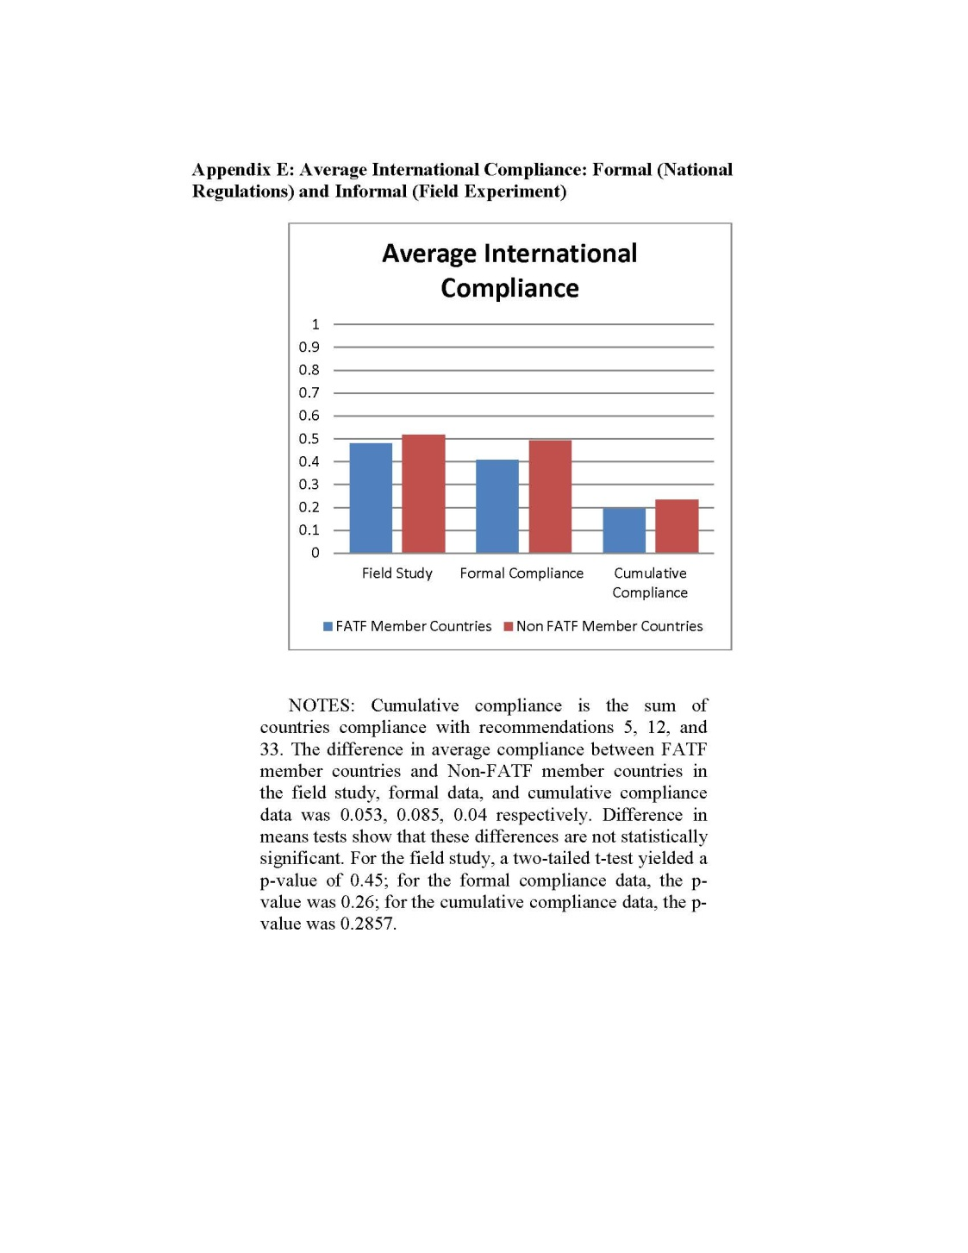

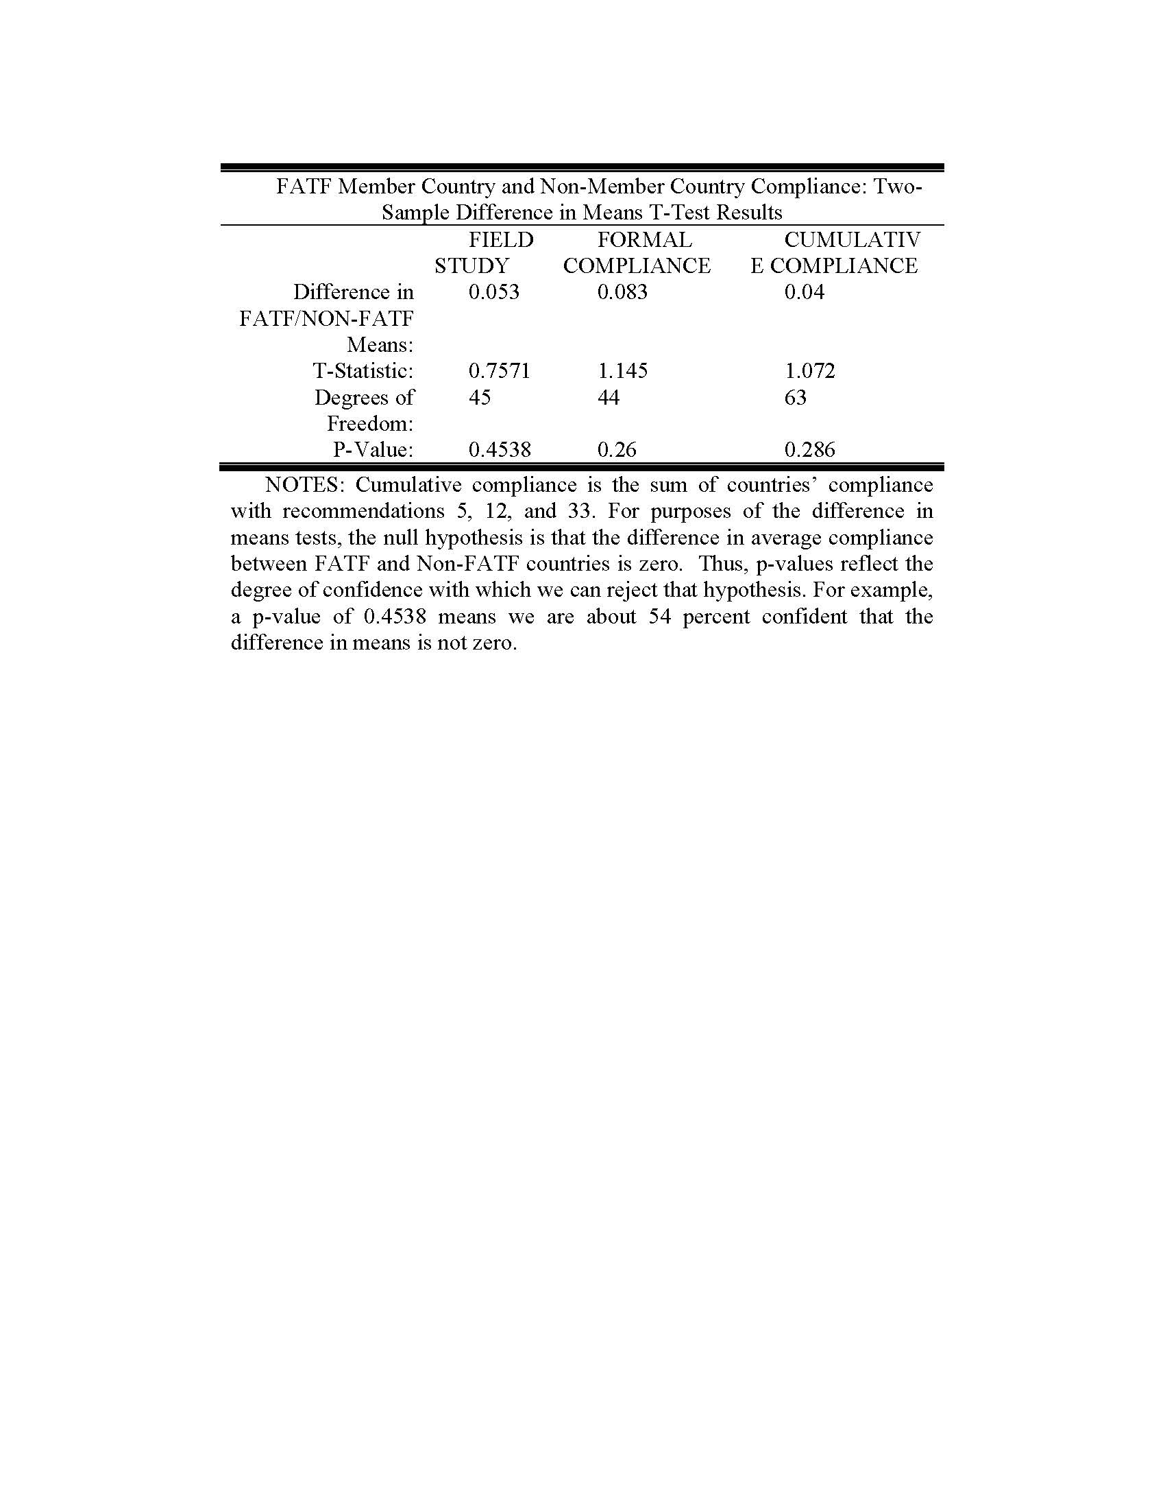

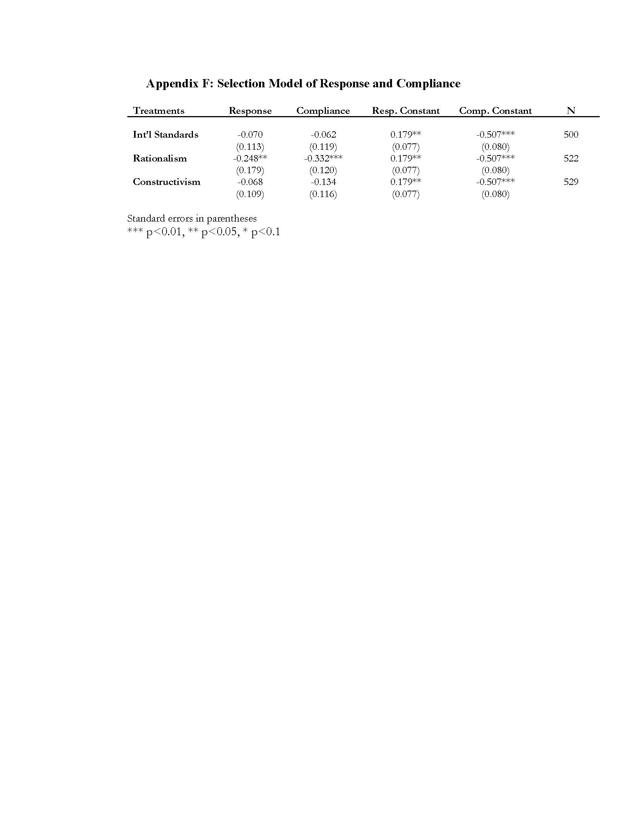

 Associate Professor of Law, BYU Law School. We express gratitude to the Yale, Columbia, Cornell, Northwestern, Vanderbilt, William & Mary, Wisconsin and BYU law and political science faculties for their feedback. We would also like to thank officials in the U.S. Department of Justice, Internal Revenue Service, Financial Action Task Force (FATF), World Bank, International Monetary Fund (IMF), Senate Permanent Subcommittee on Investigations, and United Nations Office on Drugs and Crime for their assistance in this project. We express gratitude to Professors Oona Hathaway, Jack Goldsmith, Eric Posner, Jide Nzelibe, Susan Hyde, Robert Keohane, Daniel Kono, Jim Kuklinski, Larry May, Robert Mikos, David Moore, Stephanie Rickard, Toby Rider, Michael A. Newton, Christopher Slobogin, Ned Snow, Brigham Daniels, Eric Jensen, Scott Cooper, Jordan Barry, Don Green, Darren Hawkins, Macartin Humphreys, Susan Hyde, Robert Keohane, Daniel Kono, Jim Kuklinski, Larry May, Robert Mikos, Stephanie Rickard, Toby Rider, Michael Newton, Dustin Tingley, Scott Wolford, Dustin Tingley, Scott Wolford, Ingrid Wuerth, and Yesha Yadav for each providing extremely useful comments. We thank Drew Chapman, Zach Christensen, Madeleine Gleave, James Juchau, Brock Laney, Robert Morello, Wayne Sandholtz, Brittany Thorley, Axel Trumbo, Hyrum Hemingway, Alex Mason, Mary Bevan, Tyler Albrechtsen, Aaron McKnight, Joseph Stewart, and Ryan Merriman for remarkable research assistance. We offer special thanks to Dustin Homer for so ably leading the data collection. IRB clearance and university approval received July 7, 2010.
∗ Assistant Professor of Political Science, Brigham Young University.
∗∗ Associate Professor of Political Science, Brigham Young University.
∗∗∗ Professor of Political Science, Center for Governance and Public Policy Griffith University, Australia.
Curtis A. Bradley & Jack L. Goldsmith, Customary International Law as Federal Common Law: A Critique of the Modern Position, 110 Harv. L. Rev. 815 (1997) (discussing the preeminence of customary international law); Paul B. Stephan, Privatizing International Law, 97 Va. L. Rev. 1573, 1626 (2011) (assessing that the “growth of international law” has meant an increase in international law’s domain); Edith Brown Weiss, The Rise or the Fall of International Law?, 69 Ford. L. Rev. 345, 351 (2000) (noting that binding international legal instruments have “greatly increased,” non-binding international legal instruments concluded by governments and international nongovernmental organizations have become “very significant sources of international law,” and private actors have created “important transnational instruments”); Jordan J. Paust, Customary International Law and Human Rights Treaties Are Law of the United States, 20 Mich. J. Int’l L. 301 (1999).
Harold H. Koh, Why Do Nations Obey International Law? 106 Yale L.J. 2599, 2600–01 (1997) (noting that several key scholars have argued that international law matters); Louis Henkins, How Nations Behave: Law and Foreign Policy (2d ed. 1979) (explaining that “almost all nations observe almost all principles of international law and almost all of their obligations almost all of the time”); Oona A. Hathaway, Do Human Rights Treaties Make a Difference?, 111 Yale L.J. 1935, 1937 (2002) (noting that international lawyers most often assume that nations observe international law); Jack L. Goldsmith & Eric A. Posner, A Theory of Customary International Law, 66 U. Chi. L. Rev. 1113, 1113 (1999) (noting that “[g]overnments take care to comply with [customary international law] and incorporate its norms into domestic statutes”); Laurence R. Helfer & Anne-Marie Slaughter, Toward a Theory of Effective Supranational Adjudication, 107 Yale L.J. 273, 276 (1997) (“Supranational adjudication in Europe is a remarkable and surprising success...both [the European Court of Justice and the European Court of Human Rights] developed successful strategies to make their judgments as effective, for the most part, as national court rulings.”); George W. Downs et al., Is the Good News About Compliance Goods News About Cooperation?, 50 Int’l Org. 379, 379 (1996) (explaining that the message from political scientists and scholars is that high compliance with international law is achieved “with little attention to enforcement”).
See Douglass Cassel, Does International Human Rights Law Make a Difference?, 2 Chi. J. Int’l L. 121, 131–34 (2001) (discussing human rights treaties’ ineffectiveness to change states’ practice); Jack Goldsmith, Sovereignty, International Relations Theory, and International Law, 52 Stan. L. Rev. 959 (2000) (citing Joseph M. Grieco, Anarchy and the Limits of Cooperation: A Realist Critique of the Newest Liberal Institutionalism, 42 Int’l Org. 485 (1988); Eric Lane, Mass Killing by Governments: Lawful in the World Legal Order?, 12 N.Y.U. J. Int’l L. & Pol. 239 (1979) (arguing that international agreements are ineffective at preventing a country from killing its own citizens); John J. Mearsheimer, The False Promise of International Institutions, 5 Int’l Sec., Winter 1994-1995) (explaining that “[r]ealists are skeptical about cooperation among nations” and that realists believe that “the little cooperation we see is fragile”); J. S. Watson, Legal Theory, Efficacy and Validity in the Development of Human Rights Norms in International Law, 1979 U. Ill. L.F. 609, 626–35 (1979) (arguing that states often speak like they will follow international law, but states’ actions indicate the contrary).
See David S. Ardia, Does the Emperor Have No Clothes? Enforcement of International Laws Protecting the Marine Environment, 19 Mich. J. Int’l L. 497, 508–16 (1998) (discussing difficulties in enforcing marine environmental international agreements); Emeka Duruigbo, International Relations, Economics and Compliance with International Law: Harnessing Common Resources to Protect the Environment and Solve Global Problems, 31 Cal. W. Int’l L.J. 177, 189–193 (2001) (arguing that costs of compliance and of reporting on compliance makes enforcement difficult); Richard A. Falk, On Identifying and Solving the Problem of Compliance with International Law, 58 Am. Soc’y Int’l L. Proc. 1 (1964) (arguing that enforcement is difficult because of uncertainty as to the legal rule governing state behavior); Günther Handl, Compliance Control Mechanisms and International Environmental Obligations, 5 Tul. J. Int’l & Comp. L. 29 (1997) (arguing that major difficulties in compliance increase with increased complexity of the international regime and with increased costs of compliance); Christopher C. Joyner, Sanctions, Compliance and International Law: Reflections on the United Nations’ Experience Against Iraq, 32 Va. J. Int’l L. 1, 32 (1991) (arguing that enforcement of international laws is more difficult when the international law is perceived as unfair or illegitimate).
There is also a debate about compliance with international laws because of imprecise definitions. See Christopher Greenwood, Ensuring Compliance with International Law, in Control over Compliance with International Law 201 (W.E. Butler ed., 1991) (arguing that maritime laws of war cannot be effectively complied with because it is not clear as to how they apply to current situations); David S. Ardia, Does the Emperor Have No Clothes? Enforcement of International Laws Protecting the Marine Environment, 19 Mich. J. Int’l L. 497, 504–05 (1998) (explaining that notwithstanding the many treaties involving environmental concerns, few such agreements substantively define the parties’ future obligations); Jack L. Goldsmith & Eric A. Posner, A Theory of Customary International Law, 66 U. Chi. L. Rev. 1113, 1114–15 (1999).
Beth A. Simmons, Compliance with International Agreements, 1 Ann. R. Pol. Sci. 75 (1998) [hereinafter Simmons, Compliance]; Abram Chayes & Antonia Chayes, On Compliance, 47 Int’l Org. 175 (1993) (arguing that managerial insights can improve compliance with international law); Koh, supra note 1, at 2599.
See supra notes 2–5.
Lung-chu Chen, An Introduction to Contemporary International Law 76-80 (2d ed. 2000) (noting the role of individuals and that realistically individuals are the ultimate actor); Helfer & Slaughter, supra note 2, at 300 (noting important factors for gaining compliance with international laws); Dinah Shelton, Commitment and Compliance: The Role of Nonbinding Norms in the International Legal System (2000) (discussing soft law compliance); Charles Lipson, Why Are Some International Agreements Informal?, 45 Int’l Org. 491 (1991); Kenneth W. Abbott & Duncan Snidal, Hard and Soft Law in International Governance, 54 Int'l Org. 421 (2000). See also Curtis A. Bradley & Mitu Gulati, Withdrawing from International Custom, 120 Yale L.J. 202 (2010) (questioning the mandatory nature of customary international law); Terry Nardin, Ethical Traditions in International Affairs, in Traditions of International Ethics 13 (Terry Nardin & David R. Mapel eds., 1993) (contending that international law is not “law” “because it cannot be enforced”). See generally Thomas M. Franck, Fairness in International Law and Institutions (1995).
Hans J. Morgenthau, Politics Among Nations: The Struggle for Power and Peace (4th ed. 1967) (explaining international compliance with realism theory); Franck, supra note 8, (arguing that international rules perceived as fair are considered more legitimate and are therefore followed more frequently); Andrew T. Guzman, A Compliance-Based Theory of International Law, 90 Cal. L. Rev. 1823 (2002) (explaining nations’ compliance with international law with international relations theory); Abram Chayes & Antonia Handler Chayes, The New Sovereignty: Compliance with International Regulatory Agreements (1998) (arguing that a “managerial model” of compliance in which nations cooperate in a problem solving approach to problems should replace the coercive theories that say nations comply because of sanctions); Benedict Kingsbury, The Concept of Compliance as a Function of Competing Conceptions of International Law, 19 Mich. J. Int’l L. 345 (1998) (examining various theories of compliance because the concept of compliance does not stand alone, but depends on the theory behind it); John K. Setear, Responses to Breach of a Treaty and Rationalist International Relations Theory: The Rules of Release and Remediation in the Law of Treaties and the Law of State Responsibility, 83 Va. L. Rev. 1 (1997) (examining breach and compliance with international law); Robert O. Keohane, International Relations and International Law: Two Optics, 38 Harv. Int’l L.J. 487, 487 (1997) (describing the competition between the “instrumentalist optic” and the “normative optic” compliance theories); Beth A. Simmons, Money and the Law: Why Comply with the Public International Law of Money?, 25 Yale J. Int’l L. 323 (2000) (examining international compliance with the laws governing money and arguing that nations commit to comply with international law when it is credible and plausible that they can commit); Thomas M. Franck, Legitimacy in the International System, 82 Am. J. Int’l L. 705 (1988) (arguing that compliance to international law is secured by nations’ belief in the legitimacy of the rule, which requires nations to believe that the rule came into existence through the right process); Andrew T. Guzman, Rethinking International Law as Law, 103 Am. Soc’y Int’l L. Proc. 155, 155–56 (2009) (noting that a key question in international law is “how well does international law do in its effort to influence state behavior”).
David D. Cardon, Does International Law Matter?, 98 Am. Soc’y Int’l L. Proc. 311, 312 (2004) (explaining that while certain, specific laws were broken, the laws of war were largely adhered to during the Ethiopian-Eritrean War, which took place between 1998 and 2000); Emeka Duruigbo, International Relations, Economics and Compliance with International Law: Harnessing Common Resources to Protect the Environment and Solve Global Problems, 37 Cal. W. Int’l L.J. 177, 183–84 (2001) (reporting “impressive” compliance by 1991 with the 1973 International Convention for the Prevention of Pollution from Ships); Elias N. Stebek, ICJ Judgment (1994) on the Libya/Chad Territorial Dispute: A Brief Overview and Observations, 3 Mizan L. Rev. 169 (2009) (discussing Libya’s submission to a decision handed down by the International Court of Justice in 1994); James G. Apple, Enforcement of International Law Is Not Dependent on a “Sword” or Enforcement Mechanism, Int’l Judicial Mon. (Jan./Feb. 2007) (discussing three instances in which countries submitted to an international court’s authority: Libya’s submission to a decision handed down by the International Court of Justice in 1994, Russia’s submission to a decision offered by the European Court of Human Rights in 2006, and seventy-nine out of eighty countries submitting to World Trade Organization Appellate Body decisions through 2006).
And the cross-national comparisons that exist are typically limited to a certain time period, geographic region, or set of events. Consequently, they shed little insight on the current global state of international law compliance. Hiram E. Chodosh, Comparing Comparisons: In Search of Methodology, 84 Iowa L. Rev. 1025, 1038–40 (1999) (discussing the value of comparisons of international laws but lamenting the lack of good studies due to methodological failures).
Increasingly, social scientists use field experiments to explore what motivates individuals to act in specific situations. Specifically, scholars rely on field experiments to study theories on economics, social and criminal behavior, and political economy. See, e.g., Richard D. Schartz & Sonya Orleans, On Legal Sanctions, 34 U. Chi. L. Rev. 274 (1966); Stanley Divorski et al., Public Access to Government Information: A Field Experiment, 68 Nw. U. L. Rev. 240 (1973); Donald P. Hartmann et al., Rates of Bystander Observation and Reporting of Contrived Shoplifting Incidents, 10 Criminology 248, 258 (1972) (finding that half of those who did not report crimes in violation of local law described that reporting would have been impractical in some way); Hans P. Binswagner, Attitudes Toward Risk: Theoretical Implications of an Experiment in Rural India, 91 Econ. J. 867 (1981) (field experiment to test the theories on the economics of development); Macartan Humphreys & Jeremy M. Weinstein, Field Experiments and the Political Economy of Development, 12 Ann. Rev. Pol. Sci. 367 (2009) (using field experiments to study the political economy of development projects because development agencies and implementing organizations find themselves under pressure to show that their interventions are effective); Donald P. Green et al., Does Knowledge of Constitutional Principles Increase Support for Civil Liberties? Results from a Randomized Field Experiment, 73 J. Pol. 463 (2011) (studying knowledge of constitutional law and political behavior); Alan S. Gerber et al., How Large and Long-Lasting Are the Persuasive Effects of Televised Campaign Ads? Results from a Randomized Field Experiment, 105 Am. Pol. Sci. Rev. 135 (2011) (studying the effect of campaign ads on political behavior); Gary S. Green, General Deterrence and Television Cable Crime: A Field Experiment in Social Control, 23 Criminology 629 (1985) (field experiment performed to determine how well a legal threat deters people from committing television signal theft and finding that two-thirds ceased the illegal practice after receiving notice).
There have been several local randomized field experiments measuring international organizations’ interventions in local affairs. See Jeremy M. Weinstein & James D. Fearon, Can Development Aid Contribute to Social Cohesion After Civil War? Evidence from a Field Experiment in Post-Conflict Liberia, 99 Am. Econ. Rev. 287, 287 (2009) (evaluating the impact of a community-driven reconstruction program implemented by the International Rescue Committee in northern Liberia and finding that post-conflict development aid can have a measurable impact on social cohesion); Mary Kay Gugerty & Michael Kremer, Outside Funding and the Dynamics of Participation in Community Associations, 52 Am. J. Pol. Sci. 585, 585 (2008) (finding little evidence that outside funding increased organizational strength of organizations comprised of poor and disadvantaged individuals).
Colin Wright, Philosophy of Social Science and International Relations, in Handbook of International Relations 24 (Walter Carlsnaes, et al eds., 2002) (These problems include: “a bar to constructive dialogue; a hindrance to much-needed research into issues of vital concern; a confused misrepresentation of the issues; and most importantly, a construct of those working in the field.”).
There are more than a dozen distinctions and sub-theories of rationalism and constructivism that are not discussed here. See, e.g., Emanuel Adler, Seizing the Middle Ground: Constructivism in World Politics, 3 Eur. J. Int’l Rel. 319, 335–36 (1997) (dividing constructivism into four separate camps); Scott Bruchill et al., Theories of International Relations 105 (4th ed. 2009) (noting a distinction between realism and idealism within rationalism).
Rationalists do not ever “comply” with international law but act consistently with it when compelled. Goldstein et al., Legalization and World Politics, 54 Int’l Org. 385 (2000). Neoliberal institutionalists generally believe that compliance with international law can be quite high. Simmons is the best example, but there are many others, like Keohane, Snidal, and Abbott, who believe that nations generally comply. See Simmons, Compliance, supra note 6 at 75.
Anthony Clark Arend, Do Legal Rules Matter? International Law and International Politics, 38 Va. J. Int’l L. 107, 121-22 (1997-98).
James Fearon & Alexander Wendt, Rationalism v. Constructivism: A Skeptical View, in Handbook of International Relations 54 (Walter Carlsnaes et al. eds., 2002).
Jack L. Goldsmith & Eric A. Posner, The Limits of International law 3–5 (2005). Some rationalists are realists and believe that a state’s primary interest is protecting security interests. Jack Goldsmith, Sovereignty, International Relations, and International Law, 52 Stan. L. Rev. 959, 963 (2000); see also Tom Ginsburg & Richard H. Holmes, Adjudicating in Anarchy: An Expressive Theory of International Dispute Resolution, 45 Wm. & Mary L. Rev. 1229 (2004) (explaining with game theory why countries would comply with decisions rendered by international courts).
This can be analogized to individual actors who are also motivated by the threat of penalties. See Joanne M. Miller & Jon A. Krosnick, Threat as a Motivator of Political Activism: A Field Experiment, 25 Pol. Psychol. 507 (2004).
Individualists believe that social structures can be reduced to the independent actions of agents. See Alexander Wendt, Social Theory of International Politics 26 (Steve Smith et al. eds., 1999). But see Edward Rubin, Rational States?, 83 Va. L. Rev. 1433, 1451 (1997) (“Treating collective entities as individuals, with motivations, plans, strategic responses, and the other accouterments of rational actor theory, is extremely convenient. It is much easier than trying to construct their behavior from the behavior of the real individuals who comprise them.”); Arend, supra note 17, at 119 (citing Robert O. Keohane, International Institutions: Two Approaches, 32 Int’l Stud. Q. 379, 386 (1988)).
Uta Oberdörster, Why Ratify? Lessons from Treaty Ratification Campaigns, 61 Vand. L. Rev. 681, 685 (2008).
Arend, supra note 17, at 124. But see Oberdörster, supra note 22, at 119 (discussing rationalists that “argue that the creation of institutions and regimes can independently influence state behavior); Fearon & Wendt, supra note 18, at 56 (arguing that the microeconomic concept of equilibrium is a manner in which rationalism accounts for structure that impinges and influences actors); Wendt, supra note 21, at 33.
Oona A. Hathaway, Between Power and Principle: An Integrated Theory of International Law, 72 U. Chi. L. Rev. 469, 479 (2005).
Robert Pape, Why Economic Sanctions Do Not Work, 22 Int’l Sec. 90, 109 (1997).
Goldsmith &. Posner, supra note 19, at 36–37, 87–88.
Jack L. Goldsmith & Eric A. Posner, Understanding the Resemblance Between Modern and Traditional Customary International Law, 40 Va. J. Int’l L. 639, 672 (2002).
Oona A. Hathaway, Ariel N. Lavinbuk, Rationalism and Revisionism in International Law, 119 Harv. L. Rev. 1404 (2006) (suggesting that rationalist theorists should provide information about what interests states pursue in order to better support their theory).
Jack L. Goldsmith & Eric A. Posner, The Limits of International Law 10 (2005) (“A successful theory of international law must show why states comply with international law.”).
However, a rationalist response may argue that states serve their interests by increasing benefits and avoiding penalties, with little regard to international norms. The state’s interests are determined by laws that dictate either penalties for noncompliance or benefits for obedience. See Guzman, supra note 9 at 1849 (explaining that a nation’s reputation may be damaged or enhanced by decisions to comply with international law or not; negative effects to reputation serve as penalties and positive effects as benefits). Of course, international penalties and benefits are relevant. Hathaway, supra note 24 at 480 (summarizing a rationalist theory of international law compliance by noting that states only join treaties [increasing benefits] that do not require them to act very differently than they already do [incurring little cost]).
Oona A. Hathaway & Ariel N. Lavinbuk, Rationalism and Revisionism in International Law, 119 Harv. L. Rev. 1428 (2006). Assumptions such as power and interests matter, states seek to influence one another in pursuit of often conflicting self-interests, and self-help through military force is important. See Jeffrey W. Legro & Andrew Moravcsik, Is Anybody Still a Realist?, 24 Int’l Sec. 5, 21 (1999).
Alex Geisigner & Michael Ashley Stein, A Theory of Expressive International Law, 60 Vand. L. Rev. 77, 78 (2007).
Hathaway, supra note 24, at 479. A common retort is that entering such treaties is “cheap talk” used by governments to justify their self-interested actions, but the retort fails to explain why “cheap talk” would be valuable. See, e.g., Kenneth Waltz, Theory of International Politics 200 (1979); Edward Hallett Carr, Twenty years Crisis: 1919-39 71–75 (2d ed. 1946); Morgenthau, supra note 9, at 11.
Rationalists argue that states enter such treaties to protect some self-interest, with weaker states feeling coerced by greater states who actually value human rights. Others explain states complying with international law because of internal pressure created by domestic policies and the costs of possible sanctions. Hathaway, supra note 2, at 1946, 1951–52, 1954 ; see also Waltz, supra note 33, at 136 (noting that the “expected costs of enforcing agreements, and of collecting the gains they offer, increase disproportionately as the group becomes larger”).
But see David Moore, A Signaling Theory of Human Rights Compliance, 97 N.W. L. Rev. 879 (2003) (the damage that the U.S. has suffered from not signing onto various human rights treaties, notwithstanding a history of human rights compliance, suggests otherwise).
Harlan Grant Cohen, Can International Law Work? A Constructivist Expansion, 27 Berk. J. Int’l L. 636, 651–52 (2009).
Id. at 636, 657–58. See, e.g., H.L.A. Hart, The Concept of Law 89 (1961). See also Mark A. Chinen, Game Theory and Customary International Law: A Response to Professors Goldsmith and Posner, 23 Mich. J. Int’l L. 143, 158 (2001–02). See Fernando R. Tesón, A Philosophy of International Law 79, 92–94 (1998) (“What is distinctive about doing our duty is that we are obligated to do it especially when it is costly to us, when doing it frustrates some preference or interest that we have. That is why moral choice cannot be captured by strategic analysis.”).
Like rationalism, constructivism encompasses a broad range of theories. Henkins, supra note 2, at 25–26. Constructivism draws from critical theory, post modernism, feminist theory, historical institutionalism, sociological institutionalism, symbolic interactionism, structuration theory, and others. Id. at 1. Notably, like with rationalism, constructivism is a broad term wherein much debate rages about what does and should fall beneath its umbrella. However, unlike rationalism, the debate rages to the point where a single recipe or definition is problematic. See Fearon & Wendt, supra note 18, at 56. See also Wright, supra note 14, at 34–35. Different scholars have included very conflicting ideas under this same label, raising questions about what it really means. Compare John Gerard, Constructing the World Polity: Essays on International Institutionalization (1998), with Steve Smith, Epistemology, Postmodernism and International Relations Theory, 34 J. Peace Res. 330 (1997)). Indeed, some constructivists claim that concern about reputation is a rationalist concern and that constructivists are solely concerned about acting morally. See, e.g., Larry May, The Morality of Groups: Collective Responsibility, Group-Based Harm, and Corporate Rights (1987); Larry May, Sharing Responsibility (1992).
Arend, supra note 17, at 130. See Stephen A. Kocs, Explaining the Strategic Behavior of States: International Law as System Structure, 38 Int’l Stud. Q. 535, 538–39 (1994). Kocs has suggested eight constitutive rules. The first three are seen as longstanding principles: “the sovereign equality of states, nonintervention in the affairs of other states, and good faith [pacta sunt servanda].” Five others are seen as more recent: the self-determination of peoples, [the] prohibition on the threat or use of force, [the] peaceful settlement of disputes, respect for human rights, and international cooperation.”
Hathaway, supra note 24, at 476–77.
Martha Finnemore, National Interest in International Society (1996). See, e.g., Wendt, supra note 21, at 26 (“People cannot be professors apart from students, nor can they become professors apart from the structure through which they are socialized.”).
Wendt, supra note 21, at 8–9 (arguing that states dictate social relations because they have a practical monopoly on violence).
Keohane, supra note 9, at 492.
Hathaway, supra note 24, at 481; Oona A. Hathaway & Harold H. Koh, Foundations of International Law and Politics 112 (2005).
Thomas Risse & Kathryn Sikkink, The Socialization of International Human Rights Norms into Domestic Practices: Introduction, in The Power of Human Rights 1, 57 (Thomas Risse et al. eds., 1999).
Arend, supra note 17, at 129.
Id. at 132.
Finnemore, supra note 41.
Uta Oberdörster, Why Ratify? Lessons from Treaty Ratification Campaigns, 61 Vand. L. Rev. 681, 689 (2008).
Finnemore, supra note 41.
The managerial model represents the arguments of a substantial group of international law scholars. E.g., Henkin, supra note 2.
Chayes & Chayes, supra note 6, at 9–10, 25–27, 116.
Managerialism also recognizes that compliance with international law can be costly and expects that wealthy countries are more likely to comply with international law than poor states. Therefore, managerialists argue that one of the best ways to encourage compliance is to offer economic and technical support to developing countries. Ibrahim F.I. Shihata, Implementation, Enforcement, and Compliance with International Environmental Agreements – Practical Suggestions in Light of the World Bank’s Experience, 9 Geo. Int’l Envtl. L. Rev. 37, 41 (1996); Emeka Duriugbo, International Relations, Economics and Compliance with International Law: Harnessing Common Resources to Protect the Environment and Solve Global Problems, 31 Cal. W. Int’l L.J. 177 (2001); Simon Tay, Southeast Asian Fires: The Challenge for International Environmental Law and Sustainable Development, 11 Geo. Int’l Envtl. L. Rev. 241, 289 (1999). For a critique of managerial theory see Downs et al., supra note 2, at 379–80 (arguing that states will not be willing to pay the cost of compliance for others and enforcement of this capacity building will be difficult).
Downs et al., supra note 2 at 10. Rationalists also claim that state noncompliance with international law results from a lack of sufficient information.
Downs et al., supra note 2 at 25–26. (“We propose that this process is usefully viewed as management, rather than enforcement.”).
Id. at 26.
Id. at 27, n.100. See also id. at 26 (“The process works because modern states are bound in a tightly woven fabric of international agreements, organizations, and institutions that shape their relations with each other and penetrate deeply into their internal economics and politics. The integrity and reliability of this system are of overriding importance for most states, most of the time.”).
Hathaway, supra note 24, at 483. This proposition faces mixed empirical support as evidenced in part IV of Hathway’s article. Id. See also Andrew T. Guzman, How International Law Works: A Rational Choice Theory 19–20 (2008) (arguing that constructivism is too complex to offer predictions concerning state behavior since it considers so many sub-state actors).
Arend, supra note 17, at 135. This criticism hearkens back to the desire to causally explain all relationships. Constructivists are generally not concerned with this in the same magnitude that rationalists are. Id.
Keohane, supra note 6, at 493.
Arend, supra note 17, at 134. See, e.g., John J. Mearsheimer, A Realist Reply, 20 Int’l Security 82, 92 (1995).
Richard K. Herrmann, Linking Theory to Evidence in International Relations, in Handbook of International Relations 119 (Walter Carlsnaes et al. eds., 2002).
Hathaway, supra note 24, at 526 (pointing out that states that ratify human rights treaties are more likely to commit human rights violations). But see Ryan Goodman & Derek Jinks, Measuring the Effects of Human Rights Treaties, 14 Eur. J. Int’l L. 171, 173 (2003) (arguing that several flaws in Hathaway’s methods drive her results).
See e.g., Martha Finnemore, International Organizations as Teachers of Norms: The United Nations Education, Scientific, and Cultural Organization and Science Policy, 47 Int’l Org. 565, 565 (1993) (qualitatively testing the causes of state structure evolution); David Lumsdaine, Moral Vision in International Politics: The Foreign Aid Regime (1993) (offering statistical evidence that foreign aid is motivated by moral beliefs).
Herrmann, supra note 62, at 119. Some scholars see such attempts as misguided, nothing more than selecting a favorite political preference.
But see supra note 24 at 492–93 (on both domestic and international levels, non-governmental organizations assist with the legal enforcement of states’ treaty obligations).
See, e.g., Jide Nzelibe, Strategic Globalization: International Law as an Extension of Domestic Political Conflict, 105 Nw. U. L. Rev 635 (2011) (arguing that individual politicians may have varying preferences for observing international law commitments based on partisan factors).
See, e.g., Susan Rose-Ackerman, Anti-Corruption Policy: Can International Actors Play a Constructive Role?, http://papers.ssrn.com/sol3/papers.cfm?abstract_id=1926852 (forthcoming 2012) (emphasizing the role of international organizations and non-state actors to anti-corruption policy); Bing Baltazar C. Brillo, The Financial Action Task Force and the AMLA of the Philippines: Dynamics Between Veto Players and a Non-Veto Player in Policymaking, http://papers.ssrn.com/sol3/papers.cfm?abstract_id=1925324 (forthcoming 2012) (arguing that the swiftness of enactment of anti-money laundering laws pursuant to FATF demonstrates the important influence of international bodies on sovereign states); Jordan J. Paust, Nonstate Actor Participation in International Law and the Pretense of Exclusion, 51 Va. J. Int’l L. 977 (2011) (documenting the fact that international law has never been merely state-to-state and that formal actors have included states, nations, peoples, belligerents, insurgents, among other actors and that other non-state actors have played informal participatory roles) [hereinafter Paust, Nonstate Actors]; Jordan J. Paust, The Reality of Private Rights, Duties, and Participation in the International Legal Process, 25 Mich. J. Int’l L. 1229 (2004).
Both realist and liberal institutionalists agree that individual actors are more important than states in many areas of international law. See, e.g., Daniel Drezner, All Politics Is Global: Explaining International Regulatory Regimes (2007); Robert Keohane et al., Effectiveness of International Environmental Standards, in Institutions for the Earth: Sources of Effective International Environmental Protection 3 (Peter M. Haas et al. eds., 1993); Chen, supra note 8; Paust, Nonstate Actors, supra note 67.
Though governments also choose whether to enforce these provisions or choose not to enforce, the private actors ultimately decide (based either on norms or sanctions) whether to follow international law. Goss Int’l Corp. v. Tokyo Kikai Seisakusho, Ltd., 321 F. Supp. 2d 1039, 1054-55 (N.D. Iowa 2004) (discussing a Japanese corporation’s potential violation of international anti-dumping provisions); Helmac Products Corp. v. Roth (Plastics) Corp., 814 F. Supp. 581, 582, 588 (E.D. Mich. 1993) (discussing a private corporation’s violation of federal and international anti-dumping provisions).
See, e.g., Jeff Vize, Torture, Forced Confessions, and Inhuman Punishments: Human Rights Abuses in the Japanese Penal System, 20 UCLA Pac. Basin L.J. 329 (2003) (discussing human rights violations in the Japanese penal system); United States v. Winters, 1997 U.S. App. LEXIS 12988 (2007) (convicting prison guard after beating escaped prisoner).
Hegglund v. United States, 100 F.2d 68, 70 (5th Cir. 1938) (finding the master of a motor tank-ship guilty for discharging oil and permitting it to be discharged from his ship into the Calcasieu River in Louisiana); Adrienne J. Oppenheim, The Plight of the Patagonia Toothfish: Lessons from the Volga Case, 30 Brook. J. Int’l L. 293 (2004) (discussing the Volga River Case where a Russian ship, which was carrying several thousand tons of illegally caught Patagonian tooth-fish, was seized by Australians); Lisa Lambert, At the Crossroads of Environmental and Human Rights Standards: Aguinda v. Texaco, Inc. Using the Alien Tort Claims Act to Hold Multinational Corporate Violators of International Laws Accountable in U.S. Courts, 10 J. Transnat’l L. & Pol’y 109 (2000) (analyzing Ecuadorian claims that Texaco Corporation breached the Rio Declaration on Environment and Development international agreement by committing large-scale environmental abuse).
Downs et al., supra note 2.
Harlan G. Cohen, Finding International Law: Rethinking the Doctrine of Sources, 93 Iowa L. Rev. 65, 97 (2007) (describing the theories that support that if the right enforcement mechanisms are arrayed, states will comply with international law).
Id. at 95.
Paul B. Stephan, Privatizing International Law, 97 Va. L. Rev. 1573, 1575 (2011) (“Today the production and enforcement of international law increasingly depends on private actors, not traditional political authorities.”)
This could take place through an archival, qualitative assessment or perhaps by measuring the amount of resources a state invests in enforcing a particular law. We leave this to future researchers, though we note that the framers of the international law will often not be the same individuals who ratify the law or sign it. Consequently, there is a question of which motivations actually matter.
The slightly dismissive response to this criticism is that measuring state motivations does not matter as much as private motivations. Motivating private actors to comply with international law induces actual international compliance, thus this is the critical measure to determine on the aggregate why nations are complying with international law. And while it would be interesting to determine the motivations of the state actors who sign on and enforce international laws, ironically, this is not as critical to determining whether private actors actually comply with international law.
This may suggest that states are more complex than private actors, and thus a more complex theory should apply to determining state action. This is a possibility to be explored by future researchers. See Paul B. Stephan, Privatizing International Law, 97 Va. L. Rev. 1573, 1618 (2011).
David P. Baron, Review of Grossman and Helpman’s Special Interest Politics, 40 J. Econ. Lit. 1221 (2002) (noting the political influence of special interest groups on securing benefits for their members through lobbying activities). For instance, the Incorporation Transparency bill introduced in the United States would ratify the FATF and UNOTC agreements made by the U.S. and require identity documents from individuals seeking to incorporate in the United States. Though this bill has broad support in international law and public opinion, it was thwarted primarily by the lobby of incorporation firms in the U.S. who stand to gain from their relatively lax standards compared to foreign competitors. See, e.g., Rebecca Menes, Corruption in Cities: Graft and Politics in American Cities at the turn of the Twentieth Century 4–5 (2001) (“At the end of the 19th Century, the governments of many (though not all) large American cities came to be dominated by what was known at the time as “machine” politics,--patronage based political systems where the government dispensed private favors in exchange for votes.”); Nicholas Confessore, Varied Bills for Special Interests Move Quietly Through Albany, N.Y. Times (June 30, 2010) (discussing a bill that would only benefit the owner of a large tobacco store, allowing his store to be exempt from strict antismoking laws); Charge Corruption in the Wool Tarriff: Carded Wool-Makers Ask Taft Not to Sign Payne-Aldrich Bill Till an Inquiry Is Made, N.Y. Times (Aug. 5, 1909) (asking President Taft to withhold signing a bill into law until investigating the role wool manufacturers played in its formulation).
This is of course assuming that we do not care about the expressive power and the effect of such laws aside from how they affect behavior.
But see supra note 24, at 492–93.
See Chayes & Chayes, supra note 6; Downs et al., supra note 2; Simmons supra note 6; Kal Raustiala & Anne-Marie Slaughter, International Law, International Relations and Compliance, in Handbook of International Relations 538 (Walter Carlsnaes et al. eds., 2002).
Downs et al., supra note 2; Beth Simmons, Compliance with International Agreements, 1 Ann. Rev. Pol. Sci. 75 (1998); Jana Von Stein, Do Treaties Constrain or Screen? Selection Bias and Treaty Compliance, 99 Am. Pol. Sci. Rev. 611 (2005).
Richard A. Berk, An Introduction to Sample Selection Bias in Sociological Data, 48 Am. Soc. Rev. 386 (1983).
See id.
Chayes & Chayes, supra note 6.
Downs et al., supra note 2, at 383 (explaining that a treaty is an endogenous strategy because states choose the treaties they make from an infinitely large set of possible treaties. “If some treaties are more likely to be complied with than others or require more enforcement than others, this will almost certainly affect the choices states make . . . [S]tates will rarely spend a great deal of time and effort negotiating agreements that will continually be violated. This inevitably places limitations on the inferences we can make from compliance data alone. . . . [W]e do not know what a high compliance rate really implies”).
Raustiala supra note 79; Daniel Drezner, All Politics Is Global: Explaining International Regulatory Regimes (2007).
Chayes & Chayes, supra note 6 at 186–87 (noting that once nations have decided to ratify they tend to comply because (1) it is easier to make decisions once and (2) nations presumably ratified because it was in their interest.)
Simmons, supra note 2.
Id.
Von Stein, supra note 80.
Id.
It is important to determine whether Von Stein believes that complying states and noncomplying states are different or whether he just points out pre-adoption trajectories for the two types of states are different.
And indeed, international scholars like Von Stein have lamented the failureof experiments to uncover cause and effect in IR. Id. at 612. The implication: if they could be used, randomized trials might shed light on unresolved questions.
This approach continues to achieve prominence and success in fields such as international political economy. See Stephen D. Levitt & John A. List, Field Experiments in Economics: The Past, the Present, and the Future, 53 Eur. Econ. Rev. (2009); Macartan Humphreys & Jeremy M. Weinstein, Field Experiments and the Political Economy of Development, 12 Ann. Rev. Pol. Sci. 367 (2009) (using a randomized field experiment where the units of analysis are normal individuals that can be treated as research subjects).
The other key here is that private actors can be not only observed but manipulated, allowing a testing.
Oran Young, Compliance and Public Authority (1979) (defining compliance as “actual behavior” following “prescribed behavior” and defining noncompliance or a violation as “actual behavior [that] departs significantly from prescribed behavior”).
See, e.g., International Convention for the Suppression of the Financing of Terrorism United Nations, Treaty Series, vol. 2178, p. 197, Ch. XVIII: Penal Matters, Part 11 (Apr. 10, 2002), No. 38349; International Convention for the Suppression of Acts of Nuclear Terrorism, United Nations, Treaty Series, vol. 2445, p. 89, Ch. XVIII: Penal Matters, Part 15, Jul. 7, 2007, No. 44004.
This also provides a large pool of countries to test, as 180 countries have signed on to international financial transparency laws.
See United Nations, Uniting Against Terrorism Report (discussing the importance of counter-terrorism coordination and information sharing to stop terrorism); Elizabeth MacDonald, Shell Games, Forbes, Feb. 12, 2007, at 96 (explaining that there is no cooperation or united front in the U.S. to force states to verify ownership of corporations, allowing the formation of roughly 1.9 million private companies each year with less information than is required to obtain a driver’s license); Assistant Secretary for Terrorist Financing David S. Cohen Remarks on Terrorist Financing Before the Council on Foreign Relations as Prepared for Delivery, U.S. Treasury Department Office of Public Affairs, Jan. 28, 2010 (explaining that the Taliban and al Qaeda understand the critical role that a strong, sound and transparent financial system plays in safeguarding a nation’s security and that they expose weaknesses in such laws to finance terrorism).
Hard laws are those that have legal binding force. Gregory C. Shaffer & Mark A. Pollack, Hard vs. Soft Law: Alternatives, Complements and Antagonists in International Governance, 93 Minn. Law Rev. 193 (2009).
Soft laws are laws that may be quasi-legal and without binding force. They may also have weaker enforcement than hard laws. Andrew T. Guzman & Timothy Meyer, International Soft Law, 2 J. Legal Analysis 171 (2010).
Prior scholarship distinguishes international commitments into hard law and soft law, which have varying degrees of rigor. “Hard law” agreements obligate states in precise legal ways, with governments sometimes delegating both interpretation and enforcement to an independent organization. Abbott & Snidal, supra note 8. On the other hand, “soft law” accords outline presumably weaker standards of conduct that are likely either less precise or less independently enforced. Id. Debates in the international literature discuss the relative effectiveness of soft and hard law on international compliance. Financial transparency with respect to company ownership is governed by both soft and hard law. This intersection between hard and soft law makes financial transparency an ideal testing ground as it includes both standards, including standards that contain penalties. Employing an experiment in the area of financial transparency allows a close look at whether legal penalties or international norms cause compliance with international law.
Lisa Anderson, Global Partnership to Combat Corruption Launched, Reuters (Sept. 21, 2011) (explaining that incorporation transparency is “designed to thwart tax evaders, money launderers, corrupt politicians and even terrorist organizations from hiding behind American shell companies” and noting that “the demand for transparency is unstoppable and the technology makes it irresistible”).
See World Bank, The Misuse of Corporate Vehicles, (Wash, D.C. 2011) ; President Obama said that his administration will support passage of the Incorporation Transparency and Law Enforcement Assistance Act, which would require U.S. states where companies are registered to collect information about the true owners, in compliance with FATF standards. Anderson, supra note 12.
Declaration of the Summit on Financial Markets and the World Economy, November 15, 2008, G.A. Res. 55/25, art. 7 ¶ 1(a), U.N. Doc. A/RES/55/25 (Nov. 15, 2000); see also FATF, FATF 40 Recommendations: October 2003 (2010). These often include a notarized passport copy and certified utility bill. Without such documentation, individuals can form anonymous, untraceable “shell” corporations.
We note here that FATF Recommendation 24 does not state that notarized identification is essential, but practically speaking, this is how many countries comply with the language of the Recommendation. There are three options for satisfying Recommendation 24, including strong investigative powers, information at the registry and information collected by the corporate service provider. Many countries have ended up complying using the third option, which has evolved into requiring notarized identification documents.
Paul Schott, Reference Guide to Anti-Money Laundering and Combating the Financing of Terrorism (2006); The Misuse of Corporate Vehicles in Grand Corruption Cases, WorldBank.org, [hereinafter Misuse of Vehicles].
Dirty Dictator Loot: Obama Talks Tough, but the U.S. Remains a Haven for the Ill-Gotten Gains of Bloodthirsty Despots, Newsweek (Mar. 13, 2011) (noting that while freezing assets owned by Gaddafi’s children, the U.S. is looking the other way with Teodoro Obiang, son of Equatorial Guinea’s brutal dictator).
Representative Malony, Incorporation Transparency and Law Enforcement Assistance Act, H.R. 6098 (noting that movement of funds through banks in NY by entities controlled by the Iranian Military through domestic shell companies that “were opened in two different states to further secret Iranian interests”).
License to Loot, The Economist (Sept. 17, 2011) (Iran, al-Qaeda, and a Russian arms trader have all benefited from America’s regime that allows “lax” shell company formation).
Michael Field, Web of Intrigue, Sunday Star Times (May 29, 2011) (noting that Mexican drug cartels, Russian organized crime organizations, and North Korean arms smugglers all have used New Zealand based shell corporations).
Haven Hypocrisy, The Economist (Mar. 26, 2009) (discussing America’s attractiveness to those looking to form shell corporations); Dan Izenberg, A Critical Step in Terrorism Prevention, The Jerusalem Post 6 (Nov. 11, 2004) (discussing legislation that would allow the government to “more easily prevent payments to the widows and orphans of suicide bombers and other terrorists killed in action); Kelly Carr and Brian Grow, Special Report: A Little House of Secrets on the Great Plains, Reuters, (Jun. 28, 2011) (“Criminals use U.S. shell companies to commit financial fraud, drug trafficking, even terrorist financing, in part because our states don’t require anyone to name the owners of the companies they form.”).
In 2002, the Kenyan government called for bids to create a new national passport system. Although a French firm bid €6 million, the Kenyan government secretly chose to award the contract to a British company called Anglo-Leasing Finance, which bid €30 million. Upon acceptance of its bid, Anglo-Leasing immediately subcontracted the work out to its French competitor for €6 million. A low-level government official disclosed the deal to the media, creating public outrage in both England and Kenya. Upon inquiry, it turned out that the company, Anglo-Leasing, was nothing more than an English postal address; it was an anonymous “shell” corporation. The investigation was derailed because the real names of the firm’s owners could not be discovered. Michela Wrong, It’s Our Turn to Eat: The Story of a Kenyan Whistle Blower (2009); Memorandum from E.N. Mwai, Controller and Auditor-Gen. to Kenya Nat’l Audit Office (Apr. 2006).
See FATF, The Misuse of Corporate Vehicles, Including Trust and Company Service Providers (2006); Keeping Foreign Corruption out of the United States: Four Case Studies, State.gov, Misuse of Vehicles, supra note 87.
Andrew T. Guzman, How International Law Works: A Rational Choice Theory (2008) at 160, 231 n.41 (describing the FATF as an exception to other soft laws because it includes both monitoring and sanctions and does not, like other soft laws “omit formal sanctions . . . and other devices that serve to amplify the costs of a violation or allow states to avoid an obligation while remaining in compliance with the precise language of the agreement”); Ben Saul, Terrorism and International Criminal Law: Questions of (In)Coherence and (Il)Legitimacy, in International Criminal Justice: Legitimacy and Coherence (forthcoming Gideon Boas et al. eds., 2012) (discussing the importance of the FATF Recommendations as international soft law on terrorism).
FATF, supra note 14. The FATF is specifically geared towards assessing a country’s compliance with Recommendations, not private individuals. Background to Methodology, No. 1, p. 3. Under the FATF, incorporation services are defined as DNFBPs (designated non-financial businesses and professions), see FATF Recommendations, Glossary. DNFBPs are included with financial institutions and are equally required to comply with Recommendation 10, 20, 23 when it relates to creation of companies. See Methodology for Assessing Compliance with the FATF 40 Recommendations and the FAFT 9 Special Recommendations [hereinafter Compliance] ¶¶ 12.1, 16.1, 16.1 n.27 (2009) (Recommendation numbers altered to reflect changes FATF instituted in February 2012. See International Standards on Combating Money Laundering and the Financing of Terrorism & Proliferation [hereinafter Standards] [2012]).
See supra note 104–06.
Id.
Bretton Woods is a system of monetary management that set forth rules for financial and commercial relations among industrialized countries. See A. Van Dormael, Bretton Woods: Birth of a Monetary System (1978).
FATF, supra note 14 (interpretive notes also require these basic obligations to be set out in laws or regulations); see Compliance, supra note 91, at ¶ 27. Lawyers, law firms and companies are defined as financial institutions or legal persons depending on the context. Id. at 61. See Standards at 4-5 for comparison of Recommendation numbers prior to February 2012 with current Recommendation numbers.
Compliance, supra note 91, at 12 and ¶¶ 26–27 (explaining that these sanctions should be “effective, proportionate and dissuasive” and “directly or indirectly applicable for a failure to comply”).
FATF, supra note 14, at 4-5; see also id. at 7 (dealing specifically with forming a corporation). Id. at 11-12. The Recommendations also require financial institutions and DNFBPs to assess and manage or mitigate money laundering and terrorism financing risks. Assessed risks should be documented and risk management controls identified and monitored, see Standards at 33. Countries are required to designate a competent authority within the country to monitor and ensure compliance by DNFBPs with the power to sanction if necessary. See Compliance, supra note 91, at ¶¶ 24.1, 24.2.1.
Compliance, supra note 91, at ¶¶ 15–16, 19 (effective implementation of the FATF includes that “the requisite law, regulation or other enforceable means is in place and is being effectively implemented . . . [using] quantitative data and qualitative and other information.”)
See id. at ¶ 11 (explaining that business and institutions “should be required by law or regulation” to comply with FATF Recommendations).
FATF, supra note 14, at 9, Recommendation 17.1. Note that Recommendation 17 has been renumbered as Recommendation 35, see Standards at 5.
Recommendation 20 says “financial institution[s] . . . should be required, by law, to report promptly its suspicions to the financial intelligence unit (FIU)” when it “suspects or has reasonable grounds to suspect that funds are the proceeds of a criminal activity.” Id. at 8. Recommendation 22 holds DFNBP’s to the Recommendation 20 requirements during the “creation, operation or management of legal persons.” Id. See Standards at 4-5 for comparison of Recommendation numbers prior to February 2012 with current Recommendation numbers.
The FATF recommendations promoting financial transparency have achieved considerable legitimacy and support worldwide, gaining endorsements from the UN Security Council (Resolution 1617) and G20 for example. Declaration of the Summit on Financial Markets and the World Economy (November 15, 2008).
See supra note 100 discussing FATF blacklist; Drezner supra note 73, at 142-45; J.C. Sharman, The Bark Is the Bite: International Organizations and Blacklisting, 16 Rev. Int’l Pol. Econ. 573 (2009).
G.A. Res. 55/25, art. 7 ¶ 1(a), U.N. Doc. A/RES/55/25 (Nov. 15, 2000). UNTOC rapidly gathered 146 signatures from 178 countries; 125 states have since ratified and another 30 acceded by simultaneously signing and ratifying. See UN Conv. Against Transnational Organized Crime (Nov. 15, 2000).
International Convention for the Suppression of the Financing of Terrorism, 10 MSU-DCL J. Int’l L. 641 (2001) It has a total of 173 parties as well as four states that signed but have not yet ratified.
G.A. Res. 54/109, U.N. Doc. A/RES/54/109 (Dec. 9, 1999).
As of October 2010, FATF membership extends to 36 nations, including the United States, the other OECD countries, and South Africa, Singapore, Russia, Hong Kong, China, Brazil, and Argentina. See FATF Members and Observers, http://www.fatf-gafi.org/document/52/0,3746,en_32250379_(last accessed Feb. 10, 2012).
For current list of FATF countries see www.fatf-gafi.org.
Note that while 180 countries have committed to comply with FATF provisions through external bodies, only 36 have actually become FATF members. See infra note 134−36.
Current member states include Australia, Belgium, Brazil, Canada, China, Denmark, France, India, Japan, The Netherlands, Mexico, New Zealand, Norway, Republic of Korea, Russian Federation, Singapore, South Africa, Spain, Turkey, United Kingdom and United States. See www.fatf-gafi.org. The difference between FATF members and others who are members of satellite bodies is that the former are rule-makers concerned with implementation whereas all regional bodies are bound to adopt FAFT standards.
FATF Membership Policy, 29 February 2008 at www.fatf-gafi.org
Though we are not sure that FATF membership means any more than FATF signers that are members of FATF-like regional organizations. See, e.g., Group of International Finance Centre Supervisors (GIFCS) and Gulf Cooperation Council at http://www.fatf-gafi.org. We test the difference between member and nonmember states, though, in case there is a difference.
This multi-lateral peer review includes a review team from various countries that review and visit the various countries to determine their level of compliance with FATF provisions. See www.fatf-gafi.org.
Peer reviews are called mutual evaluations by the FATF. These evaluations are the primary way that the FATF determines whether countries are complying with its provisions. The evaluations must be independent, objective and accurate and are cross-checked by the FATF with other enforcement bodies. See Key Principles for Mutual Evaluations and Assessments, at http://www.fatf-gafi.org.
See Appendix D.
See Appendix E.
Forty percent of countries were fully or largely compliant with the 49 FATF standards, according to mutual evaluations. Only 14.66% of countries were fully compliant with FATF standards, 35% partially compliant and 22.5% noncompliant. See Appendix B.
The full chart on compliance by these 100 countries with FATF recommendations is contained in Appendix B. See Standards at 4-5 for comparison of Recommendation numbers prior to February 2012 with current Recommendation numbers.
For Recommendation 10, a similar analysis (including partial compliance, largely compliance and full compliance) brings the total to 63.09% and with Recommendation 12 to 35.91%. See Appendix B for definition of noncompliance, compliance and partial and largely compliant. See Standards at 4-5 for comparison of Recommendation numbers prior to February 2012 with current Recommendation numbers.
Arguably, faking notarized documents is possible but much more difficult given stricter government regulations of notaries in many countries and the fact that it often constitutes fraud.
See Appendix C.
The identity requirements in Appendix C require list of shareholder and director names but not identity documents. Thus, these listed as partially compliant in Appendix C would be noncompliant in our experiment.
See supra note 6. And none have specifically examined the effectiveness of international anti-terrorism policies. Daniel G. Arce et al., Terrorism Experiments, 48 J. Peace Res. 373 (2011) (noting that field experiments are unique in anti-terrorism policies, with “few field experiments hav[ing] been run in this domain”). But see Michael Tomz, Reputation and the Effects of International Law on Preferences and Beliefs 32 (Feb. 2008), http://www.stanford.edu/~tomz/working/Tomz-IntlLaw-2008-02-11a.pdf (using a field experiment to understand “how international law affects preferences and beliefs,” Tomz demonstrated that international treaties may change cost/benefit calculations, stemming from an increased commitment to international law and a reputational cost of reneging on international commitments).
Susan D. Hyde, The Future of Field Experiments in International Relations, 628 The Ann. of Am. Acad. Pol’t. & Soc. Sci. 72, 75 (2010) (noting that field experiments are often criticized for dealing with insignificant phenomena, failing to address the big questions).
This experiment is not assuming though that the subjects are working under a blank slate. Obviously, their impressions will be based not only on the treatments we give them but also on their various levels of knowledge about international laws and their opinions and business practices relating to such laws. We try to address this concern through randomization which should provide a good sampling of different subjects for each of the various treatments.
See Berk, supra note 54.
For example, Levitt and List demonstrate that when subjects know they are being scrutinized (such as in laboratory experiments), and when volunteers self-select into experiments, this creates strong limits on any generalized conclusions. Stephen D. Levitt & John A. List, What Do Laboratory Tests Measuring Social Preferences Tell Us About the Real World? 21 J. Econ. Persp. 153 (2007).
See supra note 6.
But see Susan D. Hyde, The Observer Effect in International Politics: Evidence From a Natural Experiment, 60 World Pol. 37 (2007); Susan D. Hyde, Experimenting in Democracy Promotion: International Observers and the 2004 Presidential Elections in Indonesia, 8 Persp. on Pol. 511 (2010).
When Cohen and Dupas claimed that the results of their experiment in Western Kenya proved that free distribution of mosquito nets was more effective at preventing malaria than selling nets, they were met with critics that challenged their extrapolation of findings from one region of one country to the rest of the developing world. Jessica Cohen & Pascaline Dupas, Free Distribution or Cost Sharing? Evidence from a Randomized Malaria Prevention Experiment (Brookings Global Econ. and Dev. Working Paper No. 11, 2007); Angus Deaton, Evidence-Based Aid Must Not Become the Latest in a Long String of Development Fads, in Making Aid Work 55 (2007); Dani Rodrik, The New Development Economics: We Shall Experiment, But How Shall We Learn? (Harv. Kenn. Sch. Work. Paper No. RWP08-055, 2008).
This results in greater external validity than laboratory experiments.
Susan D. Hyde, supra note 108, at 511 (1,822 village-level observations to test whether international observers impacted the quality of democratic elections); Donald P. Green et al., Getting out the Vote in Local Elections: Results from Six Door-to-Door Experiments, 65 J. Pol. 1083 (2003) (Sample size of 18,933).
The final sample includes more than 2,100 international services and 1,400 services in the United States.
The full experiment includes several other treatments, which are described in another work. See Baradaran, Findley, Nielson and Sharman (forthcoming).
Treating firms as individual actors is a necessary simplification. Many firms are no doubt quite large and those responding to emails are likely low level employees with little discretion to deviate from company policy. However, regardless of the prominence of the employee responding to the email, the response is still indicative of the effectiveness of international law. See also infra nn. 259-60 (demonstrating that further review by a supervisor is unlikely to change the initial response).
Organization for Economic Cooperation and Development, or OECD includes twenty countries including those listed in the text as well as other relatively wealthy countries which include the United States and the United Kingdom.
For instance, like Nigeria with email scams.
Only a few of the top ten least corrupt on the CPI (Switzerland and Singapore, for example) are excluded because they are associated with financial secrecy or other “tax-haven” conditions. Interviews and other material from the corporate sector indicate that the prospective client’s country of residence and the business sector are the primary indicators of risk to the finance industry. KPMG International, Global Anti-Money Laundering Survey 25 (2007).
See Appendix A for sample language for each treatment and control.
The fee ranges between $1000 and $3000.
We collected information on firms, including name, contact information, locations, service areas, and costs. In addition, to reduce bias in the selection of firms, we avoided commercially sponsored links and took great care not to duplicate correspondence to the same firms. Duplication of correspondence to service providers is a notable concern and we took great care to avoid this. Many services respond to multiple names or are closely affiliated with other providers. Sending two emails to the same provider could both bias our sample and allow for detection.
To obtain our sample, we extracted government data and conducted extensive internet searches to ensure a comprehensive selection of services from each nation in the sample. For the international sample, we relied almost exclusively on Google searches but also obtained data from government and commercial listings. With such an enormous market and the possibility of underground markets, it was impossible to obtain all incorporation firms. However, with extensive searching by seven researchers over a period of five months, we feel confident that we have captured a large portion of the most accessible parts of the market. Given their public presence, these firms are arguably more likely to be compliant than other firms that are “off the radar,” as the former firms are more likely to be scrutinized by regulators and law enforcement. Therefore, any differences should bias in favor of compliance in the experiment, making this a conservative test.
See, e.g., an internet incorporation company, www.incorporate.com.
See, e.g., law firms that provide incorporation services, www.lawinc.com.
At the outset, we must note that we omit a discussion of balance statistics for the blocking strata. Unfortunately, the nature of our data is such that the current dataset has no quantifiable variables with which to evaluate the homogeneity of the observations within blocks as well as heterogeneity between blocks. While a quantitative balance test would be preferable, our blocking criteria are theoretically sensible and, we would argue, sufficient for creating relatively homogeneous experimental blocks.
As an additional blocking criterion, we employed service type, separating law firms from specialized incorporation services. We presume that these types of providers may respond differently to our requests and deem the covariate notable enough to warrant inclusion in the block design. We used the Coarsened Exact Matching routine in Stata to generate the statistical blocks. See Matthew Blackwell, et al., Coarsened Exact Matching in Strata, 9 Stata J. 524 (2009). Within each blocking stratum, a treatment or control condition employing standard Stata routines was randomly assigned.
Ease of Doing Business Index, WorldBank.org (2012). Note that some critiques of the World Bank Doing Business indicators provide that these indicators are problematic and push compliance with particular policy objectives which make it possible for countries to appear like great business destinations when their compliance with World Bank compliance is paper-based and not rooted in reality. See, e.g., Simon Commander & Jan Svejnar, Do Institutions, Ownership, Exporting and Competition Explain Firm Performance? Evidence from 26 Transition Countries, IZA Discussion Paper No. 2637) (2007); Benjamin Eifert, Do Regulatory Reforms Stimulate Investment and Growth? Evidence from the Doing Business Data, 2003-07, (Center for Glob. Dev. Work. Paper, January 14, 2009).
See Appendix A.
We varied these slightly to avoid the risk of detection if a firm accidentally received two emails.
Examples of each are included in Appendix A.
Twenty-one aliases were created with associated email accounts; each alias corresponded to a country used in the experiment.
We did not interject gender as a potential difference between treatments as all of the aliases were based on the most popular male names in the country the inquirer was based. See Marianne Bertrand & Sendhil Mullainathan, Are Emily and Greg More Employable than Lakisha and Jamal? A Field Experiment on Labor Market Discrimination, 94 Am. Econ. Rev. 991 (2004) (determining that people with traditionally white names were 50% more likely to receive call-backs in response to help wanted ads than those with traditionally African-American names); David Neumark, Detecting Discrimination in Audit and Correspondent Studies (Nat’l Bureau of Econ. Res. Work. Paper No. 16448, 2010). Each email address was created by combining an alias with a Gmail extension in the following form: “alias@gmail.com”. The names were carefully vetted so that no special connotation would accompany any alias, such as a famous actor or athlete.
See Royce Singleton Jr. et al., Approaches to Social Research 452 (1988).
Though, no laws were violated in this study.
With aliases originating in countries where English is not the native language, we introduced two minor grammar, syntax, or spelling errors to increase authenticity.
We carefully reviewed each email to ensure that no details were presented disproportionately, thereby biasing treatment effects and creating potential outliers. Despite the similarities, each email differed enough to limit detection potential if one service were to receive two of our experimental emails. None of the specific texts were found to be statistically related to outcome measures, so the textual differences did not bias the results. Likewise, none of the aliases linked to specific countries were significantly related to outcomes, indicating no meaningful differences across the aliases.
This includes a certified copy of at least one official photo identity document like a notarized copy of a passport picture page or national identification card. For full compliance, proof of address is required, which can come for instance with a notarized utility bill.
When more than five business days pass with no response from providers , the researcher playing the consultant role sends a standardized brief second email. When a firm’s initial response to the approach email fails to specify the requirements for identity documentation (if any), researchers pull from a standardized pool of response scenarios and draft a suitable follow-up email. In each case, the researchers respond to as many questions as prudent, and then refer back to the initial email and request information pertaining to the service’s requirements for identifying documents.
The emails are cross-checked to ensure reasonable standardization before sending them out. For example, when providers request a Skype or phone conversation, research assistants stress that travel commitments make this unworkable, and that communication must occur via email. When providers suggest multiple options for incorporation (e.g., a choice of a Nevada or Delaware company), the protocol is to choose that preferred by the provider, or where there is no preference, to select the first option mentioned. With respect to questions about taxes, research assistants indicate that this is being addressed domestically.
See supra note 104 for discussion of notarized documents.
Id.
To more carefully distinguish between “compliant,” “partially compliant,” and “non-compliant” services, we further parse response codes according to the specific types of documents required by each service. Using a series of “document codes,” we record each relevant identifying document as outlined and clarified by the FATF and the Basel Committee, respectively. See Basel Committee on Banking Supervision, Compliance and the Compliance Function in Banks (2005) available at http://www.bis.org/publ/bcbs113.pdf For example, we record whether the service requires a notarized passport copy, a passport copy, or an in-person visit. We also capture requests for address proof (such as an original utility bill), bank reference letters, business plans, funding source disclosure, curriculum vitae, and a variety of other identifying documents that are suggested by the Basel Committee.
We also analyze the content of the received emails to trace motives and rationales.
We used foreign cellular accounts to avoid detection.
Before filing copies of correspondence for future reference, all identifying information is purged from them..
See Chris Brummer, How International Financial Law Works (and How It Doesn’t), 99 Geo. L.J. 291 (2011).
See supra notes 115−20 and accompanying text.
See supra Part I.D.2.
See supra note 189
The balance of subjects received alternative treatments and are reported elsewhere See Baradaran et al., supra note 181. Note that some services either returned error messages indicating invalid email addresses or responded in a foreign language.
Before conducting our experiment, we surveyed a medium-sized sample (n=59) of international studies scholars to gauge their expectations of our response outcomes. On average, the scholars guessed that 42 percent of subjects would respond (with a relatively high standard deviation of 22 percent). Over the subject pool the actual response rate averaged 51 percent – higher than the experts expected. The results of this survey of international studies scholars is on file with authors.
Analysis of experimental data typically proves more straightforward than is often the case with observational studies. The values of confounding variables – both observed and unobserved – have been balanced across the conditions, and the blocking procedure likely improved the balance yet further. Thus, simple difference of means tests employing t-statistics can be used to report treatment effects. In the far right column we report significance levels (compared to the control condition) using one-tailed t-tests.
Difference from control condition in two-tailed t test: * significant at .1 level, ** significant at .05 level, *** significant at .01 level.
This is a difference that is statistically significant at the .05 level in a two-tailed t test.
Arguably, individuals who seek to act illegally may also rely on constructivist norms but our field experiment examines whether the firm interprets this cue as a reason to comply with international law or not comply. This is the relevant decision.
See supra note 104 for discussion of notarized documentation.
See Table 2 and Figure 2.
Here we grouped lower-middle- and lower-income countries together.
We then created a measure of compliance, employing a dichotomous variable with non-compliance and part-compliance scored as “0” and compliance and refusal scored as “1” (with non-responses excluded). See Figure X. When we test the differences in compliance levels among country groups, the disparities remain statistically significant at the .01 level compared to the tax-haven countries.
This could be due to the importance of their complex and sensitive financial sectors.
In this analysis, we deal with emails that were undeliverable or returned in a foreign language by treating them as untreated observations. See supra note 171.
For example, one provider accidentally forwarded us an internal email discussion after receiving a follow up email from our alias. One firm employee asks another: “This one has also come back again. Will I pretend it went into junk or reply?” This provider demonstrates that as we suspect, many services purposely do not respond and indicate a soft refusal to violate international law. This is why we account for response rates and compliance rates in two separate analyses.
These results are robust as to treating partial compliance as compliance.
We note that since some emails indicate familiarity with the FATF some firms may have thought that they could ask for documents and assume that they must be notarized. We made sure to avoid this problem with following-up on the request to determine if they required notarized documents if the initial response did not make this clear.
We gave them a score of 1 in the binary indicator. Non-response is excluded so as not to be conflated with compliance.
One difficulty is that most two-stage models cannot identify the model without the addition of different information. We thus use a selection model allowing the same identification parameter– in this case treatment condition – to see how it affects both selection (response) and the outcome (compliance). See Anne E. Sartori, An Estimator for Some Binary: Outcome Selection Models Without Exclusion Restrictions, 11 Political Analysis 2, 111 (2003) (providing a “new maximum‐likelihood estimator for selection models with dichotomous dependent variables when identical factors affect the selection equation and the equation of interest”).
This finding is significant at the .01 level. See Appendix F.
Finally, we reanalyzed the results considering all non-responses as though the treatment emails never arrived and the subjects were never treated. Thus, as opposed to the exercise above where non-response was considered as substantively meaningful, we now regard the problem merely as a statistical fix. We include the bounced emails as well as the foreign language replies infix. The results when we estimate the treatment effect on the treated are similar to those contained in Table 2:each condition displays a negative treatment effect. The rationalism treatment is still statistically significant at the levels reported in Table 2, but now constructivism is also negative and significant for compliance at the 0.1 level.
To compare compliance rates with expected compliance rates, we also surveyed international studies scholars to predict the compliance rates across the field experiment. They actually over-estimated compliance rates, estimating that, on average, 64 percent of firms would comply with international law. This was considerably more optimistic than the observed compliance rate of 49 percent, demonstrating lower actual compliance than expected compliance internationally.
To be sure, by agreeing to break the law versus just allowing the client to break the law, the firms may be acting in a less risky manner.
See supra note 104 and discussion of notarized documents and notes 115–20 discussing FATF requirements.
A similar response stated: “We don’t need a whole lot of info from you. You can place the order on our website under ‘starting your company.’ It should only take 10 minutes and that is all the information we need from you.”
See supra note 212 and accompanying text for discussion of test of formal compliance.
Significant discussion of differences in results between blocks of countries and individual countries will be dealt with at length in a follow-up piece.
See Appendix B.
Id.
See Appendix B and D. This brings up the question of what percentage compliance would demonstrate appropriate compliance. For instance, would a state comply with an antiterrorism provision if 50 illegal shell companies were formed each year? 100? We do not reach this important question here but leave this discussion for future researchers.
International scholars predicted that 64% of international services would comply with international law.
See notes supra 106–11 discussing high profile nefarious activities taken behind the protection of anonymous shell companies by Iran, Libya, al-Qaeda and North Korea. See also, License to Loot, supra note 109, at 64 (“An al-Qaeda fund-raiser (using a company called Truman Used Auto Parts), Iran (which owned a Manhattan skyscraper) and Viktor Bout, an arms trader now facing trial, are among those that America’s lax regime has benefited.”)
See Appendix E.
See Part I.A.
Fear of sanctions may not outweigh the cost of developing the capacity to comply or investing the resources to comply with provisions.
However, our experimental results only partly support this conclusion. A treatment priming the threat of legal penalties indeed decreased the proportion of responses from subjects, but the same prompt also decreased the proportion of those responding who complied with international law. Only for some subjects did the threat of sanctions move them. Others were willing to offer anonymous incorporation despite the primed risk of legal penalties.
We reveal a more in depth country-by-country analysis in a forthcoming piece.
See Appendix D. Upper-middle and lower-income countries, however, replied at rates nearly 20 percent lower than tax haven countries, again significant at the .01 level. The response rates for lower-income countries being less than tax havens may support managerial theory. However, there is no statistically significant difference between middle- and lower-income countries and OECD countries.
This is statistically significant at the .01 level. Firms based in the low and middle income countries and middle-high income countries were also significantly less likely to respond (at the .05 level) than those in the OECD countries and replied at rates 20 percent lower than tax haven countries (at the .01 level). We grouped lower-middle and low income countries together, based on the World Bank Ease of Doing Business Index. See supra note 170.
See supra Part I.B.
See supra note 227
Both low response rates of the rationalist treatment were significant as compared to the control, which made no mention of international law.
This result is what clinicians call a “heterogeneous treatment effect,” meaning that the treatment affected some subjects different than others.
Note though that as “clear” as these prompts may be, the client is stating that he wants to keep information secret notwithstanding the law that requires the information to be made known. See Part III.C.4 discussing conspirator theory of rationalism.
Arguably, shared norms have also been internalized and may be significant to subjects without mention. If this is the case, these norms are still not able to induce the level of compliance as fear of legal penalties, under the rationalist model. Being reminded of legal penalties induces compliance at a much higher level than reminding subjects of the international norms at play.
E.g., Thomas M. Frank, The Power of Legitimacy Among Nations (1990); Jeffrey Checkel, Why Comply? Social Learning and European Identity Change, 55 Int’l Org. 553 (2001).
Beth A. Simmons, International Law and State Behavior: Commitment and Compliance in International Monetary Affairs, 94 Am. Pol. Sci. Rev. 819 (2000) (Most studies are not able to show credibly that international rule compliance is based on anything other than immediate state interests)
Daniel Drezner, All Politics is Global: Explaining International Regulatory Regimes (2007).
See Part I.A discussing rationalism.
These results are statistically significant at the .01 level.
The conspirator theory relies on game theoretical logic. See generally Douglas G. Baird et al., Game Theory and the Law (1994).
The theory here is that an individual is more willing to conspire where the penalties are more severe because they are sure that their conspirator is committed.
OECD countries are more likely to comply with international financial regulations because the economies of OECD countries are so integrated one with another that they need to coordinate internationally. See Allison Christians, Networks, Norms, and National Tax Policy, 9 Wash. U. Glob. Stud. L. Rev. 1, 2 (2010) (“Increasing economic integration inevitably draws states to coordinate their tax policies.”). Indeed, OECD countries are more likely to accept norms favoring international cooperation. See William Bradford, International Legal Compliance: Surveying the Field, 36 Geo. J. Int’l L. 495, 509 (2005) (“[T]ransnational Legal Process Theory … postulates that repetitive interactions within transnational epistemic communities consisting largely of foreign policy elites give rise to norms favoring cooperation and that the internalization of these norms in domestic law and legal institutions fosters the progressive evolution of rule-governed cooperation.”); OECD countries “are in an iterative relationship in which they learn over time to deepen the natural and rational propensity” to comply with OECD related international rules. William Bradford, International Legal Compliance: Surveying the Field, 36 Geo. J. Int’l L. 495, 509 (2005). It may also be that OECD countries are more likely to comply with international financial regulation because OECD countries have self-interests in complying with international financial regulations and their membership in the OECD is simply a reflection of those self-interests. Jack L. Goldsmith & Eric A. Posner, International Agreements: A Rational Choice Approach, 44 Va. J. Int’l L. 113 (2003).
See supra note 200.
The effect of the rationalism treatment is different when comparing OECD countries with non-OECD countries. In non-OECD countries, rationalism induces lower compliance rates (p<0.05), which is the overall result for most countries. But in OECD countries, the rationalism treatment (or threat of legal penalties) results in a higher compliance rate (p<0.1). See supra note 55 and accompanying text for further discussion of results.
There is a possibility that less wealthy countries are more likely to fail to comply with international law because they have a less sophisticated regulatory regime.
This may be an example of external outcasting in international law, such that members of the OECD enforce the law by exclusion of noncompliant members from community benefits and cooperation. See Oona Hathaway & Scott J. Shapiro, Outcasting: Enforcement in Domestic and International Law, 121 Yale L. J. 252, 308 (2011).
Though, this individual may have been less likely to respond if informed that a domestic body may penalize them for noncompliance, than an unknown international body.
Indeed, the more a firm fears prosecution, the more likely it is that the state enforces international laws domestically.
See supra notes 230 and accompanying text discussing this finding.
This could apply to the responses to all of the treatments.
The semi-informed customer (FATF treatment) states that the FATF requires disclosure but the individual is not sure what documents are required. The disobedient customer (rationalism) states that international law requires disclosure and penalties may follow, but despite those penalties he still does not want to disclose information. And the hesitatingly obedient customer (constructivism) states that international law requires disclosure and that he would really like to comply with the law, even though he does not want to disclose this information.
Indeed, the language expressing knowledge of the FATF requirements is identical across the treatments, and the inquiry after documents is also consistently employed across the 33 individual e-mails.
All of the letters ask for anonymous incorporation, so there should be relatively consistent incentives for the bait and switch across the treatments. Thus, even if a bait and switch approach is being used by incorporation services there is a balance induced by the randomization that the bait-and-switch services are evenly distributed across the conditions.
See Sharman supra note 127, at 573. To the extent bait and switch plays a role, this would be when a website advertises 'anonymous' companies and maybe bank accounts as well, then in the correspondence require identification, though promise not to give it to others unless the customer is engaged in serious crime. We short circuit this by directly asking about identification rather than relying on the website. Also, while the treatments do indicate a desire for confidentiality, they do not indicate that the potential client will not incorporate if asked to disclose documents. Arguably as well it is typical for a client’s initial request to innocently ask what information and documents they may have to gather in order to expedite the incorporation process.
These results may be encouraging to some supporters, given that both response rates and compliance rates were higher than predicted by international studies scholars. See supra notes 192 and 208.
Our data mark by far the most robust picture available of global compliance with rules on financial transparency. Compare FATF, The Misuse of Corporate Vehicles, Including Trust and Corporate Service Providers (Paris 2006) and World Bank, The Misuse of Corporate Vehicles,(Wash.D.C. 2011). . The fact that we discern a significant level of non-compliance helps to address the objection that studies of international standards create a false impression of a rule-governed world. This is thanks to the confirmation bias produced by endogeneity and selection effects. See Part III.D.1.b.
This result also took the response rate into account. See Part IV.B.
See supra notes 106–12
With the exception of a few tax havens, of course. See supra note 200.
This assertion is debatable in the aggregate, and depends on what we measure.

